# Criminal Identification System Based on Open CV

### Vedha Mukund , Vidul ,Uthirapathi Eswaran

Department of Information Technology,UG student ,Sri Ramakrishna Engineering College,Coimbatore,India.

**ABSTRACT**

This project is a real time face recognition using an automated surveillance camera. The proposed system consists of 4 steps,

1. Training the images in the database.
2. Using Haar-classifier, detecting the face.

(3) Comparison of trained real time images with images from the surveillance camera.

(4) Result based on the comparison.

(5) Alert message send to the specified station or member.

An important application of interest is automated surveillance, where the objective is to recognize people who are on a watch list. The aspiration of this project is to compare an image with several images which has been already trained. In this project , we represent a methodology for face detection robustly in real time environment. Haar cascading is one of the algorithm for face detection. Here we use Haar like classifiers to track faces on Open CV platform. The accuracy of the face recognition is very high. The proposed system can successfully recognize more than one face which is useful for quickly searching suspected persons as the computation time is very low. And the Alert message send by Simple Mail Transfer Protocol (SMTP) is a communication protocol for electronic mail transmission.

Keywords:methodology:haar-classifier;protocol:SMTP;open CV:database processi

**INTRODUCTION:**

In this project, an automated facial recognition system for criminal database was proposed using known Haar feature-based cascade classifier. This system will be able to detect face and recognize face automatically in real time. An accurate location of the face is still a challenging task. Viola-Jones framework has been widely used by researchers in order to detect the location of faces and objects in a given image. Face detection classifiers are shared by public communities, such as Open CV.

**BLOCK DIAGRAM:**

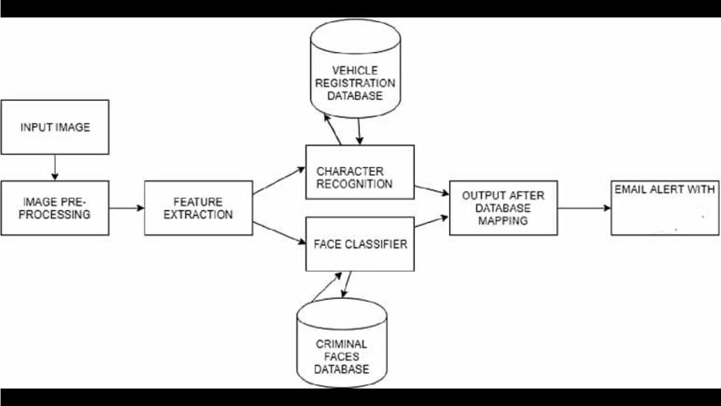

CRIMINAL

The input images and the image captured through live streaming. Both these process undergoes four common procedures namely, face acquisition, pre-processing, face detection using Haar-cascade classifier and feature extraction using Linear Binary Pattern algorithm to compute LBP values. These values are stored in the database only in case of processing an input image. Finally, comparison of the values in the database with the values computed via live streaming takes place which recognizes the human face as known or unknown based on the matching.

**WORKING PRINCIPLE:**

LBPH considers texture descriptor which is useful to symbolize Faces. Because face data can be split as compositions of patterns of micro textures. Basically LBPH is carried out in 3 stages they are

1. Feature extraction,

2. Matching,

3. Classification

The face recognition is carried out as stages first stage the image capturing and converting into grey scale then the haar features are checked if the features are their then it is considered as face if not non face, after that the pixels are mapped and checked the face.

**ALGORITHM:**

**Training the Algorithm**:

First, we need to train the algorithm. To do so, we need to use a dataset with the facial images of the people we want to recognize. We need to also set an ID for each image, so the algorithm will use this information to recognize an input image and give you an output. Images of the same person must have the same ID. With the training set already constructed, let’s see the LBPH computational steps.

**Applying the LBPH operation**:

The first computational step of the LBPH is to create an intermediate image that describes the original image in a better way, by highlighting the facial characteristics. To do so, the algorithm uses a concept of a sliding window, based on the parameters **radius** and **neighbors**.

The image below shows this procedure:

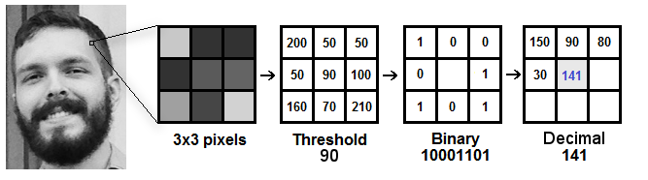

**Fig.** **Applying the LBP operation**

* Suppose we have a facial image in grayscale.
* We can get part of this image as a window of 3x3 pixels.
* It can also be represented as a 3x3 matrix containing the intensity of each pixel (0~255).
* Then, we need to take the central value of the matrix to be used as the threshold.
* For each neighbor of the central value , we set a new binary value. We set 1 for values equal or higher than the threshold and 0 for values lower than the threshold.
* Then, we convert this binary value to a decimal value and set it to the central value of the matrix, which is actually a pixel from the original image.
* At the end of this procedure (LBP procedure), we have a new image which represents better the characteristics of the original image.

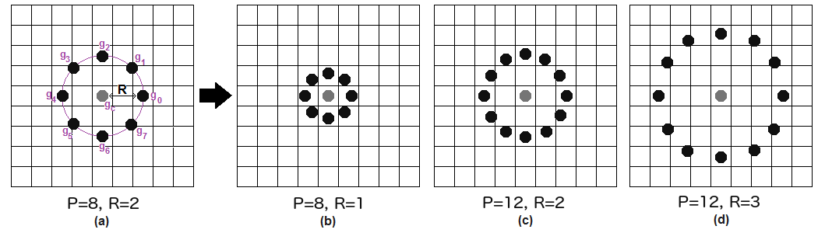

**Fig. Graph of image**

**Extracting the Histogram**:

Now, using the image generated in the last step, we can use the **Grid X**and **Grid Y**parameters to divide the image into multiple grids, as can be seen in the following image:

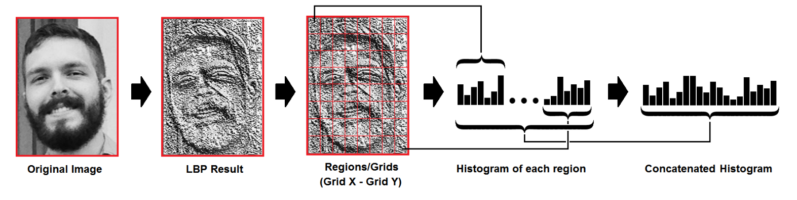

**Fig. Extracting the Histogram**

* As we have an image in grayscale, each histogram (from each grid) will contain only 256 positions (0~255) representing the occurrences of each pixel intensity.
* Then, we need to concatenate each histogram to create a new and bigger histogram. Supposing we have 8x8 grids, we will have 8x8x256=16.384 positions in the final histogram. The final histogram represents the characteristics of the image original image.

**FACE PROCESS**

**1.Face detection:**

Many kinds of face detections are used in plenty appliance occurrence management, surveillance eventualities, gaming, human-computer interaction, etc. Viola associated Jones devised an formula, known as haar features classifiers, to chop-chop find any object, as well as human faces, victimization Haar classifier cascades that area unit supported Haar-Like options. Different types of ways area unit out there for detecting the face for identification and recognition. Face detection is using haar like features, so we’ll work with face detection. Initially, the formula lots of positive pictures (images of faces) and negative pictures (images while not faces) to coach the classifier. Then we’d like to extract options from it. For these, haar features shown in image area unit used. Which are similar to our convolutional kernel. There are line features, edge features and rectangle features.

**2.Face Recognition:**

Face recognition applications is categorized into the three categories: verification, identification and watch. Face confirmation part is considered to be a one. The system can compare face image to the face image(s) of a similar registered identity within the information to form call on whether declining or not acceptive the identity claim. In distinction, the face identification task may be a one: N matching drawback. The face image is conferred to the system while not associate degree mark claim and also the system can search through the existing identities within the information of face to compare the conferred face image. Usually, it’s considered that the conferred face image belongs to at least one of the themes within the information. Lastly, the watch list task is typically very just like the identification task. but in watch list task, the question subjects square measure usually larger than the themes within the information and thus the question subject might not exist within the information.

**3.Application:**

* Prevent Retail Crime.
* Unlock Phones.
* Smarter Advertising.
* Find Missing Persons.
* Help the Blind.
* Protect Law Enforcement.
* Aid Forensic Investigations.
* Identify People on Social Media Platforms.

**RESULTS**

The face detection and recognition is done using LBPH , the efficiency is up till 72% and the tilling of image is allowed till forty five degrees, the following images are the of face matched or recognized. The below image is the face that should be recognized, the image is matched and in the right of the image is the atmost matched image, this is done using raspberry pi using open CV.Finally, an Alert message is sent to the nearest police station using SMTP protocol.

**SOFTWARE SPECIFICATION:**

**Open CV:**

Open CV (Open Source Computer Vision) is a bunch of programming functions which is used for real-time computer vision, developed by Intel’s research center which was supported by Willow Garage and It see is maintaining now. Open CV was developed to bring a common platform for applications of computer vision and also accelerate the use of commercial products in machine perception. Open CV makes easy for businesses to modify and utilize the code since it is a BSD-licensed. More than 2500 algorithms are included in the library, which includes both machine learning algorithms and state of the art and classic computer vision. To identify objects, detect and recognize faces, classify human actions from videos, track moving objects, track camera movements, from stereo cameras produce 3D point clouds, extract 3D model of objects, to produce a high resolution image by stitching images of one entire scene, from image data base to find the similar images. Follow eye movements, red eyes which is appeared due use of flash can be removed, and many more can bedeveloped using these algorithms.

**REFERENCES**

1.Ahonen T, Pietikäinen M, Hadid M and Mäenpaä T (2004), “Face Recognition Based on the Appearance of Local Regions”, Machine Vision Group, InfoTech. University of Oulu, Finland, IEEE.

2. Ahonen T, Hadid A and Pietikäinen M (2006),“Face Description with Local Binary Patterns: Application to Face Recognition”, Draft, June 5, 2006.

3. Faizi A (2008), “Robust Face Detection using Template Matching Algorithm,” University of Toronto, Canada.

4. Feng P (2004), “Face Recognition based on Elastic Template,” Beijing University of Technology, China, M H Yang, D J Kriegman, and N Ahuja. Detecting facesin images: a survey. IEEE Trans. on PAMI, 2002.

5. Hadid A, Heikkilä M, Ahonen T and Pietikäinen M (2004), “A Novel Approach to Access Control based on Face Recognition”, Machine Vision Group, InfoTech Oulu and Department of Electrical and Information Engineering. University of Oulu, Finland.

6. Rodriguez Y (2006), Face Detection and Verication Using Local Binary Patterns, Ph.D. Thesis, ~Acole Polytechnique Federale de Lausanne.

7. Nosaka R, Ohkawa Y and Fukui K (2012), “Feature extraction based on co-occurrence of adjacent local binary patterns,” in Proceedings of the 5th Pacic Rim conference on Advances in Image and Video Technology - Volume Part II, PSIVT2011, pp. 82-91.

Author name in ascending order ,,,, M pietikainen and M Hadid…