**Machine Learning Model Deployment with IBM Cloud Watson Studio**

**PHASE 2**

**INTRODUCTION:**

Machine learning, a branch of artificial intelligence that enables systems to learn patterns from data and make intelligent decisions, is one of the most powerful technologies at their disposal. The real-world applications of machine learning, rather than just its algorithms, are where its actual potential lies. To fully realize this potential, machine learning models must be deployed successfully. This will allow companies to benefit from data-driven insights.

The problem of deploying machine learning models effectively and creatively using IBM Cloud Watson Studio is the focus of our endeavor. The challenge is straightforward there is an urgent need for businesses to convert complex machine learning algorithms into workable, scalable solutions. Our project's importance is rooted on finding novel solutions to these problems.

**PROBLEM STATEMENT:**

The project involves training a machine learning model using IBM Cloud Watson Studio and deploying it as a web service. The goal is to become proficient in predictive analytics by creating a model that can predict outcomes in real-time. The project encompasses defining the predictive use case, selecting a suitable dataset, training a machine learning model, deploying the model as a web service, and integrating it into applications.

**SIGNIFICANCE:**

**Realizing the Potential:**

Machine learning models, when deployed effectively, can revolutionize decision-making processes. Whether it’s predicting market trends, optimizing supply chains, or enhancing customer experiences, these models hold the key to unlocking new realms of efficiency and productivity.

**Meeting Market Demands:**

In a world where consumers expect personalized services and instant responses, businesses need innovative solutions to stay competitive. Deploying machine learning models swiftly and accurately is no longer a luxury but a necessity to meet these demands effectively.

**Optimizing Resources:**

Innovative deployment solutions are crucial in optimizing resources. By automating repetitive tasks, predicting equipment failures, or streamlining workflows, businesses can save costs and redirect resources to areas that need strategic attention.

**IBM CLOUD WATSON STUDIO:**

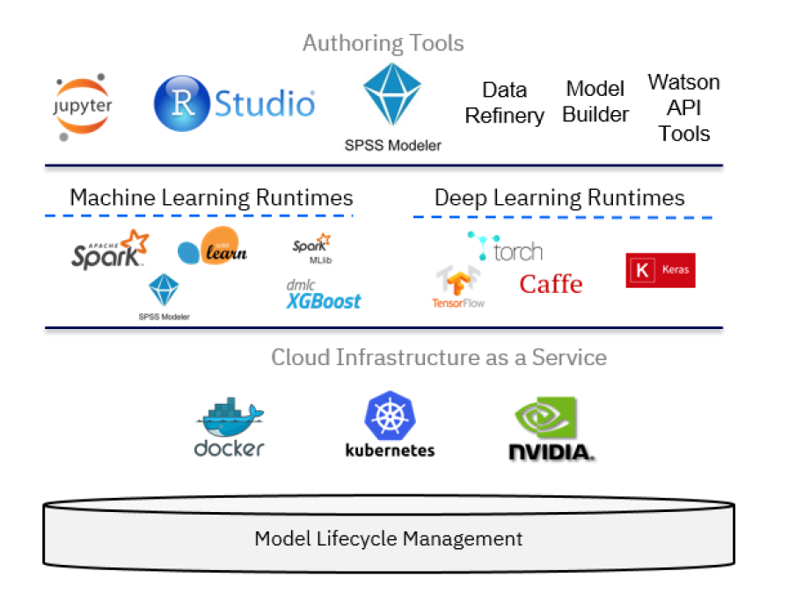

An effective tool for streamlining the creation, testing, and deployment of machine learning models is IBM Cloud Watson Studio. In our project, we made use of a number of important IBM Cloud Watson Studio features, each of which had a big impact on how we developed and deployed our models.

1. **Collaborative Environment:**

IBM Cloud Watson Studio offers a collaborative setting for real-time collaboration between data scientists and developers. Its collaborative technologies enable seamless teamwork by enabling people to exchange information, code, and resources. This characteristic promotes an inventive environment where ideas are encouraged to flow freely and group problem-solving flourishes.

1. **Tools for Data Preparation:**

The platform provides a range of tools for data preparation that make data cleaning, transformation, and feature engineering effective. With Watson Studio, data preparation becomes a creative process, leading to innovative feature sets.

1. **AutoAI and Model Builder:**

With the help of IBM Cloud Watson Studio's AutoAI and Model Builder features, models may be created automatically with little to no manual input. AutoAI investigates various algorithms and hyperparameters, giving us knowledge on the most efficient model setups. By letting us to concentrate on improving the models and analyzing the outcomes rather than spending a lot of time on initial setup, this automation speeds up our creativity.

**4. Integration of Open Source Software Tools:**

The IBM Cloud Popular open-source tools and libraries are effortlessly integrated into Watson Studio, increasing our arsenal of innovative capabilities. With Watson Studio's compatibility, we can experiment with cutting-edge methods from TensorFlow or use scikit-learn's adaptability to expand the possibilities for model creation.

In summary, IBM Cloud Watson Studio serves as the catalyst for innovation in our project.

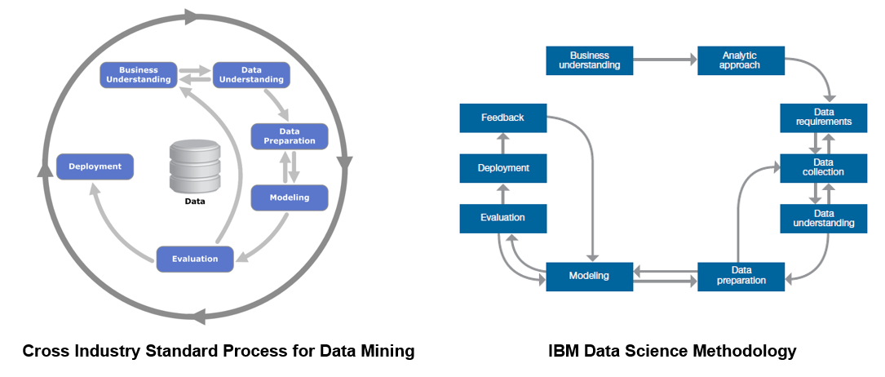

**INNOVATION:**

Innovation in machine learning isn't just about data and algorithms it's also about how we put these solutions to use in the real world. Innovative machine learning model deployment entails moving beyond conventional approaches, adopting cutting-edge technologies, and making sure that sophisticated models are seamlessly integrated into current business processes. In this project, we've used IBM Cloud Watson Studio to deploy models in a novel way, setting the standard for new techniques and approaches that transform how companies utilize artificial intelligence.

**1.Innovative Scalability for Global Impact:**

Our deployment technique dynamically adjusts to meet demands around the world in addition to scaling. Our models are prepared to handle a variety of workloads globally by utilizing IBM Cloud Watson Studio's cutting-edge scalability features. Because of our flexibility, our influence is not limited by regional borders. Whether in crowded urban regions or far-flung rural areas, our solutions scale smoothly and offer value everywhere.

**2. Ethical AI for Social Impact:**

Ethics are of the utmost importance. We've innovatively used IBM Cloud Watson Studio's moral AI capabilities to ensure that our models are impartial and fair in addition to being accurate. We're fostering a more just future by reducing computational biases. Our influence goes beyond technology, fostering diversity and closing gaps, and transforming AI into a force for social progress rather than merely technological development.

**3.User-Centric Innovation for Improved Experiences:**

User experience innovation is our compass. We've created user-centric models by combining intuitive interfaces and real-time feedback loops. In this sense, impact refers to better user experiences. Our creative approach provides smooth interactions, encouraging trust and confidence in AI-driven solutions, whether it's a student looking for educational insights or a healthcare provider identifying ailments.

**4.Economic Empowerment through Innovation:**

Innovation is about empowering businesses, not only about algorithms. We have made it possible for companies to optimize their operations, saving resources and promoting economic growth, through dynamic, scalable deployment. The results are observable: higher production, lower costs, and quicker innovation cycles. Our deployment technique has a cascading impact that promotes economic empowerment at all levels by increasing corporate efficiency.

**5. Innovative Security for Reliability and Trust:**

In the digital age, reliability and trust are crucial. In order to guarantee data integrity and user privacy, our creative deployment method incorporates cutting-edge security mechanisms. In this case, trust has an impact. Users engage with our AI-driven solutions with confidence because they know their data is protected. A positive feedback loop of trust and innovation results from the relationship between dependability and trust. dependability increases impact.

**6. Environmental Impact from Efficiency:**

Resource efficiency is a form of innovation that goes beyond algorithms. We have reduced resource waste by utilizing the scalable and optimized deployment features of IBM Cloud Watson Studio. Impact fits nicely with environmental protection in this aspect. We are promoting environmental sustainability and bringing technical advancement and environmental sustainability together by minimizing computational footprints.

Finally, the true potential of machine learning deployment with IBM Cloud Watson Studio appears at the intersection of creativity and impact. We've entered into the full potential of AI to make a difference by developing scalable, moral, user-centric, economically empowering, secure, and environmentally conscientious solutions.

**CONCLUSION:**

In conclusion, this project represents a holistic journey into the world of predictive analytics, encompassing problem definition, data selection, model development, web service deployment, and seamless integration into practical applications. By leveraging IBM Cloud Watson Studio and following a structured approach, the aim is not only to build a proficient predictive model but also to empower the team with the skills and knowledge required to harness the power of real-time predictions for informed decision-making. This project serves as a valuable opportunity to bridge the gap between data-driven insights and real-world applications, enhancing both proficiency in predictive analytics and the potential for meaningful business impact.