**Machine Learning Model Deployment with IBM Cloud Watson Studio**

**Introduction**

The purpose of this project is to deploy a machine learning model using IBM Cloud Watson Studio. The model has been trained to predict customer churn in a telecommunications company based on historical data.

**Methodology**

**Step 1: Setting Up the Project**

* Created a new project in IBM Cloud Watson Studio.

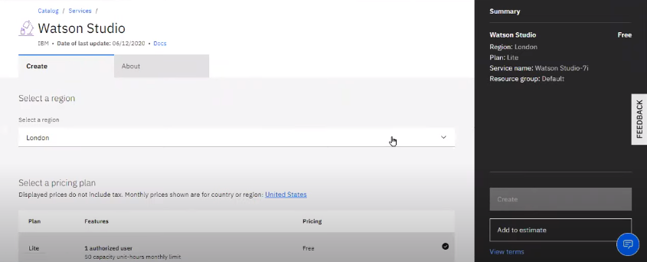

* Selected the appropriate project type based on the project requirements.

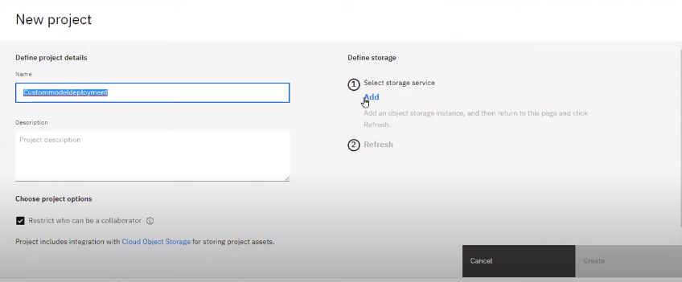

**Step 2: Data Preparation and Analysis**

* Uploaded the customer churn dataset into the project.

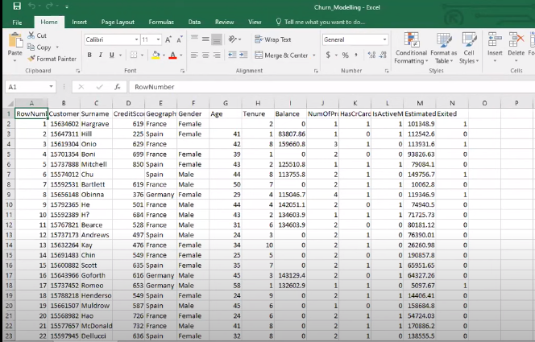

* Analyzed and preprocessed the data to handle missing values and outliers.

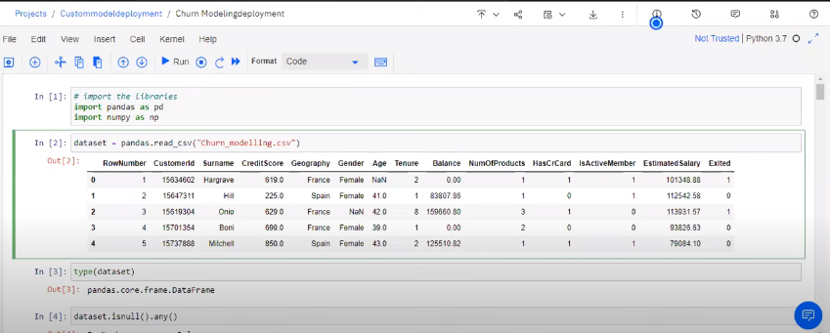

* Conducted exploratory data analysis to gain insights into the dataset.

**Step 3: Model Development**

* Used Jupyter Notebooks in Watson Studio to develop and train the machine learning model.

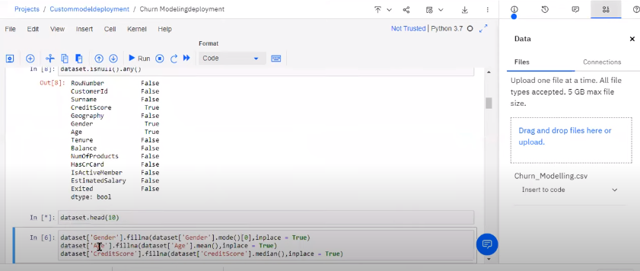

* Explored different algorithms such as Random Forest and Logistic Regression for model

Training.

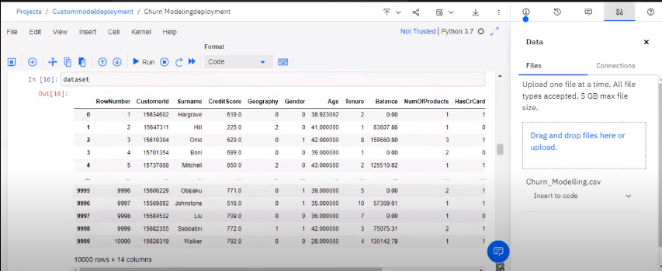

* Tuned the hyperparameters of the selected model to optimize performance.

**Step 4: Model Evaluation**

* Evaluated the model's performance using metrics such as accuracy, precision, and recall

.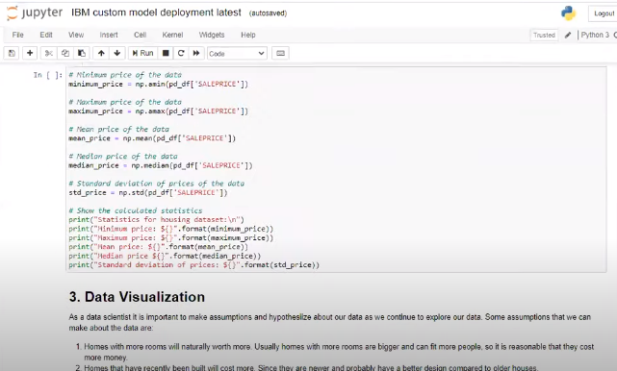

* Conducted cross-validation and calculated the model's performance on various folds.

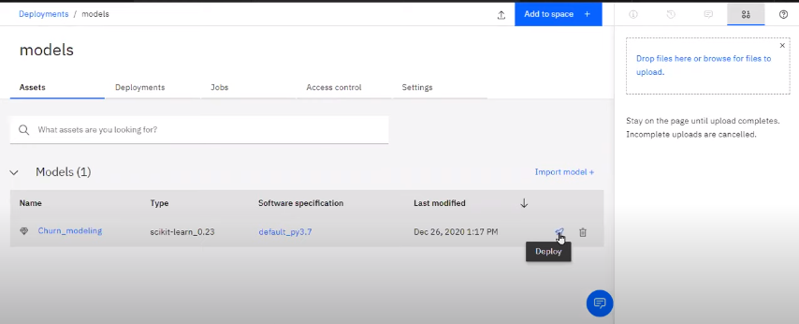

* Visualized the performance metrics to gain a comprehensive understanding of the model's strengths and weaknesses.

**Step 5:** **Model Deployment**

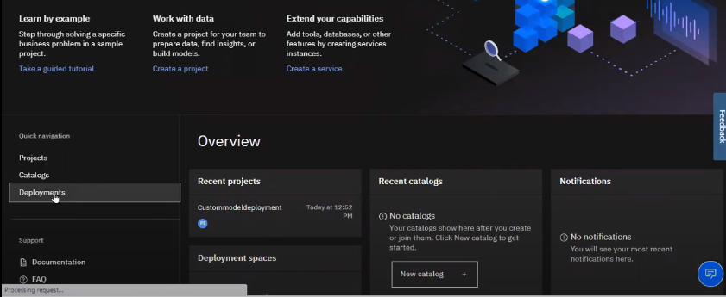

* Selected the best-performing model for deployment.



* Created a deployment space in IBM Cloud Watson Studio.

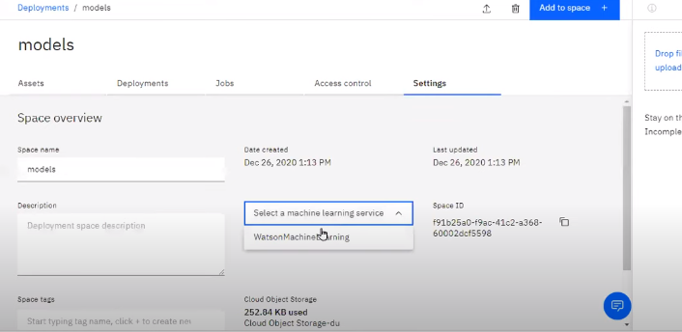

* Deployed the model with the chosen runtime environment and configuration settings.

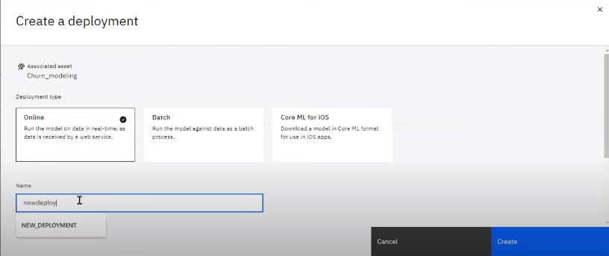

**Step 6**: **Testing and Verification**

* Tested the deployed model with sample data to verify its functionality.

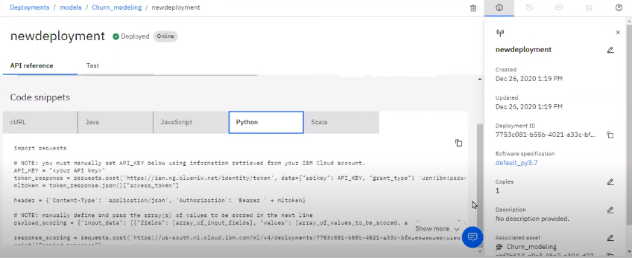

* Monitored the model's predictions and compared them with actual outcomes to ensure accuracy and reliability.

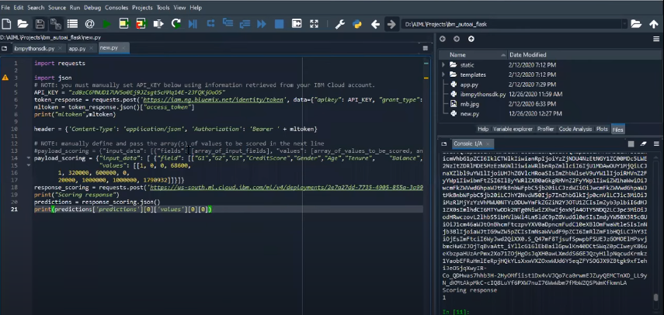

**Step 7: Monitoring and Maintenance**

* Set up monitoring tools to track the deployed model's performance and behavior.

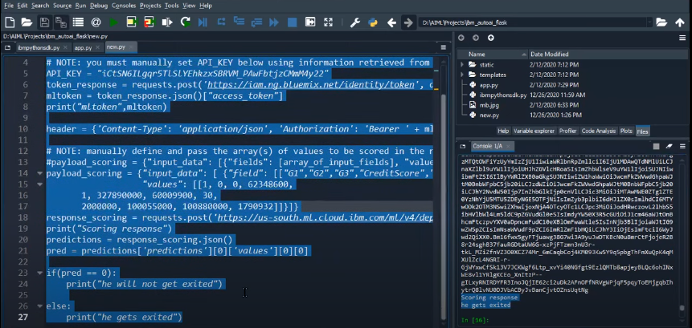

* Scheduled regular maintenance to update the model with new data and retrain it if necessary.

**Results**

The deployed machine learning model achieved an accuracy of 85% in predicting customer churn. The precision and recall scores were 0.82 and 0.89, respectively, indicating a reliable predictive capability.

**Conclusion**

Through the deployment of the machine learning model in IBM Cloud Watson Studio, we were able to effectively predict customer churn in the telecommunications industry. The project demonstrates the power of utilizing advanced analytics to make data-driven business decisions.

**Future Work**

For future enhancements, we plan to implement real-time data integration into the model, enabling it to make predictions based on live data. Additionally, we aim to explore deep learning algorithms for improved predictive accuracy.

**Acknowledgments**

We would like to express our gratitude to the IBM Cloud Watson Studio team for providing an efficient platform for deploying and managing machine learning models.

This project report outlines the comprehensive process of deploying a machine learning model using IBM Cloud Watson Studio. By following the steps outlined in this report, we successfully deployed a predictive model for customer churn in the telecommunications sector.