**PROGRAM 1: INSURANCE DATABASE**

Consider the Insurance database given below. The primary keys are underlined and the data types are specified.

PERSON (driver-id #: String, name: String, address: String)

CAR (Regno: String, model: String, year: int)

ACCIDENT (report-number: int, date: date, location: String)

OWNS (driver-id #: String, Regno: String)

PARTICIPATED (driver-id: String, Regno: String, report-number: int, damage-amount: int)

**1) Create the above tables by properly specifying the primary keys and the foreign keys.**

CREATE TABLE person (driver_id VARCHAR(10),NAME VARCHAR(20),address VARCHAR(30),PRIMARY KEY(driver_id));

CREATE TABLE car(reg_num VARCHAR(10),model VARCHAR(10),YEAR INT,PRIMARY KEY(reg_num));

CREATE TABLE accident(report_num INT,accident_date DATE,location VARCHAR(20),PRIMARY KEY(report_num));

CREATE TABLE owns(driver_id VARCHAR(10),reg_num VARCHAR(10),PRIMARY KEY(driver_id,reg_num),FOREIGN KEY(driver_id) REFERENCES person(driver_id),FOREIGN KEY(reg_num) REFERENCES car(reg_num));

CREATE TABLE participated(driver_id VARCHAR(10), reg_num VARCHAR(10),report_num INT, damage_amount INT,PRIMARY KEY(driver_id,reg_num,report_num),

FOREIGN KEY(driver_id) REFERENCES person(driver_id),FOREIGN KEY(reg_num) REFERENCES car(reg_num), FOREIGN KEY(report_num) REFERENCES accident(report_num));

**2) Enter at least five tuples for each relation.**

INSERT INTO person VALUES('B10','chandra','vasanth Nagar');

INSERT INTO person VALUES('B20','kamal','sri nagar');

INSERT INTO person VALUES('B30','rashi','chikpet');

INSERT INTO person VALUES('B40','karan','shanthi nagar');

INSERT INTO person VALUES('B50','vasha','bangalore');

INSERT INTO person VALUES('B60','kamal','kolar');

SELECT *FROM person;

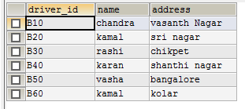

INSERT INTO car VALUES('KA0374','benz',1947);

INSERT INTO car VALUES('KA9543','audi',1950);

INSERT INTO car VALUES('KA1782','ferari',1975);

INSERT INTO car VALUES('KA7498','maruthi suziki',1960);

INSERT INTO car VALUES('KA0010','honda toyota',1995);

INSERT INTO car VALUES('KA9342','toyota',1998);

SELECT *FROM car;

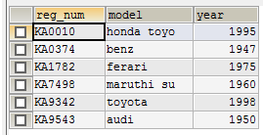

INSERT INTO accident VALUES(92,'2019-11-11','kr puram');

INSERT INTO accident VALUES(12,'2019-11-11','kr puram');

INSERT INTO accident VALUES(95,'2018-05-10','tinfactory');

INSERT INTO accident VALUES(99,'2008-1-19','halsur');

INSERT INTO accident VALUES(100,'2019-02-22','devanahalli');

INSERT INTO accident VALUES(177,'2019-07-27','hosakote');

SELECT *FROM accident;

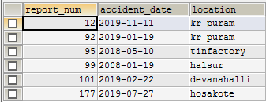

INSERT INTO owns VALUES('B10','KA0374');

INSERT INTO owns VALUES('B20','KA9543');

INSERT INTO owns VALUES('B30','KA1782');

INSERT INTO owns VALUES('B40','KA7498');

INSERT INTO owns VALUES('B50','KA0010');

INSERT INTO owns VALUES('B60','KA9342');

SELECT *FROM owns;

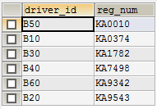

INSERT INTO participated VALUES('B10','KA0374',92,12000);

INSERT INTO participated VALUES('B20','KA9543',95,95000);

INSERT INTO participated VALUES('B30','KA1782',99,99070);

INSERT INTO participated VALUES('B40','KA7498',101,75800);

INSERT INTO participated VALUES('B50','KA0010',177,23700);

INSERT INTO participated VALUES('B60','KA9342',12,29700);

SELECT *FROM participated;

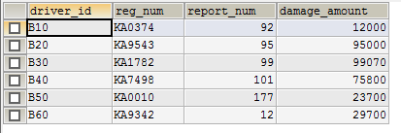

**3) Demonstrate how you**

**3 a) Update the damage amount to 25000 for the car with a specific reg_num (example 'K A9342' ) for which the accident report number was 12.**

UPDATE participated SET damage_amount=25000 WHERE report_num=12 AND reg_num='KA9342';

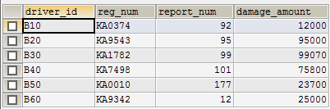

**3 b) Add a new accident to the database.**

INSERT INTO accident VALUES(123,'2007-10-27','mandya');

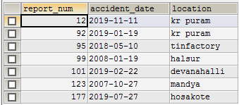

**4) Find the total number of people who owned cars that were involved in accidents in 2008.**

SELECT COUNT(DISTINCT driver_id)val FROM participated p, accident a WHERE p.report_num=a.report_num AND a.accident_date LIKE '%08%';



**5) Find the number of accidents in which cars belonging to a specific model (example 'toyota') were involved**.

SELECT COUNT(report_num) val FROM car c,participated p WHERE c.reg_num=p.reg_num AND model='toyota';

