**PROGRAM 2. BANKING ENTERPRISE DATABASE**

Consider the following database for a banking enterprise.

BRANCH (branch-name: String, branch-city: String, assets: real)

ACCOUNTS (accno: int, branch-name: String, balance: real)

DEPOSITOR (customer-name: String, customer-street: String, customer-city: String)

LOAN (loan-number: int, branch-name: String, amount: real)

BORROWER (customer-name: String, loan-number: int)

**i. Create the above tables by properly specifying the primary keys and the foreign keys.**

**ii. Enter at least five tuples for each relation.**

CREATE TABLE branch(branch_name VARCHAR(30),branch_city VARCHAR(20),assets REAL,PRIMARY KEY(branch_name));

DESC branch

INSERT INTO branch VALUES('SBI-chamarajpet','banglore',50000);

INSERT INTO branch VALUES('SBI-residencyroad','banglore',10000);

INSERT INTO branch VALUES('SBI-shivajiroad','bombay',20000);

INSERT INTO branch VALUES('SBI-parlimentroad','delhi',10000);

INSERT INTO branch VALUES('SBI-jantarmanar','delhi',20000);

SELECT *FROM branch;

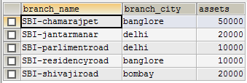

CREATE TABLE accounts(acctno INT,branch_name VARCHAR(20),balance REAL,PRIMARY KEY(acctno),FOREIGN KEY(branch_name)REFERENCES branch(branch_name));

INSERT INTO accounts VALUES(1,'SBI-chamarajpet',2000);

INSERT INTO accounts VALUES(2,'SBI-residencyroad',5000);

INSERT INTO accounts VALUES(3,'SBI-shivajiroad',6000);

INSERT INTO accounts VALUES(4,'SBI-parlimentroad',9000);

INSERT INTO accounts VALUES(5,'SBI-jantarmanar',8000);

INSERT INTO accounts VALUES(6,'SBI-shivajiroad',4000);

INSERT INTO accounts VALUES(8,'SBI-residencyroad',4000);

INSERT INTO accounts VALUES(9,'SBI-parlimentroad',3000);

INSERT INTO accounts VALUES(10,'SBI-residencyroad',5000);

INSERT INTO accounts VALUES(11,'SBI-jantarmanar',2000);

SELECT *FROM accounts;

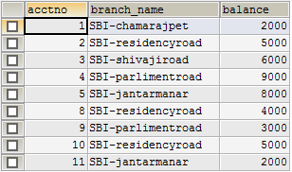

CREATE TABLE depositor(customer_name VARCHAR(20),customer_street VARCHAR(20),customer_city VARCHAR(20),PRIMARY KEY(customer_name));

INSERT INTO depositor VALUES('avinash','gs road','banglore');

INSERT INTO depositor VALUES('dinesh','mg road','banglore');

INSERT INTO depositor VALUES('mohan','jp road','banglore');

INSERT INTO depositor VALUES('nikil','kp road','delhi');

INSERT INTO depositor VALUES('ravi','ab road','delhi');

SELECT *FROM depositor;

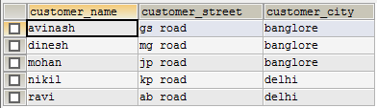

CREATE TABLE borrower(customer_name VARCHAR(30),acctno INT,PRIMARY KEY(customer_name,acctno),FOREIGN KEY(customer_name)REFERENCES depositor(customer_name),FOREIGN KEY(acctno)REFERENCES accounts(acctno));

INSERT INTO borrower VALUES('avinash',1);

INSERT INTO borrower VALUES('dinesh',2);

INSERT INTO borrower VALUES('nikil',4);

INSERT INTO borrower VALUES('ravi',5);

INSERT INTO borrower VALUES('avinash',8);

INSERT INTO borrower VALUES('nikil',9);

INSERT INTO borrower VALUES('dinesh',10);

INSERT INTO borrower VALUES('nikil',11);

SELECT *FROM borrower;

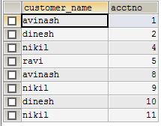

CREATE TABLE loans(loan_number INT,branch_name VARCHAR(30),amount REAL,PRIMARY KEY(loan_number),FOREIGN KEY(branch_name)REFERENCES branch(branch_name));

INSERT INTO loans VALUES(1,'SBI-chamarajpet',1000);

INSERT INTO loans VALUES(2,'SBI-residencyroad',2000);

INSERT INTO loans VALUES(3,'SBI-shivajiroad',3000);

INSERT INTO loans VALUES(4,'SBI-parlimentroad',4000);

INSERT INTO loans VALUES(5,'SBI-jantarmantar',5000);

SELECT *FROM loans;

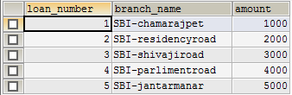

**iii. Find all the customers who have at least two accounts at the Main branch.**

SELECT c.customer_name FROM depositor c WHERE EXISTS(SELECT d.customer_name,COUNT(d.customer_name) FROM borrower d,accounts a WHERE d.acctno=a.acctno AND c.customer_name=d.customer_name AND a.branch_name='SBI-residencyroad' GROUP BY d.customer_name HAVING COUNT(d.customer_name)>=2);



**iv. Find all the customers who have an account at all the branches located in a specific city**.

SELECT d.customer_name FROM borrower d,branch b,accounts a WHERE b.branch_name=a.branch_name AND a.acctno=d.acctno AND branch_city='delhi' GROUP BY d.customer_name HAVING COUNT(DISTINCT b.branch_name)=(SELECT COUNT(branch_name)FROM branch WHERE branch_city='delhi');



**v. Demonstrate how you delete all account tuples at every branch located in a specific city.**

DELETE FROM accounts WHERE branch_name IN(SELECT branch_name FROM branch WHERE branch_city='bombay');

SELECT *FROM accounts;

