**Program 8:**

Consider the following database of student enrollment in courses & books adopted for each course.

STUDENT (regno: string, name: string, major: string, bdate:date)

COURSE (course #:int, cname:string, dept:string)

ENROLL ( regno:string, course#:int, sem:int, marks:int)

BOOK _ ADOPTION (course# :int, sem:int, book-ISBN:int)

TEXT (book-ISBN:int, book-title:string, publisher:string, author:string)

Database applications laboratory GCEM DEPARTMENT OF CSE Page - 5 - 5th semester

i. Create the above tables by properly specifying the primary keys and the foreign keys.

CREATE TABLE student(regno VARCHAR(15),NAME VARCHAR(20),major VARCHAR(20),bdate DATE,PRIMARY KEY (regno) );

CREATE TABLE course(courseno INT,cname VARCHAR(20),dept VARCHAR(20),PRIMARY KEY (courseno) );

CREATE TABLE enroll(regno VARCHAR(15),courseno INTEGER,sem INTEGER,marks INTEGER,PRIMARY KEY(regno,courseno),FOREIGN KEY(regno)REFERENCES student(regno),FOREIGN KEY(courseno)REFERENCES course(courseno));

CREATE TABLE text_book(book_isbn INT(5),book_title VARCHAR(20),publisher VARCHAR(20),author VARCHAR(20),PRIMARY KEY (book_isbn) );

CREATE TABLE book_adoption(courseno INT,sem INT(3),book_isbn INT(5),PRIMARY KEY(courseno,book_isbn),FOREIGN KEY(courseno)REFERENCES course (courseno),FOREIGN KEY (book_isbn) REFERENCES text_book(book_isbn) );

ii. Enter at least five tuples for each relation.

INSERT INTO student VALUES('1pe11cs002','b','sr','19930924');

INSERT INTO student VALUES('1pe11cs003','c','sr','19931127');

INSERT INTO student VALUES('1pe11cs004','d','sr','19930413');

INSERT INTO student VALUES('1pe11cs005','e','jr','19940824');

INSERT INTO course VALUES(111,'OS','CSE');

INSERT INTO course VALUES(112,'EC','CSE');

INSERT INTO course VALUES(113,'SS','ISE');

INSERT INTO course VALUES(114,'DBMS','CSE');

INSERT INTO course VALUES(115,'SIGNALS','ECE');

INSERT INTO text_book VALUES(10,'DATABASE SYSTEMS','PEARSON','SCHIELD');

INSERT INTO text_book VALUES(900,'OPERATING SYS','PEARSON','LELAND');

INSERT INTO text_book VALUES(901,'CIRCUITS','HALL INDIA','BOB');

INSERT INTO text_book VALUES(902,'SYSTEM SOFTWARE','PETERSON','JACOB');

INSERT INTO text_book VALUES(903,'SCHEDULING','PEARSON','PATIL');

INSERT INTO text_book VALUES(904,'DATABASE SYSTEMS','PEARSON','JACOB');

INSERT INTO text_book VALUES(905,'DATABASE MANAGER','PEARSON','BOB');

INSERT INTO text_book VALUES(906,'SIGNALS','HALL INDIA','SUMIT');

INSERT INTO enroll VALUES('1pe11cs002',114,5,100);

INSERT INTO enroll VALUES ('1pe11cs003',113,5,100);

INSERT INTO enroll VALUES ('1pe11cs004',111,5,100);

INSERT INTO enroll VALUES ('1pe11cs005',112,3,100);

INSERT INTO book_adoption VALUES (111,5,900);

INSERT INTO book_adoption VALUES (111,5,903);

INSERT INTO book_adoption VALUES (111,5,904);

INSERT INTO book_adoption VALUES (112,3,901);

INSERT INTO book_adoption VALUES (113,3,10);

INSERT INTO book_adoption VALUES (114,5,905);

INSERT INTO book_adoption VALUES (113,5,902);

INSERT INTO book_adoption VALUES (115,3,906);

SELECT *FROM student;

SELECT*FROM course;

SELECT *FROM text_book;

SELECT *FROM enroll;

SELECT *FROM book_adoption;

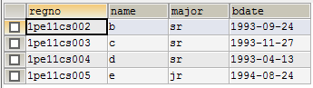

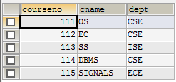

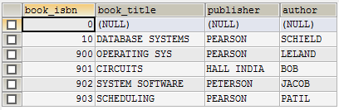

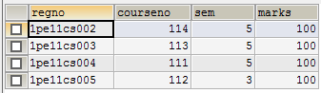

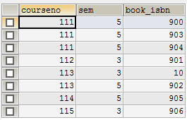

iii. Demonstrate how you add a new text book to the database and make this book be adopted by some department

INSERT INTO text_book VALUES(908,'UNIX CINCEPTS','TATA MCGRAW HILL','SUSMITABHA DAS');

INSERT INTO book_adoption VALUES(113,4,908);

SELECT*FROM text_book;

SELECT*FROM book_adoption;

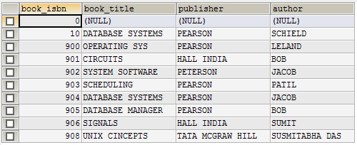

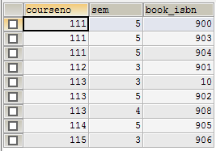

iv. Produce a list of text books (include Course #, Book-ISBN, Book-title) in the alphabetical order for courses offered by the ‘CS’ department that use more than two books.

SELECT c.courseno,t.book_isbn,t.book_title FROM course c,book_adoption ba,text_book t WHERE c.courseno=ba.courseno AND ba.book_isbn=t.book_isbn AND c.dept='CSE' AND 2<(SELECT COUNT(book_isbn) FROM book_adoption b WHERE c.courseno=b.courseno)ORDER BY t.book_title;

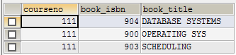

v. List any department that has all its adopted books published by a specific publisher.

SELECT DISTINCT c.dept FROM course c WHERE c.dept IN( SELECT c.dept FROM course c,book_adoption b,text_book t WHERE c.courseno=b.courseno AND t.book_isbn=b.book_isbn AND t.publisher='PEARSON')AND c.dept NOT IN(SELECT c.dept FROM course c,book_adoption b,text_book t WHERE c.courseno=b.courseno AND t.book_isbn=b.book_isbn AND t.publisher != 'PEARSON');

