**Cambridge IGCSE™**

*7392438156*

**MATHEMATICS**

**0580/42**

Paper 4 (Extended)

**October/November**

**2023**

**hours 30 minutes**

**2**

You must answer on the question paper.

You will need:

Geometrical instruments

**INSTRUCTIONS**

* Answer **all** questions.
* Use a black or dark blue pen. You may use an HB pencil for any diagrams or graphs.
* Write your name, centre number and candidate number in the boxes at the top of the page.
* Write your answer to each question in the space provided.
* Do **not** use an erasable pen or correction fluid.
* Do **not** write on any bar codes.
* You should use a calculator where appropriate.
* You may use tracing paper.
* You must show all necessary working clearly.
* Give non-exact numerical answers correct to 3 significant figures, or 1 decimal place for angles in degrees, unless a different level of accuracy is specified in the question.
* For r, use either your calculator value or 3.142.

**INFORMATION**

* The total mark for this paper is 130.
* The number of marks for each question or part question is shown in brackets [ ].

This document has **20** pages. Any blank pages are indicated.

DC (CE/FC) 318220/3

© UCLES 2023 **[Turn over**

**1**

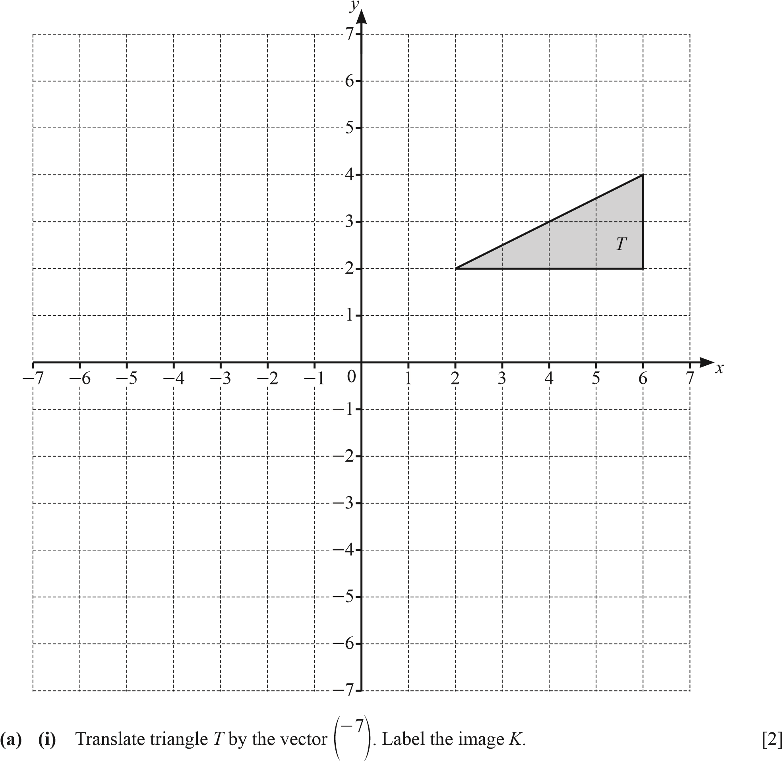1

**(ii)** Describe fully the **single** transformation that maps triangle *K* onto triangle *T*.

.............................................................................................................................................

............................................................................................................................................. [1]

1. Reflect triangle *T* in the line *y* = 4. [2]
2. Rotate triangle *T* through 90° clockwise about (0, 0). [2]
3. **(i)** Enlarge triangle *T* by scale factor -, centre (0, 0). Label the image *P*. [2]

**(ii)** Describe fully the **single** transformation that maps triangle *P* onto triangle *T*.

.............................................................................................................................................

............................................................................................................................................. [2]

**2 (a)** Daisy records her 50 homework marks. The table shows the results.

|  |  |  |  |  |  |  |
| --- | --- | --- | --- | --- | --- | --- |
| Homework mark | 15 | 16 | 17 | 18 | 19 | 20 |
| Frequency | 1 | 3 | 19 | 11 | 10 | 6 |

* + 1. Write down the range.

................................................. [1]

* + 1. Write down the mode.

................................................. [1]

* + 1. Find the median.

................................................. [1]

* + 1. Calculate the mean.

................................................. [3]

**(b)**  21 33 20 25 21 34 22 21 20 30 18

The list shows Ed’s scores in 11 tests.

* + 1. Complete the stem-and-leaf diagram to show this information.

|  |  |
| --- | --- |
| 1 |  |
| 2 |  |
| 3 |  |

Key: 2|5 represents 25

[2]

* + 1. Find the median.

................................................. [1]

* + 1. Find the interquartile range.

................................................. [2] **3 (a)** The value of Priya’s car decreases by 10% every year. The value today is $7695.

* + 1. Calculate the value of the car after one year.

$ ................................................ [2]

* + 1. Calculate the value of the car one year ago.

$ ................................................ [2]

* 1. Ali invests $600 at a rate of 2% per year simple interest.

Calculate the value of Ali’s investment at the end of 5 years.

$ ................................................ [3]

* 1. Sara invests $500 at a rate of *r*% per year compound interest.

At the end of 12 years, the value of Sara’s investment is $601.35, correct to the nearest cent.

Find the value of *r*.

*r* = ................................................ [3]

**(d)** The mass of a radioactive substance decreases exponentially at a rate of 3% each day.

* + 1. Find the overall percentage decrease at the end of 10 days

............................................. % [2]

* + 1. Find the number of whole days it takes until the mass of this substance is one half of its original amount. $\frac{\ln\left(0.5\right)}{\ln\left(0.97\right)}$



................................................. [3]

**4 (a)**

*O*

*O*

*A*

*B*

*B*

*A*

*x°*

7.5

cm

7.5

cm

NOT TO

SCALE

1.5

cm

The diagram shows a sector of a circle that is made into a cone by joining *OA* to *OB*.

The sector angle is *x*° and the radius of the sector is 7.5 cm. The base radius of the cone is 1.5 cm.

Calculate the value of *x*.

*x* = ................................................ [3]  **(b)**

NOT TO

SCALE

The diagram shows a cylinder with radius 8 cm inside a sphere with radius 17 cm. Both ends of the cylinder touch the curved surface of the sphere.

**(i)** Show that the height of the cylinder is 30 cm.

[2]  **(ii)** Calculate the volume of the cylinder as a percentage of the volume of the sphere.

[The volume, *V*, of a sphere with radius *r* is *V* = r*r*3.]

............................................. % [4]  **(c)**

15 cm NOT TO

SCALE

The diagram shows a solid sphere with radius 6 cm inside a cube with side length 20 cm.

The cube contains water to a depth of 15 cm. The sphere is removed.

Calculate the new depth of water in the cube.

[The volume, *V*, of a sphere with radius *r* is *V* = r*r*3.]

............................................ cm [3] **5 (a)** In a shop the cost of a fiction book is $*x* and the cost of a reference book is $(*x* +2).

The cost of 11 fiction books is the same as the cost of 10 reference books.

Find the value of *x*.

*x* = ................................................. [2]

**(b)** In another shop, the cost of a fiction book is $*y* and the cost of a reference book is $(*y* +2).

Maria spends $95 on fiction books and $147 on reference books.

She buys a total of 12 books.

* + 1. Show that 6*y*2 -109*y* -95 = 0 .

[4]

* + 1. Factorise 6*y*2 -109*y* -95 .

................................................. [2]

* + 1. Find the value of *y*.

*y* = ................................................ [1] **6**

NOT TO SCALE

*w*

°

(2

*t*

+

3)

cm

5

cm

*t* cm

The diagram shows a right-angled triangle.

Find the value of *w*.

*w* = ................................................ [7] **7 (a)**

NOT TO

2.8

m

7.1

m

*X*

*P*

*Q*

*R*

SCALE

The diagram shows a right-angled triangle *PQR* on horizontal ground.

*X* is vertically above *R* and the angle of elevation of *X* from *P* is 21°. *XR* = 2.8 m and *RQ* = 7.1 m.

* + 1. Calculate the angle of elevation of *X* from *Q*.

................................................. [2]

* + 1. Calculate *PQ*.

............................................. m [3]

**(b)**

9.1 cm NOT TO

16.7

cm

32

°

*M*

*L*

*K*

SCALE

Calculate the acute angle *KML*.

Angle *KML* = ................................................ [3]  **(c)**

NOT TO

SCALE

12.3

cm

21.5

cm

*C*

*A*

*B*

*D*

The area of triangle *ABC* is 62 89. cm2.

* + 1. Show that angle *BAC* = 28.4°, correct to 1 decimal place.

[2]

* + 1. Calculate *BC*.

............................................ cm [3]

* + 1. *AB* is extended to a point *D* such that angle *BDC* = 90°.

Calculate *BD*.

............................................ cm [3] **8**

1

2

2

2

3

3

Dice A Dice B

The diagram shows two fair dice.

Dice A is numbered 1, 2, 2, 2, 3, 6.

Dice B is numbered 2, 3, 3, 4, 4, 4.

**(a) (i)** Dice A is rolled once.

Write down the probability that it lands on the number 6.

................................................. [1]

**(ii)** Dice A is rolled 150 times.

Find the number of times it is expected to land on the number 6.

................................................. [1]

**(b)** Dice A and Dice B are each rolled once.

* + 1. Find the probability that the two numbers they land on have a total of 6.

................................................. [3]

* + 1. Find the probability that when the two numbers they land on have a total of 6, both numbers are 3.

................................................. [2]  **(c)** Dice B is rolled *n* times.

The probability that on the *n*th roll it first lands on a number 3 is 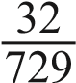.

Find the value of *n*.

*n* = ................................................ [2]

**9**

*y*

*x*

*A*

*B*

*O*

NOT TO

SCALE

The diagram shows a sketch of the graph of *y* = 4*x*3 - *x*4.

The graph crosses the *x*-axis at the origin *O* and at the point *A*. The point *B* is a maximum point.

* 1. Differentiate 4*x*3 - *x*4.

................................................. [2]

* 1. Find the coordinates of *B*.

(....................... , .......................) [3]

* 1. Find the gradient of the graph at the point *A*.

................................................. [3] **10 (a)**

# E D

NOT TO

SCALE

*F*

*C*

# A B

*ABCDEF* is a regular hexagon. *DF*, *DA* and *DB* are diagonals.

Complete the following statements using three different triangles.

Triangle *DEF* is congruent to triangle ..................

Triangle .................. is congruent to triangle ..................

[2]

**(b)**

NOT TO

SCALE

*P*

*O*

*T*

*Q*

*P* and *Q* are points on the circle with centre *O*.

*TP* and *TQ* are tangents to the circle from the point *T*.

Complete the following statements and reasons.

In triangles *OPT* and *OQT*

*OP* = .................. because each is a radius of the circle

*OT* is a common side

Angle *OPT* = angle .................. = 90° because ..............................................................................

Triangles *OPT* and *OQT* are congruent using the criterion ..................

This proves that the tangents *TP* and *TQ* are ..................................................

[5] **11**  f( )*x* = 1-3*x* g( )*x* = (*x* -1)2 h( )*x* = 3*x*, *x* ! 0

1. Find g(3).

................................................. [1]

1. Find f(*x* -2), giving your answer in its simplest form.

................................................. [2]

1. Find f-1( )*x* .

f-1( )*x* = ................................................ [2]  **(d)** gf( )*x* -g( ) ( )*x* f *x* = 3*x*3 + *ax*2 + *bx* + *c*

Find the value of each of *a*, *b* and *c*.

*a* = ................................................ *b* = ................................................ *c* = ................................................ [5]  **(e)** Find h( )*x* -f( )*x* , giving your answer as a single fraction in its simplest form.

................................................. [3]

**(f)** h(*xn*) = 3*x*7

Find the value of *n*.

*n* = ................................................ [1]

**12**

NOT TO

*A*

*B*

*O*

*y*

*x*

SCALE

*O* is the origin (0, 0), *A* is the point (8, 1) and *B* is the point (2, 5).

1. Write as column vectors.

**(i)** *OB*

|  |  |
| --- | --- |
| **(ii)** | *AB* |

*OB* =   f p [1]

*AB* =   f p [1]

1. Find the equation of the line *AB*.

Give your answer in the form *y* = *mx* + *c*.

*y* = ................................................ [3]

1. Find the equation of the perpendicular bisector of *AB*. Give your answer in the form *y* = *mx* + *c*.

*y* = ................................................ [4]

1. The line *AB* meets the *y*-axis at *P*.

The perpendicular bisector of *AB* meets the *y*-axis at *Q*.

Find the length of *PQ*.

................................................. [2] **BLANK PAGE**

Permission to reproduce items where third-party owned material protected by copyright is included has been sought and cleared where possible. Every reasonable effort has been made by the publisher (UCLES) to trace copyright holders, but if any items requiring clearance have unwittingly been included, the publisher will be pleased to make amends at the earliest possible opportunity.

To avoid the issue of disclosure of answer-related information to candidates, all copyright acknowledgements are reproduced online in the Cambridge Assessment International Education Copyright Acknowledgements Booklet. This is produced for each series of examinations and is freely available to download at www.cambridgeinternational.org after the live examination series.

Cambridge Assessment International Education is part of Cambridge Assessment. Cambridge Assessment is the brand name of the University of Cambridge Local Examinations Syndicate (UCLES), which is a department of the University of Cambridge.