**Create a Spring Web Project using Maven**   
**package** com.cognizant.spring_learn;

**import** org.springframework.web.bind.annotation.GetMapping;

**import** org.springframework.web.bind.annotation.RestController;

@RestController

**public** **class** HelloController {

@GetMapping("/")

**public** String hello() {

**return** "Hello from Spring Boot!";

}

}

Applications.properties

spring.application.name=spring-learn

server.port=8085

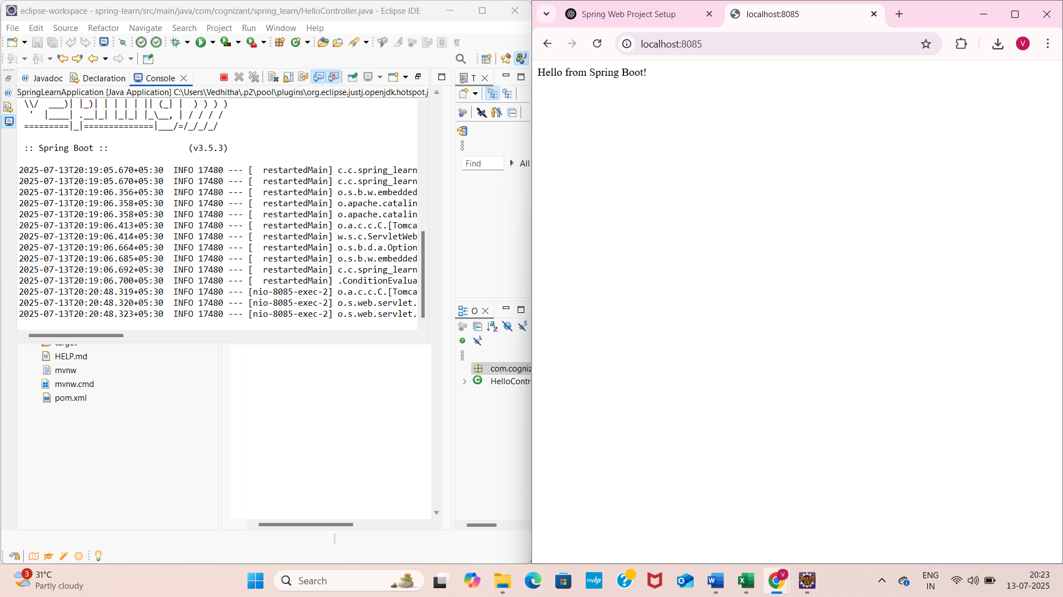

Spring Core – Load Country from Spring Configuration XML

Country.java

**package** com.cognizant.spring_learn;

**import** org.slf4j.Logger;

**import** org.slf4j.LoggerFactory;

**public** **class** Country {

**private** **static** **final** Logger ***LOGGER*** = LoggerFactory.*getLogger*(Country.**class**);

**private** String code;

**private** String name;

**public** Country() {

***LOGGER***.debug("Inside Country Constructor.");

}

**public** String getCode() {

***LOGGER***.debug("Inside getCode()");

**return** code;

}

**public** **void** setCode(String code) {

***LOGGER***.debug("Inside setCode()");

**this**.code = code;

}

**public** String getName() {

***LOGGER***.debug("Inside getName()");

**return** name;

}

**public** **void** setName(String name) {

***LOGGER***.debug("Inside setName()");

**this**.name = name;

}

@Override

**public** String toString() {

**return** "Country [code=" + code + ", name=" + name + "]";

}

}

SpringLearnApplication.java

**package** com.cognizant.spring_learn;

**import** com.cognizant.springlearn.Country;

**import** org.slf4j.Logger;

**import** org.slf4j.LoggerFactory;

**import** org.springframework.context.ApplicationContext;

**import** org.springframework.context.support.ClassPathXmlApplicationContext;

**public** **class** SpringLearnApplication {

**private** **static** **final** Logger ***LOGGER*** = LoggerFactory.*getLogger*(SpringLearnApplication.**class**);

**public** **static** **void** main(String[] args) {

*displayCountry*(); // 🔽 invoke your method

}

**public** **static** **void** displayCountry() {

ApplicationContext context = **new** ClassPathXmlApplicationContext("country.xml");

Country country = context.getBean("country", Country.**class**);

***LOGGER***.debug("Country : {}", country.toString());

}

}

Country.xml

<?xml version=*"1.0"* encoding=*"UTF-8"*?>

<beans xmlns=*"http://www.springframework.org/schema/beans"*

xmlns:xsi=*"http://www.w3.org/2001/XMLSchema-instance"*

xsi:schemaLocation=*"*

*http://www.springframework.org/schema/beans*

*http://www.springframework.org/schema/beans/spring-beans.xsd"*>

<bean id=*"country"* class=*"com.cognizant.springlearn.Country"*>

<property name=*"code"* value=*"IN"* />

<property name=*"name"* value=*"India"* />

</bean>

</beans>

**Hello World RESTful Web Service**   
**package** com.cognizant.spring_learn;

**import** org.slf4j.Logger;

**import** org.slf4j.LoggerFactory;

**import** org.springframework.web.bind.annotation.GetMapping;

**import** org.springframework.web.bind.annotation.RestController;

@RestController

**public** **class** HelloController {

**private** **static** **final** Logger ***LOGGER*** = LoggerFactory.*getLogger*(HelloController.**class**);

@GetMapping("/hello")

**public** String sayHello() {

***LOGGER***.info("START sayHello");

String message = "Hello World!!";

***LOGGER***.info("END sayHello");

**return** message;

}

}

SpringLearnApplication.java

**package** com.cognizant.spring_learn;

**import** org.springframework.boot.SpringApplication;

**import** org.springframework.boot.autoconfigure.SpringBootApplication;

@SpringBootApplication

**public** **class** SpringLearnApplication {

**public** **static** **void** main(String[] args) {

SpringApplication.*run*(SpringLearnApplication.**class**, args);

}

}

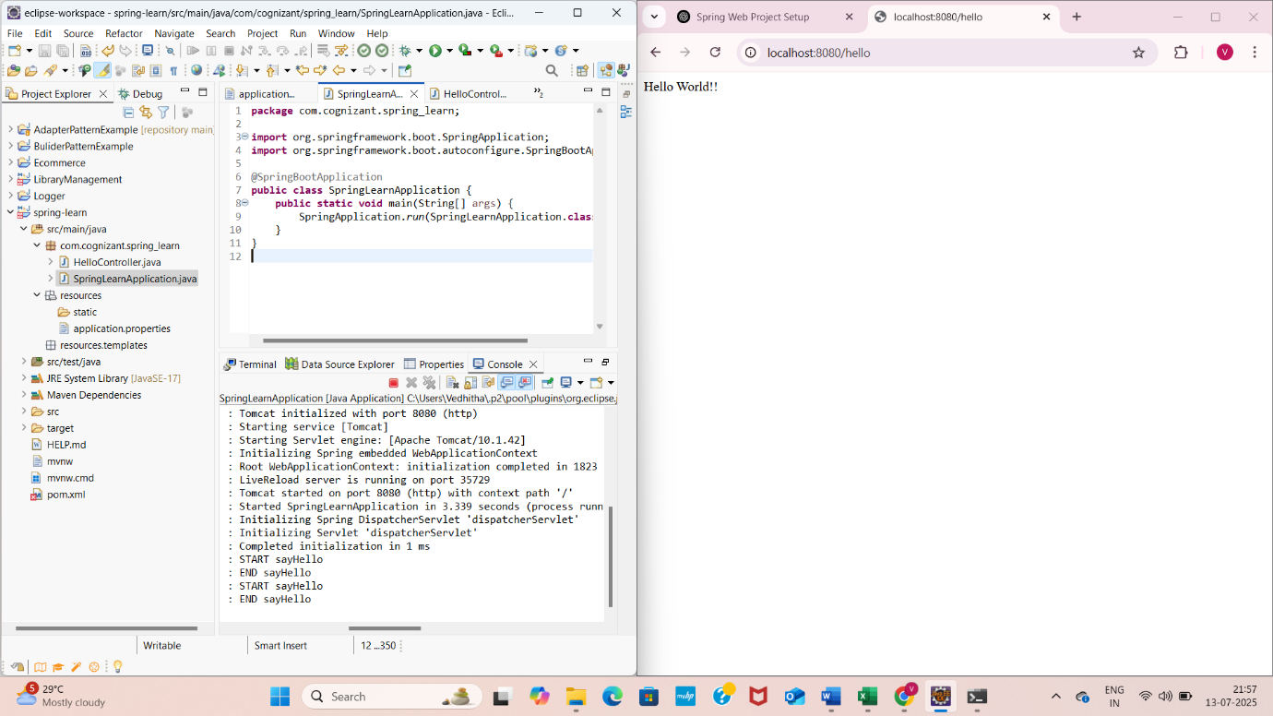

**REST - Country Web Service**

CountryController.java  
**package** com.cognizant.spring_learn.controller;

**import** com.cognizant.spring_learn.model.controller;

**import** org.springframework.context.ApplicationContext;

**import** org.springframework.context.support.ClassPathXmlApplicationContext;

**import** org.springframework.web.bind.annotation.RequestMapping;

**import** org.springframework.web.bind.annotation.RestController;

@RestController

**public** **class** CountryController {

@RequestMapping("/country")

**public** Country getCountryIndia() {

ApplicationContext context = **new** ClassPathXmlApplicationContext("country.xml");

Country country = context.getBean("country", Country.**class**);

**return** country;

}

}

Country.java

**package** com.cognizant.spring_learn.model;

**public** **class** Country {

**private** String code;

**private** String name;

**public** Country() {

System.***out***.println("Inside Country Constructor");

}

**public** String getCode() {

System.***out***.println("Getting Code");

**return** code;

}

**public** **void** setCode(String code) {

System.***out***.println("Setting Code");

**this**.code = code;

}

**public** String getName() {

System.***out***.println("Getting Name");

**return** name;

}

**public** **void** setName(String name) {

System.***out***.println("Setting Name");

**this**.name = name;

}

@Override

**public** String toString() {

**return** "Country [code=" + code + ", name=" + name + "]";

}

}

Country.xml

<?xml version=*"1.0"* encoding=*"UTF-8"*?>

<beans xmlns=*"http://www.springframework.org/schema/beans"*

xmlns:xsi=*"http://www.w3.org/2001/XMLSchema-instance"*

xsi:schemaLocation=*"*

*http://www.springframework.org/schema/beans*

*https://www.springframework.org/schema/beans/spring-beans.xsd"*>

<bean id=*"country"* class=*"com.cognizant.spring_learn.model.Country"*>

<property name=*"code"* value=*"IN"*/>

<property name=*"name"* value=*"India"*/>

</bean>

</beans>