React 1

import logo from './logo.svg';

import './App.css';

function App() {

  return(

    <h1>Welcome the first session of React</h1>

  );

}

export default App;

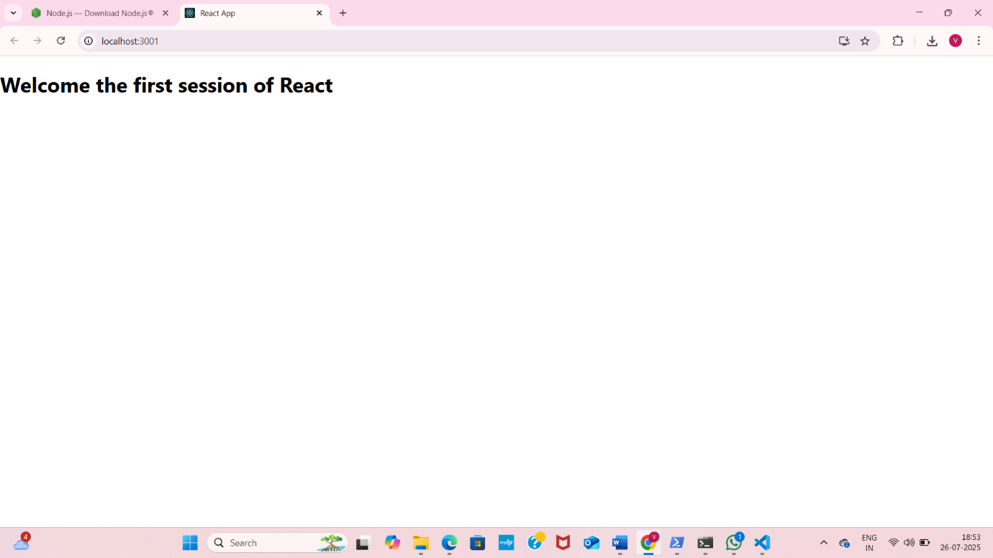

React 2

Components

-Home.js

import React from 'react';

const Home = () =>{

         return (

      <div>

        <h3>Welcome to the Home page of Student Management Portal</h3>

      </div>

    );

};

export default Home;

src-

About.js

import React from 'react';

const About = () => {

  return (

    <div>

      <h2>Welcome to the About page of the Student Management Portal</h2>

    </div>

  );

};

export default About;

src-

Contact.js

import React from 'react';

const Contact = () => {

  return (

    <div>

      <h2>Welcome to the Contact page of the Student Management Portal</h2>

    </div>

  );

};

export default Contact;

App.js

import React from 'react';

import './App.css';

import Home from './Components/Home';

import About from './About';

import Contact from './Contact';

function App(){

    return (

        <div className="App">

            <Home/>

            <About/>

            <Contact/>

            </div>

    );

}

export default App;

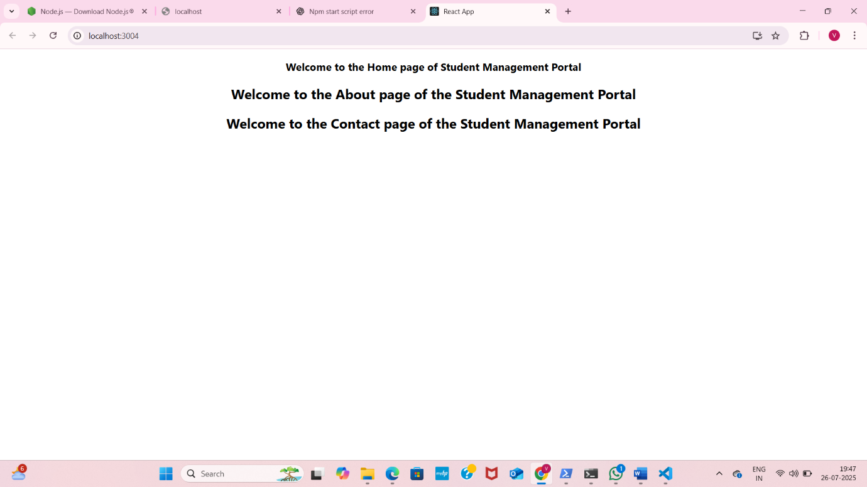

React-3

Src-

Components

CalculateScore.js

import '../Stylesheets/mystyle.css';

const percentToDecimal = (decimal) => {

  return (decimal \* 100).toFixed(2) + '%';

};

const calcScore = (total, goal) => {

  return percentToDecimal(total / goal);

};

export const CalculateScore = ({ Name, School, total, goal }) => (

  <div className="formatstyle">

    <h1 style={{ color: 'brown' }}>Student Details:</h1>

    <div className="Name">

      <b><span>Name:</span></b>

      <span>{Name}</span>

    </div>

    <div className="School">

      <b><span>School:</span></b>

      <span>{School}</span>

    </div>

    <div className="Total">

      <b><span>Total:</span></b>

      <span>{total}</span> <span>Marks</span>

    </div>

    <div className="Score">

      <b>Score:</b>

      <span>{calcScore(total, goal)}</span>

    </div>

  </div>

);

Src-

Stylesheets-

mystyle.css

.Name{

    font-weight:300;

    color:blue;

}

.School{

    color:crimson;

}

.Total{

    color:darkmagenta;

}

.formatstyle{

    text-align:center;

    font-size:large;

}

.Score{

    color:forestgreen;

}

App.js

import { CalculateScore}  from "./Components/CalculatorScore";

function App(){

  return(

    <div>

    <CalculateScore Name={"Steve"}

    School={"DNV Public School"}

    total={284}

    goal={3}

    />

    </div>

  )

}

export default App;

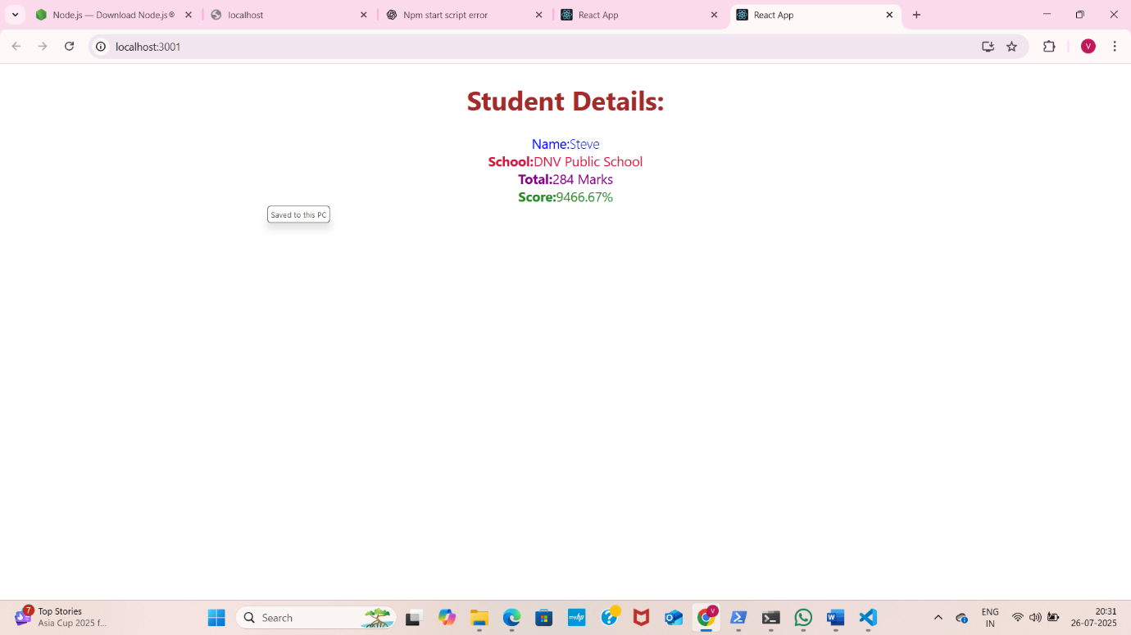

React5

CohortDetails.module.css

.box {

  width: 300px;

  display: inline-block;

  margin: 10px;

  padding: 10px 20px;

  border: 1px solid black;

  border-radius: 10px;

}

dt {

  font-weight: 500;

}

CohortDetails.js

import React from 'react';

import styles from './CohortDetails.module.css';

const CohortDetails = ({ name, status }) => {

  const headingStyle = {

    color: status === 'ongoing' ? 'green' : 'blue'

  };

  return (

    <div className={styles.box}>

      <h3 style={headingStyle}>{name}</h3>

      <dl>

        <dt>Status:</dt>

        <dd>{status}</dd>

      </dl>

    </div>

  );

};

export default CohortDetails;

App.js

import React from 'react';

import './App.css';

import CohortDetails from './CohortDetails';

function App() {

  return (

    <div className="App">

      <CohortDetails name="React Bootcamp" status="ongoing" />

      <CohortDetails name="Java Fullstack" status="completed" />

    </div>

  );

}

export default App;

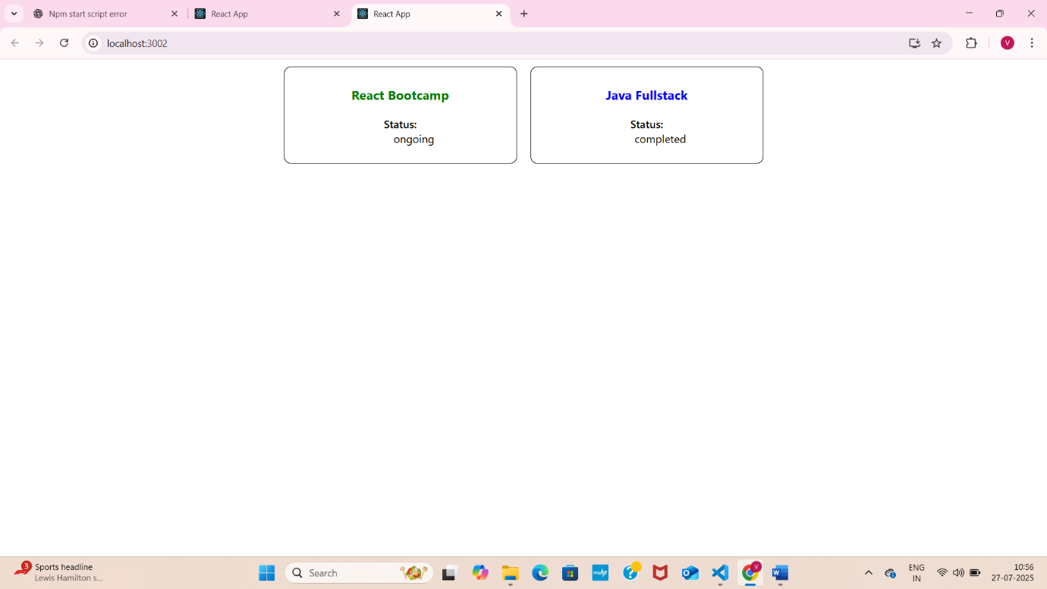

React6

Src-Components

Home.js

import React from 'react';

const Home = () => {

  return (

    <div>

      <h2>Welcome to the Trainers Portal</h2>

      <p>Use the navigation menu to explore trainer details.</p>

    </div>

  );

};

export default Home;

TrainerDetail.js

import { useParams } from 'react-router-dom';

import trainers from './TrainersMock';

const TrainerDetail = () => {

  const { id } = useParams();

  const trainer = trainers.find(t => t.TrainerId === parseInt(id));

  if (!trainer) return <p>Trainer not found</p>;

  return (

    <div>

      <h3>{trainer.Name}</h3>

      <p>Email: {trainer.Email}</p>

      <p>Phone: {trainer.Phone}</p>

      <p>Technology: {trainer.Technology}</p>

      <p>Skills: {trainer.Skills.join(', ')}</p>

    </div>

  );

};

export default TrainerDetail;

TrainersList.js

import React from 'react';

import { Link } from 'react-router-dom';

const TrainersList = ({ trainers }) => {

  return (

    <div>

      <h2>Trainers List</h2>

      <ul>

        {trainers.map((trainer) => (

          <li key={trainer.TrainerId}>

            <Link to={`/trainer/${trainer.TrainerId}`}>{trainer.Name}</Link>

          </li>

        ))}

      </ul>

    </div>

  );

};

export default TrainersList;

TrainersMock.js

const trainers = [

{

TrainerId: 1,

Name: 'Alice Johnson',

Email: 'alice.johnson@example.com',

Phone: '123-456-7890',

Technology: 'Java',

Skills: ['Spring', 'Hibernate', 'JPA']

},

{

TrainerId: 2,

Name: 'Bob Smith',

Email: 'bob.smith@example.com',

Phone: '987-654-3210',

Technology: 'JavaScript',

Skills: ['React', 'Node.js', 'Express']

},

{

TrainerId: 3,

Name: 'Carol White',

Email: 'carol.white@example.com',

Phone: '555-123-4567',

Technology: 'Python',

Skills: ['Django', 'Flask', 'Pandas']

},

{

TrainerId: 4,

Name: 'David Lee',

Email: 'david.lee@example.com',

Phone: '222-333-4444',

Technology: 'C#',

Skills: ['.NET Core', 'Entity Framework', 'LINQ']

},

{

TrainerId: 5,

Name: 'Eva Brown',

Email: 'eva.brown@example.com',

Phone: '333-444-5555',

Technology: 'DevOps',

Skills: ['Docker', 'Kubernetes', 'Jenkins']

}

];

export default trainers;

App.js

import React from 'react';

import { BrowserRouter as Router, Routes, Route, Link } from 'react-router-dom';

import Home from './Components/Home';

import TrainersList from './Components/TrainersList';

import TrainerDetail from './Components/TrainerDetail';

import trainers from './Components/TrainersMock';

function App() {

  return (

    <Router>

      <div className="App">

        <nav>

          <ul>

            <li><Link to="/">Home</Link></li>

            <li><Link to="/trainers">Trainers</Link></li>

          </ul>

        </nav>

        <Routes>

          <Route path="/" element={<Home />} />

          <Route path="/trainers" element={<TrainersList trainers={trainers} />} />

          <Route path="/trainer/:id" element={<TrainerDetail />} />

        </Routes>

      </div>

    </Router>

  );

}

export default App;

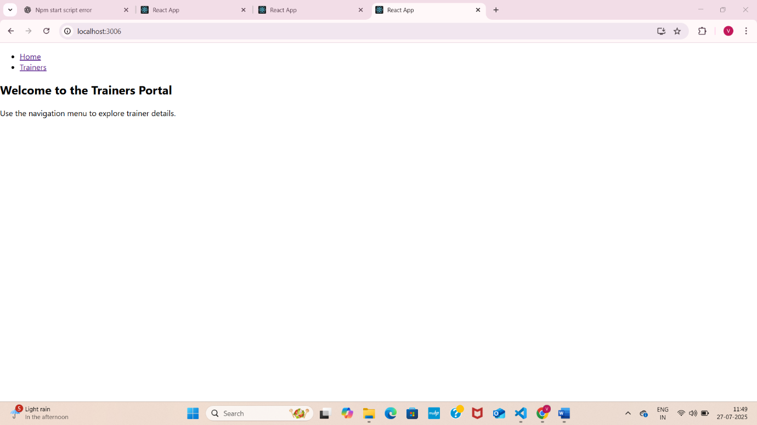

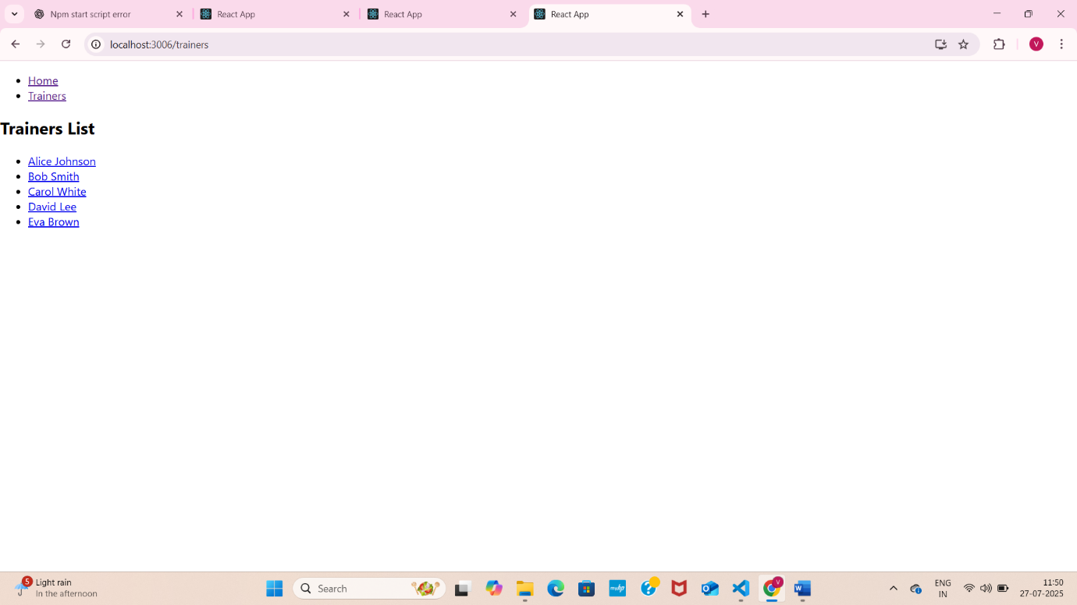

React7

Src-components

Cart.js

import React, { Component } from 'react';

class Cart extends Component {

  render() {

    const { itemname, price } = this.props;

    return (

      <div style={{ border: '1px solid gray', padding: '10px', margin: '10px', width: '300px' }}>

        <h3>Item: {itemname}</h3>

        <p>Price: ₹{price}</p>

      </div>

    );

  }

}

export default Cart;

OnlineShopping.js

import React, { Component } from 'react';

class Cart extends Component {

  render() {

    const { itemname, price } = this.props;

    return (

      <div style={{ border: '1px solid gray', padding: '10px', margin: '10px', width: '300px' }}>

        <h3>Item: {itemname}</h3>

        <p>Price: ₹{price}</p>

      </div>

    );

  }

}

export default Cart;

App.js

import React from 'react';

import OnlineShopping from './components/OnlineShopping';

function App() {

  return (

    <div className="App">

      <OnlineShopping />

    </div>

  );

}

export default App;

