An AI-Driven Adaptive Honeypot Framework for Intelligent Cloud Threat Detection and Automated Risk Response
ATIPAMULA VISHNU PRIYA  Student,  Department of Computer Science and Engineering  CMR Technical Campus, Hyderabad,  India  vishnupriya28a@gmail.com | IPPAKA YOGANANDA BHARATH  Student,  Department of Computer Science and Engineering  CMR Technical Campus, Hyderabad, India  iybharath339@gmail.com | PUPPALA SAI KIRAN  Student,  Department of Computer Science and Engineering  CMR Technical Campus, Hyderabad,  India  saikiranpuppala774@gmail.com
MUNIGELA SRILEKHA,  Assistant Professor,  Department of Computer Science and Engineering  CMR Technical Campus, Hyderabad, India  srilekha.cse@cmrtc.ac.in | Dr. BAGAM LAXMAIAH,  Associate Professor,  Department of Computer Science and Engineering  CMR Technical Campus, Hyderabad, India  blaxmanphd@gmail.com | MASULA VASAVI,  Assistant Professor,  Department of Computer Science and Engineering  CMR Technical Campus, Hyderabad,  India  vasavi.cse2013@gmail.com

Abstract— Cloud computing has become the backbone of modern data storage and application delivery, but its shared, distributed, and highly accessible nature has made it an increasingly attractive target for cyberattacks. Traditional cloud security mechanisms and conventional honeypot-based systems are largely reactive: they capture attacker activity but depend on manual analysis, offer limited attacker profiling, and provide no automated, risk-based response. This paper presents IntelliTrap, an AI-Driven Adaptive Honeypot Framework that combines honeypot deception technology with Machine Learning (ML) to deliver real-time cloud threat detection and automated risk response. The framework verifies incoming users, diverts suspicious sessions to a honeypot of behaviour-matched decoy files, and scores every session with a 15-tree Random Forest trained on 8,000 labelled synthetic sessions, complemented by a signature module that screens inputs and uploads for injection payloads and malicious files. Attackers are profiled from their IP address, browser and device characteristics, and login behaviour, and every session receives a 0–100 risk score mapped to Low, Medium, High, or Critical severity. Based on this score, the system automatically allows, challenges, redirects, or blocks the visitor, while a real-time administrator dashboard provides continuous visibility into live attacks, attacker profiles, and system health. On a held-out test set of 1,600 sessions the Random Forest reaches 96.5% accuracy, 96.8% precision, 94.4% recall, an F1-score of 95.6%, and an ROC-AUC of 0.968, against 76.9% accuracy and 43.4% recall for the hand-written rule engine it replaces; these figures come from synthetic data and are not a measured real-world detection rate.
Keywords— Cloud Security, Adaptive Honeypot, Artificial Intelligence, Machine Learning, Intrusion Detection, Attacker Profiling, Risk Scoring, Automated Threat Response, Deception Technology, Real-Time Monitoring.
I. Introduction
Cloud computing is now widely used across industry, government, and academia to store data and deliver applications at scale, since it offers flexibility, low infrastructure cost, and on-demand availability. This same openness and accessibility, however, has made cloud infrastructure an increasingly attractive target for cyberattacks. Attackers routinely scan cloud-facing services for weak credentials, unpatched vulnerabilities, and misconfigurations, and traditional perimeter defences such as static firewalls and signature-based intrusion detection systems are frequently unable to detect all modern, evolving attack patterns.
Honeypot technology has long been used to address this gap by deploying decoy systems that lure attackers away from genuine assets while recording their activity for later analysis [1]. Cloud-oriented variants such as HoneyLab [3] and HoneyCloud [22] have shown that honeypots can be deployed at scale and provisioned on demand within cloud infrastructure. Even so, the widely used "Honey Cloud" style of deployment mainly attracts attackers and stores their activity; it does not, by itself, analyse the captured behaviour, assess how dangerous a given attacker is, or take any automated action. Security teams are still left to manually review logs, correlate events, and decide how to respond, which delays detection and response in exactly the situations where speed matters most.
Recent research has begun to bring Artificial Intelligence (AI) and Machine Learning (ML) into honeypot design, for example by using large language models to generate more convincing decoy responses [8], [9], [16], [17], or by applying reinforcement learning to decide how long to engage an attacker [10], [13]. Parallel work has shown that ML and deep learning models can substantially improve intrusion detection accuracy in cloud environments [11], [12]. However, most of these efforts address only one part of the problem — realistic deception, engagement policy, or detection accuracy — rather than providing a single, unified pipeline that takes a system from detecting a suspicious user all the way through to an automated, risk-based response.
This paper proposes IntelliTrap, an AI-Driven Adaptive Honeypot Framework for Intelligent Cloud Threat Detection and Automated Risk Response. IntelliTrap enhances the traditional Honey Cloud approach by using a trained Random Forest and a signature module to detect cyberattacks, profile attackers using their IP address, browser, device, and login behaviour, generate behaviour-matched decoy files to strengthen deception, calculate a graded 0–100 risk score for every session, and automatically challenge, divert, or block high-risk attackers. A real-time administrator dashboard continuously displays live attacks, attacker profiles, and system status, giving administrators the situational awareness that manual log review cannot provide quickly enough. By automating the full pipeline from detection to response, IntelliTrap aims to reduce the manual workload on security teams while significantly shortening the time between an attack being attempted and being contained. The paper also reports a reproducible evaluation of the detection model, including the dataset, the experimental protocol, and the limitations of the evidence.
II. Literature Review
Early honeypot research focused on forensic event collection and its integration with broader security monitoring. Briffaut et al. [1] describe a high-interaction honeypot whose system and network logs are correlated to reconstruct attacker sessions, and show how such forensic methodologies can be integrated into a Security Information and Event Management (SIEM) platform for centralised monitoring. This work demonstrates the forensic value of honeypot data but relies on offline correlation and manual investigation rather than automated, real-time attack prevention.
A second line of work focuses on automated, low-interaction data collection. Baecher et al. [2] present Nepenthes, a platform that emulates only the vulnerable parts of network services in order to automatically harvest self-replicating malware at scale. The platform is efficient and scalable, but it does not perform machine-learning-based classification of the captured activity or assess the risk posed by a given attacker.
Large-scale and cloud-hosted honeypot deployment has also received sustained attention. Akritidis et al. [3] introduce HoneyLab, a platform for deploying large numbers of honeypots and sharing the collected security data among researchers, while Clemente et al. [22] propose HoneyCloud, which provisions high-interaction honeypot virtual machines on demand within a private cloud so that each attacker is transparently assigned an isolated instance. More recently, Devi Priya and Sibi Chakkaravarthy [23] demonstrate a containerized, cloud-based honeypot deception architecture for tracking attackers, and Mahajan and Peddoju [18] integrate network intrusion detection with honeypot networks specifically for cloud environments. These works confirm that honeypots-as-a-service is technically feasible at cloud scale, but none of them incorporate AI-driven classification, attacker risk scoring, or automated response.
Virtualisation and software-defined networking have been used to make honeypot deployment cheaper and more manageable. Provos [4] introduces Honeyd, a virtual honeypot framework that allows many low-cost virtual hosts to run on a single physical machine, while Kyung et al. [14] present HoneyProxy, an SDN-based honeynet that dynamically transitions attackers between honeypots and actively resists fingerprinting attacks. These systems improve deployment efficiency and network-level control but remain reactive network tools rather than intelligent, behaviour-aware defences.
Other work has focused on malware threat analysis and hybrid detection architectures. Leita and Dacier [5] present SGNET, a distributed sensor framework that observes malicious traffic to support large-scale malware threat analysis. This approach strengthens malware analysis but stops short of providing a graded, continuously updated risk assessment for individual attackers.
Domain-specific honeypot applications further illustrate both the value and the limitations of the technology. Maesschalck et al. [7] study the real-world deployment of Conpot honeypots that imitate Industrial Control System (ICS) devices, highlighting how easily poorly configured honeypots can be fingerprinted by attackers. This work confirms that deployment realism and domain awareness matter a great deal, yet it does not propose a unified AI-based classification or risk-scoring mechanism.
The application of data mining and, more recently, AI to honeypot data has grown steadily. Veerasamy et al. [6] were among the first to apply data-mining techniques to automatically characterise attacks captured by a honeypot rather than relying purely on manual inspection. Building on this direction, recent studies use large language models to generate realistic, adaptive honeypot responses: Otal and Canbaz [8] fine-tune an open-source LLM to produce convincing shell interactions, Guan et al. [17] similarly enable shell honeypots with LLMs, and Corbett and Zargari [9] integrate GPT-4o into a high-interaction honeypot that classifies every attacker command as Safe, Suspicious, or Malicious. Memos and Psannis [15] combine AI with cloud computing in a hybrid honeynet aimed at IoT botnet detection. These studies show that AI can make honeypots substantially more convincing and more capable of classifying attacker actions, but each is scoped to a specific environment — a Linux shell or an IoT network — rather than a general, end-to-end cloud protection pipeline.
Reinforcement learning and game-theoretic reasoning have also been explored to make honeypot engagement adaptive. Huang and Zhu [13] model honeypot engagement as a semi-Markov decision process to decide how long an attacker should be kept engaged before the risk of exploitation outweighs the intelligence gained, Radoglou-Grammatikis et al. [10] apply reinforcement learning to strategic honeypot deployment in beyond-5G networks, and Guan et al. [16] use reinforcement learning to adapt high-interaction IoT honeypots to attacker behaviour. These studies confirm that adaptive, learning-based engagement policies outperform static configurations, but their focus is on when and how long to engage an attacker rather than on scoring risk and triggering an automated protective response.
A final group of studies strengthens individual pieces of the detection-to-response pipeline that IntelliTrap seeks to unify. Bakro et al. [11] and Nassif et al. [12] show that machine learning and deep learning models can substantially improve intrusion detection accuracy in cloud environments; Lee et al. [20] propose PhantomFS, a file-based deception technique for generating decoy files that mislead malicious users; Kandanaarachchi et al. [21] present HoneyBoost, which fuses honeypot data with anomaly detection to improve overall performance; and Li et al. [19] analyse optimal attack strategies against honeypots that attackers themselves can fingerprint, underscoring the importance of dynamic, hard-to-detect deception. A broader survey [24] catalogues these many individual directions — forensic analysis, malware capture, cloud deployment, SDN management, AI-driven deception, and reinforcement-learning engagement — and consistently observes that no existing system combines AI-based attack classification, behavioural attacker profiling, continuous risk scoring, dynamic decoy generation, and fully automated risk-based response within a single cloud-native framework. IntelliTrap is designed specifically to close this gap.
III. Existing System
Current cloud honeypot deployments, including the widely used Honey Cloud style of architecture, mainly rely on a honeypot to attract attackers and record their activity for later, manual analysis [1], [3], [22]. Traditional honeypot and honeynet systems typically depend on a single detection modality — network traffic monitoring, system-call logging, or basic signature matching — and require a security analyst to interpret the collected logs before any decision can be made about how to respond. Some systems capture a large volume of attack data efficiently [2], but this data still has to be manually correlated and classified before it becomes actionable. Because none of these systems assess how dangerous an individual attacker is, every captured session tends to be treated with the same level of urgency, and because none of them take automated action, the time between detection and containment is governed by how quickly a human analyst can respond rather than by the speed of the attack itself.
Limitations of Existing Systems:
- Reactive, Manual-Analysis Dependency: Attacker activity is logged but not automatically analysed, so meaningful action depends on a security analyst reviewing logs after the fact.
- Limited Attacker Profiling: Most systems record raw traffic or session data without building a structured profile (IP, browser, device, behaviour) that would allow the same attacker to be recognised across multiple sessions.
- Static Deception: Decoy files and services are typically fixed, making them easier for experienced attackers to fingerprint and avoid [19].
- No Graded, Automated Risk Assessment: Existing systems do not assign a risk score to an attacker, so low-risk reconnaissance and high-risk exploitation attempts are handled with the same manual process.
- Absence of Automated Response: Even when an attack is clearly identified, most honeypot systems do not automatically allow, redirect, or block the attacker — the response still has to be triggered manually.
- No Unified Real-Time Monitoring: Administrators typically rely on delayed log review rather than a live dashboard that consolidates attacks, risk levels, and system status in one place.
IV. Methodology
IntelliTrap's methodology is organised into seven stages: user access and traffic acquisition, user verification, honeypot redirection with dynamic decoy generation, AI-based threat detection, attacker profiling, AI-based risk assessment with automated response, and real-time monitoring through an administrator dashboard. Fig. 1 illustrates how a cloud user request moves through these stages, and how every stage continuously reports events to the dashboard for administrator oversight.

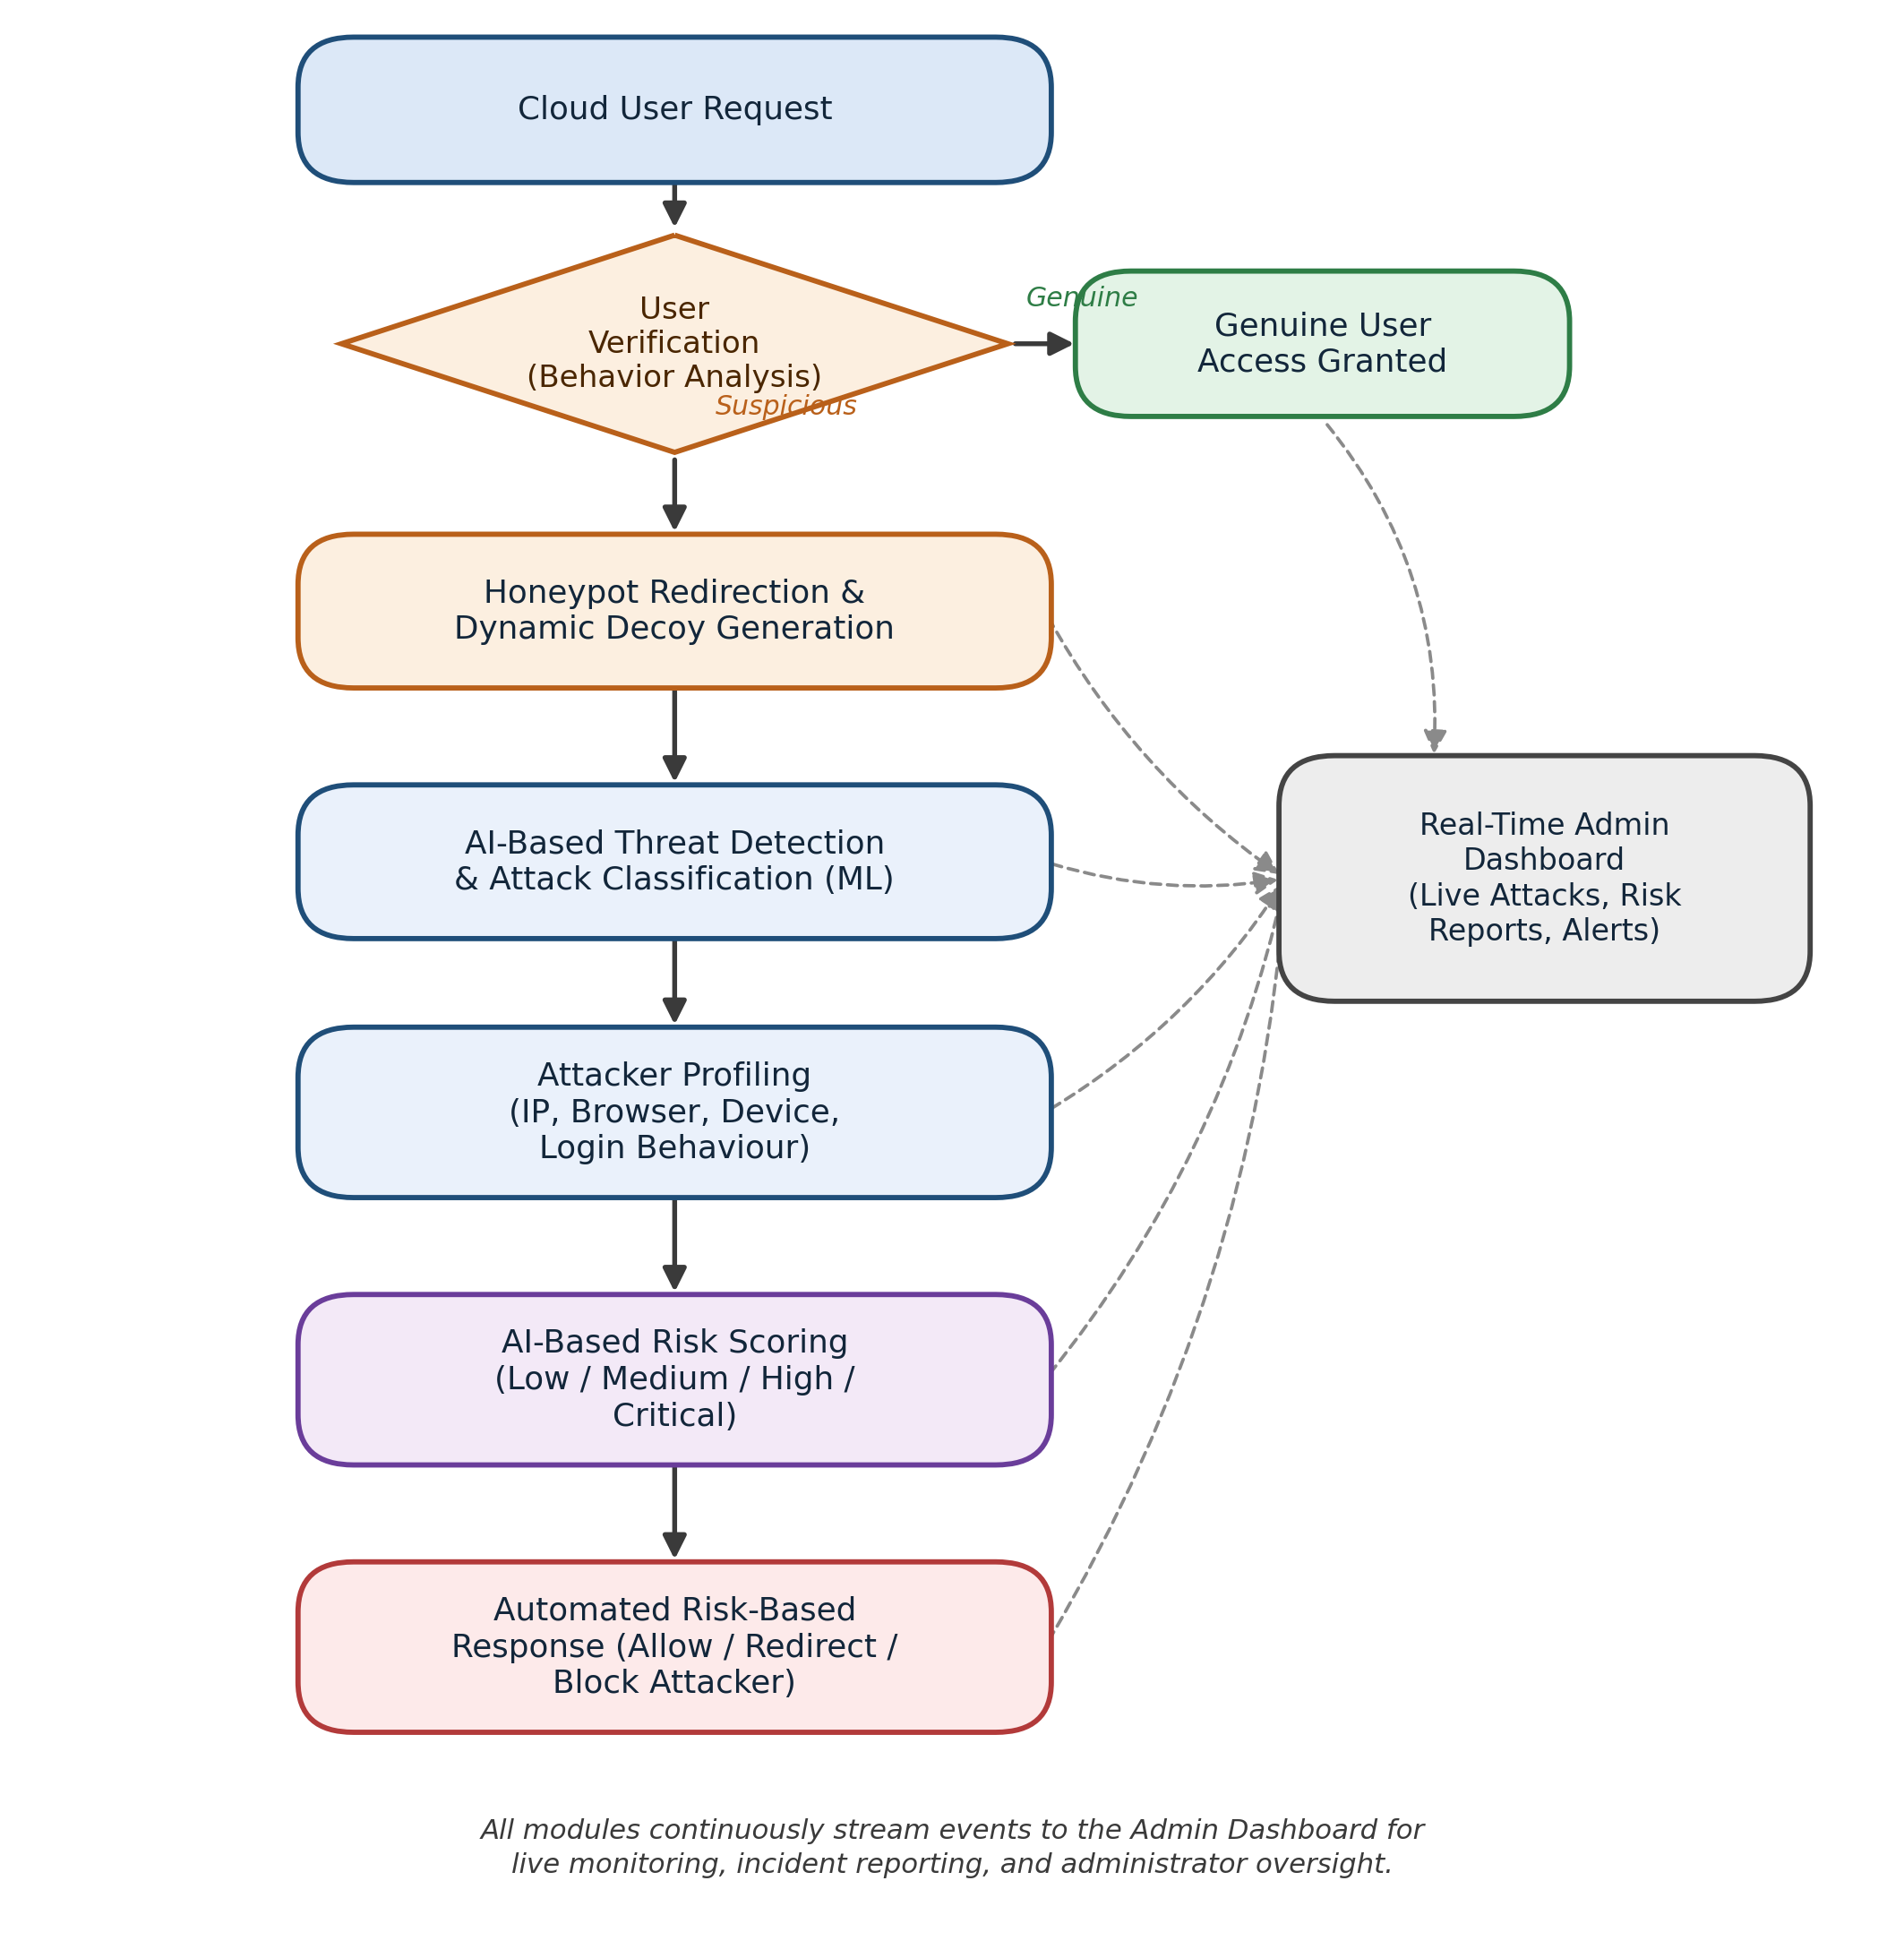
Fig. 1. System Architecture of the Proposed AI-Driven Adaptive Honeypot Framework

1. User Access and Traffic Acquisition
Every request to the protected cloud application is first captured at the entry point of the system. Basic request metadata — including the source IP address, browser and device information, request timing, and login attempt details — is logged for every user, whether or not the request later turns out to be malicious. This continuous acquisition of baseline data ensures that no interaction is missed and provides the raw material that later stages use for verification, profiling, and risk assessment.
2. User Verification and Behavioural Analysis
Incoming requests are then evaluated to distinguish genuine users from suspicious ones. This stage examines login behaviour, request patterns, and known indicators of automated or malicious activity to make an initial classification. Users classified as genuine are allowed to proceed to the real cloud application without any noticeable delay, preserving a normal user experience, while users classified as suspicious are transparently diverted away from the production system in the next stage. The verdict of this stage is the stricter of a server-side rule-weighted score and the client-side Random Forest verdict described in Stage 6, so that the client can never relax a decision taken by the server.
3. Honeypot Redirection and Dynamic Decoy Generation
Suspicious traffic is redirected to an isolated honeypot environment that mimics the real cloud application closely enough to keep the attacker engaged. Rather than presenting the same static files every time, IntelliTrap generates a fresh set of decoy files for each session from eight lure categories: credentials, employee records, financial data, customer databases, strategic plans, source code, medical records, and company-confidential documents. Each category holds plausible file names and a content template formatted to the file type (for example a text credential file, a CSV export, or a JSON customer export) that contains only redacted or rotated values, so that no genuine secret can be exposed. For every decoy the generator randomly selects the file name, assigns a displayed size between 200 KB and 4 MB, and stamps the current date, and a session receives up to three decoys drawn from different categories. The selection is attack-specific: wrong share passwords favour credential and source-code lures, invalid share codes favour customer-database and employee-record lures, and more than ten requests per minute favour source-code and financial lures. A visitor is also diverted to the honeypot after five wrong share passwords in a single session, and every interaction with a decoy is logged with its action, file name, and time spent. This dynamic, behaviour-matched generation is intended to make the honeypot harder to fingerprint than the static decoys used in earlier systems [19], in the spirit of file-based deception [20], while giving the detection stage a richer set of attacker interactions to analyse.
4. AI-Based Threat Detection and Attack Classification
Threat detection combines a learned model with a signature module. The learned model is a Random Forest classifier [25] (scikit-learn; 15 trees, maximum depth 6, at least 15 samples per leaf, Gini criterion, random seed 42) that labels each session as legitimate or attacker from 14 features: failed share passwords, invalid share codes, requests per minute, mouse movements, mean keystroke interval, proxy flag, hosting-network flag, automation user-agent flag, off-hours flag, previous blocks, time on page, scroll events, page views, and a keystroke-missing indicator. Missing keystroke data is encoded as −1 together with the indicator rather than imputed, so that the absence of keystroke telemetry typical of bots is preserved. No hyperparameter search or feature selection was performed; the settings were fixed in advance, with 15 trees chosen to match the application's per-tree vote schema and a depth of 6 to keep the exported model small. The fitted forest is exported as a 21.8 KB JSON file and evaluated in the browser, and per-feature explanations are obtained by summing path attributions over the trees. Behaviours such as credential brute-forcing, code enumeration, and scanning or scraping are therefore detected through the features they change (failed attempts, request rate, page views, and scroll and input activity) rather than as separate output classes. A separate signature module classifies free-text inputs as SQL injection, cross-site scripting, path traversal, or command injection using regular-expression signatures, and screens uploads for executable or double extensions, MIME-type mismatch, and executable file headers disguised as documents. This module is rule-based and is not a learned model.
5. Attacker Profiling
In parallel with threat detection, IntelliTrap builds a structured profile of the attacker from the IP address, browser fingerprint, device characteristics, and login or interaction behaviour observed during the session. The profile has two layers. A server-side rule-weighted score adds fixed points for each observed signal and caps the total at 100: each failed share password adds 12 points (maximum 35), repeated invalid share codes 15 points each (maximum 30), a datacenter IP 22, a proxy or VPN 15, an automation user-agent 25, a missing user-agent 15, a high request rate 10 or 20, absent mouse activity 18, very fast typing 15, earlier blocks 12 each (maximum 25), and off-hours access 8. These weights were assigned from security-domain judgement and are not statistically calibrated. The second layer is the learned weighting of the Random Forest, whose most important features by Gini importance are requests per minute (0.306), scroll events (0.164), failed passwords (0.156), time on page (0.137), and keystroke interval (0.084). Browser fingerprint and device attributes such as screen size, hardware concurrency, and touch support are recorded for every visitor to support session correlation and forensic review, but they are not inputs to either score. The stored profile provides the contextual evidence used by the risk assessment stage and by administrators reviewing the dashboard.
6. AI-Based Risk Assessment and Automated Response
The detected attack type and the attacker profile are combined into a single AI-based risk score, categorised as Low, Medium, High, or Critical. The score is the mean attacker probability of the 15 trees scaled to 0–100, s = round(100 · (1/15) Σ p_t), where p_t is the proportion of attacker sessions in the leaf reached in tree t; it is classified as Low (0–30), Medium (31–60), High (61–80), or Critical (81–100). The access decision is taken by a majority vote over the trees, each tree mapping its leaf probability to allow (below 0.30), challenge with an emailed one-time code (0.30 to below 0.60), honeypot (0.60 to below 0.80), or block (0.80 and above). The final decision is the stricter of this verdict and the server-side verdict, in which a score above 80 triggers a block. A block records an active IP-block entry with the trigger score, signals, and device and location snapshot, notifies every administrator, and refuses further requests from that address until an administrator lifts it; blocks are therefore persistent but reversible, are applied per IP address, and are never applied to whitelisted addresses. Because the response is triggered automatically as soon as a risk score is computed, the delay between detection and containment is no longer governed by how quickly a human analyst can respond.
7. Real-Time Monitoring, Admin Dashboard and Evaluation
Every stage of the pipeline — verification outcomes, honeypot activity, detected attack types, attacker profiles, risk scores, and response actions — streams events to a real-time administrator dashboard. The dashboard is designed to give administrators live visibility into ongoing attacks, historical incidents, and overall system health, replacing the delayed, manual log review associated with traditional honeypot deployments. This stage also supports evaluation of the system, since detection precision, response latency, and the proportion of correctly graded risk levels can all be assessed from the same event stream that feeds the dashboard.
Experimental Setup
No labelled corpus of attacker sessions existed for this application and no public dataset matched the 14 session features, so a synthetic dataset of 8,000 sessions was generated from eight hand-designed behavioural archetypes whose feature distributions deliberately overlap. The legitimate archetypes are casual desktop users (2,640 sessions), mobile users with little mouse activity (1,200), users who mistype a password (576), and VPN users (384); the attacker archetypes are credential-stuffing bots (1,120), scraper bots (800), careful human attackers who imitate normal behaviour (704), and repeat offenders (576). Four percent of the labels were then flipped at random to imitate annotation error, giving 4,759 legitimate (59.5%) and 3,241 attacker (40.5%) sessions, of which 18.6% have no keystroke data.
The data were split 80/20 with stratification (random seed 42) into 6,400 training sessions (3,807 legitimate, 2,593 attacker) and 1,600 test sessions (952 legitimate, 648 attacker). Five-fold stratified cross-validation was run on the training set only, and the test set was used once for the final figures. Accuracy, precision, recall, F1-score, and ROC-AUC are reported with the attacker class as positive and a decision threshold of 0.5. The baseline is a line-for-line reimplementation of the original fifteen hand-written rule trees evaluated on the same test sessions; its decision “granted” counts as legitimate, any other decision as attacker, and its score divided by 100 is used for ROC-AUC. The dataset, generator, training script, and trained model are available in the project repository (github.com/Vedhrishi/intellitrap-batch-3).
V. Results
The results below were obtained on the held-out synthetic test set described in Section IV. They show how well the models recover the structure of the generated data and are not measured detection rates for real traffic. The two dashboard captures are taken from the implemented prototype.
Table I. Test-set performance on 1,600 held-out synthetic sessions.
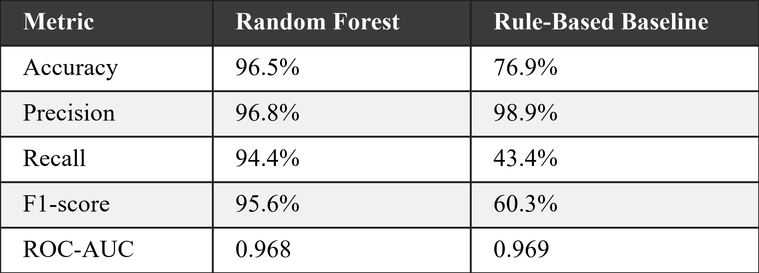
Table I compares the trained Random Forest with the rule-based engine on the 1,600 test sessions. The Random Forest produced 932 true negatives, 20 false positives, 36 false negatives, and 612 true positives; the rule engine produced 949, 3, 367, and 281. Both models rank sessions almost equally well (ROC-AUC 0.968 against 0.969, Fig. 2), but the fixed rule thresholds miss more than half of the attackers (recall 43.4%), mainly the careful human attacker whose behaviour crosses no single threshold, whereas the learned forest recovers 94.4% of them at a similar precision.
Table II. Five-fold cross-validation on the 6,400 training sessions.
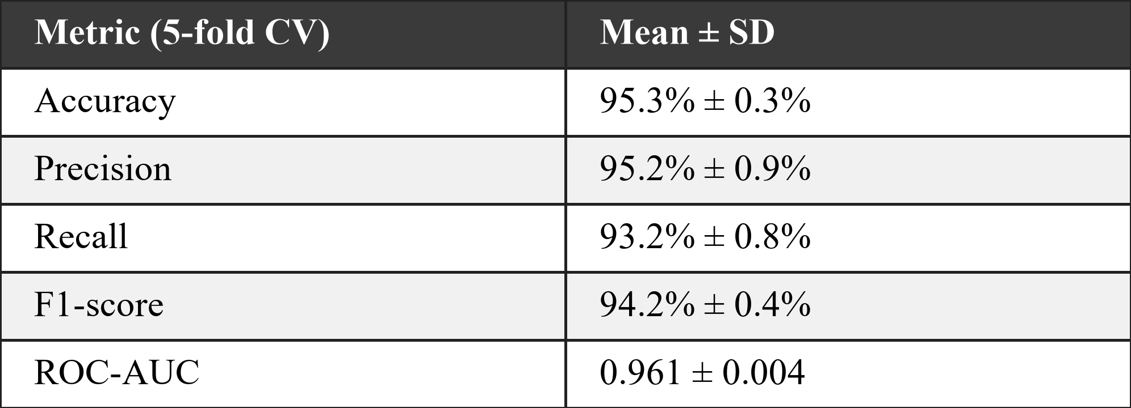
Table II gives the five-fold cross-validation results on the training set; the small standard deviations indicate that the outcome does not depend on one particular split. The score distribution is strongly bimodal (Fig. 3): of the 1,600 test sessions, 943 fall in the Low band (3.3% attackers), 40 in Medium (37.5%), 56 in High (96.4%), and 561 in Critical (97.7%), so few sessions fall in the middle bands. The signature module was checked on a labelled corpus written by the authors: 90 of 91 text inputs (51 attacks in four classes and 40 benign look-alikes) and 33 of 33 uploads were classified correctly. This corpus measures coverage of known patterns only and does not show resistance to an adaptive attacker.
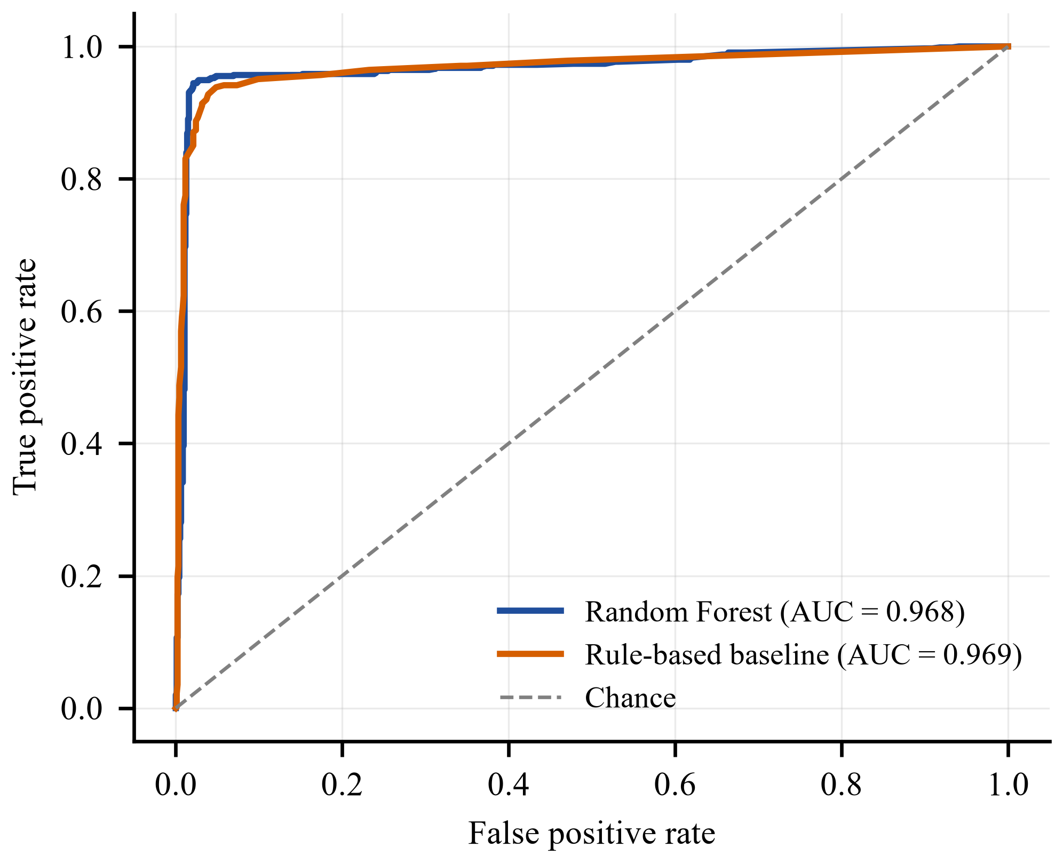
Fig. 2. ROC curves of the Random Forest and the rule-based baseline on the 1,600 held-out synthetic test sessions.
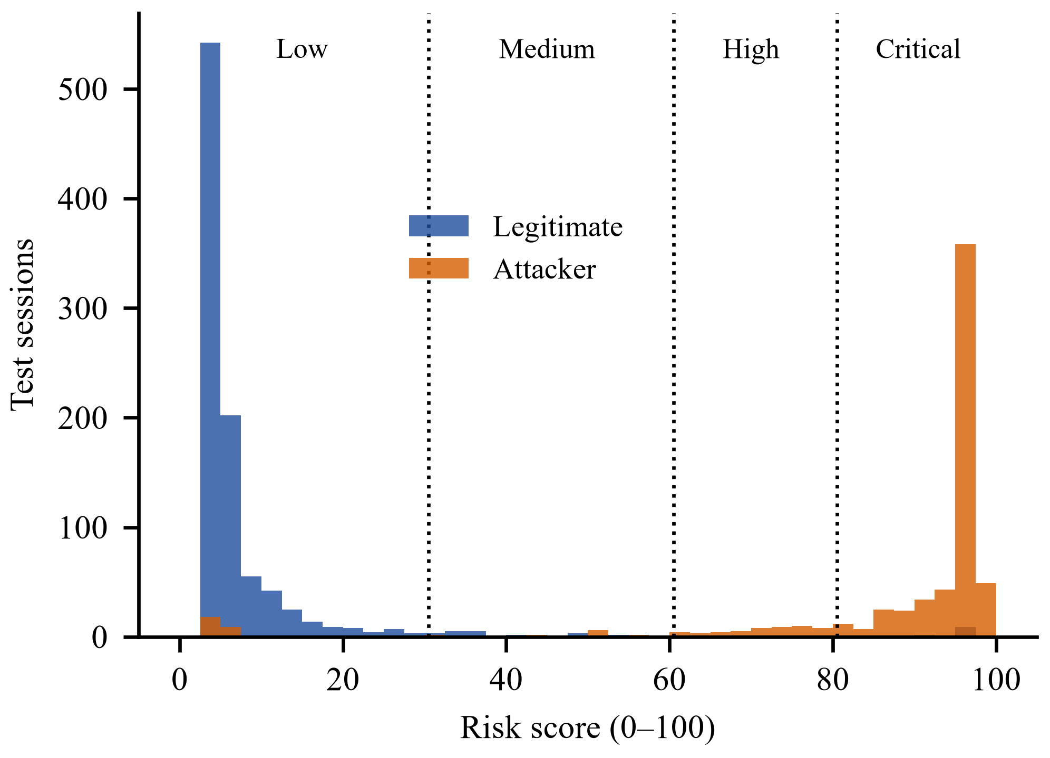
Fig. 3. Risk-score distribution of the test sessions with the four severity-level boundaries (30, 60, 80).
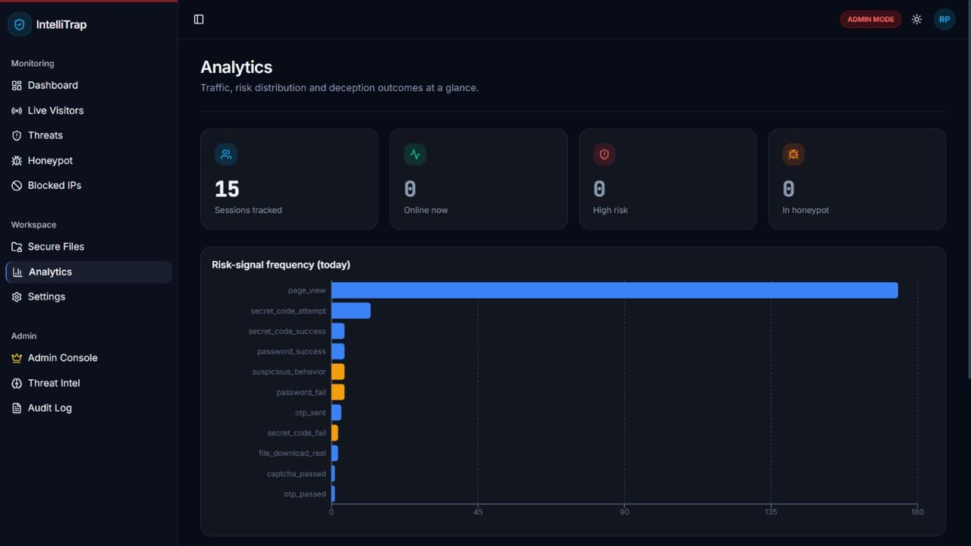
Fig. 4. Analytics view of the administrator dashboard showing session counts and risk-signal frequency.
Attacker profiling combines the rule-weighted signals and the learned feature weights described in Section IV into one record per session. Request rate, scroll activity, failed passwords, and time on page carry most of the model’s importance, whereas the proxy, user-agent, and off-hours flags carry little on their own. Fig. 4 shows the analytics view that summarises session counts and risk-signal frequency for the administrator.
The AI-based risk scoring stage separates low-risk reconnaissance from high- and critical-risk exploitation attempts, so that the automated response module can act proportionately: quiet monitoring for low-risk probes, an emailed one-time-code challenge or honeypot diversion for medium and high scores, and an IP block for scores of 81 and above. This graded response is intended to reduce unnecessary blocking of harmless activity while ensuring rapid containment of genuine threats.
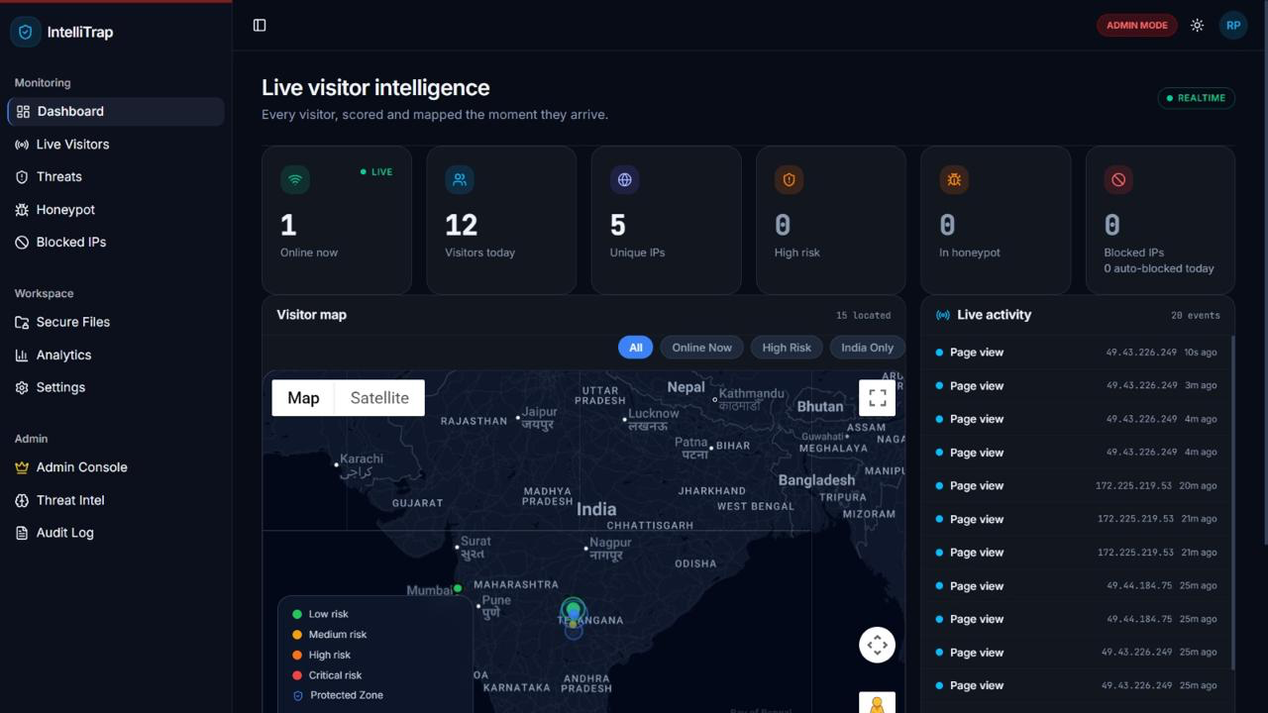
Fig. 5. Live visitor intelligence view of the administrator dashboard with the visitor map and live activity feed.
Finally, the real-time administrator dashboard (Fig. 5) gives administrators continuous visibility into live visitors, attacker risk profiles, and overall system status, shortening the time between attack detection and response compared with the delayed, manual log review associated with traditional honeypot deployments.
VI. Discussion and Future Work
By combining AI-based detection, dynamic deception, structured attacker profiling, and graded automated response within a single pipeline, IntelliTrap is intended to move cloud honeypot defence from the largely reactive, manually analysed posture of earlier systems [1]–[3], [22] toward a proactive, self-defending model. Where prior AI-enhanced honeypots have generally focused on a single capability — more convincing decoy responses [8], [9], [16], [17], improved detection accuracy [11], [12], or adaptive engagement policy [10], [13] — IntelliTrap is designed to bring these capabilities together so that detection, profiling, scoring, and response happen as one continuous process rather than as separate, manually bridged tools.
At the same time, several practical challenges are anticipated and should be acknowledged. The quality of AI-based threat detection and risk scoring depends heavily on the diversity and quality of the attacker interaction data used to train the underlying models, and performance may degrade against genuinely novel attack techniques that differ substantially from prior training data. Skilled attackers may also attempt to fingerprint the honeypot itself, as demonstrated in ICS honeypot deployments [7] and in studies of anti-honeypot attack strategies [19], which means decoy realism must be continuously refreshed rather than configured once. Finally, running continuous machine-learning inference alongside honeypot redirection introduces computational overhead that must be managed carefully at cloud scale. The present evaluation also has clear limitations. The Random Forest was trained and tested on a synthetic dataset, so its reported accuracy shows how well it recovers the structure of the generated data and is not a measured real-world detection rate, and validation on independently collected real sessions has not yet been performed. In the deployed client path the proxy, hosting-network, and previous-block features are not passed to the Random Forest, so its discrimination currently rests on the other ten features, although the server-side score does use them. Each session is scored in isolation, so attacks distributed across many sessions or addresses are not correlated; blocks are applied per IP address and can affect users who share a network; the server-side point weights are expert-assigned rather than statistically calibrated; the realism of the template-based decoys has not been evaluated with attackers or users; and the signature module was tested on a corpus written by the authors and can be evaded by an adaptive attacker.
Future work will focus on several directions. The most immediate step is to collect and label real session data, retrain and re-evaluate the model on it, and pass the IP-reputation and block-history signals into the model’s feature vector. Further, federated or continual learning approaches could allow the detection models to adapt to new attack types over time without centralising sensitive attacker data across deployments [12]. In addition, richer and more convincing decoy generation — potentially incorporating large language model-driven responses as explored in [8], [9], [16], [17] — could extend attacker engagement time and improve the quality of the intelligence gathered. Moreover, the risk-scoring and response stage could be extended with reinforcement-learning-based engagement policies similar to [10], [13] to decide not only how to score risk but how long to keep an attacker engaged before responding. Next, container-based and multi-cloud deployment strategies, building on [22] and [23], would allow IntelliTrap to scale elastically across cloud providers. Finally, integrating IntelliTrap's output with organisation-wide SIEM pipelines, in the spirit of [1], would allow the risk intelligence generated by individual deployments to be shared more broadly across a security operations centre.
VII. Conclusion
This paper has presented IntelliTrap, an AI-Driven Adaptive Honeypot Framework that extends traditional cloud honeypot deployments with automated, AI-based threat detection, attacker profiling, dynamic decoy generation, graded risk scoring, and automated risk-based response, all visible through a real-time administrator dashboard. By moving from the reactive, manually analysed posture of conventional honeypot systems toward an intelligent, end-to-end pipeline, IntelliTrap is designed to reduce the manual effort required to secure cloud infrastructure while shortening the time between attack detection and containment. The proposed framework brings together strands of prior research — forensic honeypot analysis, large-scale and cloud-based deployment, AI- and LLM-driven deception, and machine-learning-based intrusion detection — into a single, cloud-native architecture. On a held-out synthetic test set the trained Random Forest recovers 94.4% of attackers at 96.8% precision, compared with 43.4% recall for the rule-based engine it replaces; validation on real traffic, guided by the directions outlined in Section VI, is the next step toward a scalable and practical self-defending cloud security system.
VIII. References
[1] J. Briffaut, P. Clemente, J.-F. Lalande, and J. Rouzaud-Cornabas, “Honeypot Forensics for System and Network SIEM Design,” in Advances in Security Information Management: Perceptions and Outcomes, G. Suárez de Tangil and E. Palomar, Eds. Hauppauge, NY, USA: Nova Science Publishers, 2013, pp. 181–216.
[2] P. Baecher, M. Koetter, T. Holz, M. Dornseif, and F. Freiling, “The Nepenthes Platform: An Efficient Approach to Collect Malware,” in Proc. 9th Int. Symp. Recent Advances in Intrusion Detection (RAID), Hamburg, Germany, 2006, pp. 165–184.
[3] P. Akritidis, W. Y. Chin, E. P. Markatos, E. Kotsovinos, S. Ioannidis, and K. G. Anagnostakis, “HoneyLab: Large-Scale Honeypot Deployment and Resource Sharing,” in Proc. 5th Int. ICST Conf. Testbeds and Research Infrastructures for the Development of Networks and Communities (TridentCom), Washington, DC, USA, 2009.
[4] N. Provos, “A Virtual Honeypot Framework,” in Proc. 13th USENIX Security Symp., 2004, pp. 1–14.
[5] C. Leita and M. Dacier, “SGNET: A Worldwide Deployable Framework to Support the Analysis of Malware Threat Models,” in Proc. 7th European Dependable Computing Conf. (EDCC), 2008, pp. 99–109.
[6] N. Veerasamy, P. Mokhonoana, and J. Vorster, “Applying Data-Mining Techniques in Honeypot Analysis,” in Proc. Information Security South Africa (ISSA) Conf., Johannesburg, South Africa, Jul. 2006.
[7] S. Maesschalck, V. Giotsas, and N. Race, “World Wide ICS Honeypots: A Study into the Deployment of Conpot Honeypots,” in Proc. IEEE European Symp. Security and Privacy Workshops (EuroS&PW), 2021.
[8] H. T. Otal and M. A. Canbaz, “LLM Honeypot: Leveraging Large Language Models as Advanced Interactive Honeypot Systems,” in Proc. 2024 IEEE Conf. Communications and Network Security (CNS), 2024, doi: 10.1109/CNS62487.2024.10735607.
[9] D. Corbett and S. Zargari, “AI-Driven Honeypot: An Innovative Approach to Adaptive Cyber Security Defense,” Latin-American J. Computing (LAJC), vol. 13, no. 2, 2026, doi: 10.33333/lajc.vol13n2.01.
[10] P. Radoglou-Grammatikis et al., “Strategic Honeypot Deployment in Ultra-Dense Beyond 5G Networks: A Reinforcement Learning Approach,” IEEE Trans. Emerging Topics in Computing, vol. 12, no. 2, pp. 643–655, 2024.
[11] M. Bakro et al., “An Improved Design for a Cloud Intrusion Detection System Using Hybrid Features Selection Approach with ML Classifier,” IEEE Access, vol. 11, pp. 64228–64247, 2023.
[12] A. B. Nassif, M. A. Talib, Q. Nasir, H. Albadani, and F. M. Dakalbab, “Machine Learning for Cloud Security: A Systematic Review,” IEEE Access, vol. 9, pp. 20717–20735, 2021.
[13] L. Huang and Q. Zhu, “Adaptive Honeypot Engagement through Reinforcement Learning of Semi-Markov Decision Processes,” in Proc. 10th Int. Conf. Decision and Game Theory for Security (GameSec), Stockholm, Sweden, 2019, pp. 196–216.
[14] S. Kyung, W. Han, N. Tiwari, V. H. Dixit, L. Srinivas, Z. Zhao, A. Doupé, and G.-J. Ahn, “HoneyProxy: Design and Implementation of Next-Generation Honeynet via SDN,” in Proc. 2017 IEEE Conf. Communications and Network Security (CNS), 2017, pp. 1–9.
[15] V. A. Memos and K. E. Psannis, “AI-Powered Honeypots for Enhanced IoT Botnet Detection,” in Proc. 2020 3rd World Symp. Communication Engineering (WSCE), Thessaloniki, Greece, Oct. 2020, pp. 64–68.
[16] C. Guan, H. Liu, G. Cao, S. Zhu, and T. La Porta, “HoneyIoT: Adaptive High-Interaction Honeypot for IoT Devices through Reinforcement Learning,” in Proc. 16th ACM Conf. Security and Privacy in Wireless and Mobile Networks (WiSec), 2023, pp. 49–59.
[17] C. Guan, G. Cao, and S. Zhu, “HoneyLLM: Enabling Shell Honeypots with Large Language Models,” in Proc. 2024 IEEE Conf. Communications and Network Security (CNS), 2024, pp. 1–9.
[18] V. Mahajan and S. K. Peddoju, “Integration of Network Intrusion Detection Systems and Honeypot Networks for Cloud Security,” in Proc. 2017 Int. Conf. Computing, Communication and Automation (ICCCA), May 2017.
[19] B. Li, Y. Xiao, Y. Shi, Q. Kong, Y. Wu, and H. Bao, “Anti-Honeypot Enabled Optimal Attack Strategy for Industrial Cyber-Physical Systems,” IEEE Open Journal of the Computer Society, vol. 1, pp. 250–261, 2020.
[20] J. Lee, J. Choi, G. Lee, S.-W. Shim, and T. Kim, “PhantomFS: File-Based Deception Technology for Thwarting Malicious Users,” IEEE Access, vol. 8, pp. 32203–32214, 2020.
[21] S. Kandanaarachchi, H. Ochiai, and A. Rao, “HoneyBoost: Boosting Honeypot Performance with Data Fusion and Anomaly Detection,” Expert Systems with Applications, vol. 201, p. 117073, 2022.
[22] P. Clemente, J.-F. Lalande, and J. Rouzaud-Cornabas, “HoneyCloud: Elastic Honeypots—On-Attack Provisioning of High-Interaction Honeypots,” in Proc. Int. Conf. Security and Cryptography (SECRYPT), 2012, pp. 434–439.
[23] V. S. Devi Priya and S. Sibi Chakkaravarthy, “Containerized Cloud-Based Honeypot Deception for Tracking Attackers,” Scientific Reports, vol. 13, art. 1437, 2023.
[24] D. Fraunholz, S. D. Anton, C. Lipps, D. Reti, D. Krohmer, F. Pohl, M. Tammen, and H. D. Schotten, “Demystifying Deception Technology: A Survey,” arXiv preprint arXiv:1804.06196, 2018.
[25] L. Breiman, “Random Forests,” Machine Learning, vol. 45, no. 1, pp. 5–32, 2001.

