IntelliTrap Batch2
An AI-Driven Adaptive Honeypot Framework for Intelligent Cloud Threat Detection and Automated Risk Response
Technical Fact Dossier for the Paper Writer
Responds to the Revise-and-Resubmit decision (Reviewer 1 and Reviewer 2)
Repository: https://github.com/Vedhrishi/intellitrap-batch-3
Live system: https://intellitrap-batch-3.vercel.app
Prepared by Vedh Rishi, October 2026

How to use this document
This is a source-of-truth dossier, not a finished paper. Every statement below was checked against the project code, the training scripts and the generated result files. It gives the writer accurate facts, numbers, tables and figures so the manuscript can be written in the writer's own words.
Integrity and plagiarism. The wording here is original to this project, but no one can honestly promise a 0% similarity score. Journals and Scopus-indexed IEEE venues check submissions with similarity tools, and common technical phrases always match something. The writer should (1) write the manuscript in their own words from these facts, (2) quote nothing without attribution, (3) cite every reference used, (4) run the draft through the institution's similarity checker (for example iThenticate or Turnitin) before submission, and (5) follow the target venue's policy on disclosing the use of AI-assisted writing tools. Reusing this dossier's sentences verbatim in the paper is not recommended.
Honesty rules for the manuscript. All reported accuracy figures come from a synthetic dataset. The paper must say so plainly, in the abstract and in the results section. Section 9 lists the limitations that must appear in the paper.

Contents

1. System summary and contributions
IntelliTrap Batch2 is a cloud file-storage and sharing web application with a built-in deception layer. Every visitor session is profiled. A machine-learning risk score decides whether the visitor is allowed, challenged with a one-time code, diverted into a monitored honeypot of decoy files, or blocked. Administrators see the activity live.

Technology stack
Layer | Implementation
Front end and server functions | TanStack Start (React 19, TypeScript), deployed on Vercel
Database, authentication, storage | Supabase (PostgreSQL with row-level security, email authentication, object storage)
Behaviour tracking | Browser telemetry (mouse, keystrokes, scrolling, page views) plus server-side IP, geolocation and proxy/hosting lookup
Risk model | Random Forest, 15 trees, trained with scikit-learn and exported to JSON for dependency-free scoring in the browser
Payload and upload screening | Signature-based classifier written in TypeScript (src/lib/threatClassifier.ts)
One-time codes by email | SMTP (Gmail) with a Resend fallback

Contributions the paper can claim
- A session-level attacker-detection pipeline in which a trained Random Forest replaces a hand-written 15-rule engine, and is delivered to the browser as a 21.8 KB JSON file.
- A transparent risk score: the mean attacker probability of the 15 trees, scaled to 0-100 and mapped to four severity levels, with per-feature explanations from path attribution.
- An adaptive deception layer: sessions that cross the risk threshold, or fail the share password five times, are served decoy files chosen according to the attacker's behaviour.
- An automated, auditable response policy: challenge, trap or block, with administrator alerting and reversible blocks.
- A signature-based screen for SQL injection, cross-site scripting, path traversal, command injection and malicious uploads.
- A fully reproducible evaluation with documented dataset generation, split, cross-validation and a rule-based baseline.

2. Attacker profiling and weighting (answers R1.1)
The profile has two layers. The layers are combined by taking the stricter of the two verdicts; the client can never relax a server decision.

2.1 Server-side rule-weighted score
A function sums fixed points per observed signal and caps the total at 100. The weights were assigned by the developers from security-domain judgement. They were not statistically calibrated, and the paper must say so.
Group | Signal | Points
Login behaviour | Failed share password | 12 per failure, max 35
Login behaviour | Invalid share code (beyond the first) | 15 per failure, max 30
IP history | Previously blocked / previously sent to honeypot | 12 per block (max 25) / 8 per event (max 16)
Network | Datacenter (hosting) IP | 22
Network | Proxy or VPN (if not hosting) | 15
Network | Blacklisted IP | 40 (whitelisted IP forces score 0)
Device | Automation user-agent (curl, selenium, python and others) | 25
Device | Missing or very short user-agent | 15
Behaviour | More than 30 / more than 15 requests in 60 s | 20 / 10
Behaviour | Mouse movement under 10 with more than 5 keystrokes | 18
Behaviour | Mean keystroke interval under 40 ms | 15
Behaviour | No scrolling with more than 2 page views | 8
Time | Off-hours access (IST, 00:00-06:00) | 8

2.2 Learned weights (Random Forest)
The forest learns its own weighting from data. The table gives the Gini importance of each feature in the final model (from ml/revision_stats.json).
Feature | Importance | Meaning
requestsPerMinute | 0.306 | Requests in the last 60 seconds
scrollEvents | 0.164 | Page scroll events
failedPasswords | 0.156 | Wrong share passwords this session
timeOnPageSeconds | 0.137 | Time spent on the page
keystrokeAvgMs | 0.084 | Mean time between key presses
previousBlocks | 0.058 | Earlier blocks of this visitor
failedCodes | 0.052 | Invalid share codes entered
isHosting | 0.022 | Datacenter IP flag
mouseMovements | 0.010 | Mouse movement events
isProxy, pageViews, hasSuspiciousUA, isOffHoursIST, keystrokeMissing | below 0.006 each | Remaining features

2.3 What is and is not used (be exact in the paper)
- IP address, geolocation, proxy and hosting flags, user-agent string and login behaviour are scored by the server layer.
- Browser fingerprint and device characteristics (screen, hardware concurrency, device memory, touch support) are collected and stored per visitor for forensic review and the admin dashboard, but they are not inputs to either score. The paper should describe them as recorded context, not as scored features.
- In the deployed client path, the features isProxy, isHosting and previousBlocks are not passed into the Random Forest; they default to false, false and 0. The server layer does use them, so the combined system still reacts to them.
- Validation of the weights: the forest weights are validated only on synthetic data (Section 7). The expert weights have no empirical validation. State this as a limitation and as future work.

3. Deception layer: decoy generation (answers R1.2)
When a session is diverted to the honeypot, the system serves decoys from a generator that does not depend on database state, so the trap cannot fail because of an empty template table.
- Eight lure categories: credentials, employee records, financial data, customer database, strategic plans, source code, medical records, company confidential.
- Each category has four plausible file names and one content template formatted to the file type (text credential file, CSV export, JSON export and so on). Templates contain only redacted or rotated values, so no real secret can leak.
- Per decoy, the generator picks a random file name from the category, assigns a random displayed size between 200 KB and 4 MB, stamps the current date, and creates a unique identifier.
- Behaviour-biased selection: wrong passwords favour credential and source-code lures; invalid share codes favour customer-database and HR lures; more than 10 requests per minute favour source-code and financial lures. Remaining slots are filled randomly from unused categories, so a session sees up to three decoys from different categories.
- Every honeypot interaction is written to a honeypot activity table (action, decoy name, time spent) for later analysis.
Limits to state: decoy text is template-based, not generated per attack, and its realism has not been evaluated with human or attacker studies. Do not describe it as generative or as proven realistic.

4. Risk score, severity levels and response criteria (answers R2.4 and R1.4)

4.1 Risk score
For a session with feature vector x, tree t of the forest returns p_t(x), the proportion of attacker sessions in the leaf reached. The attacker probability is p(x) = (1/15) Σ p_t(x) and the risk score is s = round(100 · p(x)).

4.2 Four severity levels
Level | Score range | Test sessions | Share that are attackers
Low | 0 to 30 | 943 | 3.3%
Medium | 31 to 60 | 40 | 37.5%
High | 61 to 80 | 56 | 96.4%
Critical | 81 to 100 | 561 | 97.7%
Table 1. Severity levels and their observed composition on the 1,600 held-out synthetic test sessions.
The score distribution is strongly bimodal, so few sessions fall into the middle bands (Figure 4). The bands are applied to the averaged score. The access decision uses a per-tree majority vote, so level and decision can differ near band edges.

4.3 Formal response policy
Decision | Per-tree rule (leaf probability) | Effect
Allow | below 0.30 | Normal access
Challenge | 0.30 to below 0.60 | One-time code sent by email
Trap (honeypot) | 0.60 to below 0.80 | Visitor is served decoy files
Block | 0.80 or higher | IP added to the active block list

- The final decision is the stricter of the client Random Forest verdict and the server rule-score verdict (server: score above 80 means block).
- Independent trigger: five wrong share passwords in one session move the visitor to the honeypot.
- A block writes an active record (trigger score, signals, geolocation and device snapshot), flags the visitor, and notifies every administrator. Requests from a blocked IP are refused while the record is active. Whitelisted IPs are never blocked.
- Blocks are persistent but not irreversible: an administrator can lift one, and the action is recorded with who and when. There is no automatic expiry. The paper must not use the word permanent or irreversible.
- Known weakness: blocks are per IP, so shared networks and VPN exits can cause collateral blocking.

5. Machine-learning and detection modules (answers R1.5, R2.1 and R2.3)

5.1 Behavioural attacker detection (machine learning)
Item | Value
Algorithm | Random Forest classifier (scikit-learn 1.9.1)
Task | Binary classification: legitimate or attacker session
Trees / depth / min leaf | 15 / 6 / 15 samples
Criterion and seed | Gini impurity; random_state 42; other settings default
Features (14) | failedPasswords, failedCodes, requestsPerMinute, mouseMovements, keystrokeAvgMs, isProxy, isHosting, hasSuspiciousUA, isOffHoursIST, previousBlocks, timeOnPageSeconds, scrollEvents, pageViews, keystrokeMissing
Missing data | Keystroke interval is encoded as -1 plus a missing indicator, not imputed, to keep the no-keystroke-telemetry signal that bots produce
Hyperparameter tuning | None performed; settings fixed in advance (15 trees to match the application's per-tree vote schema, depth 6 to keep the exported file small)
Feature selection | None performed; all features used
Explanations | Saabas path attribution summed over trees gives per-feature contributions
Deployment | Fitted forest exported to JSON (21.8 KB) and evaluated in TypeScript; outputs matched scikit-learn to four decimals on held-out rows

5.2 Payload and upload screening (signature-based, not machine learning)
A separate module recognises what an input contains. It is applied to the share code and password inputs (a detection is logged as a suspicious-behaviour event with its category) and to the upload dialog (a detected file is rejected).
- Payload classes: SQL injection, cross-site scripting, path traversal and command injection, using 13 regular-expression signatures with percent-decoding.
- Malicious uploads: executable extension, double extension such as .pdf.exe, hidden control characters in the name, declared MIME type that does not match the extension, and executable magic bytes (Windows PE, ELF, shell script) behind a document extension.
Evaluation on a labelled corpus written by the authors (ml/threat_corpus.json): 91 text inputs (51 attacks in four classes, 40 benign look-alikes such as O'Brien, rock & roll and 'drop me a line') and 33 uploads (16 malicious, 17 benign).
Task | Samples | Correct | Notes
Text payload classes (5-way) | 91 | 90 | One SQL tautology written in parenthesis form was missed; no benign input was flagged by mistake
Malicious upload (binary) | 33 | 33 | 16 true positives, 17 true negatives, no false positives
Table 2. Signature classifier results. The corpus was authored by us from standard attack families, so it measures coverage of known patterns, not resistance to an adaptive attacker.
Wording for the paper: describe the system as a hybrid. A trained Random Forest detects attacker behaviour; a signature module identifies injection payloads and malicious uploads. Only the first is a learned model.

6. Dataset and experimental protocol (answers R1.3, R2.2 and R2.5)

6.1 Which dataset was used
A synthetic dataset generated by the authors. No real traffic and no public dataset were used for training. The site has no historical corpus of labelled attacker sessions, so a labelled dataset of 8,000 sessions was generated by ml/generate_dataset.py (seed 42) from eight hand-designed user types whose feature distributions deliberately overlap. For example, mobile users have almost no mouse movement like bots, and the careful human attacker types like a normal user.
User type | Sessions | Role
Casual desktop user | 2,640 | Legitimate
Mobile user | 1,200 | Legitimate (low mouse activity)
Password-typo user | 576 | Legitimate (some failed logins)
VPN user | 384 | Legitimate (proxy flag set)
Credential-stuffing bot | 1,120 | Attacker
Scraper bot | 800 | Attacker
Careful human attacker | 704 | Attacker (mimics human behaviour)
Repeat offender | 576 | Attacker
Table 3. Session counts per archetype before label noise (total 8,000).
After generation, 4% of the labels were flipped at random to imitate annotation error. Final class counts: 4,759 legitimate (59.5%) and 3,241 attacker (40.5%). About 18.6% of sessions have no keystroke telemetry.

6.2 Protocol
- Stratified 80/20 split with random_state 42: training set 6,400 sessions (3,807 legitimate, 2,593 attacker); test set 1,600 sessions (952 legitimate, 648 attacker).
- Five-fold stratified cross-validation on the training set only. The test set was used once, for the final numbers.
- Metrics: accuracy, precision, recall, F1 (attacker is the positive class, threshold 0.5) and ROC-AUC.
- Baseline: a line-for-line reimplementation of the original 15 hand-written rule trees, evaluated on the same test rows. The decision granted counts as legitimate and any other decision as attacker; its score divided by 100 is used for ROC-AUC.
- The dataset, scripts and trained model are in the repository (ml folder), so every number can be reproduced.

7. Results
Metric | Random Forest | Rule-based baseline | 5-fold CV (RF)
Accuracy | 0.965 | 0.769 | 0.953 ± 0.003
Precision | 0.968 | 0.989 | 0.952 ± 0.009
Recall | 0.944 | 0.434 | 0.932 ± 0.008
F1-score | 0.956 | 0.603 | 0.942 ± 0.004
ROC-AUC | 0.968 | 0.969 | 0.961 ± 0.004
Table 4. Performance on the 1,600 held-out synthetic test sessions.
Confusion matrices. Random Forest: 932 true negatives, 20 false positives, 36 false negatives, 612 true positives. Rule baseline: 949, 3, 367 and 281.
Interpretation. Both models rank sessions almost equally well (AUC 0.968 against 0.969), but the fixed rule thresholds miss more than half of the attackers (recall 0.434), mainly the careful human attacker whose behaviour crosses no single threshold. The learned forest recovers 94.4% of attackers at a similar precision. These figures describe how well the model recovers the structure built into the simulator; they are not a measured real-world detection rate.
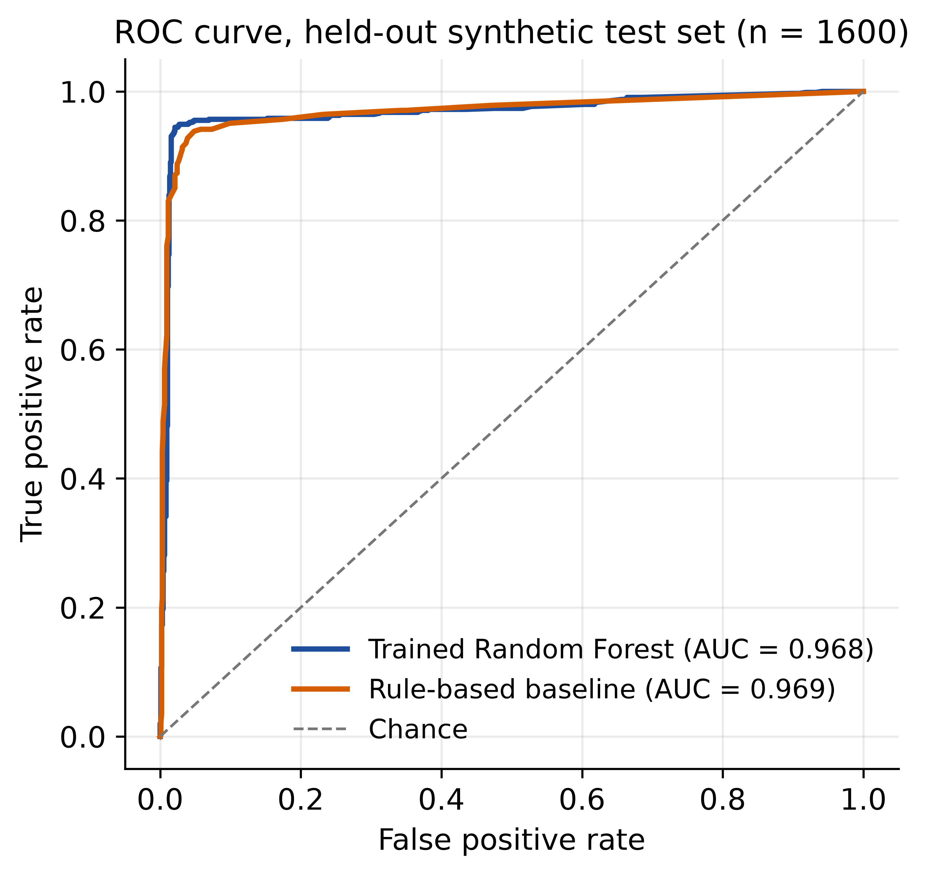
Figure 1. ROC curves for the Random Forest and the rule-based baseline.
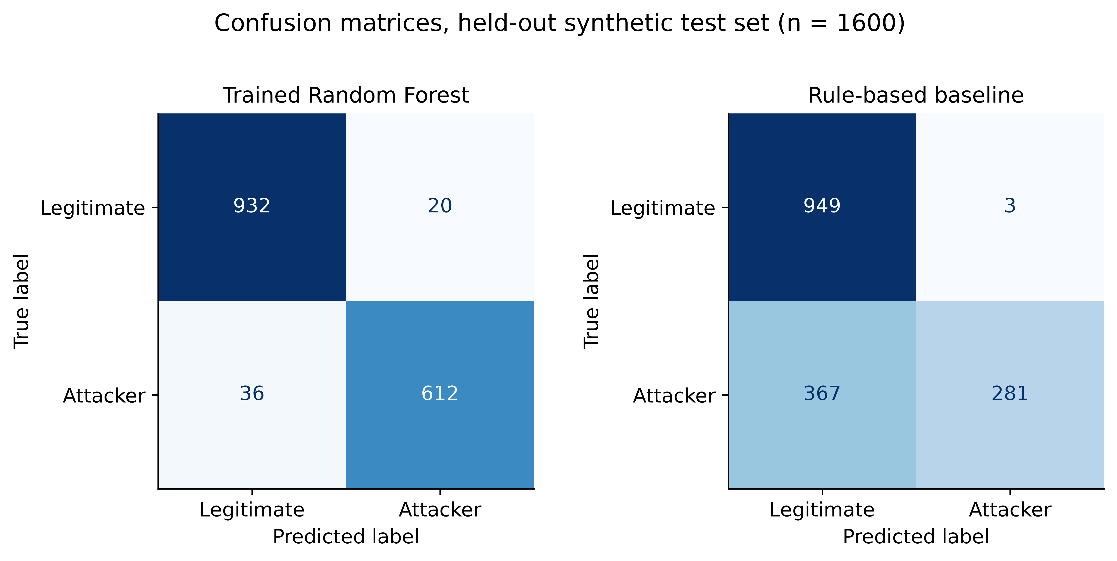
Figure 2. Confusion matrices on the held-out test set.
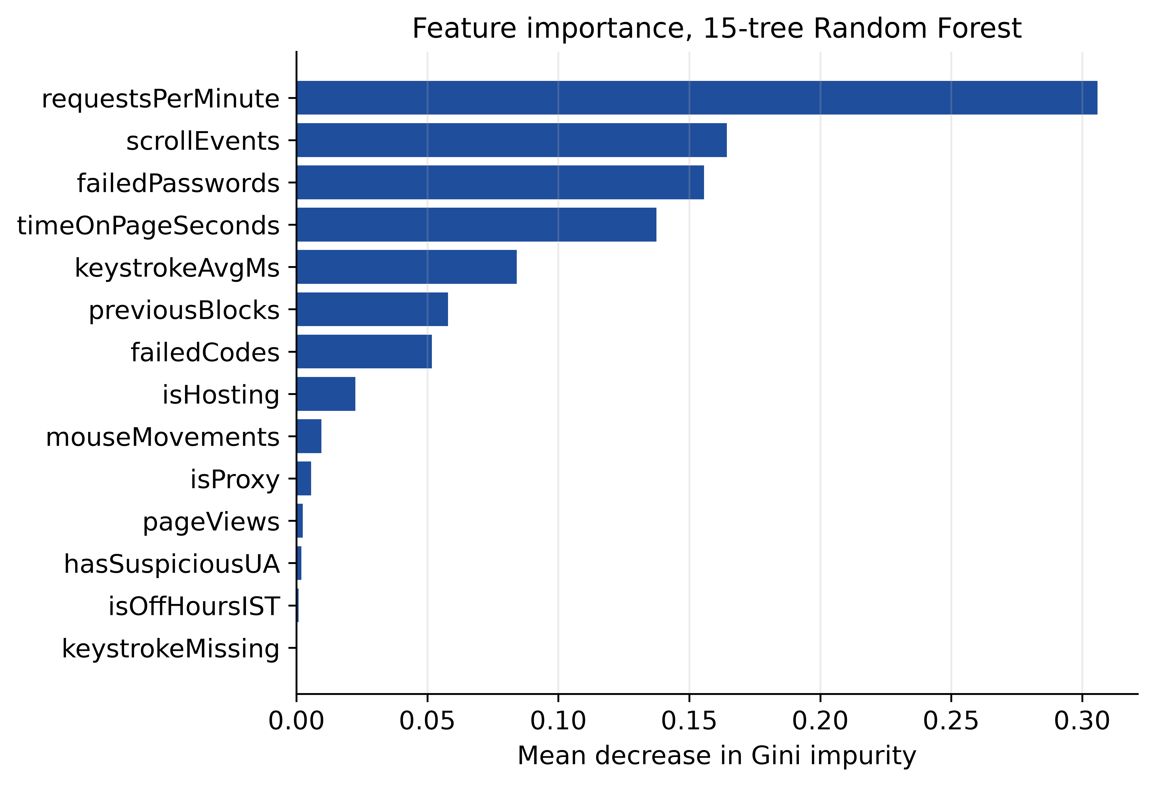
Figure 3. Feature importance of the Random Forest.
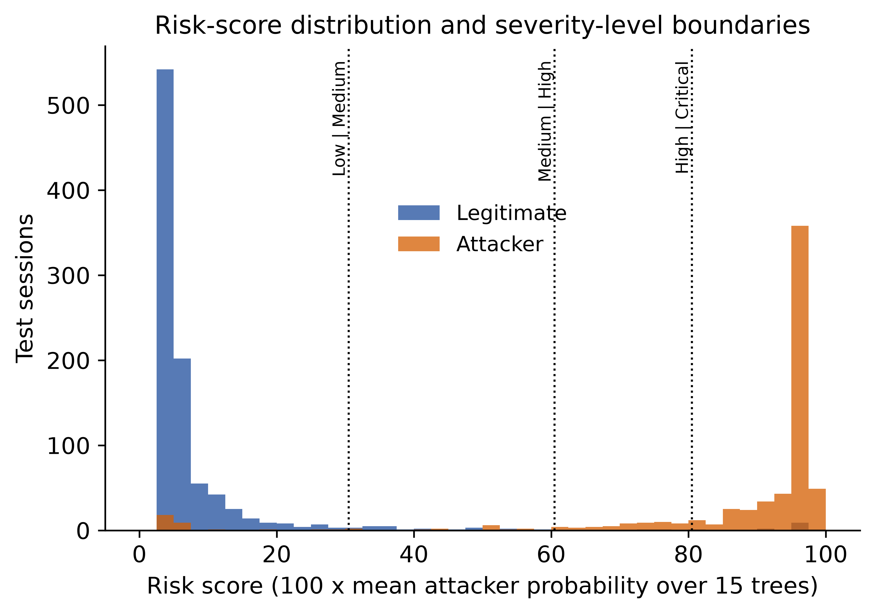
Figure 4. Risk-score distribution and the four severity-level boundaries.
High-resolution originals (600 dpi PNG and vector PDF) are in the repository folder ml/figures. Use the PDF versions in the manuscript so the figures stay sharp.

8. Limitations and threats to validity (must appear in the paper)
- Synthetic training and test data. Reported metrics measure recovery of the simulator's structure, not real-world performance. The generator and the evaluation share the same assumptions, so avoid words such as proven or verified.
- No real-session validation yet. A protocol exists (ml/collect_real_sessions.md) but the real validation set has not been collected. If it is collected, report the result even if it is worse than the synthetic one.
- Three model inputs (isProxy, isHosting, previousBlocks) are constants in the deployed client path, so the model's real discrimination rests on ten features.
- Each session is scored alone. Distributed low-and-slow attacks across many sessions or IPs are not correlated.
- Blocking is per IP, so collateral blocking of shared networks is possible.
- Decoy content is template-based and its realism is not evaluated by a user study.
- The signature classifier detects known patterns; an adaptive attacker can evade signatures, and its corpus was written by the authors.
- Expert-assigned server weights are not statistically validated.
- A single application and a single deployment context; no claim of transfer to other systems.

Suggested future work
- Collect and publish a real labelled session set, and retrain and re-evaluate on it.
- Pass the IP-reputation and block-history signals into the model.
- Add cross-session correlation and a scheduled retraining pipeline.
- Evaluate decoy believability with a user study and test against adaptive, human-mimicking attackers.

9. Suggested IEEE paper outline
- Abstract (150-250 words): problem, hybrid method, synthetic-data evaluation, headline numbers, limitation.
- Introduction: cloud storage threats, limits of static honeypots and rule engines, contributions (Section 1).
- Related work: honeypots and deception, behavioural biometrics, anomaly detection, bot detection (use the reference list in Section 11).
- System architecture: components and data flow (Section 1).
- Attacker profiling and risk scoring: features, weights, score, levels (Sections 2 and 4).
- Adaptive deception and automated response: decoys, thresholds, block policy (Sections 3 and 4).
- Threat detection modules: Random Forest and signature classifier (Section 5).
- Experimental setup: dataset, protocol, metrics, baseline (Section 6).
- Results and discussion (Section 7).
- Limitations, threats to validity and future work (Section 8).
- Conclusion.
- References (maximum 25).

Where each reviewer comment is answered
Comment | Request | Section of this dossier
R1.1 | Weighting and validation of profile features | 2
R1.2 | Decoy generation mechanism | 3
R1.3 | Dataset size, class distribution, protocol | 6
R1.4 | Formal criteria for blocking | 4.3
R1.5 | Models, training data, parameters | 5, 6
R2.1 | Algorithms specified | 5
R2.2 | Dataset described | 6
R2.3 | Training, feature selection, hyperparameters | 5.1
R2.4 | Risk score and four severity levels | 4.1, 4.2
R2.5 | Experimental details for the metrics | 6, 7
R2.6 | Clear, high-resolution figures | 7 and ml/figures
R2.7 | Reference list of 25 or fewer | 11

10. Reproducing the results
git clone https://github.com/Vedhrishi/intellitrap-batch-3.git
cd intellitrap-batch-3/ml
python generate_dataset.py # 8,000 synthetic sessions, seed 42
python train.py # model, metrics.json, 5-fold CV
python make_revision_assets.py # figures (600 dpi) and statistics
python make_threat_corpus.py # signature-classifier test corpus
The web application itself: see SETUP.md in the repository (Supabase project, environment variables, Vercel deployment).

11. Reference list (24 entries; limit is 25)
Verify before use. These entries were compiled from memory without a live database search. Check authors, venue, pages and DOI for every entry, cite only what the manuscript actually uses, and renumber in order of first citation (IEEE style). Entries 19, 20 and 23 are the least certain.
1. L. Breiman, "Random forests," Machine Learning, vol. 45, no. 1, pp. 5-32, 2001.
2. F. Pedregosa et al., "Scikit-learn: Machine learning in Python," J. Machine Learning Research, vol. 12, pp. 2825-2830, 2011.
3. L. Spitzner, Honeypots: Tracking Hackers. Addison-Wesley, 2002.
4. N. Provos, "A virtual honeypot framework," in Proc. USENIX Security Symposium, 2004.
5. A. Juels and R. L. Rivest, "Honeywords: Making password-cracking detectable," in Proc. ACM CCS, 2013.
6. Y. M. Pa Pa et al., "IoTPOT: Analysing the rise of IoT compromises," in Proc. USENIX WOOT, 2015.
7. D. Fraunholz et al., "Demystifying deception technology: A survey," arXiv:1804.06196, 2018.
8. V. Chandola, A. Banerjee, and V. Kumar, "Anomaly detection: A survey," ACM Computing Surveys, vol. 41, no. 3, art. 15, 2009.
9. R. Sommer and V. Paxson, "Outside the closed world: On using machine learning for network intrusion detection," in Proc. IEEE Symposium on Security and Privacy, 2010.
10. I. Sharafaldin, A. H. Lashkari, and A. A. Ghorbani, "Toward generating a new intrusion detection dataset and intrusion traffic characterization," in Proc. ICISSP, 2018.
11. K. S. Killourhy and R. A. Maxion, "Comparing anomaly-detection algorithms for keystroke dynamics," in Proc. IEEE/IFIP DSN, 2009.
12. Z. Jorgensen and T. Yu, "On mouse dynamics as a behavioral biometric for authentication," in Proc. ACM ASIACCS, 2011.
13. Q. Cao, X. Yang, J. Yu, and C. Palow, "Uncovering large groups of active malicious accounts in online social networks," in Proc. ACM CCS, 2014.
14. P. Eckersley, "How unique is your web browser?," in Proc. Privacy Enhancing Technologies Symposium (PETS), 2010.
15. P. Laperdrix, N. Bielova, B. Baudry, and G. Avoine, "Browser fingerprinting: A survey," ACM Trans. on the Web, vol. 14, no. 2, 2020.
16. T. Fawcett, "An introduction to ROC analysis," Pattern Recognition Letters, vol. 27, no. 8, pp. 861-874, 2006.
17. T. Saito and M. Rehmsmeier, "The precision-recall plot is more informative than the ROC plot when evaluating binary classifiers on imbalanced datasets," PLoS ONE, vol. 10, no. 3, e0118432, 2015.
18. R. Kohavi, "A study of cross-validation and bootstrap for accuracy estimation and model selection," in Proc. IJCAI, 1995.
19. C. Iliou et al., "Detection of advanced web bots by combining web logs with mouse behavioural biometrics," ACM Digital Threats: Research and Practice, 2021. (verify)
20. P. A. Legg et al., "Automated insider threat detection system using user and role-based profile assessment," IEEE Systems Journal, 2017. (verify)
21. J. Bergstra and Y. Bengio, "Random search for hyper-parameter optimization," J. Machine Learning Research, vol. 13, pp. 281-305, 2012.
22. B. Frenay and M. Verleysen, "Classification in the presence of label noise: A survey," IEEE Trans. Neural Networks and Learning Systems, vol. 25, no. 5, pp. 845-869, 2014.
23. A. Saabas, "Interpreting random forests," blog post, 2014. (cited for path-based attribution; verify URL)
24. S. M. Lundberg and S.-I. Lee, "A unified approach to interpreting model predictions," in Proc. NeurIPS, 2017.

