MAD Question Bank

UNIT I & II
- List any four features of Android operating system.
- Define OHA and state goal of OHA.
- State how the APK files are built?
- Describe the different features of Android.
- Explain features of Android SDK.
- Define Dalvik Virtual Machine (DVM).
- Describe Android architecture with diagram.
- Differentiate between DVM and JVM.
- Write down the steps to install and configure Android studio
- Describe android and importance of OHA.
- Explain Dalvik Virtual Machine and state it’s importance.
- State android ECO system.
- List various tools for android application development
- Describe various installation steps of android studio and its environment.
- Explain the need of Android Operating System. Also describe any four features of android.
- Explore all steps to install Android studio and SDK.
- List all tools and softwares required for developing an android application.
- Define emulator.
- Describe role of Emulator.
- Explain Android system architecture in detail.

UNIT III
- Enlist the elements of UI.
- Describe directory structure and its components.
- Explain the fundamentals of Ul design in detail
- List various components of android UI design.
- Describe linear layout and frame layout with example.
- List any four attributes of layout.
- Explain how linear and frame layout is used to design an android application with suitable example.
- Explain relative layout with all its attributes. (Likewise Other layout attributes)
- List various layouts used in android UI design.
- Explain with example, code to create GUI using absolute layout (Assume suitable data)
- List any four folders from directory structure of Android project and elaborate in one line.

UNIT IV
- Write a program to display a rectangular progress bar.
- List various attribute of Button
- List various attribute of Text view
- Write an xml tag for determinate progress bar.
- List any two attributes of Toggle Button.
- How to custom toast.
- Develop a program to perform addition, subtraction, division, multiplication of two numbers and display the result. (Use appropriate UI controls) – arithmetic
- State syntax to create Text View and Image button with any two attributes of each.
- Write a program to demonstrate Date and Time picker. Also display the selected time.
- List any four attributes of check box.
- Write a program to convert temperature from celcius to farenhite and vice versa using Toggle button. (Design UI as per your choice. Write XML and java file)
- Design UI using table layout to display buttons with 0 – 9 numbers on it. Even display submit and clear button. When user clicks on particular buttons and later when clicks on submit button, it should display the numbers clicked.
- Design a employee registration form using UI component.
- Develop an android application using radio button.
- Name any four attributes of Edit Text control.
- Explain Gridview with its attributes with suitable example.
- Write an xml file to create login page using Table Layout.
- Develop a program to add “Hello World” marker at (10,10) co-ordinates. Write only . java file.
- Explain scrollview with its attributes and with suitable example.
- Write a program to create first display screen of any search engine using auto complete text view
- Write difference between toggle button and radio button.
- Write a program to show five checkboxes and toast selected checkboxes using linear layout.
- Explain data and time picker with its method
- Develop a simple calculator using relative layout.
- Develop a program to implement
i) List view of 5 items
ii) Grid view of 4 x 4 items
iii) Image view.

UNIT V
- State the uses of Intent in Android.
- Define service in android operating system.
- Write down syntax to create an intent and start another activity.
- Write a program to demonstrate declaring and using permissions with any relevant example.
- Name two classes used to play audio and video in Android.
- Write a program to capture an image using camera and display it.
- Write a program to implement Android Activity Life Cycle. Use toast messages to display message through life cycle.
- Describe Android service life cycle along with diagram.
- State the use of fragments in android App development.
- State syntax to display built in zoom control.
- Draw diagram of activity life cycle.
- Describe permissions required for android application development.
- Develop an android application for taking student feedback with database connectivity.
- State intent. List types of intent./Explain types
- Difference between Explicit intent and Implicit Intent
- Describe with example, how to create a simple dtoastatabase in SQLite (Assume suitable data).
- Explain property animation method to animate the properties of view object with example.
- Describe multimedia framework of Android with diagram.
- Explain text to speech conversion technique in android.
- Design an android application to show the list of paired devices by Bluetooth.
- Develop an application to update a record of an employee whose emp.id is ‘E101’ in SQlite database. Change employee name from “PQR” to “XYZ”. Also display the updated record. (Write .java and .xml files)
- Write significance of SQLite database in android.
- Explain importance or use of developer console.
- Develop an application to store customer's details like, customer-id, customer-name, mobile number, address, pin-code and retrieve customer information using customer-id in SQLite databases. (Any other relevant logic can be considered)
- Develop a program to TURN ON and OFF bluetooth. Write .java file and permission tags.
- What is fragment? Explain with example.
- Describe types of permissions used while developing android application.
- Develop android application to enter one number and display factorial of a number once click on button.
- Write a program to capture an image using camera and display it.
- Develop a program for providing bluetooth connectivity.
- Develop an application to convert “thanks” text to speech as given in the following GUI.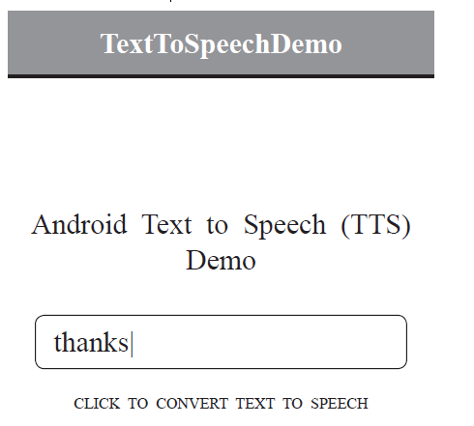

UNIT VI
- Elaborate Android Security Model.
- Name any four methods to get location data in android.
- Explain significance of content provider
- Write a program to display the list of sensors supported by device.
- Write a program to send e-mail.
- Write a program to show users current location.
- Develop a program to send an SMS.
- Explain two methods of Google Map.
- Define Geocoding and Reverse Geocoding.
- Develop an application to display a Google Map. (Write JAVA and Manifest file)
- State and elaborate the syntax of required class and methods for Geocoding.
- Develop and application to send and receive SMS (Design minimal UI as per your choice. Write XML, java and manifest file)
- Define SMS service in android application development.
- List different types of sensors used in android.
- Develop an android application to show current location of an user’s car.
- Explain Geocoding and Reverse Geocoding with suitable example.
- Describe process of getting the map API Key.
- List and elaborate steps to deploy an Android application on Google play store.
- Develop an android application for sending Short Message Service (SMS).
- Write steps for customized permissions.
- Explain the Android security model.
- Discuss developer console with at least four features.
- Elaborate the need of permissions in Android. Explain the permissions to set system functionalitics like SEND-SMS, bluetooth
- Explain the procedure of Geo-coding and reverse Geo-coding.
- Develop an application to send and receive SMS (Write only Java and permission tag in manifest file).
- Develop a program to send and receive an Email.
- Write a program to find the direction from user's current location to MSBTE, Bandra. (Write only Java and manitest file).
(Note : Any other relevant logic to get the required output can also be considered.)
- Develop an application to display Google map with user’s current location.
- Define :
- i) Fragment
ii) Broadcast receiver

