BioScan: Reference-Aware DNA Barcode Identification with Out-of-Reference Detection for Fish Environmental DNA
Shreya Jadhav  UCE2024435 | Vedika Kurhade  UCE2024444 | Sharvari Somvanshi  UCE2024460
Department of Computer Engineering, Cummins College of Engineering for Women, Pune, India
Under the guidance of [Laboratory Faculty Name]
Abstract—Environmental DNA (eDNA) surveys name the animals in a water sample by comparing short DNA barcodes with a reference library. A classifier always returns one of its known labels, and a similarity search always returns a best hit, so a sequence from a species missing from the library can still receive a confident name. We present BioScan, a reference-aware identification system for fish 12S rRNA barcodes. It predicts taxonomy rank by rank from k-mer features, measures the normalised Levenshtein distance to every reference sequence, and applies a Distance Veto that declares a sequence out of reference when its nearest reference is too far away, whatever the classifier says. We built it on the 2019 New Jersey Ocean Trawl eDNA survey, whose 13,736 rows reduce to only 101 unique sequences, and evaluate it by leave-one-sequence-out validation on de-duplicated data. Class, order and family reach macro F1 of 1.00, 0.59 and 0.79; genus and species cannot be scored because 89 of 90 species have a single sequence. The veto rejected all 19 real non-fish sequences and none of 153 altered known sequences, and it abstained on most sequences from unseen genera. A plain nearest-reference search matched the trained models above class level, so the contribution lies in the decision logic and the evaluation.
Index Terms—environmental DNA, DNA barcoding, 12S rRNA, open-set recognition, hierarchical classification, k-mer features, edit distance, leakage-safe evaluation
I. Introduction
Environmental DNA (eDNA) is genetic material that organisms shed into water, soil or air. Sequencing a short, informative gene region from a filtered water sample and matching it against a reference library shows which animals were present, without capturing any of them [1]. For fishes, a widely used marker is a hypervariable stretch of the mitochondrial 12S rRNA gene, amplified with the MiFish primers [2]. The accuracy of such surveys depends on one step: giving each sequence a taxonomic name.
Two common tools fail in different ways. A supervised classifier must choose among the labels it was trained on, so its probabilities describe only the known classes and an unfamiliar sequence can still receive a confident, wrong species name. A similarity search such as BLAST [3] returns a best hit even when the true species is absent, and judging whether the hit is good enough is left to the analyst. Reference libraries are never complete [4], so this is not a rare case. Recognising inputs from classes never seen in training is the open-set recognition problem [5], [6], which has received little attention for DNA barcodes.
A second difficulty is the data. Reference libraries often hold one or two barcodes per species, and survey tables repeat each sequence across samples and replicates. Splitting such rows at random puts identical sequences into both training and test sets and inflates accuracy. Honest evaluation must therefore work on unique sequences and must say plainly which taxonomic ranks the data cannot support.
This paper presents BioScan, a reference-aware identification system for fish 12S barcodes. Its contributions are: (1) a pipeline that combines hierarchical k-mer classifiers with an exact edit-distance search and a Distance Veto, so that a taxon is named only as deep as the evidence supports; (2) a leakage-safe evaluation protocol for small, duplicated reference data that treats taxonomy accuracy and unknown-sequence detection separately and reports “insufficient data” where a rank cannot be scored; (3) an empirical finding that, on this library, nearest-reference search is as accurate as the trained classifiers above class level, which places the value of the system in its decision logic; and (4) a tested web application that is publicly deployed. The code and data are at https://github.com/Vedika-k187/BioScan and the application is at https://bioscan-dna.streamlit.app.
II. Related Work
The MiFish primers amplify a short 12S region that separates many fish species and have been used to detect hundreds of species from seawater [2]. Identification then relies on alignment search [3] against curated libraries such as BOLD [4]. Alignment yields a similarity score but not a decision about whether the library covers the query.
Composition-based classifiers assign taxonomy without alignment. The RDP classifier applies naive Bayes to short word frequencies and attaches a bootstrap confidence [7], but it is closed-set: its output is always one of the training taxa. Denoising methods such as DADA2 [8] improve read quality before identification but do not address library coverage.
Open-set recognition formalises the need to reject inputs from unseen classes [5], and recent surveys describe distance-based and probabilistic rejection rules [6]. The distance to the nearest training example is a long-standing baseline [9]. We apply this idea to barcodes, combine it with a hierarchical classifier so that a partial answer remains possible, and evaluate it on data that were not used to set its thresholds.
III. Data and Preparation
A. Source
We use the 2019 New Jersey Ocean Trawl eDNA survey, NCBI BioProject PRJNA638560 [10]. The raw table has 13,736 rows and 59 columns: a 12S V5 sequence of 87–112 bp, its taxonomy, station coordinates, depth and read counts. The marker was amplified with MiFish-style primers. The SHA-256 checksum of the raw file was recorded and re-verified after processing, so the original data were never altered.
B. Duplicate structure
The rows are not independent. Each of 101 unique sequences appears exactly 136 times (68 sampling events × 2 primer replicates). We normalise each sequence (upper case, whitespace removed), check that it contains only A, C, G and T, remove exact duplicates after confirming that duplicates carry identical taxonomy, and use the 101 unique sequences as the unit of modelling and evaluation. The repeated rows are used only to build 1,604 de-duplicated occurrence records at 36 stations for map context.
C. Reference library
Table I summarises the library. Of the 101 sequences, 91 carry a species label (90 species) and 10 do not; those 10 keep their class, order and family. Teleosts dominate (82 sequences, against 17 elasmobranchs and two singleton classes), and 89 of the 90 species are represented by a single sequence. These facts shape the evaluation in Section V.
TABLE I
Reference Library Summary
Property | Value
Raw rows × columns | 13,736 × 59
Unique sequences | 101 (each repeated 136×)
Sequence length | 87–112 bp (median 106)
Classes / orders / families | 4 / 30 / 66
Genera / named species | 87 / 90
Species with one sequence | 89 of 90
Survey occurrence records | 1,604 at 36 stations

IV. Method
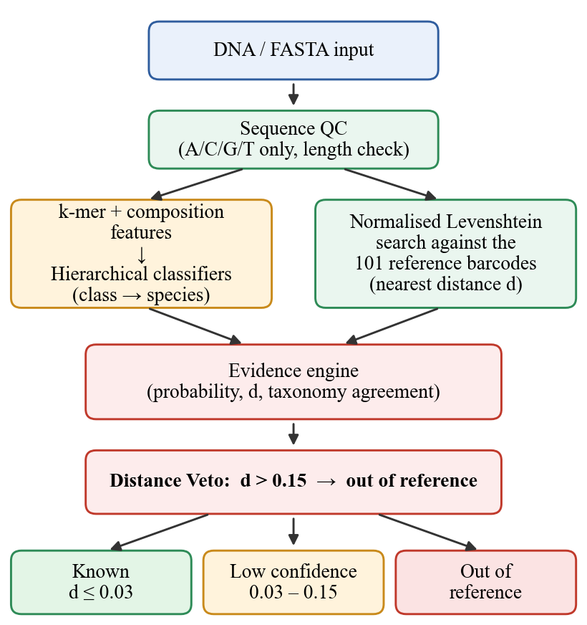
Fig. 1. BioScan pipeline. The classifier and the reference search run in parallel on the quality-checked sequence, and the evidence engine and Distance Veto decide the status.
A. Quality control
Input is upper-cased, stripped of whitespace and accepted only if it contains A, C, G and T. Ambiguity codes are rejected, not guessed. Lengths outside the reference range of 87–112 bp raise a warning and do not cause rejection. In batch mode each record is checked independently, so one invalid sequence does not stop a run.
B. Features
Each sequence becomes a fixed-length vector. The 17 basic features are length, nucleotide counts and frequencies, GC and AT content, counts of distinct 1-, 2- and 3-mers, the Shannon entropy [11] of base composition, and the maximum and minimum base frequency. The k-mer features are the relative frequencies
f_{w} = c_{w} / (L − k + 1) (1)
of every word w of length k over a sliding window, where c_{w} is its count and L the sequence length. This gives 16 values for k = 2 and 64 for k = 3. We also built k = 4 and k = 5 vectors (256 and 1,024 values) and compared them in baseline experiments, but with 101 sequences such vectors outnumber the samples and were dropped from the hierarchical comparison. Location, date and other metadata never enter the features.
C. Classifiers
Three families are compared: k-nearest neighbours [9] (one neighbour, Manhattan distance, standardised features), random forest [12] (100 trees, unlimited depth) and gradient-boosted trees, XGBoost [13] (100 trees, depth 3, learning rate 0.1, subsample and column sampling 0.8, softmax objective). We use scikit-learn [14] and fixed random seeds, and every scaler is fitted on training data only.
D. Hierarchical inference
Separate models predict class, order, family, genus and species. At each rank the candidates are restricted to the children of the rank already chosen, which makes the lineage consistent by construction; on the library itself this raised full-lineage consistency from 92.1% to 100%. The model for each rank was chosen by held-out performance: random forest for class and order, and one-nearest-neighbour for family, genus and species (3-mer features, and 2-mer for species).
E. Reference search
The query is compared with all 101 reference sequences using the normalised Levenshtein distance
d(s, r) = Lev(s, r) / max(|s|, |r|) (2)
where Lev is the minimum number of insertions, deletions and substitutions needed to turn s into r [15]. Unlike the Hamming distance this handles the different sequence lengths in the library. Similarity is 1 − d. The nearest reference, its distance and the gap to the second nearest are passed to the evidence engine.
F. Decision rules
The evidence engine merges the classifier probabilities (top-1 probability, margin, entropy), the nearest distance, and the taxonomic agreement between the classifier and the nearest reference. Table II gives the rules. The Distance Veto is applied first and cannot be overridden: if d > 0.15 and the match is not exact, the status is out of reference, no taxonomy or survey location is attached, and the output states that this means “not in this library”, not “new species”. In the intermediate band the system reports only the ranks, up to family, on which the classifier and the nearest reference agree. A species is named only when d ≤ 0.03, because a classifier trained on one example per species cannot support species-level claims.
TABLE II
Decision Rules
Status | Condition | Output
Known reference | d ≤ 0.03 and class, order agree | Taxon to species
Low confidence | 0.03 < d ≤ 0.15 | Agreed ranks, up to family
Out of reference | d > 0.15 | No taxonomy, no map

The thresholds came from leave-one-genus-out experiments: lowering the close threshold from 0.05 to 0.03 cut the share of unseen genera accepted as known from 30% to 10% while keeping 90% of altered known sequences. BioScan is implemented in Python with pandas, scikit-learn, XGBoost, Plotly and Streamlit [16], offers single-sequence, batch and FASTA interfaces, and is covered by 172 automated tests.
V. Evaluation Protocol
A. Taxonomy
We use leave-one-sequence-out cross-validation over unique sequences: each sequence is held out once, the scaler and model are fitted on the others, and predictions are pooled. A sequence can be held out only if another sequence of the same class remains in training, since a closed-set model cannot otherwise predict its label; such singletons are counted and reported but not scored. A rank is scored only if at least 20 sequences and two classes can be held out. This leaves class (99 sequences, 2 of 4 classes), order (87, 16 of 30) and family (52, 17 of 66). Genus (19) and species (2) are reported as insufficient data. We report top-1 accuracy, macro precision, macro recall and macro F1, which weight every class equally, and macro one-vs-rest ROC AUC computed from the pooled held-out probabilities.
B. Unknown-sequence detection
Out of reference is the positive class. Four kinds of test sequence are kept separate (Table III) because they are not the same kind of unknown. References, genera and external organisms are split 50/50 into a calibration half and a test half with a fixed seed, and results are reported on the test half. We report precision, recall, false-positive rate (known sequences wrongly rejected), coverage (the fraction receiving an accepted identification), and the AUROC of the nearest distance used as an unknown score.
TABLE III
Unknown-Detection Test Categories
Category | Construction | Truth
Exact known | Each reference queried | Known (check)
Altered known | 1, 2 or 5 random substitutions per reference | Known
Held-out genus | All sequences of a genus removed, then queried | Unknown
External non-fish | 106-bp windows of NCBI mammal, bird, reptile and amphibian 12S records | Unknown

VI. Results
A. Taxonomy classification
Table IV gives held-out performance. Accuracy falls with depth as classes multiply and examples per class shrink. Random forest is best at class and order on accuracy and one-nearest-neighbour is best at family (macro F1 0.79), while XGBoost is clearly weakest at order and family (macro F1 0.38 and 0.37) because boosting needs more examples per class than the library offers. XGBoost nevertheless has the highest order AUC (0.944): AUC rewards ranking the true class highly, whereas F1 depends on the top choice being right. KNN uses one neighbour, so its probabilities are 0 or 1 and its AUC is not comparable. Class-level scores come from two testable classes and describe an almost binary task.
TABLE IV
Held-Out Taxonomy Performance
Model | Acc. | Prec. | Rec. | F1 | AUC
Class (n = 99, 2 classes)
KNN | 0.990 | 1.000 | 0.994 | 0.997 | 0.997
Random forest | 1.000 | 1.000 | 1.000 | 1.000 | 1.000
XGBoost | 0.990 | 0.972 | 0.994 | 0.983 | 1.000
Order (n = 87, 16 classes)
KNN | 0.736 | 0.642 | 0.647 | 0.630 | 0.815
Random forest | 0.759 | 0.593 | 0.601 | 0.586 | 0.913
XGBoost | 0.667 | 0.360 | 0.423 | 0.383 | 0.944
Family (n = 52, 17 classes)
KNN | 0.865 | 0.804 | 0.794 | 0.792 | 0.895
Random forest | 0.769 | 0.722 | 0.681 | 0.685 | 0.961
XGBoost | 0.596 | 0.347 | 0.402 | 0.367 | 0.928
Precision, recall, F1 and AUC are macro averages. Genus and species: insufficient data.
B. Nearest-reference baseline
Predicting the label of the closest other reference, with no training, gives accuracies of 100%, 81.6% and 90.4% at class, order and family, which is comparable to or above the trained models (100%, 75.9% and 86.5% for the deployed choice). Fig. 2 shows that accuracy rises as the allowed distance shrinks: within d ≤ 0.10, 47 of the 52 evaluable sequences were accepted and 96% of those had the correct family.
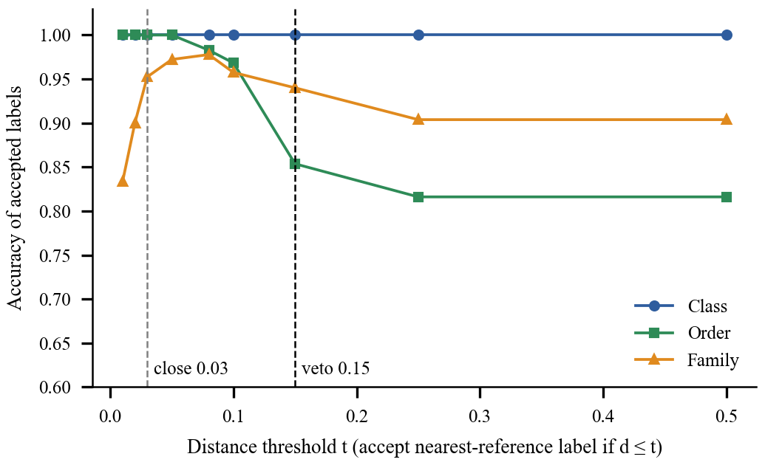
Fig. 2. Accuracy of the nearest-reference label as the accepted distance threshold varies (leave-one-out).
C. Unknown-sequence detection
Table V gives results on the test half: 153 altered known and 71 unknown sequences (52 from held-out genera and 19 non-fish). The production veto never rejected an altered known sequence (false-positive rate 0) and rejected all 19 non-fish sequences, but only 11.5% of held-out-genus sequences, giving a recall of 0.352. This is low because most unseen genera have a relative in the library and fall between the close-match line (0.03) and the veto (0.15) (Fig. 3). They are rarely accepted wrongly (11.5%); most are abstained on. Counting abstention as rejection raises recall to 0.915 but also the false-positive rate to 0.333, because sequences with five substitutions (d ≈ 0.05) are abstained on as well. The AUROC of the nearest distance is 0.902. A single threshold chosen on the calibration half (0.05) catches 74.6% of unknowns at a 2.0% false-positive rate, which is the leakage-free estimate; the production thresholds were first chosen using these same sequences, so their figures are optimistic.
TABLE V
Out-of-Reference Detection (Test Half)
Rule | Prec. | Rec. | FPR | Cov.
Production veto | 1.000 | 0.352 | 0.000 | 0.482
Reject or abstain | 0.560 | 0.915 | 0.333 | 0.482
Threshold 0.05 (calibrated) | 0.946 | 0.746 | 0.020 | 0.750

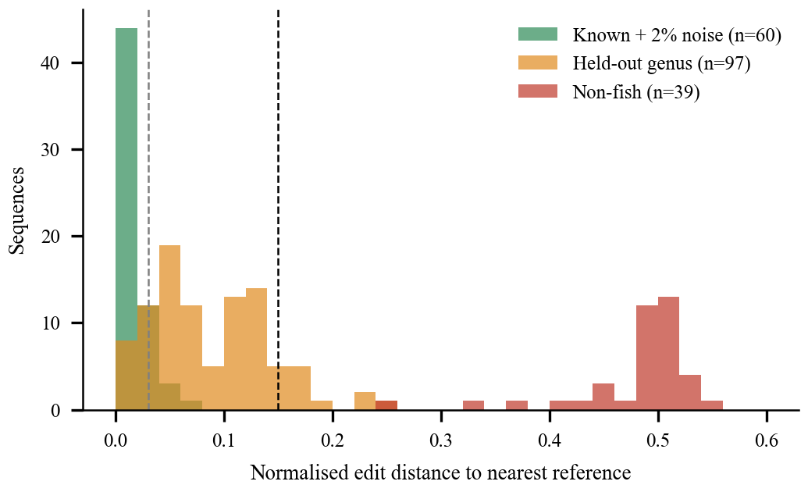
Fig. 3. Distance to the nearest reference for altered known, held-out genus and non-fish sequences (all sequences, descriptive).
D. Robustness to substitutions
Table VI shows that up to two random substitutions in a sequence of about 100 bp are tolerated and still named. With five, every sequence moves into the abstention band, which is conservative behaviour. Insertions, deletions and real sequencing errors were not tested.
TABLE VI
Altered Known Sequences (Test Half, n = 51 Each)
Substitutions | Median d | Accepted | Abstained | Rejected
1 | 0.009 | 100% | 0% | 0%
2 | 0.019 | 100% | 0% | 0%
5 | 0.047 | 0% | 100% | 0%

VII. Discussion and Limitations
Three points stand out. First, the main constraint is the library, not the algorithm: with 101 sequences and 89 single-sequence species, genus and species generalisation cannot be measured, and species output is reference matching and not a validated classifier. Second, the trained models add little beyond class level over a plain nearest-reference search, so the practical value of BioScan is its decision logic: graded answers, a veto that a confident classifier cannot override, and an evaluation that separates taxonomy accuracy from unknown detection. Third, “out of reference” is not “new species”: held-out genera mostly land near a relative, which is why abstention, not rejection, is the dominant outcome for them.
The limitations are as follows. Class-level results rest on two testable classes. Per-class support is about five sequences at order and three at family, so per-class values are unstable. The non-fish negatives are windows of full-length records and not amplicon reads, only substitutions were simulated, and no BLAST comparison or external dataset was used. The thresholds were first tuned on the same small library, which is why a calibration-half result is reported separately.
VIII. Conclusion and Future Work
We presented BioScan, which names a fish barcode only as deep as the evidence supports and refuses sequences that fall outside its reference library. On de-duplicated, held-out data it classifies class, order and family with macro F1 of 1.00, 0.59 and 0.79, rejects every tested non-fish sequence without rejecting any altered known one, and abstains on most sequences from unseen genera. The evaluation also shows what a library of 101 sequences cannot support: genus and species cannot be validated, and nearest-reference search is as accurate as the trained models above class level.
Future work includes a larger, independently sourced library with several sequences per species; a comparison with BLAST or vsearch on the same held-out queries; a FASTQ-to-ASV front end so that real reads can be analysed; recalibration of the thresholds on larger data, with tolerance for ambiguous bases and reverse-complement reads; and additional markers and taxa.
References
[1] K. Deiner et al., “Environmental DNA metabarcoding: Transforming how we survey animal and plant communities,” Molecular Ecology, vol. 26, no. 21, pp. 5872–5895, 2017.
[2] M. Miya et al., “MiFish, a set of universal PCR primers for metabarcoding environmental DNA from fishes: detection of more than 230 subtropical marine species,” Royal Society Open Science, vol. 2, no. 7, p. 150088, 2015.
[3] S. F. Altschul, W. Gish, W. Miller, E. W. Myers, and D. J. Lipman, “Basic local alignment search tool,” J. Molecular Biology, vol. 215, no. 3, pp. 403–410, 1990.
[4] S. Ratnasingham and P. D. N. Hebert, “BOLD: The Barcode of Life Data System,” Molecular Ecology Notes, vol. 7, no. 3, pp. 355–364, 2007.
[5] W. J. Scheirer, A. de Rezende Rocha, A. Sapkota, and T. E. Boult, “Toward open set recognition,” IEEE Trans. Pattern Anal. Mach. Intell., vol. 35, no. 7, pp. 1757–1772, 2013.
[6] C. Geng, S.-J. Huang, and S. Chen, “Recent advances in open set recognition: A survey,” IEEE Trans. Pattern Anal. Mach. Intell., vol. 43, no. 10, pp. 3614–3631, 2021.
[7] Q. Wang, G. M. Garrity, J. M. Tiedje, and J. R. Cole, “Naïve Bayesian classifier for rapid assignment of rRNA sequences into the new bacterial taxonomy,” Appl. Environ. Microbiol., vol. 73, no. 16, pp. 5261–5267, 2007.
[8] B. J. Callahan et al., “DADA2: High-resolution sample inference from Illumina amplicon data,” Nature Methods, vol. 13, no. 7, pp. 581–583, 2016.
[9] T. Cover and P. Hart, “Nearest neighbor pattern classification,” IEEE Trans. Inf. Theory, vol. 13, no. 1, pp. 21–27, 1967.
[10] NCBI, “BioProject PRJNA638560: 2019 New Jersey Ocean Trawl Survey environmental DNA.” [Online]. Available: https://www.ncbi.nlm.nih.gov/bioproject/PRJNA638560
[11] C. E. Shannon, “A mathematical theory of communication,” Bell Syst. Tech. J., vol. 27, no. 3, pp. 379–423, 1948.
[12] L. Breiman, “Random forests,” Machine Learning, vol. 45, no. 1, pp. 5–32, 2001.
[13] T. Chen and C. Guestrin, “XGBoost: A scalable tree boosting system,” in Proc. 22nd ACM SIGKDD Int. Conf. Knowledge Discovery and Data Mining, 2016, pp. 785–794.
[14] F. Pedregosa et al., “Scikit-learn: Machine learning in Python,” J. Machine Learning Research, vol. 12, pp. 2825–2830, 2011.
[15] V. I. Levenshtein, “Binary codes capable of correcting deletions, insertions, and reversals,” Soviet Physics Doklady, vol. 10, no. 8, pp. 707–710, 1966.
[16] Streamlit Inc., “Streamlit documentation.” [Online]. Available: https://docs.streamlit.io

