Chapter 1
INTRODUCTION

1.1 PROJECT DEFINITION
Desktop application is the part of this project. In this project bail applications are considered. Based on head note/judgements in the legal documents keywords are which are attributes for our dataset. Using machine learning algorithms such as Naïve Bayes, we are predicting whether the bail will be granted to accused or not. This will be based on the input given by the user. The input will be in the form of answers given to the questions asked by the system.
1.2 PROBLEM STATEMENT
Predicting whether the bail is granted or not in attempt to murder and murder cases using ML.
1.3 MOTIVATION
1. In India, the judiciary system and the law stresses the principle of presumption of innocence.
2. In any legal case which is filed, while considering the bail applications of accused court is required to balance consideration of personal liberty with public interest.
3. A person arrested under bailable offence may secure bail in the police station itself but in case of non-bailable offence the bail can be secured only through the court.
4. The accused has every right to apply for the bail but it is upto judiciary system or judge whether to grant the bail or not. For this the judge will be required to have all the evidences and considerations regarding the case.
5. All this investigation is to be done by the in-charge or the officer and has to be reported to the judge. This process takes a much longer time.
6. The purpose of this project is to save the time and energy required for this process by automating it.

1.4 PROJECT SCOPE-
The scope of this project is to deal with bail application in attempt to murder (IPC sec 307) and murder cases (IPC sec 302) i.e. non-bailable offence. The dataset is balanced i.e. we have bought down the legal cases to single level so that the prediction will be easy. All the cases are processed based on the factors or attributes which are present in the dataset. All the attributes present in dataset are independent in nature. All the problem features are grouped into strong, default and weak models. The combined output of the models implies the overall prediction. This project can be extended for different cases based on particular domain. By revising various algorithms, efficiency of the machine learning model can be increased up to 75%.Keyword extraction is manual.
1.5 METHODOLOGIES TO PROBLEM SOLVING-
Different machine learning algorithms are implemented using modular programming.

Chapter 2
LITERATURE SURVEY

We studied and explore the papers and journals related and needed in the scope of our problem statement. It helped us with the basic and conceptual terms related to our system requirement. Bail is the set of pre-trial restrictions that are inflicted on a suspect to ensure that suspect comply with judicial process. Every case is different so the factors that are considered for bail appeal are different; these factors are independent of one another so that we use Naive Bayes Classifiers for predicting the result.
Collaboration between Artiﬁcial Intelligence (AI) and the legal domain has been going on for some decades already .Theoretical model for the case result prediction is proposed in country like Europe and Philippines using NLP and machine learning. Theoretical model proposed in this country useful for approaching towards the system.
Philippine Supreme Court case decisions[1] are readily available online, so they use this as their dataset for the theory that they proposed. They gives n-gram and topic features are then input to the machine learning algorithms such as linear support vector machines and random forest classifiers. Linear support vector machine results reached 45% on the n-gram datasets and 55% on the topic datasets. The best result we obtained is 59% on the topic datasets using a random forest classifier.
For extracting the features for cases lawyers knowledge and different legal terminologies are examined. A bail bond[3] is a written promise signed by a defendant and surety to ensure that a criminal defendant will appear in court at the scheduled time and date, as ordered by the court. The bail amount is set by the court. The goal of a bail bond is to prevent abuse of the appeal process, where the intent for appeal is for a reason other than that for which it is intended. Sections are the distinct portion or provision of a legal code or set of laws, often establishing a particular legal requirement. There are different sections or murder acquisition cases like IPC section 307, section 302 etc. These sections are used for deciding attribute for our model.
Because of the feature’s independence, naive Bayes classifiers are highly scalable and can quickly learn to use high dimensional features with training data. This is useful for many real world datasets where the amount of data is small in comparison with the number of features for each individual piece of data, such as text.

Chapter 3
SOFTWARE REQUIREMENTS SPECIFICATION

3.1 Assumptions and Dependencies:
- The headnote coming to the application is assumed to be in the specified bail type i.e. bail for murder acquisition and murder.
- The prediction regarding the bail is granted or not granted highly depends upon the accuracy of underlying machine learning model.
- We assume the data which is required for training the machine learning model to be real.
3.2 FUNCTIONAL REQUIREMENTS
3.2.1 System feature for Lawyers-
The lawyer needs to register to the system as a Admin. Admin access are given to the lawyers to add the new cases and can answer questions provided by the system in a specified format so that the system can predict the result whether the bail can be granted or not so that it can provide rapid assistant for the lawyers. The lawyer can add headnote only under the supervision of software developer.
3.2.2 System feature for Assistant-
The Assistant needs to register to the system as Assistant. He needs to login to the system using userid and password. Assistant can answer questions provided by the system in a specified format so that the system can predict the result whether the bail can be granted or not so that it can provide rapid assistant for the Assistants.
3.3 EXTERNAL INTERFACE REQUIRED
3.3.1 User interfaces
- The input is taken from the user in the form of questions and user is required to answer the question in a given format and then the prediction of the model whether the bail is granted or not is shown in the form of percentage. And if the bail is not granted then the reason of why the bail is not granted is shown on the user interface.
- User is required to login to the system to proceed further.

3.3.2 Hardware interfaces
- 64 bit operating system(Windows)
- 4GB/8GB RAM
- 500 GB/1 TB ROM

3.3.3 Software interfaces
- Anaconda
- Libraries such as-sklearn,numpy,pandas
- Flask for UI

3.3.4 Communication interfaces
- Data preprocessing model to data storage model interface.

3.4 NON-FUNCTIONAL REQUIREMENTS
    - Performance requirements
- Accuracy of the machine learning model tells us about how efficiently the output is predicted. Larger the dataset to train the machine learning model larger will be the accuracy.
- When the input to the system is in proper format, prediction should be done within fraction of seconds.
- Accuracy also varies from algorithm to algorithm. Hence, performance depends upon algorithm used to train the model.
3.4.2 Safety requirements
- Delete operation is prohibited on the .csv file otherwise accuracy of the machine learning model is affected.
3.4.3 Security requirements
- Common man doesn’t given an access to input the data. Input operation can be performed by authorized person only.
- Headnote can be added via authorized person i.e. lawyer.

3.4.4 Software quality attributes
Efficiency-
The efficiency for the model will be approximately 75%
Maintainability-
The system generates proper output for the head node which will be in the specified type, generates proper output using NLP and output will be stored in the CSV file.
Reliability-
User should find system trustworthy that is result provided should be accurate.
Interoperability-
Components of the system exchanges information in between.
Availability-
Only authorized user will have access to information from anywhere.

3.5 SYSTEM REQUIREMENTS
3.5.1 Database requirements
MySQL Database :
MySQL is a relational database management system based on SQL which we used to store the login credentials.
3.5.2 Software requirements
Anaconda:
Anaconda is a free and open-source distribution of the Python and R programming languages for data science, machine learning applications, large-scale data processing, predictive analytics.

Flask:
Flask is a web framework written in Python. Flask provide tools, libraries and technologies that allow to build a web application. Flask is micro-framework because it does not require particular tools or external libraries.

Excel:
CSV file is best viewed in Microsoft Excel which stores dataset in tabular format.
Language: Python
Scikit-learn :
Scikit-learn is a free software machine learning library for the Python. It contains various classification, regression and clustering algorithms (e.g. support vector machines, k-means, random forest etc.) and also is designed to interoperate with the Python numerical and scientific libraries like NumPy and SciPy.

3.5.3 Hardware requirements:
- Windows (64 bit OS)
- 4 GB / 8GB RAM

3.6 ANALYSIS MODEL: SDLC MODEL
Based upon the basic SDLC block which are requirement gathering, planning, design, construction, deployment various SDLC models are built which help us to achieve the goal of the project in systematic manner and minimum time.
In this project, we have used Incremental model. Incremental model focuses on implementation of small set of requirements and then iteratively enhances the evolving version until the complete system is deployed. In this we have considered only bail cases in attempt to murder and murder and can apply incremental model on different case domains.
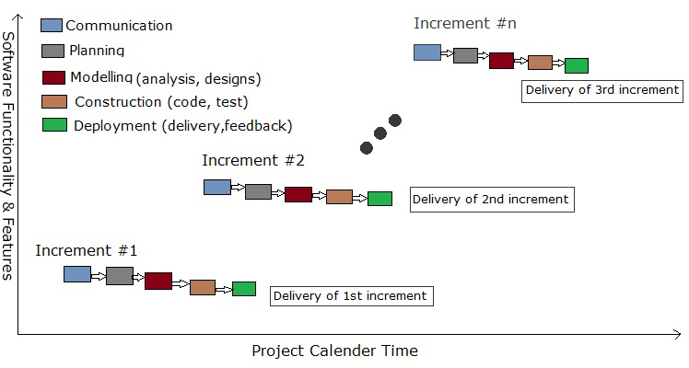
Figure 3.1 Incremental model
Requirement analysis-
- Taking the domain knowledge from the lawyers.
- Gathering the legal cases for bail application in attempt to murder and murder.
- Identifying the key features on which the prediction is based and checking interdependency between the features.
Planning-
- Classifying the dataset as Strong, weak, default
- After the first risk analysis adding weighted probability to the features.
Modelling-
- The solution of the problem is modelled using various diagrams.
- Building the mathematical model for Naïve bayes.
Construction-
- Dataset is prepared and coding is completed.
Deployment-
- The model is deployed to the endusers i.e lawyers

Chapter 4
SYSTEM DESIGN

4.1 SYSTEM ARCHITECTURE
UPLOAD NEW HEADNOTE
/JUDGEMENT

KEYWORD EXTRACTION
(Manually)

CLASSIFICATION FOR SPECIFIC BAIL TYPE

MODEL TRAIN
UI

PREDICTION AND DIAGNOSIS

Figure 4.1 System architecture
4.2 Mathematical Model
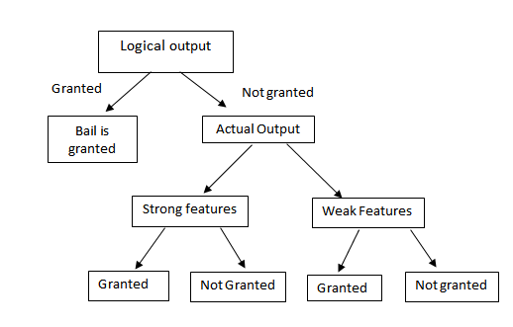

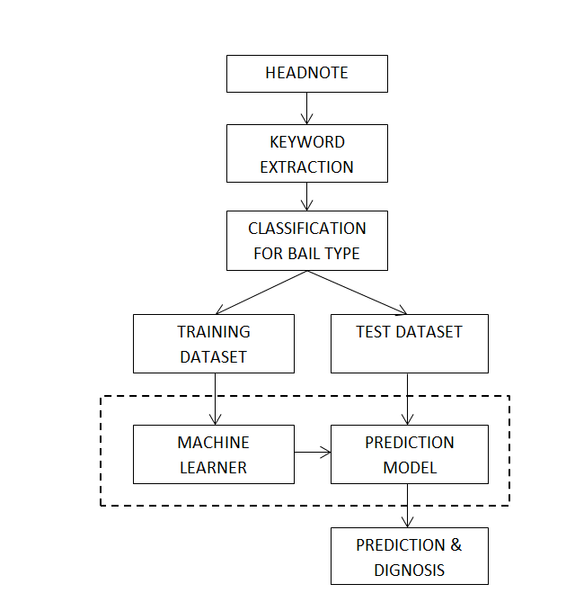
4.3.DFD

Fig 4.2 Data flow diagram
4.4 ENTITY RELATIONSHIP DIAGRAM
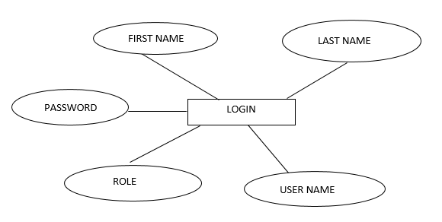

Figure 4.3 Entity relationship diagram
4.5 UML DIAGRAMS
4.5.1 ACTIVITY DIAGRAM
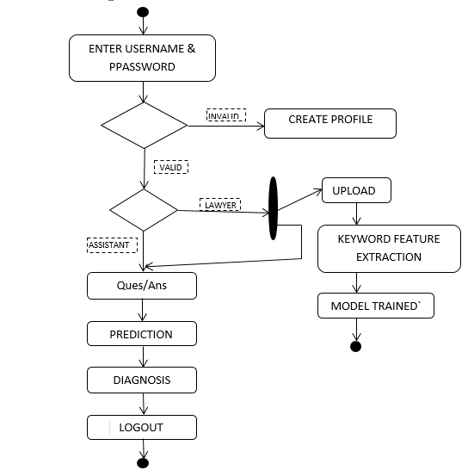
Figure 4.4 Activity diagram

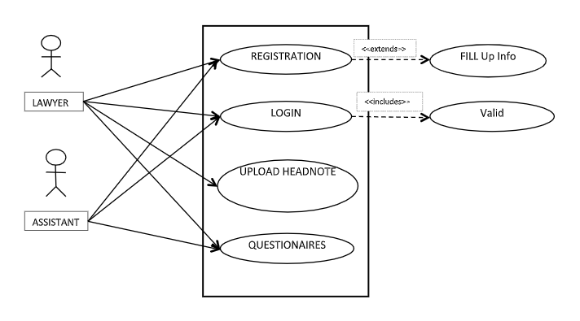
4.5.2 USE CASE DIAGRAM
Figure 4.5 Use case diagram

4.5.3 SEQUENCE DIAGRAM
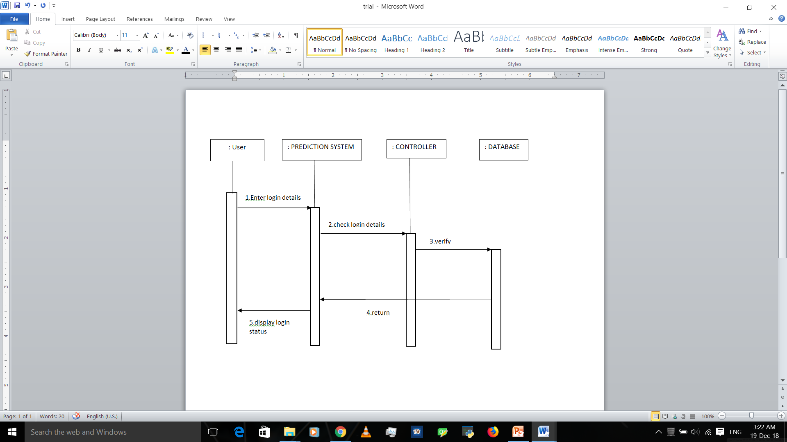
Figure 4.6 Sequence diagram

Chapter 5
PROJECT PLAN

  - Project Estimates:
5.1.1 Reconciled Estimates
Cost Estimate:
INR 5000/-
Time Estimate:
7 to 8 months
5.1.2 Project Resources:
Supreme Today – To take out legal data of judgements
Haredware – Any processor which is greater than 1.7 GHz and have greater than 4 GB RAM, hard disk must be greater than 100 GB.
Tools –Python, Anaconda, Spyder, Flask, MySQL, HTML, Angular JS

  - Risk Management:
5.2.1Risk Identification:
Security Information and management: The identified risk in this project is if any unauthorized person gets the access to this secured and private data, he/she can use it inappropriately and illegally.
Intrusion Detection: Also the wrong data regarding legal case can be fed in the dataset, to avoid this identified risk, only the senior lawyer is authorized to feed the data.
Non Linear poutlier detection
Risk Modelling: To improve risk assessment some machine learning models built.
5.2.2 Risk Analysis:
ID | Risk Description | Probability | Impact
ID | Risk Description | Probability | Schedule | Quality | Overall
1 | Security Information & Management | Low | Low | Low | Low
2 | Intrusion Detection | Low | Medium | Low | Low
3 | Risk Modelling | High | High | High | High
Table 5.1: Risk Table

Probability Value | Probability of occurance
High | >75%
Medium | 26-75%
Low | <25%
Table 5.2: Risk Probability Definitions

Impact | Value | Descriptions
Very High | >10% | Schedule impact or unacceptab le equality
High | 5-10% | Schedule impact or quality impact
Medium | <5% | Schedule impact or barely noticeable quality impact
Table 5.3: Risk Impact Definition

5.2.3 Overview of Risk Mitigation, Monitoring and Management:
Mitigation:
The identified risks are minimized using login module so that no unauthorized person can have access to legal secured data.
Also the data Feeding is only allowed to only senior lawyer and not intern or common user.
Monitoring:
Risk monitoring is the ongoing process of managing risk. Risk management often has an initial phase that involves identifying risk, agreeing to treatments and designing controls. The risks are identified and mitigated using secure functionalities like login.
The wrong data if fed in can lead to wrong model building and so on wrong result prediction. So the access to input the data has been restricted and can be only given to the senior lawyers.
5.3 PROJECT SCHEDULE
5.3.1Project Task-set
Major tasks in project stages are:
1.Requirement Gathering
2.Literature Survey
3.Mathematical Modelling
4.Feasibility Testing
5.UML Diagrams
6.Dataset Design
7.GUI Design
8.Dataset Pre-processing
9.Model Selection
10.Front End Implementation
11.System Integration
12.Testing
13.Reporting
5.3.2.Task Network
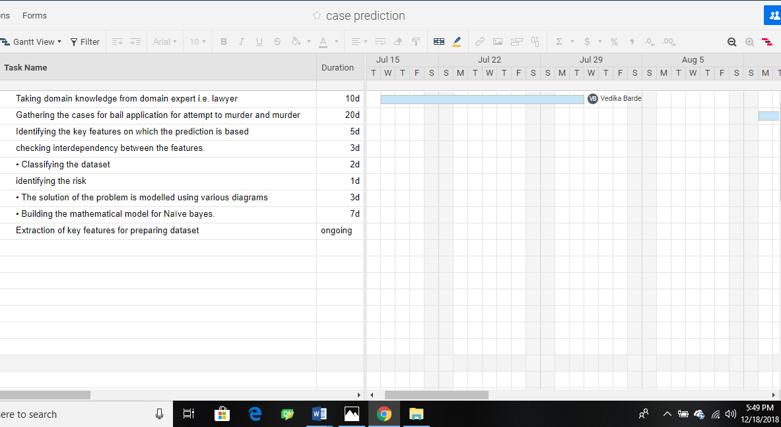

5.3.3.Timeline Chart
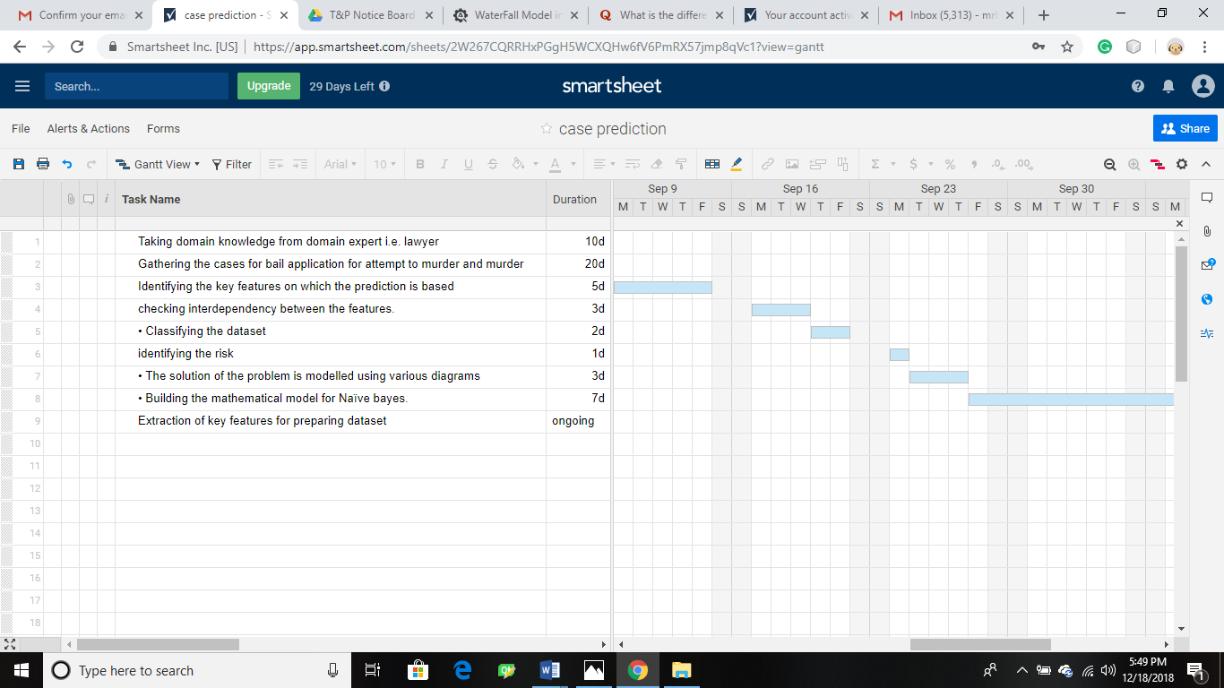

5.4. Team Organization
5.4.1. Team Structure:
Guide Name | Team Members
Internal Guide:  Mrs. Meenal Kamlakar | Vedika Abhaykumar Barde
Internal Guide:  Mrs. Meenal Kamlakar | Mokshada Ramdas Bhojane
External Guide:  Mr. Prasad Bhale, Mobicloud | Neha Chandrakant Bidave
External Guide:  Mr. Prasad Bhale, Mobicloud | Shweta Vitthal Mathesul

5.4.2. Management Reporting And Communication:
No. | Member Name | Organization
1. | Vedika Abhaykumar Barde | Data Preprocessing, SVM And PCA Tuning
2. | Mokshada Ramdas Bhojane | Data Preprocessing, Neural Network
3. | Neha Chandrakant Bidave | Data Preprocessing, Decision Tree, Angular, Flask
4. | Shweta Vitthal Mathesul | Data Preprocessing, Logistic Regression, Naïve Bayes, Angular

The team members have performed their fair share of tasks of each assignment on allocation.

Chapter 6
PROJECT IMPLEMENTATION

6.1 Overview of Project Modules
Sign up and Login Module:
In this module, the user (i.e Lawyer or junior lawyer) has to register into the system for security purpose. The junior lawyers will get the access to the system once the senior lawyer verifies him/her.
Once the user confirms, he needs to login to the system with the specific credentials to get further access of the system.
Data-preprocessing Module:
In this module, the data which is already present in the .csv file is preprocessed. Data preprocessing includes label encoding, standardization of the data as well as outlier detection.
Label encoding is done to convert categorical variables like ‘Gender’ having values like ‘Male’ or ‘Female’ to 0 and 1.
Dataset consist different attributes like categorical, numerical and ordinal. Before feeding this data to machine learning algorithm one needs to standardize it. Hence, Data Standardization is used.
Outlier detection is important step as this application is based on real time data. While fetching the data, wrong data can enter the system. Hence this data is identified and eliminated accordingly.
Machine learning Model and Prediction:
In this Module, the preprocessed data is given to the appropriate machine learning model (i.e SVM). PCA is also used for visualizing the data. For prediction, output from different machine learning algorithm is combined.

6.2 Tools and Technologies Used
Spyder: This tool is used along with python language to do development. Data preprocessing, fitting different machine learning algorithm to the data, predicting the outcome of run time data is done with the help of this tool and python language.
Flask: This tool is used to connect front end to back end.
HTML, CSS, Angular JS: These technologies are used to build front end i.e. single page application.
MySQL: Login details of every user are stored in MySQL like username, emailId, privacy question, password, designation, etc.
6.3 Algorithm Details
Algorithm 1: Data Preprocessing:
Input: Data in .csv format
Output: Preprocessed Data
Steps:
1. Label Encoding is used to convert the attribute containing categorical values like male or female into 0 and 1.
bail['Gender']= number.fit_transform(bail['Gender'])
2. Data Standardization is used because .csv file contains features with different attributes like categorical, ordinal, numeric.
x = StandardScaler().fit_transform(X)

3. Outliers are identified and removed with Z-score normalization technique.
from scipy import stats
z = np.abs(stats.zscore(X))
threshold = 3
print(np.where(z > 3))
fbail_1= bail[(z < 3).all(axis=1)]
Algorithm 2: KernelPCA:
Input: Feature vector with x number of features.
Output: Feature vector with only 2 principal components.
Steps:
1. KernelPCA function is called along with kernel value as “rbf” and many more parameters.
2. The above function converts x number feature vector into 2.
Algorithm 3: SVM:
Steps:
1. The classifier is built with SVC function having different parameters like kernel, degree, etc.
2. Then the preprocessed data is fitted into the classifier.
3. New data is given to classifier which predicts the output class along with probability.
Algorithm 4: Neural Network:
Steps:
1. Basic neural network is built with 1 hidden layer.
2. Confusion matrix gives the accuracy.
classifier.add(Dense(output_dim=4,init='uniform',activation='relu'))

Chapter 7
TESTING

Software testing ensures the quality of the system. The testing process involves the execution of the software components to check whether the requirements are according to the application.

- To meet all functional and non-functional requirements.
- Correctly responding to all inputs.
- Acceptable time boundaries for system.
- Checks usability of the system.

7.1 Types of Testing Used

Manual Testing-

In manual testing all the features of the system are verified by testers to ensure static as well as dynamic behavior of the system without using any automation tool.
Stages of manual testing-
- Unit Testing-

Individual units are tested to validate the performance accordingly. In our project we have three modules, we have separately tested each of them.
- Integration Testing-

In this stage individual units are combined and tested as a group.All three modules are integrated and tested to ckeck their combined performance and the faults in interaction if any.
- System testing-

Complete and integrated system is tested to evaluate system’s performance. It validates and verifies all specified functional and non-functional requirements.

Chapter 8
Results

Outcomes-

After preparing the dataset we have applied different machine learning algorithms. Various Machine learning models were applied to check which model is best fitted for our dataset. We have used various Models like Naïve Bayes ,Logistic Regression and Decision tree classifier.

Naïve Bayes-

As target variables for our dataset were in binary form i.e. the bail is granted or not granted we have firstly used Naïve Bayes as Naïve Bayes is best fitted for binary classification. After applying naïve Bayes for our dataset some of the data was overfitted and also after applying cross validation overfitting problem was not overcomed. And also some of our features were dependent on other therefore using Naïve Bayes was not a good choice. The accuracy we got from Naïve Bayes model was around 90% which is quite high.
Therefore we shifted to Logistic Regression.

Logistic Regression-

We shifted to Logistic Regression as Naïve Bayes had some limitations for our dataset and also Logistic Regression works best when the target variable is categorical. But after applying Logistic Regression again the data was overfitted more than Naïve Bayes and also the accuracy was quite high i.e. 93% and also after testing it for new sample of data it gave wrong output.
And therefore we used another machine Learning algorithm i.e. Decision Tree.

Decision Tree-

A Decision tree is a flowchart like tree structure, where each internal node denotes a test on an attribute, each branch represents an outcome of the test, and each leaf node (terminal node) holds a class label. As Logistic Regression failed for our dataset we shifted to decision tree. After applying Decision tree again the accuracy was more i.e. 93% and the data was overfitted.
As all the linear algorithm failed for our dataset we understood that our data is non-linear and therefore we started searching for non-linear data and SVM is the best classifier for non-linear data. And therefore we finally shifted to SVM.

SVM(Support Vector Machine)-

SVM is an algorithm that can be applied for non-linear data. firstly we applied SVM for linear after plotting the graph the data was not separated correctly and after changing kernel values i.e. for non-linear data kernel values such as poly, sigmoid and rbf were used. By using kernel value as poly the data was much separated and the graph was more visible and after changing C and gamma values SVM finally worked good for our dataset.

Screenshots-

Naïve Bayes-

Confusion Matrix-
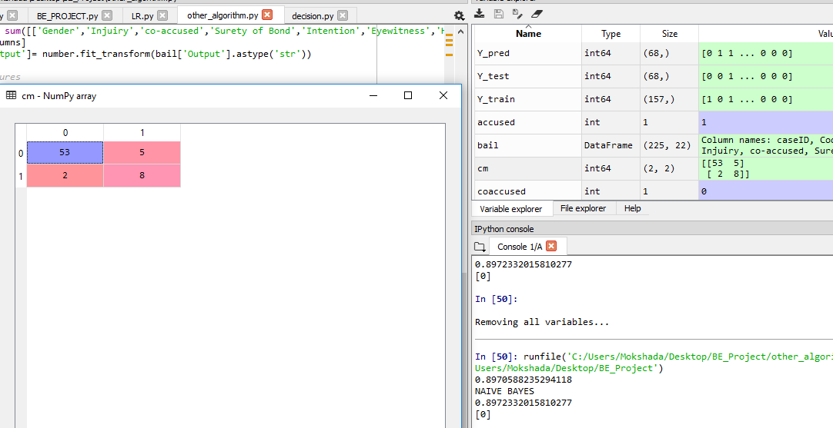

2.Logistic Regression-

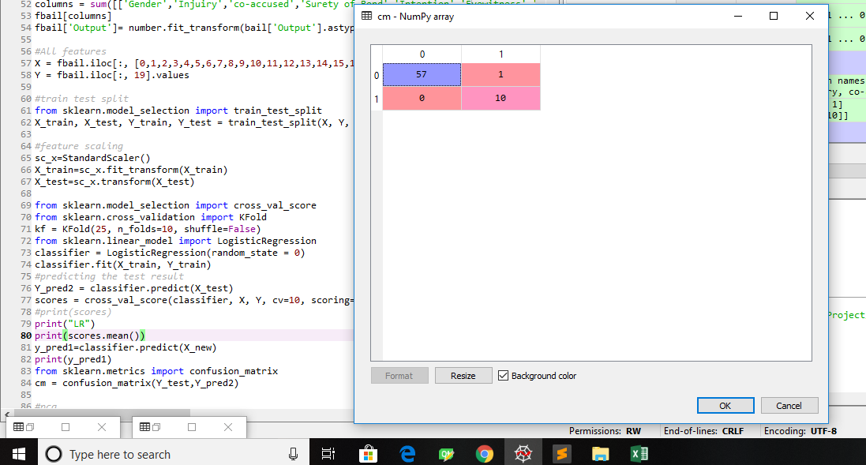
Confusion Matrix

3.Decision Tree-

Confusion Matrix-

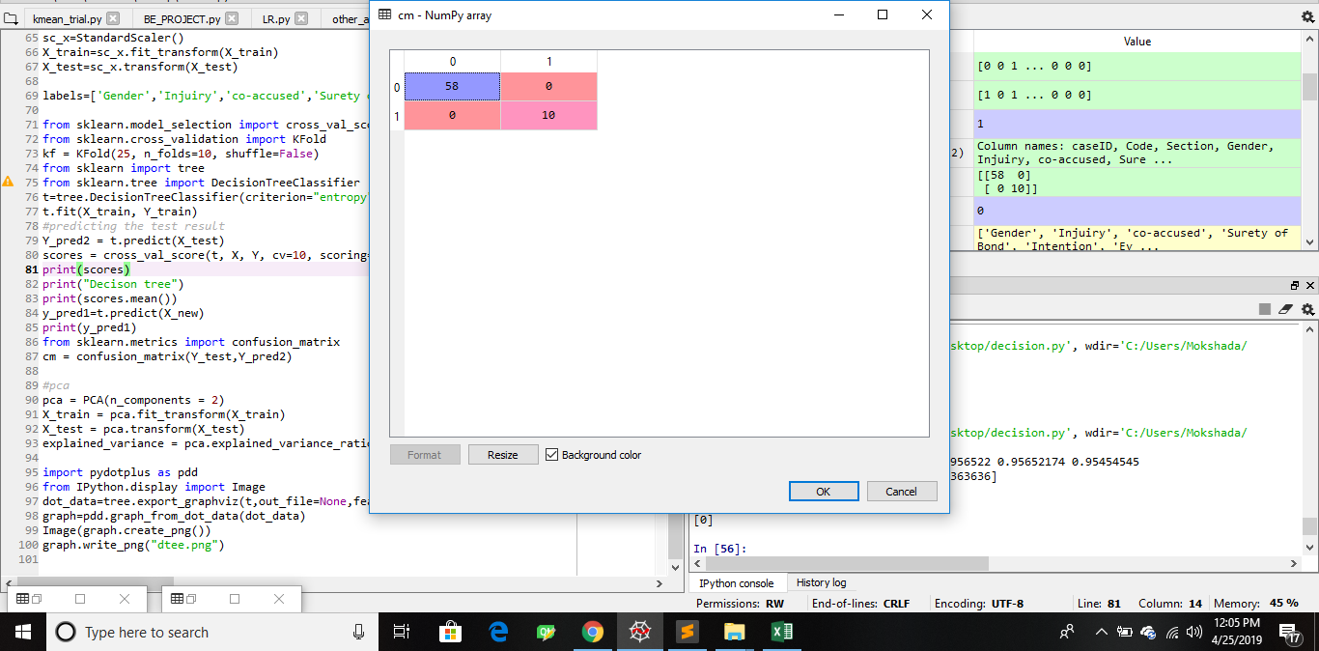

Graph-
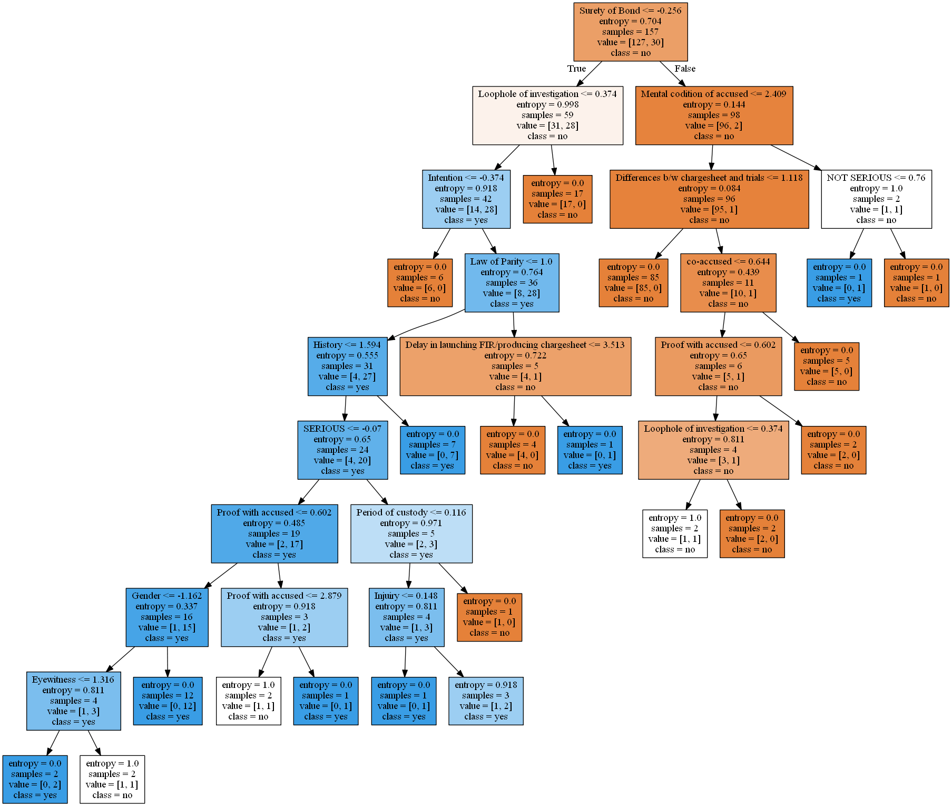

SVM-

Output-
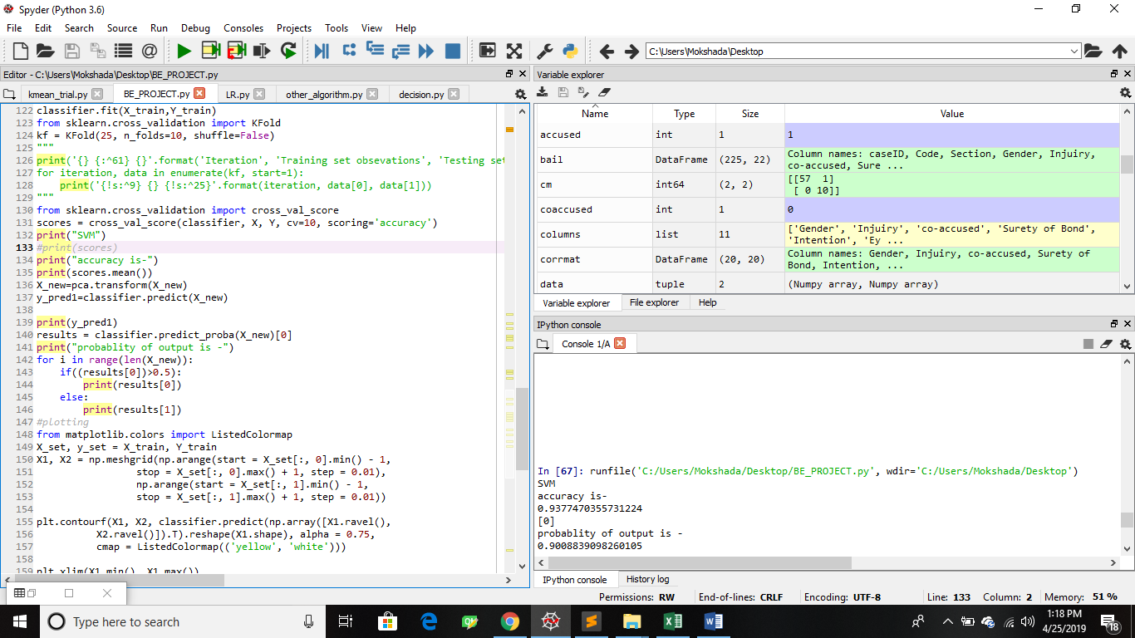

Graph-
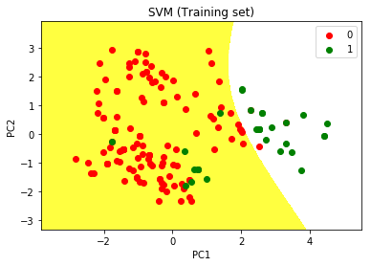

Chapter 9
CONCLUSIONS

9.1 CONCLUSION-
In India , all the investigation of legal cases/bail are done by the in-charge officer, this process requires much longer time. The purpose of this project is to save the time and energy required by this in-charge officer by automating the process. In this project we have proposed a legal bail prediction model that will provide a rapid assistant for lawyers/assistant that will help ease their work. The software system considers bail cases to give the prediction of whether the new case fed in as the input to the system will get the bail or not. The system considers domain of law such as bail for murder acquisition. The system will ask questions to the lawyer and based on the answers provided keywords will be extracted and accordingly the ML model will be trained. Prediction model such as SVM, LG will be trained accordingly and results will be generated based on the accuracy of the model.

9.2 FUTURE WORK
The future work of the system includes that we can use multi-dimensionality to handle dependent attribute. We can use cloud to store the data as the data of cases is large in number and also the processing speed of the model can be increased.
Also, we have consider only law domains i.e. bail for murder acquisition . The model can be enhanced to consider bail and cases of all types in law domain by training it for one domain accordingly.
9.3 APPLICATIONS
- This implementation can be used at Educational level by the new law students .
- Extended version of implementation is used by the judges as rapid assistance.

APPENDIX A

FEASIBILITY MATRIX
I | D | E | A
Increase:  Accuracy can be increased by considering more number of factors | Discover:  Discover many new reasons for granting the bail or not, purpose | Educate:  Lawyers and Assistances | Accelerate:  Speed up data analysis process
Improve:  User Interface, Accuracy | Deliver:  Predicted Bail Grant Status, Reasons for Not Granting | Evaluate:  Data from the head-note documents and questionnaires | Associate:  End users, Lawyers
Innovate:  New methods of keyword extraction | Define:  Invention define clearly through this idea matrix | Eliminate:  Eliminating some factors that are less important or contradictory. | Avoid:  Misuse of the data

FEASIBILTY ASSESSMENT OF PROBLEM STATEMENT
1.Technical feasibility
Technical feasibility assesses whether a given system can be developed with technology that is currently available. In the technical marketplace it finds out technical requirements of propose system and matches them against technical expertise available within organization. Analysts determine whether technical capabilities need to be upgrade and new technical resources can be to hired fulfill the technical requirements.
2.Economic feasibility
Economic feasibility is the most frequently used technique for evaluating the effectiveness of proposed system more commonly known as cost/ benefits analysis, the procedure is to determine the benefits and savings that are expected from proposed system and compare them with costs. If benefits outweigh cost , a decision is taken to design and implement the system. Otherwise further justification or alternative in the proposed system will have to be made if it is to have a chance of being approved. This is an outgoing efforts that improves in accuracy at each phase of the system life cycle.

P- COMPLETE ANALYSIS
A problem is assigned to the P (Polynomial Time) class if there is atleast one algorithm to solve the problem such that number of steps of algorithm is bounded by polynomial in O(n), where n is size of the input. That is the computing time of such problems can be represented in form of polynomial, O(n).
The algorithm we are using for solving our problem statement is naïve bayes classifier algorithm. The time complexity of selected algorithm is O(NK), where ‘N’ is number of training example and ‘K’ is number of features.
Input:
Let S be the
S = {D₁,D₂,D₃}
Where,
D_{1:} {Set of Strong attributes/features}
D₂: {Set of Default attributes/features}
D₃: {Set of Weak attributes/features}

Output:
Let O be the
O = {C_{k}}
Where,
C_{k} : { Predicted Class Value }

Function:
S = {F₁,F₂,F₃}
Where,
F₁ : { Prediction for Strong attributes}
F₂ : {Prediction for Default attributes}
F₃ : {Prediction for Weak attributes}

Success condition:
In the generated confusion matrix, True positives and true negative give success condition.
Failure condition:
In the generated confusion matrix, False positives and False Negatives give failure condition.

MATHEMATICAL MODEL
In the bail application for murder acquisition, Given a data point of features such as eyewitnesses, history of accused, injuries for ‘n’ number of legal cases as x₁, x₂, …, x_{n}, Naive Bayes predicts the class C_{k} for the particular bail application according to the probability. The classes for prediction in this problem statement will be 2 as per YES (bail is granted) or NO (Bail is not granted).
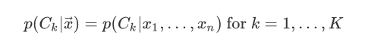
Using Bayes' Theorem, this can be factored as
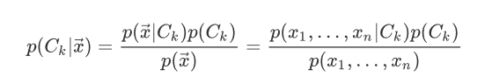

Using the chain rule, the factor in the numerator can be further decomposed as
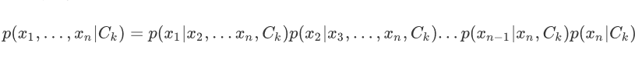
At this point, the "naive" conditional independence assumption is put into play. Specifically, naive Bayes models assume that feature is independent of feature for given the class . Using the previous decomposition, this can be formulated as
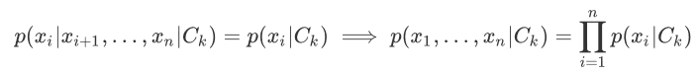

Thus,
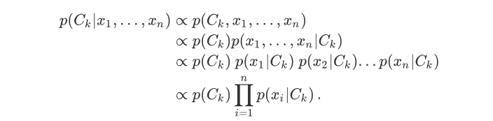

Since determining the most likely class for a data point consists of calculating the product of (N+1) factors K times, the big O notation for the runtime complexity of classification is O(NK) . This is very computationally efficient and gives naive Bayes its high scalability since the runtime scales linearly in the number of features N and number of classes K . This is especially useful in the domain of very high dimensional data.

APPENDIX B

- Predicting Decisions of the Philippine Supreme Court Using Natural Language Processing and Machine Learning
Year: 2018
Author: Michael Benedict L. Virtucio, Jeffrey A. Aborot†, John Kevin C. Abonita, Roxanne S. Avinante, Rother Jay B. Copino, Michelle P. Neverida, Vanesa O. Osiana
Abstract: In this paper, model use a Natural Language Processing (NLP) plus Machine Learning (ML) based approach to predicting case outcome. Features extracted are used to train linear Support Vector Machine. Each classiﬁcation model trained for each section are then validated and tested to determine which set of features best predict the outcome of the case. In this paper linear support vector machines and random forest classiﬁers are used. Based on analysis random forest classifier gives more accuracy than the support vector machine.

- Predicting judicial decisions of the European Court of Human Rights: A natural language processing perspective
Year: 2016
Author: N. Aletras
Abstract: This paper gives an alternative approach to implement the system for one particular type. In this paper they framed task as a binary classification problem, where the training data consists of textual features extracted from given cases and the output is the actual decision made by the judge. The SVM model used to examine which topics are most important for inferring whether an article of the Convention has been violated or not by looking at their weights. This model can predict the court’s decisions with a strong accuracy (79% on average).

APPENDIX C

PLAGARIS M REPORT
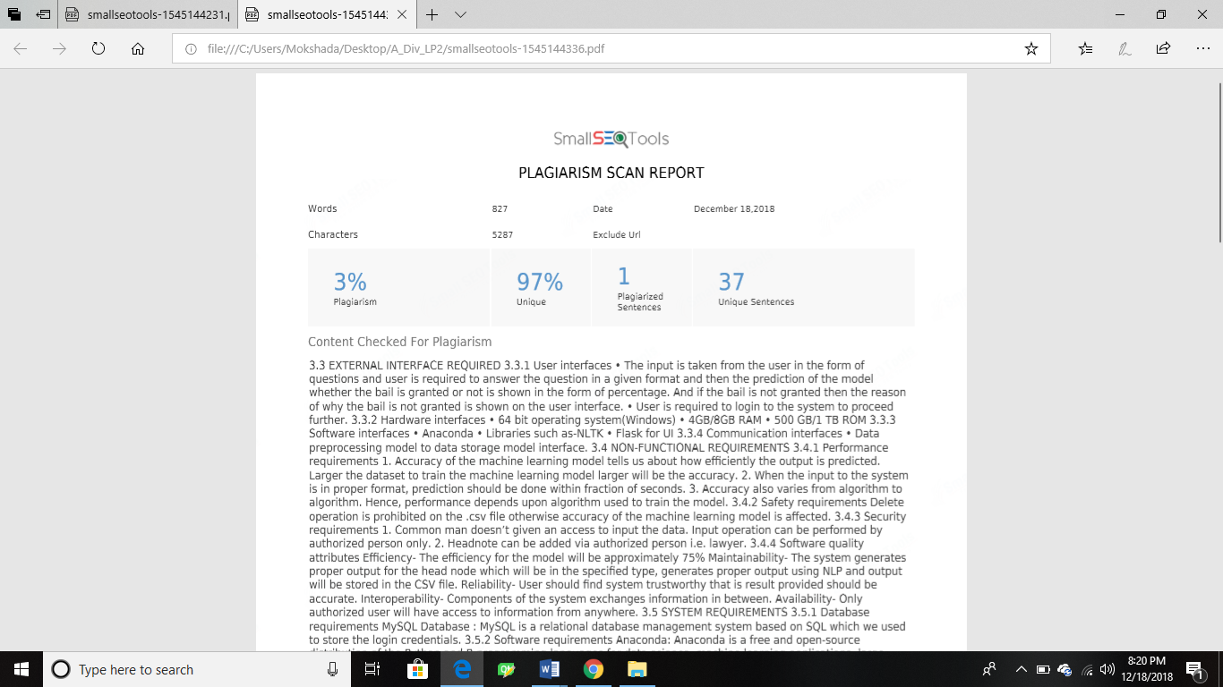

Figure A – Plagiarism check-I



Figure B – Plagiarism check-II

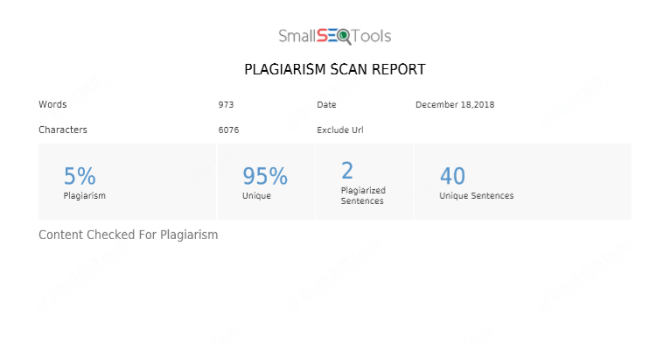
Figure C –Plagiarism check-III

REFERENCES

[1] Michael Benedict L. Virtucio, Jeffrey A. Aborot†, John Kevin C. Abonita, Roxanne S. Avinante, Rother Jay B. Copino, Michelle P. Neverida, Vanesa O. Osiana, “Predicting Decisions of the Philippine Supreme Court Using Natural Language Processing and Machine Learning”
[2] N. Aletras et al. “Predicting judicial decisions of the European Court of Human Rights: A natural language processing perspective”. In: PeerJ Computer Science 2
(2016), e93.
[3] https://indiankanoon.org/doc/455468/
[4] https://indiankanoon.org/doc/1560742/
[5]www.nearlaw.com
[6]SupremeToday- licenced Software for lawyers

Chapter 7
TESTING

Software testing ensures the quality of the system. The testing process involves the execution of the software components to check whether the requirements are according to the application.

- To meet all functional and non-functional requirements.
- Correctly responding to all inputs.
- Acceptable time boundaries for system.
- Checks usability of the system.

7.1 Types of Testing Used

Manual Testing-

In manual testing all the features of the system are verified by testers to ensure static as well as dynamic behavior of the system without using any automation tool.
Stages of manual testing-
- Unit Testing-

Individual units are tested to validate the performance accordingly. In our project we have three modules, we have separately tested each of them.
- Integration Testing-

In this stage individual units are combined and tested as a group.All three modules are integrated and tested to ckeck their combined performance and the faults in interaction if any.
- System testing-

Complete and integrated system is tested to evaluate system’s performance. It validates and verifies all specified functional and non-functional requirements.

