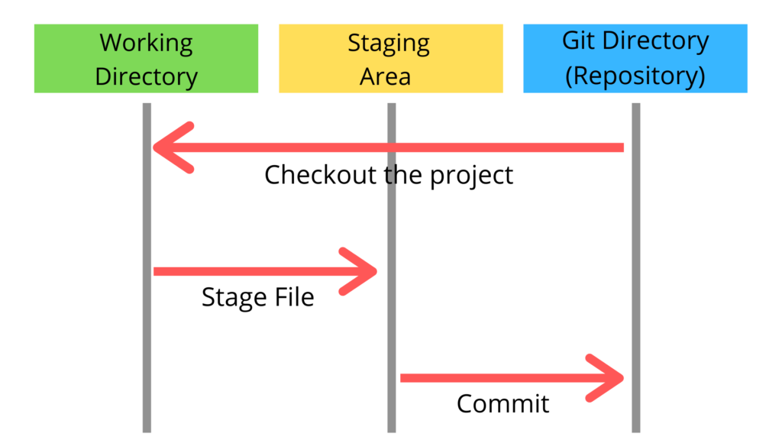

**Key Takeaways**

* Git uses a three-stage architecture - working directory, staging area, and local repository to optimize change tracking.
* Key concepts like committing, branching, merging, and remotes enable powerful version control workflows.
* Git maintains an extensive history and provides commands like git log and git diff to analyze changes over time.

**Git Architecture & Components**

While many version control systems use a two-tier architecture consisting of a repository and a working copy, Git distinguishes itself with a three-stage model optimized for tracking changes: the **working directory**, **staging area**, and **local repository**. Additionally, Git includes the concept of **remote repositories** for collaboration. 