Game Design Document

Fill up the following document

1. Write the title of your project.

Healthy food runner game

1. What is the goal of the game?

The player has to collect the healthy food

1. Write a brief story of your game.

The player is unhealthy eating a lot of junk food so help the player

To find healthy food and avoid junk food, the player can jump using

The up arrow key. The player has 3 lives, and if it loses that the game

will end. The lives will loose if player touches the junk food and if it touches the healthy food then the score gets increased, there will be levels in the game, with different targets.

1. Which are the playing characters of this game?

* Playing characters are the ones who respond to the user based on the input from the user.
* Cars, monkeys, dinos, wizards, etc., are the playing characters in the game.

|  |  |  |
| --- | --- | --- |
| Number | Character Name | What can this character do? |
| 1 | Player | Can jump using up arrow key |
| 2 |  |  |
| 3 |  |  |
| 4 |  |  |
| 5 |  |  |
| 6 |  |  |
| 7 |  |  |
| 8 |  |  |

1. Which are the Non-Playing Characters of this game?

* Non-Playing characters are the ones that don't have an action or behavior when the user interacts with the game.
* Hurdles, stones, bananas, coins, etc., are non-playing characters in the game.

|  |  |  |
| --- | --- | --- |
| Number | Character Name | What can this character do? |
| 1 | Junk food | This is non player character, it contineously keep spawning after a particular framecount |
| 2 | Healthy food | This is non player character, it contineously keep spawning after a particular framecount |
| 3 |  |  |
| 4 |  |  |
| 5 |  |  |
| 6 |  |  |
| 7 |  |  |
| 8 |  |  |

Draw your imagination of this game. What does this game look like?

* Draw the game either on your computer or on paper.
* Add images of the game scenes to show each of the playing and non-playing characters at least once.

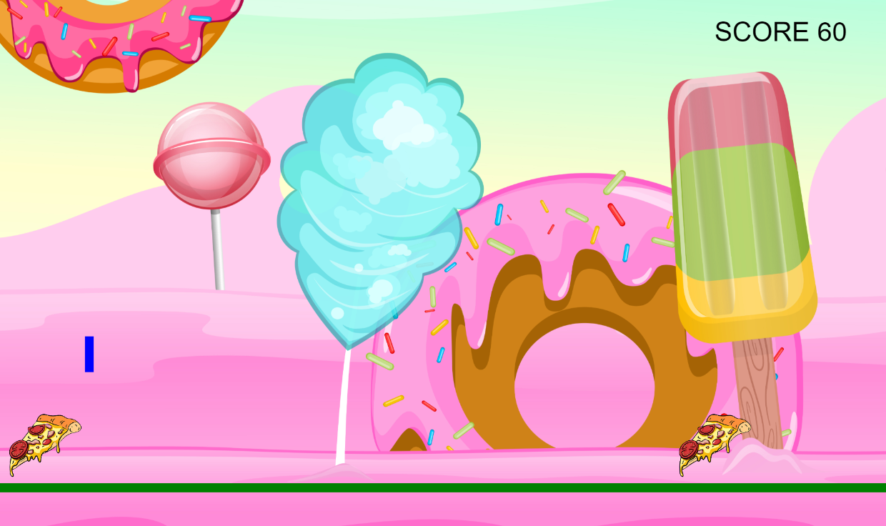

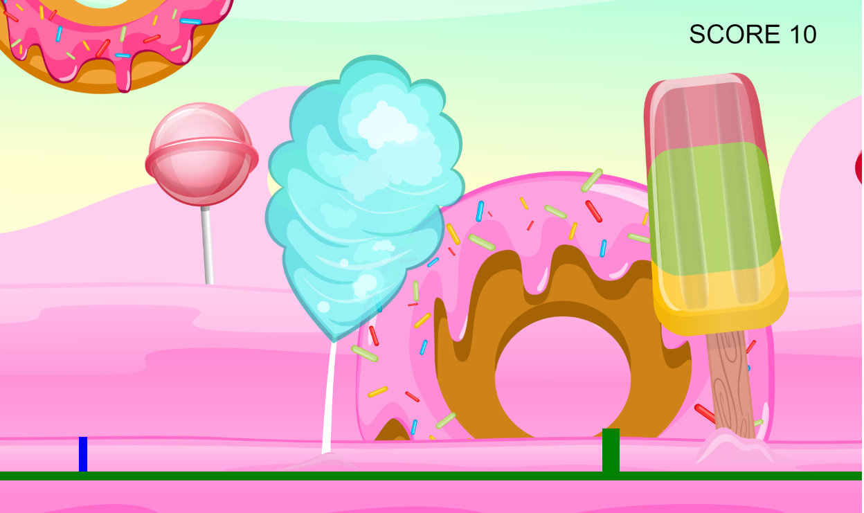



How do you plan to make your game engaging?

The game will have more diificult targets as the level increases and the game will be more fast, it will be more challenging. In this way the game will be engaging.