Experiment No: 2
Aim: Use var, let const and demonstrate basic features like template literals and destructuring; build a billing calculator with user input.
Software Required: VS Code (HTML, JS), Google Chrome
Experiment Program Code:
1.
<!DOCTYPE html>
<html lang="en">
<head>
<meta charset="UTF-8">
<meta name="viewport" content="width=device-width, initial-scale=1.0">
<title>Document</title>
</head>
<body>
<script>
const colors = ["Red","Green","Blue"];
const [first, second] = colors;
console.log(first);
console.log(second);
const student = {id: 1, name: "Riya", branch: "CSE" };
const {name, branch} = student;
console.log(name);
console.log(branch);
</script>
</body>
</html>

2.
<!DOCTYPE html>
<html lang="en">
<head>
<meta charset="UTF-8">
<meta name="viewport" content="width=device-width, initial-scale=1.0">
<title>Document</title>
</head>
<body>
<h2> Enter values </h2>
x: <input type = "number" id = "num1"><br><br>
y: <input type = "number" id = "num2"><br><br>
z: <input type = "number" id = "num3"><br><br>
<button onclick = "showValues()">Show</button>
<p id = "result"></p>
<script>
function showValues(){
var x = Number(document.getElementById("num1").value);
let y = Number(document.getElementById("num2").value);
const z = Number(document.getElementById("num3").value);
x = x + 10;
y = y + 10;
document.getElementById("result").innerHTML = "Updated x: " + x + "<br>"
+ "updated y: " + y + "<br>" + "z(const): " + z;
}
</script>
</body>
</html>

3.
<!DOCTYPE html>
<html lang="en">
<head>
<meta charset="UTF-8">
<meta name="viewport" content="width=device-width, initial-scale=1.0">
<title>Document</title>
</head>
<body>
<script>
let str = "Hello";
let num = 42;
let isReady = true;
let empty = null;
let notDefined;
console.log(typeof str);
document.write(str);
console.log(typeof num);
console.log(typeof isReady);
console.log(typeof empty);
console.log(typeof notDefined);
</script>
</body>
</html>

4.
<!DOCTYPE html>
<html lang="en">
<head>
<meta charset="UTF-8">
<meta name="viewport" content="width=device-width, initial-scale=1.0">
<title>Variables</title>
</head>
<body>
<script>
var x = 5;
let y = 10;
const z = 15;
console.log("var x: ",x);
console.log("let y: ",y);
console.log("const z: ",z);
x = 20;
y = 25;
z = 30;
console.log("updated x: ",x);
console.log("updated y: ",y);
// updated values are not seen as these are immutable
</script>
</body> </html>
Code Outputs:
VedikaNaidu_1274
2.
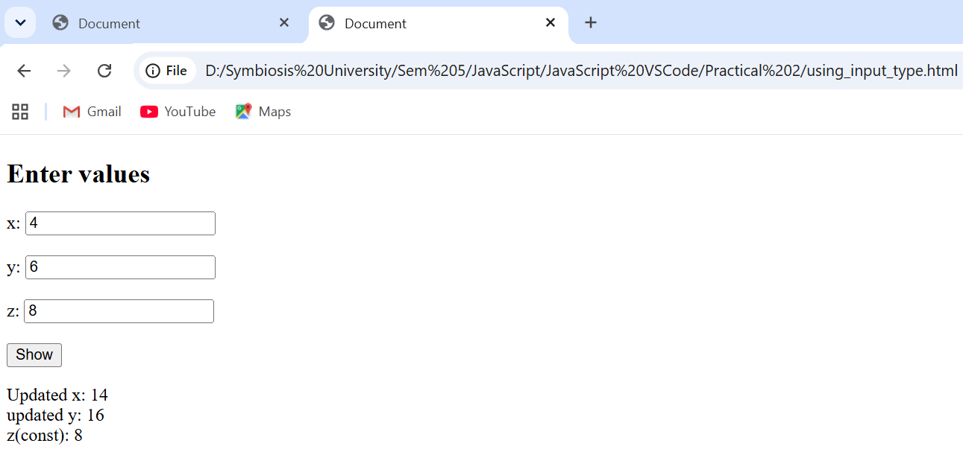
VedikaNaidu_1274
3.
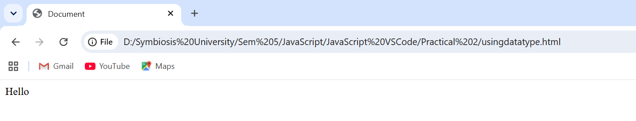
4.
VedikaNaidu_1274

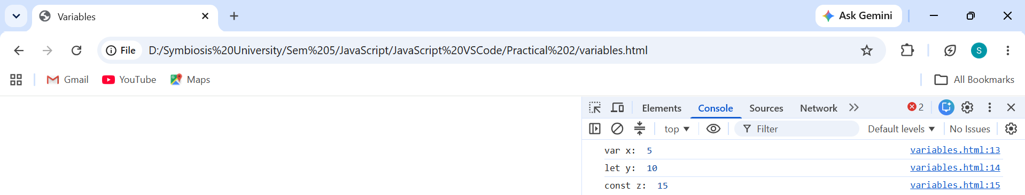

Case Study Title – Build a simple online shopping website. The webpage accepts customer details and product information, processes the purchase details, calculates the total amount and GST, and dynamically displays an order summary. Template literals are used to generate the order details, while destructuring is used to extract product information efficiently.
Case Study Program Output – 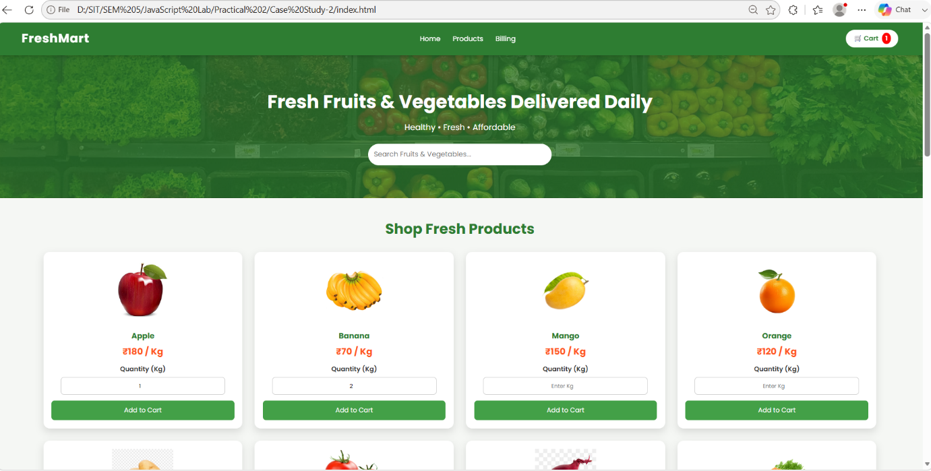
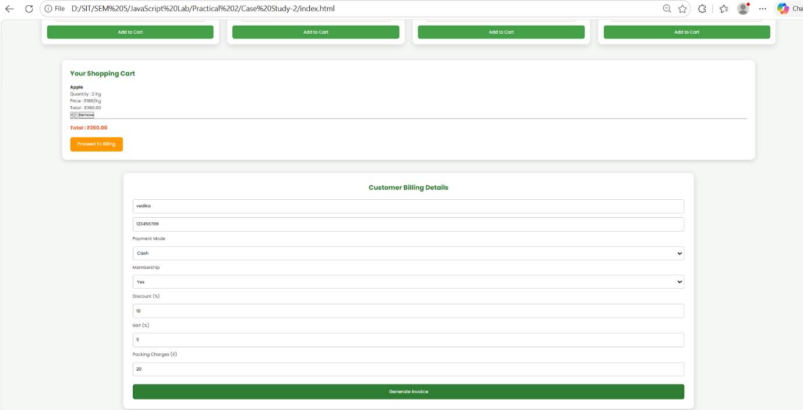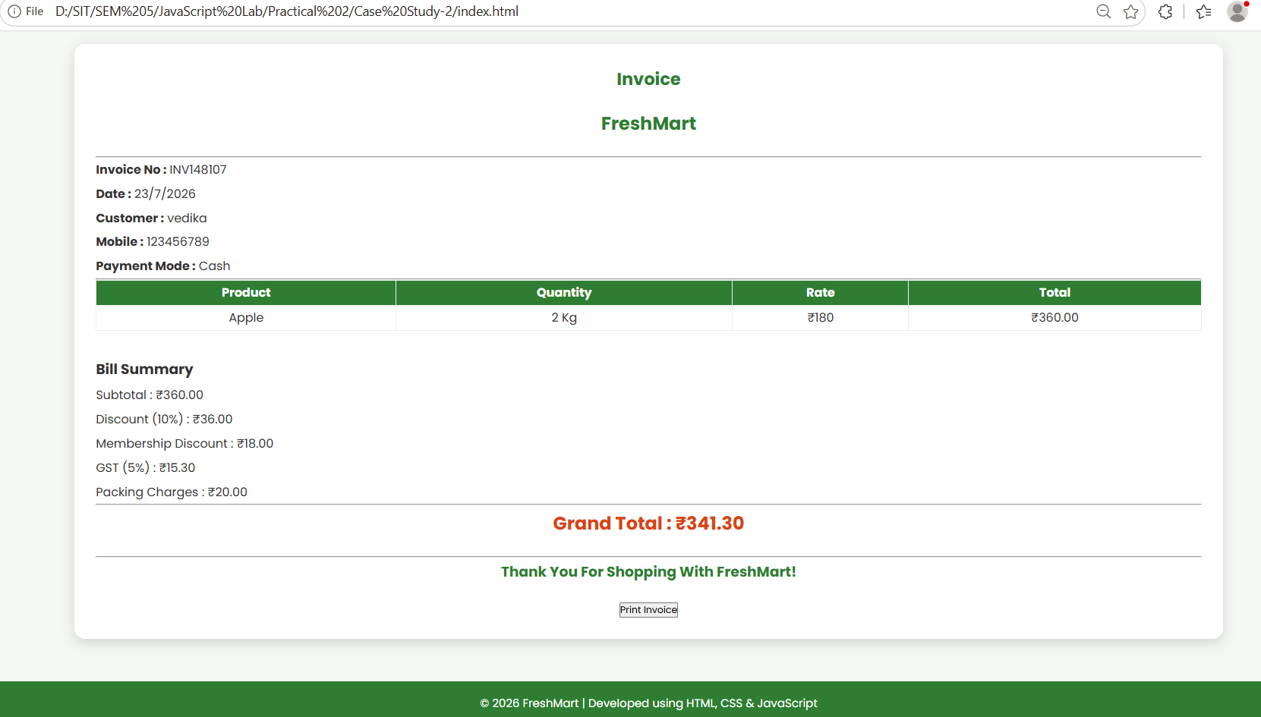
Path: D:\SIT\SEM 5\JavaScript Lab\Practical 2\Shopping Web
Name: Vedika Naidu PRN: 24070521274

