JavaScript Experiment: 9
Aim: Implement localStorage and sessionStorage to save user preferences like theme settings.
Software/Tools required: Text editor (VS code, Notepad), Web Browser (Chrome, Edge)
Experiment Program Code
1.Dark
<!DOCTYPE html>
<html lang="en">
<head>
<meta charset="UTF-8">
<meta name="viewport" content="width=device-width, initial-scale=1.0">
<title>Dark Mode</title>
</head>
<body>
<h2>Dark Mode Example</h2>
<button onclick="saveTheme()">Dark Mode</button>
<p id="result">Selected Theme: None</p>
<script>
function saveTheme(){
localStorage.setItem("Theme", "dark");
document.body.style.backgroundColor = "black";
document.body.style.color = "white";
document.getElementById("result").textContent =
"Selected Theme: " + localStorage.getItem("Theme");
}
</script>
</body>
</html>
2. Get
<!DOCTYPE html>
<html lang="en">
<head>
<meta charset="UTF-8">
<meta name="viewport" content="width=device-width, initial-scale=1.0">
<title>Get Theme</title>
</head>
<body>
<h2>Get Theme</h2>
<button onclick="getTheme()">Get Theme</button>

<p id="result"></p>
<script>
function getTheme(){
let theme = localStorage.getItem("Theme");
document.getElementById("result").textContent =
"Selected Theme: " + theme;
}
</script>
</body>
</html>
3.Session Storage
<!DOCTYPE html>
<html lang="en">
<head>
<meta charset="UTF-8">
<meta name="viewport" content="width=device-width, initial-scale=1.0">
<title>Session Storage</title>
</head>
<body>
<h2>Session Storage Example</h2>
<button onclick="saveData()">Save Data</button>
<button onclick="getData()">Get Data</button>
<p id="result"></p>
<script>
function saveData(){
sessionStorage.setItem("Name", "Student");
document.getElementById("result").textContent =
"Data Saved Successfully!";
}
function getData(){
let name = sessionStorage.getItem("Name");
document.getElementById("result").textContent =
"Stored Name: " + name;
}
</script>
</body>
</html>
4.Student Name
<!DOCTYPE html>
<html lang="en">
<head>
<meta charset="UTF-8">
<meta name="viewport" content="width=device-width, initial-scale=1.0">
<title>Student Name</title>
</head>
<body>
<h2>Student Name</h2>
<input type="text" id="name" placeholder="Enter Student Name">
<button onclick="saveName()">Save Name</button>
<button onclick="getName()">Get Name</button>
<p id="result"></p>
<script>
function saveName(){
let name = document.getElementById("name").value;
localStorage.setItem("StudentName", name);
document.getElementById("result").textContent =
"Name Saved: " + name;
}
function getName(){
let name = localStorage.getItem("StudentName");
document.getElementById("result").textContent =
"Student Name: " + name;
}
</script>
</body>
</html>
5.Theme
<!DOCTYPE html>
<html lang="en">
<head>
<meta charset="UTF-8">
<meta name="viewport" content="width=device-width, initial-scale=1.0">
<title>Document</title>
</head>
<body>
<button onclick="saveTheme('light')">Light Mode</button>
<button onclick="saveTheme('dark')">Dark Mode</button>
<p id="result"></p>
<script>
function saveTheme(theme){
localStorage.setItem("Theme", theme);
document.body.style.backgroundColor = theme === "dark" ? "black" : "white";
document.body.style.backgroundColor = theme === "dark" ? "white" : "black";
document.getElementById("result").textContent = "Selected Theme: " + loalStorage.getItem("theme");
}
</script>
</body>
</html>

Code Outputs:
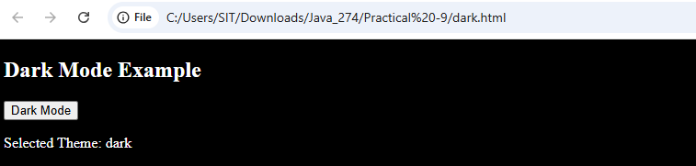
NAME: VEDIKA NAIDU PRN: 24070521274 – DARK
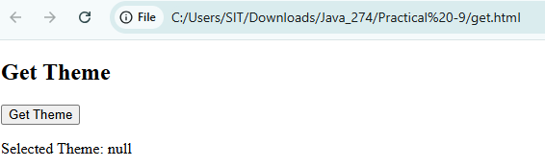
NAME: VEDIKA NAIDU PRN: 24070521274 -GET
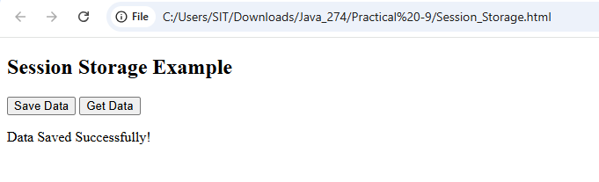
NAME: VEDIKA NAIDU PRN: 24070521274 -SESSION STORAGE
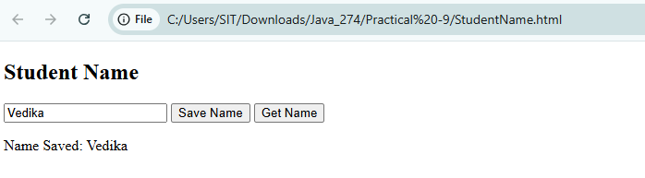
NAME: VEDIKA NAIDU PRN:24070521274 – STUDENT NAME
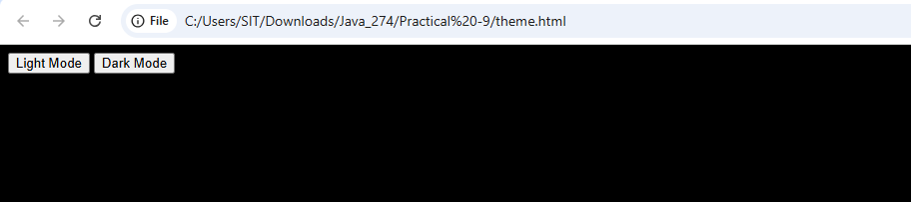
NAME: VEDIKA NAIDU PRN: 24070521274 -THEME

CASE STUDY OUTPUT:
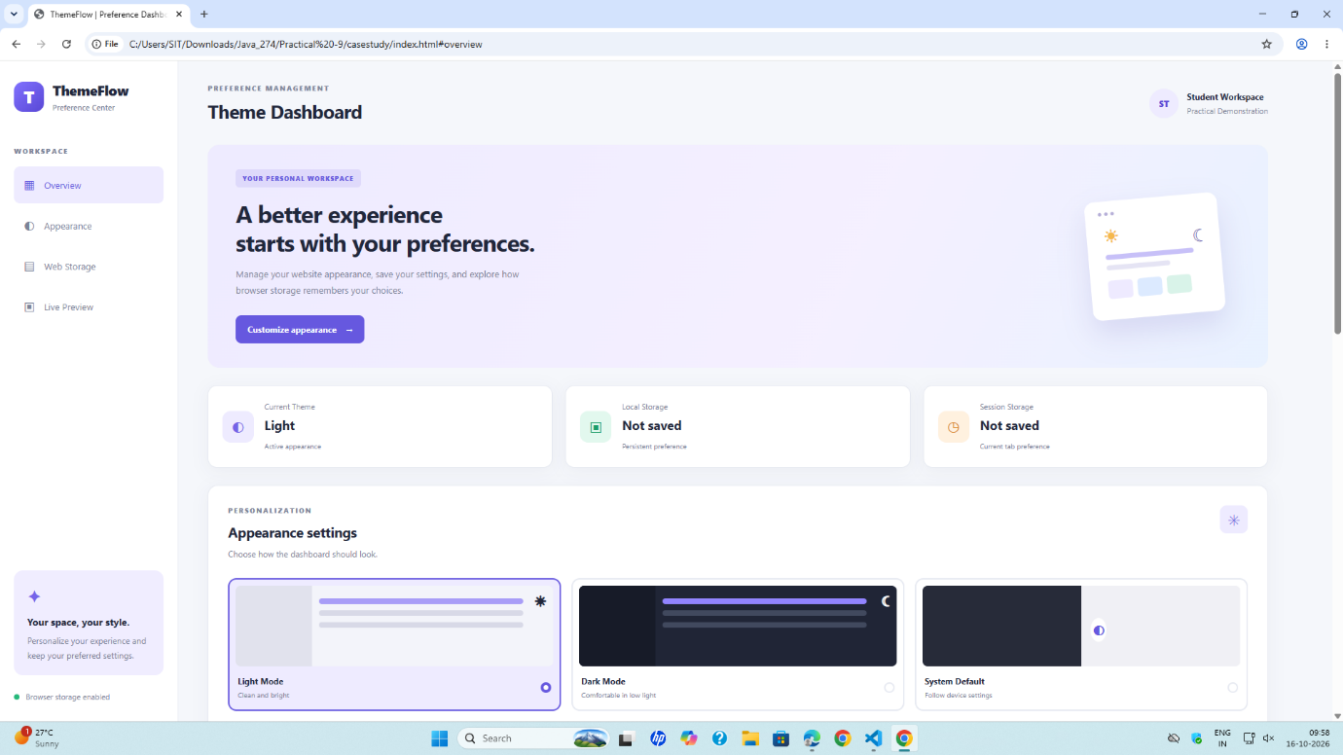
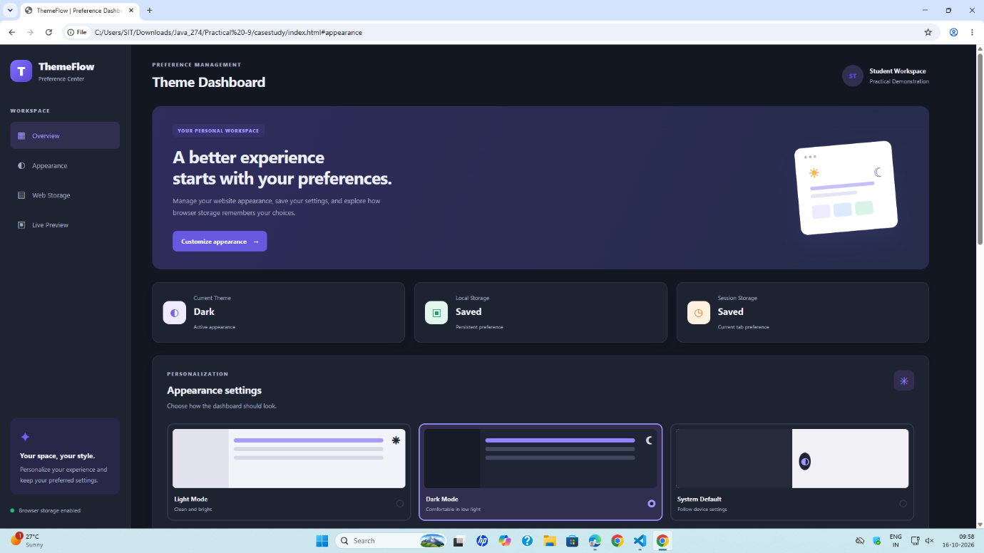
NAME: VEDIKA NAIDU PRN: 24070521274
PATH: D:\SIT\SEM 5\JavaScript Lab\Practical 9

