JavaScript Experiment – 8
Aim: Access and validate form fields using events; design a gym admission form with live input checks.
Software/Tools required: Text editor (VS code, Notepad), Web Browser (Chrome, Edge)
Experiment Program Code
1.Change
<!DOCTYPE html>
<html lang="en">
<head>
<meta charset="UTF-8">
<meta name="viewport" content="width=device-width, initial-scale=1.0">
<title>Change event</title>
</head>
<body>
<h3>Select your course</h3>
<select id="course">
<coption value="">Select Course</option>
<option value="CSE">CSE</option>
<option value="IT">IT</option>
<option value="ECE">Ece</option>
</select>
<p id="result"></p>
<script>
let course = document.getElementById("course").value;
select.addEventListener("change", function() {
document.getElementById("result").innerHTML =
"You selected " + select.value + " course";
});
</script>
</body>
</html>
2.Event Listener
<!DOCTYPE html>
<html lang="en">
<head>
<meta charset="UTF-8">
<meta name="viewport" content="width=device-width, initial-scale=1.0">
<title>Change event</title>
</head>
<body>
<h3>Select your course</h3>
<select id="course">
<coption value="">Select Course</option>
<option value="CSE">CSE</option>
<option value="IT">IT</option>
<option value="ECE">Ece</option>
</select>
<p id="result"></p>
<script>
let course = document.getElementById("course").value;
select.addEventListener("change", function() {
document.getElementById("result").innerHTML =
"You selected " + select.value + " course";
});
</script>
</body>
</html>
3.Get Value
<!DOCTYPE html>
<html lang="en">
<head>
<meta charset="UTF-8">
<meta name="viewport" content="width=device-width, initial-scale=1.0">
<title>Value Example</title>
</head>
<body>
<input type ="text" id ="name">
<button id = "btn">show name</button>
<p id="result"></p>
<script>
document.getElementById("btn").addEventListener("click", function() {
let name = document.getElementById("name").value;
document.getElementById("result").innerText = name;
});
</script>
</body>
</html>
4.Sample
<!DOCTYPE html>
<html lang="en">
<head>
<meta charset="UTF-8">
<meta name="viewport" content="width=device-width, initial-scale=1.0">
<title>JavaScript input example</title>
</head>
<body>
<h2>Enter your name:</h2>
<input type="text" id="name" placeholder="Enter your name">
<p id="output"></p>
<script>
let input = document.getElementById("name");
input.addEventListener("input", function() {
let name = input.value;
document.getElementById("output").textContent = "Hello: " + name;
});
</script>
</body>
</html>
5.Submit
<!DOCTYPE html>
<html lang="en">
<head>
<meta charset="UTF-8">
<meta name="viewport" content="width=device-width, initial-scale=1.0">
<title>Submit event</title>
</head>
<body>
<form id="myForm">
<input type="text" id="name" placeholder="Enter your name">
<button type="submit">Submit</button>
</form>
<p id="result"></p>
<script>
let form = document.getElementById("myForm");
form.addEventListener("submit", function(event) {
event.preventDefault(); // Prevent form submission
let name = document.getElementById("name").value;
document.getElementById("result").innerHTML = "You submitted: " + name;
});
</script>
</body>

Code Outputs:
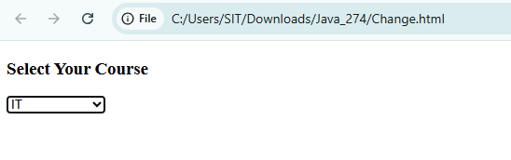
Name: Vedika Naidu PRN: 24070521274 -CHANGE
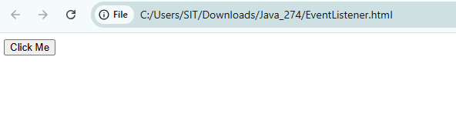
NAME: VEDIKA NAIDU PRN: 24070521274 – EVENT LISTENER
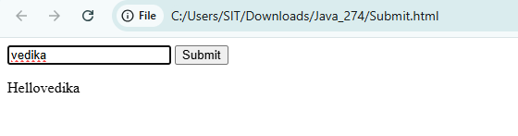
NAME: VEDIKA NAIDU PRN: 24070521274 – SUBMIT

CASE STUDY OUTPUT:
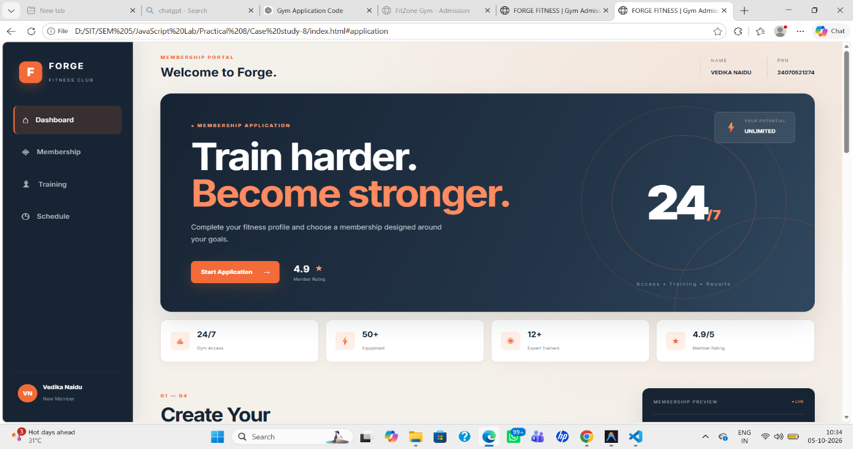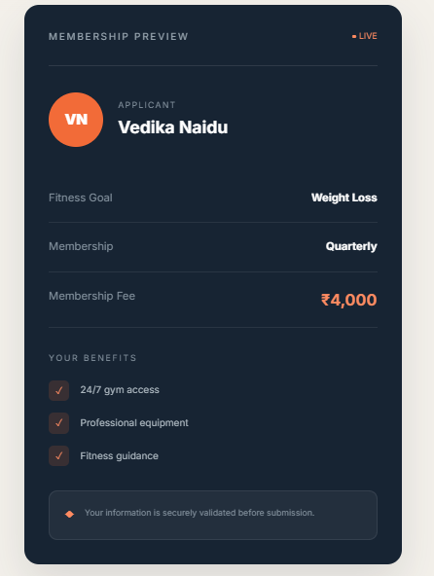
NAME: VEDIKA NAIDU PRN: 24070521274
PATH: D:\SIT\SEM 5\JavaScript Lab\Practical 8\Case study-8

