Experiment No: 5

Aim: To study the functioning of Arrays and Loops in JavaScript and understand array creation, manipulation, iteration, and evaluation of numerical elements.
Software / Tools Required:
- Visual Studio Code (VS Code)
- Google Chrome / Microsoft Edge
- HTML5, CSS3

Theory:
1. JavaScript Arrays
An array in JavaScript is a list-like data structure used to store multiple values in a single variable. The elements of an array are stored using numerical indexes, starting from 0. Arrays can store and manage collections of data efficiently and can be dynamically modified using built-in JavaScript methods.
2. Array Creation and Manipulation Methods
JavaScript provides several methods to add, remove, replace, and extract elements from an array.
Method | Description
push() | Adds one or more elements to the end of an array.
pop() | Removes and returns the last element.
shift() | Removes and returns the first element.
unshift() | Adds one or more elements to the beginning.
splice() | Adds, removes, or replaces elements at a specific index.
slice() | Extracts a portion of an array and returns it as a new array.

3. Iteration and Transformation Methods
JavaScript provides methods for processing array elements efficiently.
Method | Purpose
forEach() | Executes a function for each element of an array.
map() | Creates a new array by applying a function to every element.
filter() | Creates a new array containing elements that satisfy a condition.
reduce() | Processes elements and combines them into a single accumulated value.

AIM FOR CASE STUDY
To define an array of numerical values and write JavaScript logic to evaluate its elements and determine the maximum (highest) and minimum (lowest) values in the collection.
WORKING OF THE SYSTEM
- The user enters numerical values separated by commas.
- The input values are converted into a JavaScript numerical array.
- The first element is initially considered as both the maximum and minimum value.
- A for loop evaluates the remaining elements of the array.
- Each element is compared with the current maximum and minimum.
- If an element is greater than the maximum, the maximum value is updated.
- If an element is smaller than the minimum, the minimum value is updated.
- The final maximum and minimum values are displayed on the webpage.
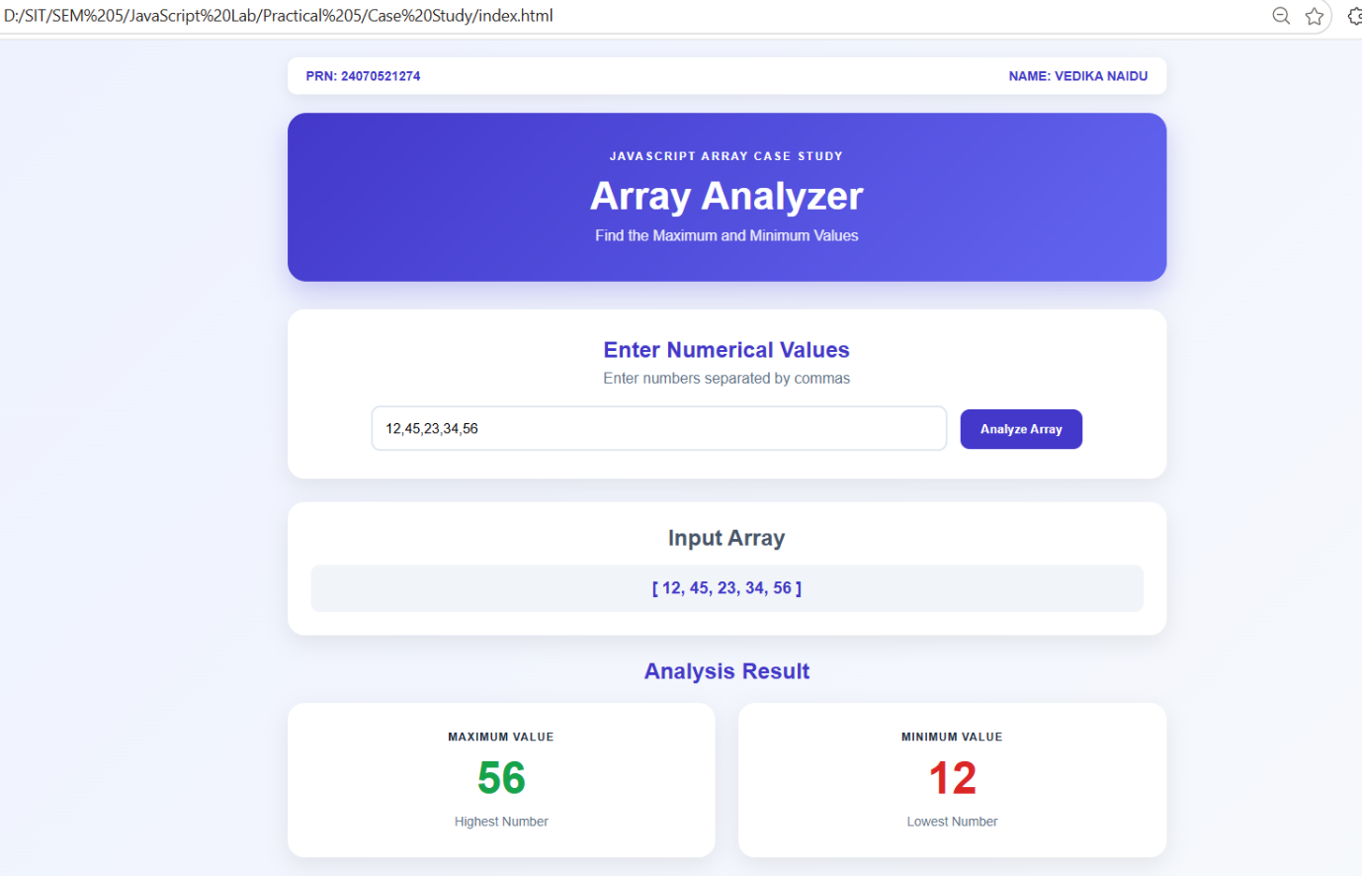
CONCLUSION: The case study successfully demonstrated the use of JavaScript arrays and loops to evaluate numerical data and determine its maximum and minimum values. It also provided practical understanding of array processing and JavaScript logic.
NAME: VEDIKA NAIDU PRN: 24070521274
PATH: D:\SIT\SEM 5\JavaScript Lab\Practical 5\Case Study

