Experiment No: 10
Aim: Load and display JSON data using fetch() and jQuery $.getJSON(); render results dynamically in a table.
TOOLS USED: VS Code, Web Browser (Google Chrome), HTML, CSS, JavaScript.
THEORY:
JSON (JavaScript Object Notation) is a lightweight, text-based data format used to store and exchange data between a client and a server. It represents data using key-value pairs and arrays. JSON is widely used in web applications because it is easy to read, write, and process.
In web development, data is often retrieved from a server or an API (Application Programming Interface). JavaScript provides the fetch() method to request data from a server, while jQuery provides the $.getJSON() method specifically for retrieving JSON data. Both methods support asynchronous requests, allowing a webpage to retrieve data without reloading the entire page.
A. JavaScript fetch() method
The fetch() method is a built-in JavaScript function used to make HTTP requests to a specified URL. It returns a Promise that resolves to a Response object. The response.json() method converts the response body into JavaScript objects.
B. jQuery $.getJSON() method
The $.getJSON() method is a jQuery function used to send an HTTP GET request and retrieve JSON data from a server. It processes the returned data through callback functions such as .done() and .fail().
Aim of the Case Study: To study and implement the process of loading JSON data using JavaScript fetch() and jQuery $.getJSON(), and to display the retrieved data dynamically in a well-designed HTML table with search functionality and dashboard statistics.
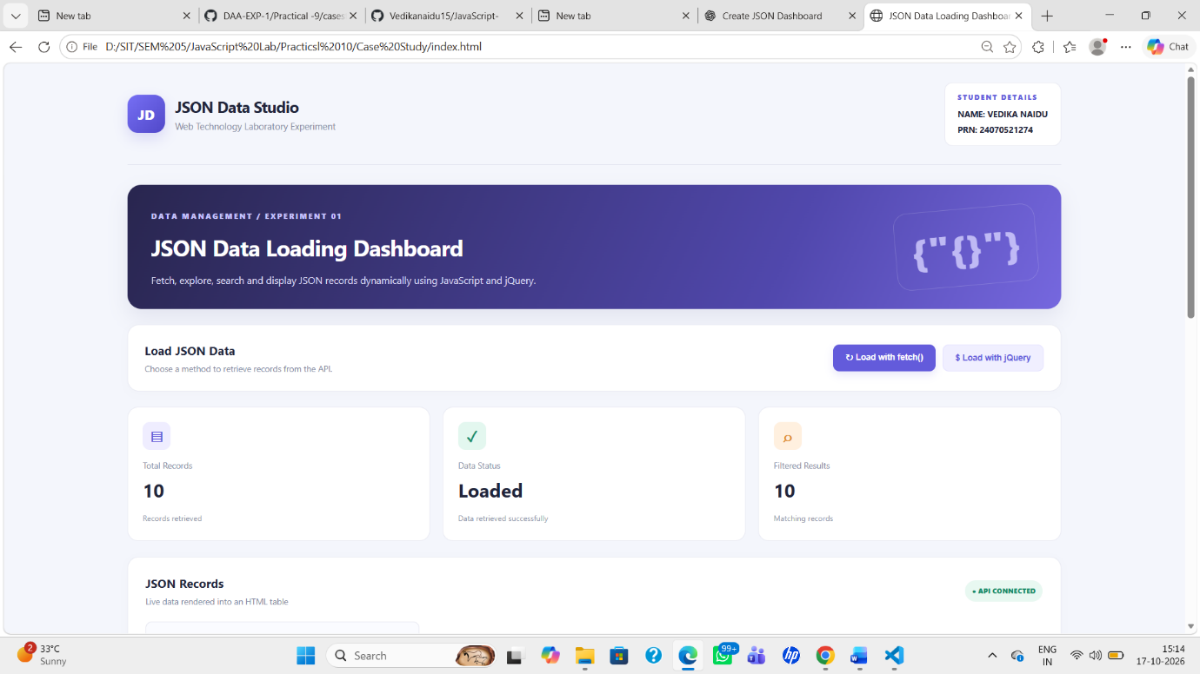 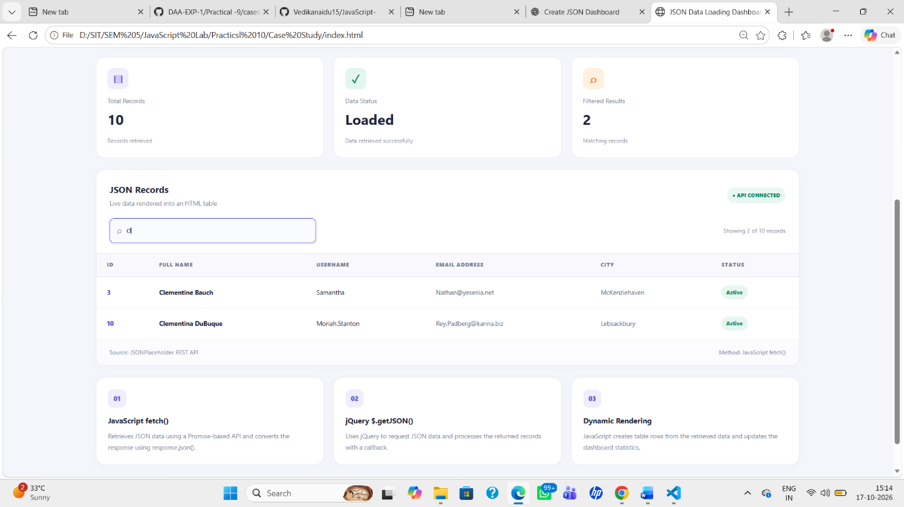 Result:The experiment was successfully implemented. JSON data was retrieved from the JSONPlaceholder API using both JavaScript fetch() and jQuery $.getJSON(). The retrieved records were dynamically displayed in an HTML table, with search functionality, summary statistics, and a responsive dashboard interface.
NAME: VEDIKA NAIDU PRN: 24070521274
PATH:D:\SIT\SEM 5\JavaScript Lab\Practicsl 10\Case Study

