Experiment No: 11
Aim: Use JavaScript timers (setTimeout(), setInterval()) and ES6 modules (import/export) to build a dynamic countdown or class scheduler with real-time updates and responsive layout.
TOOLS USED: VS Code, Web Browser (Google Chrome), HTML, CSS, JavaScript.
THEORY:
ClassFlow is a web-based Smart Class Scheduler designed to help students manage their daily class schedules efficiently. It provides an interactive dashboard that displays the timetable, upcoming classes, live time, countdown timer, and class completion status in an organized manner. The main objective of this application is to make timetable management easier through a simple, attractive, and user-friendly interface.
The dashboard is developed using HTML, CSS, and JavaScript. HTML provides the basic structure of the webpage, CSS is used to create an attractive layout with colors, cards, buttons, and responsive design, while JavaScript adds dynamic functionality and interactivity.
JavaScript timers play an important role in this experiment. The setInterval() function is used to update the clock, countdown, and class status at regular intervals. The setTimeout() function can be used to execute a particular operation after a specified delay, such as displaying notifications or updating messages.
The experiment also demonstrates the use of ES6 modules, which allow JavaScript code to be divided into reusable files using import and export. This makes the application easier to organize, maintain, and extend. Event listeners are used to handle user actions through buttons such as Start, Pause, and Reset.
The dashboard can also display completed and remaining classes, helping students track their daily academic progress. By combining timers, modular programming, and an interactive user interface, ClassFlow demonstrates how JavaScript can be used to develop a practical scheduling application.
Aim of the Case Study: To design and develop a ClassFlow Smart Class Scheduler dashboard using HTML, CSS, and JavaScript, incorporating JavaScript timers (setTimeout() and setInterval()), ES6 modules (import and export), and interactive controls to manage class schedules and monitor daily academic progress.
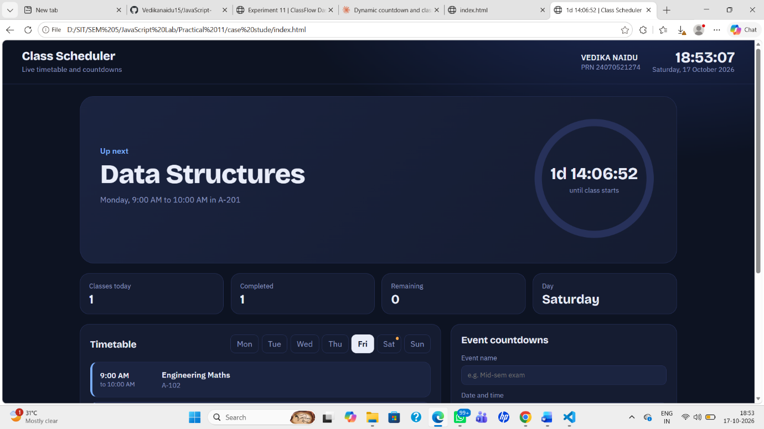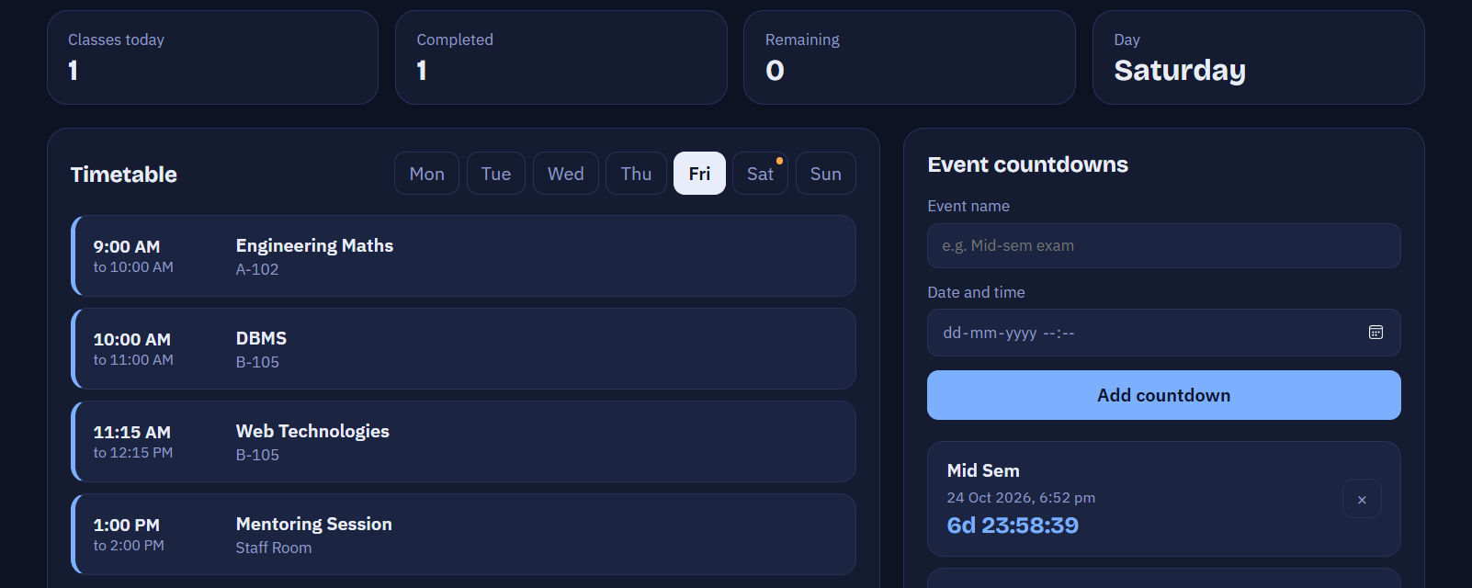
Result: The ClassFlow Smart Class Scheduler dashboard was successfully developed with an interactive interface, timetable display, live clock, countdown timer, and class status tracking. The experiment demonstrates the practical implementation of JavaScript timers, event handling, ES6 modules, and responsive web design in a real-world scheduling application.

NAME: VEDIKA NAIDU PRN: 24070521274
PATH: D:\SIT\SEM 5\JavaScript Lab\Practical 11\case study

