Experiment No: 12
Aim: Build an interactive real-time web app using JavaScript and jQuery with DOM, events, storage, and AJAX integration.
TOOLS USED: VS Code, Web Browser (Google Chrome), HTML, CSS, JavaScript.
THEORY:
1. jQuery
jQuery is a fast, lightweight JavaScript library that simplifies selecting HTML elements, handling events, changing the page and making AJAX calls. It uses short syntax such as $('#id') instead of long plain JavaScript code.
2. DOM (Document Object Model)
The DOM represents the web page as a tree of elements. JavaScript and jQuery use it to create, update or remove elements without reloading the page. In this app, the task list, activity log and feed posts are built dynamically with methods like .append(), .empty(), .text() and .addClass().
3. Events
Events are user actions such as clicks, form submissions and typing. jQuery handles them with .on(). This app uses click, submit, change and keyup. It also uses event delegation, so that elements created later (like new tasks) still respond to clicks.
4. Browser storage (localStorage)
localStorage stores data as key-value pairs in the browser, and the data stays even after the page is closed or refreshed. This app saves tasks, the selected city, saved posts and the activity log, so nothing is lost on reload.
5. AJAX
AJAX (Asynchronous JavaScript and XML) lets a page request data from a server in the background without reloading. jQuery provides $.ajax() and $.getJSON() for this. This app fetches live weather data from the Open-Meteo API and posts from the JSONPlaceholder API. The data comes back in JSON format and is shown on the page.
6. Real-time updates
setInterval() runs a function repeatedly after a fixed time. It keeps the clock updated every second and refreshes the weather every 60 seconds.
Aim of case Study: To build an interactive, real-time web application (Campus Pulse) using JavaScript and jQuery that demonstrates DOM manipulation, event handling, browser storage and AJAX integration.
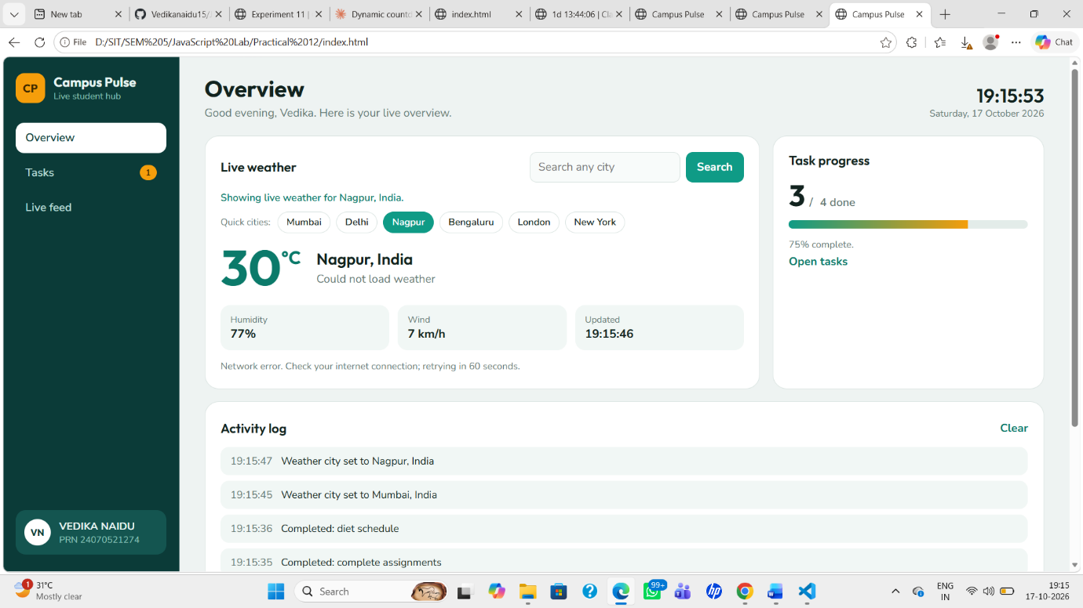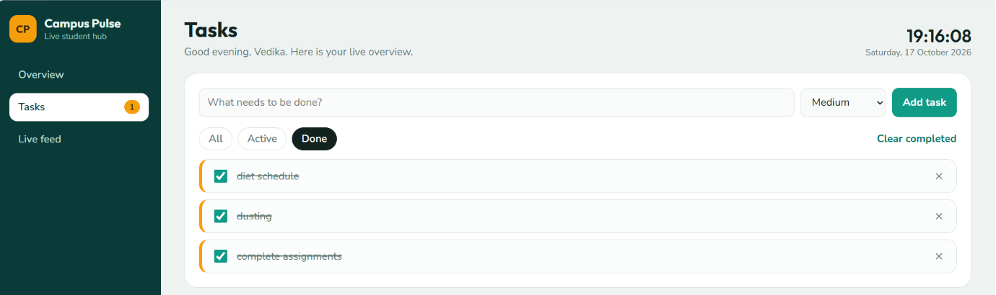
Conclusion: jQuery makes it easier to handle the DOM, events and AJAX in a real-time application, and localStorage keeps the user’s data between sessions.

NAME: VEDIKA NAIDU PRN: 24070521274
PATH: D:\SIT\SEM 5\JavaScript Lab\Practical 12

