JavaScript Lab Experiment: 1

AIM: Demonstration of Inline, Internal, and External JavaScript using Console Methods and a Webpage Displaying User Information and a Welcome Message
Software/Tools required: Text editor (VS code, Notepad), Web Browser (Chrome, Edge)
Experiment Program Code
1.Inline JavaScript:
<!DOCTYPE html>
<html lang="en">
<head>
<meta charset="UTF-8">
<meta name="viewport" content="width=device-width, initial-scale=1.0">
<title>Document</title>
</head>
<body>
<h2>Inline JavaScript Example</h2>
<button onclick="alert('Welcome to JavaScript!')">
Click Me
</button>
</body>
</html>

2. Internal JavaScript:
<!DOCTYPE html>
<html lang="en">
<head>
<meta charset="UTF-8">
<meta name="viewport" content="width=device-width, initial-scale=1.0">
<title>Document</title>
</head>
<body>
<h1>My Web Page</h1>
<p id="demo"></p>
<script>
document.getElementById("demo").innerText = "Hello World";
</script>
</body>
</html>

3. External JavaScript:
<!DOCTYPE html>
<html lang="en">
<head>
<meta charset="UTF-8">
<meta name="viewport" content="width=device-width, initial-scale=1.0">
<title>Document</title>
</head>
<body>
<h2>Exteranl JavaScript Demo</h2>
<p id="demo">Welcome!</p>
<button onclick="changeText()">Click Me</button>
<script src="script.js"></script>
</body>
</html>

4. Console:
<!DOCTYPE html>
<html lang="en">
<head>
<meta charset="UTF-8">
<meta name="viewport" content="width=device-width, initial-scale=1.0">
<title>Document</title>
</head>
<body>
<script>
console.log(5+6);
</script>
</body>
</html>

5. Console Log:
<!DOCTYPE html>
<html lang="en">
<head>
<meta charset="UTF-8">
<meta name="viewport" content="width=device-width, initial-scale=1.0">
<title>Document</title>
</head>
<body>
<button onclick = "startProgram()">Click Here</button>
<script>
function startProgram(){
displayMessage();
}
function displayMessage(){
console.log("Welcome to JavaScript");
console.trace("Function Call Trace");
}
</script>
</body>
</html>

Output:

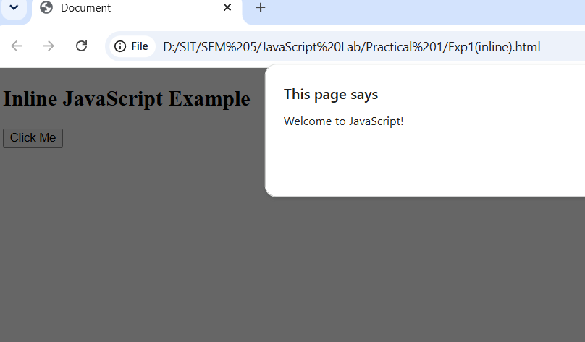
Name: Vedika Naidu, PRN: 24070521274 -Inline JavaScript Output
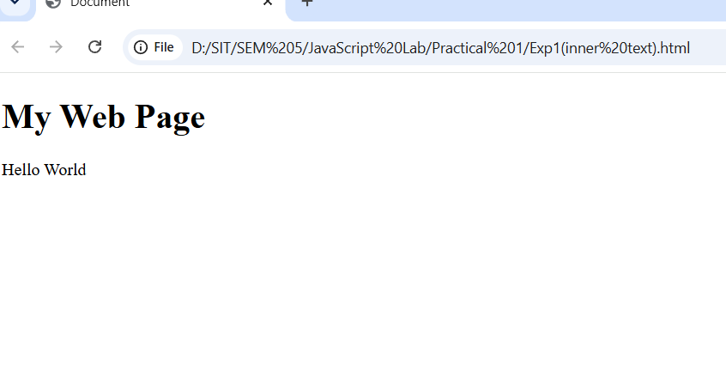
Name: Vedika Naidu, PRN: 24070521274 -Internal JavaScript Output

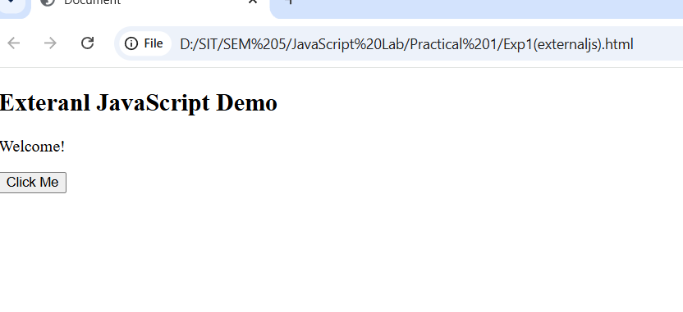
Name: Vedika Naidu, PRN: 24070521274 -External JavaScript Output

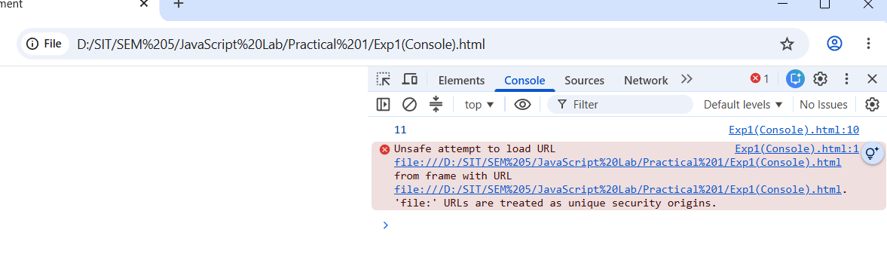
Name: Vedika Naidu, PRN: 24070521274 -Console JavaScript Output

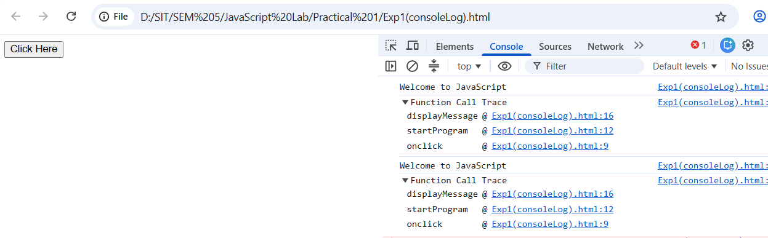
Name: Vedika Naidu, PRN: 24070521274 -Console Log JavaScript Output

Case Study: Development of a College Department Webpage Using HTML, CSS, and JavaScript


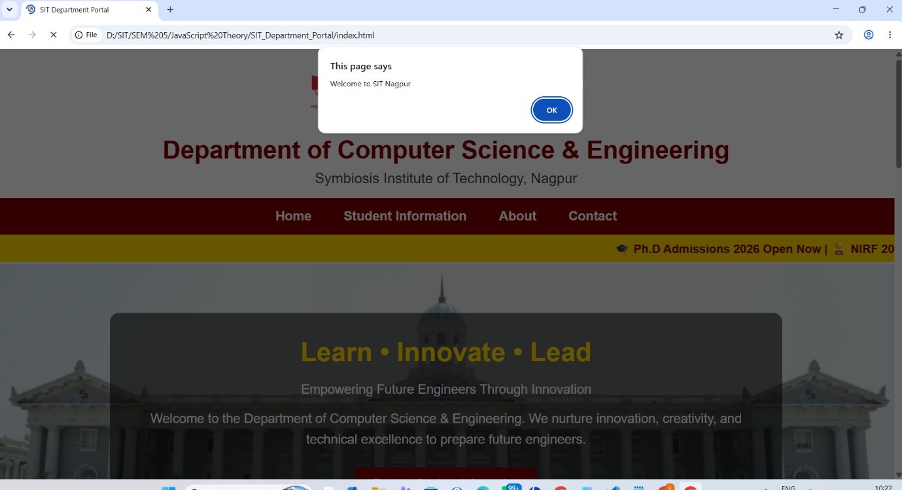

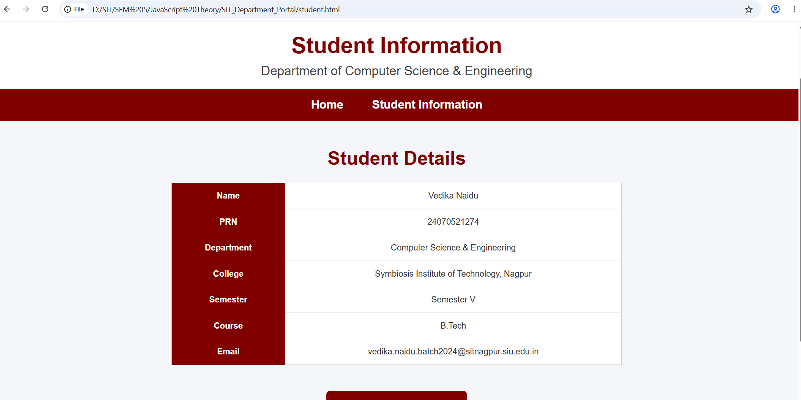

Result: The experiment was successfully completed. Inline, internal, and external JavaScript were implemented to create an interactive webpage. Console methods were demonstrated, and JavaScript was used to display a welcome message and user information, enhancing the webpage's functionality.

NAME: VEDIKA NAIDU PRN: 24070521274
PATH: SIT Department Portal

