Libreoffice, Libreoffice &, Fg, Firefox, Firefox & Commands:
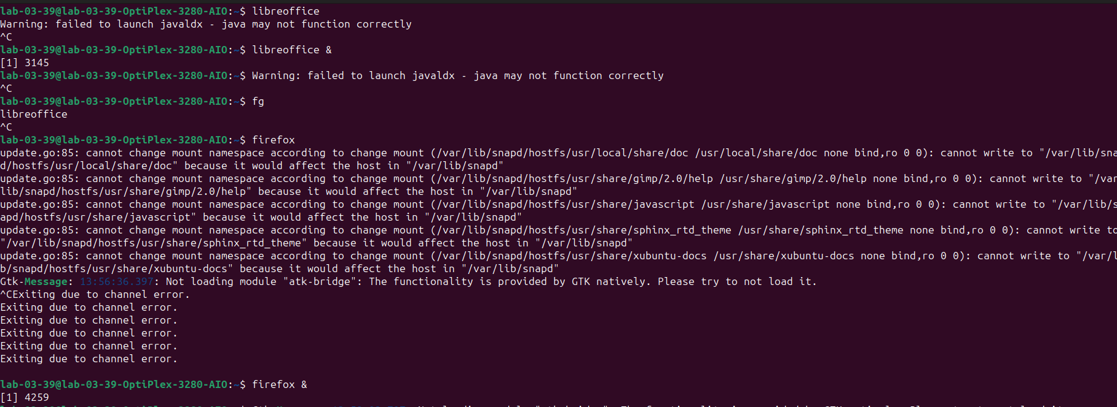
Top Command:
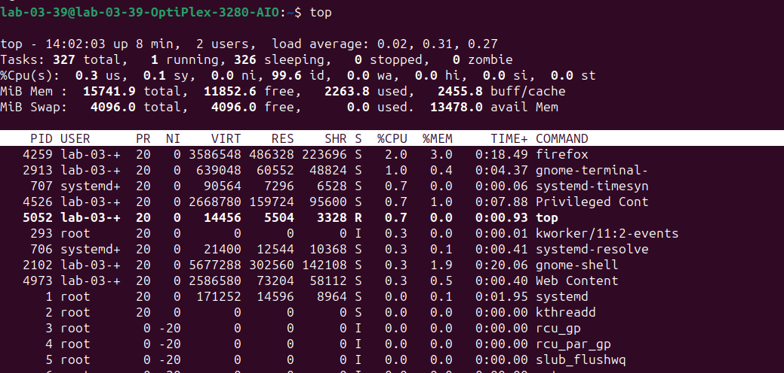
Nice Command:
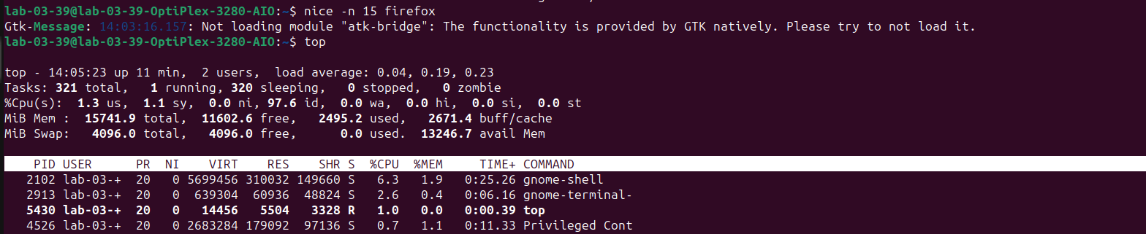

Renice & Top Commands:
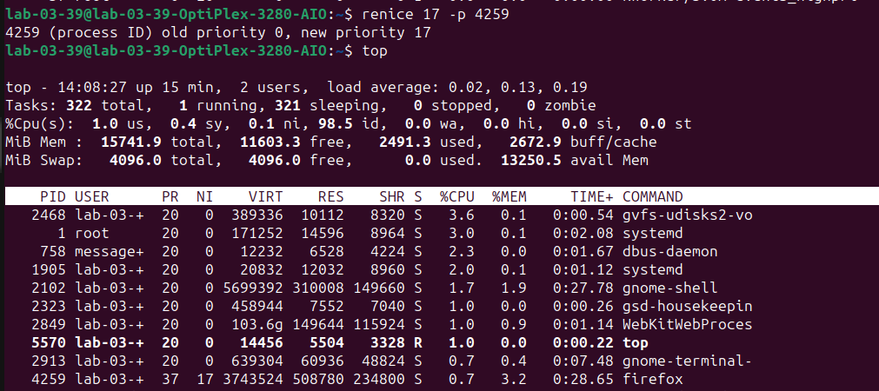
Pidoff & Kill Commands:
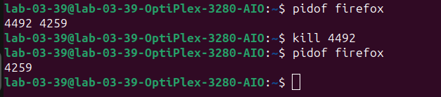
Ps Commands:
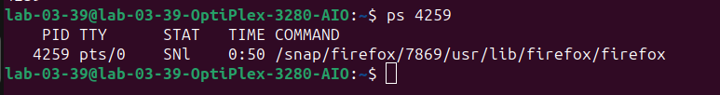
Bg Commands:
