LS: a, A, s, h, c
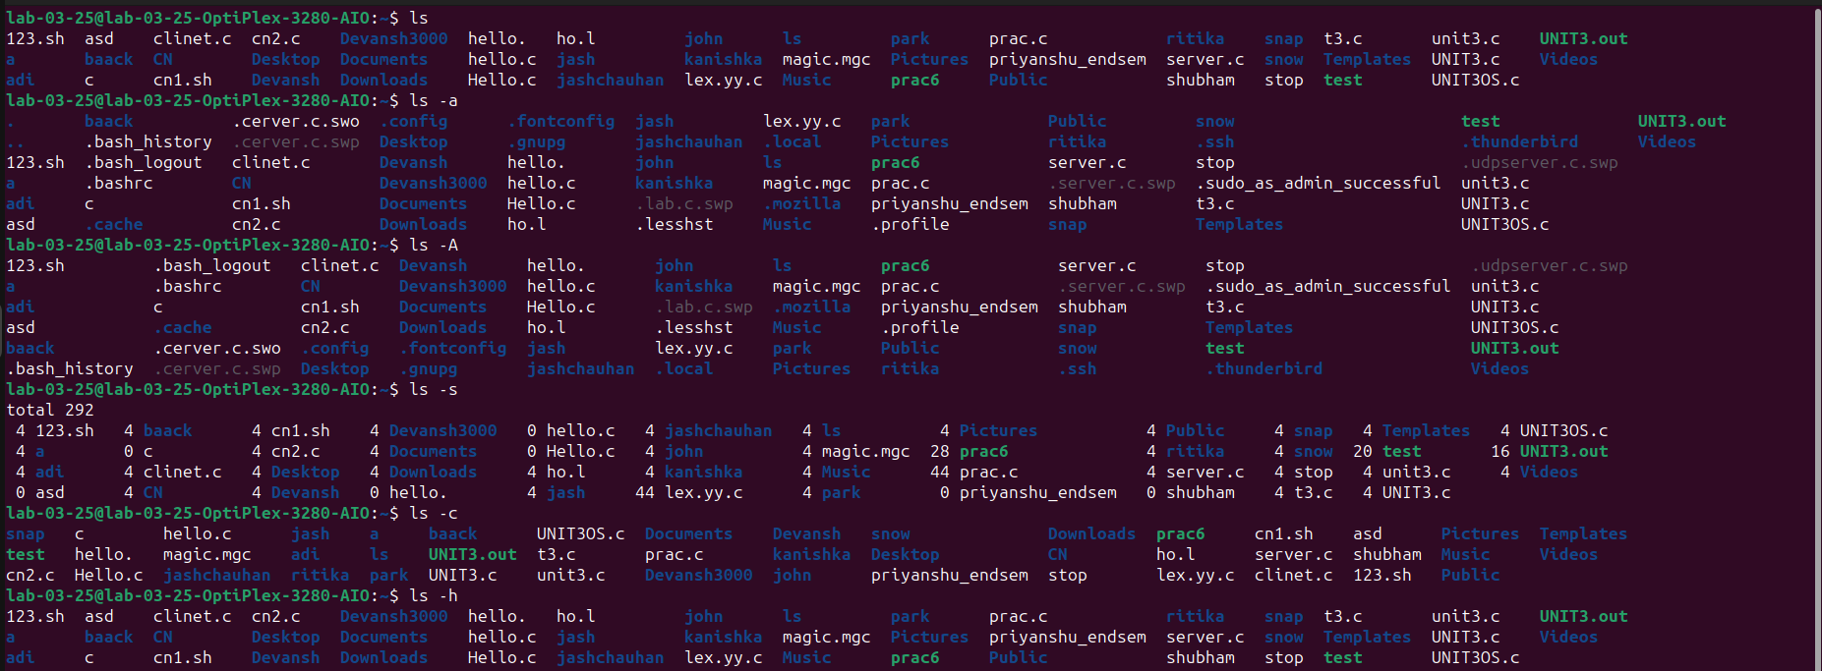
MAN LS: Manual Command
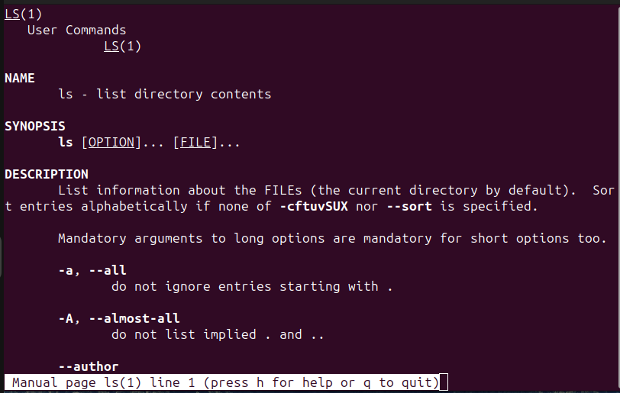
MKDIR: Make Directory
RMDIR: Remove directory

MV & RM: Move and Remove Command
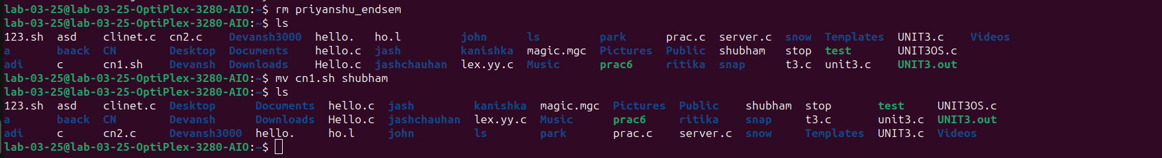
TOUCH & CP: Touch and Copy Command
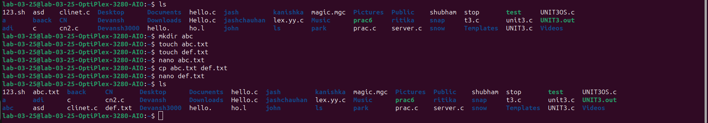
NANO Command:
PWD & CD: Print Working Directory and Change Command
CAT: Concatenate Command
UNAME, WHOAMI, ECHO Commands
