**CORE BLOCKCHAIN TESTNET PROJECT REPORT**

Project Title: KindChain -Blockchain based Appreciation System

Name: Vedita Kesarwani

Network: Core t2 Testnet

Tools Used: Remix IDE, Metamask, Solidity

Wallet address:

0xf2ce1E27611d6a379899A29Bd0C2d5Aa7422D35D

Date: 28 October 2025

**Project Description**

KindChain is a blockchain-based project that allows users to send appreciation messages that are permanently stored on the blockchain. It demonstrates the use of smart contracts to promote transparency and positivity using decentralized technology.

**Project Vision**

To promote genuine recognition and kindness through blockchain technology by enabling users to send, store, and verify appreciation messages in a secure and transparent manner.

**Key Features**

* Written in Solidity and deployed on Core Blockchain Testnet2.
* Uses Remix IDE and MetaMask for deployment and verification.
* Enables sendAppreciation and getReceivedNotes functions.
* Demonstrates contract interaction using test tokens (tCORE2).
* Transaction verified successfully on Core t2 explorer.

**Future Scope**

* Build a front-end website for real-time interaction.
* Add user profiles and appreciation history dashboards.
* Reward system for multiple appreciations (NFT-based).
* Expand to the Core Mainnet for live usage.

**Screenshots**

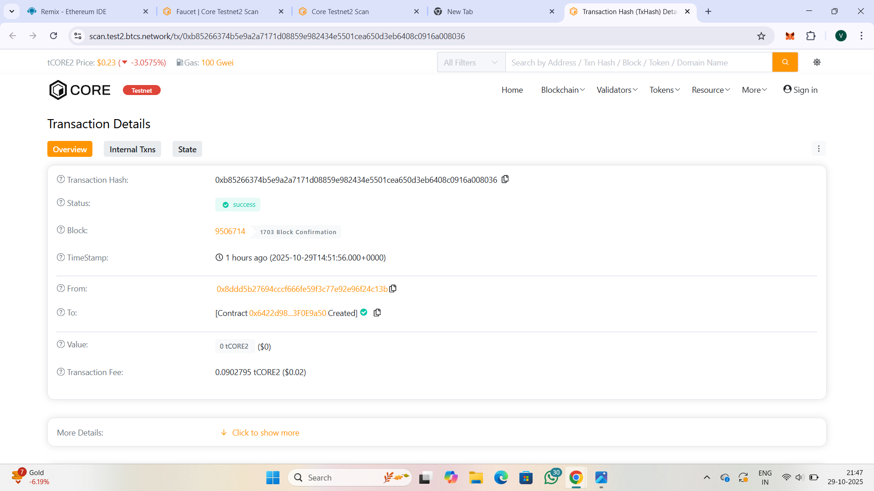

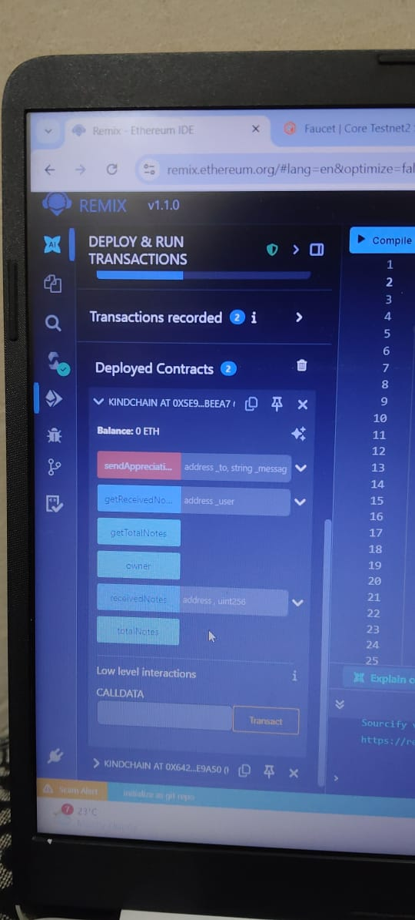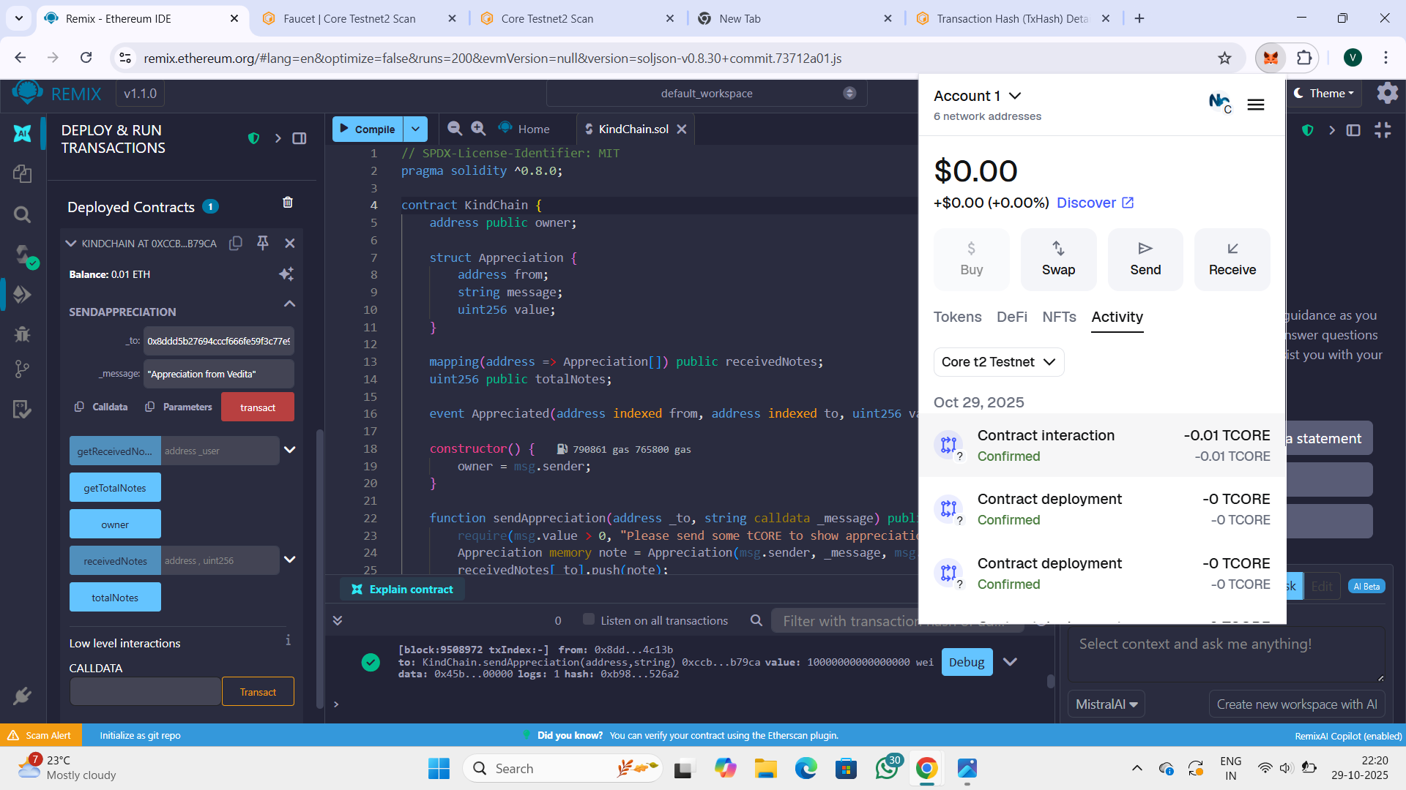

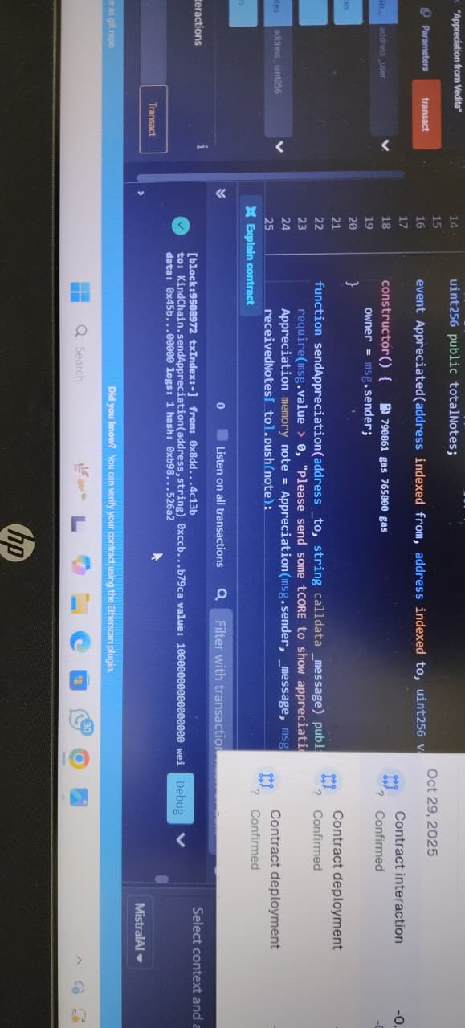

**Conclusion**

This project successfully demonstrates Vedita Kesarwani’s ability to write, deploy, and interact with a Solidity smart contract using Remix IDE and MetaMask on the Core t2 Testnet. All blockchain interactions have been verified and confirmed through the test explorer.

[**Github Repository Link**](https://github.com/Vedita-kes/KindChain)