STAFF SYNC
Functional Specification Document
Modern Human Resource Management System
Prepared as a system specification template

1. Introduction
Project title: Staff Sync – Modern Human Resource Management System
Document purpose: Define the proposed functional scope, architecture, data model, interfaces, and validation approach for a web-based HR management platform.
Team Members-SWUID2026403309

2. Project Overview
Purpose. Staff Sync centralizes employee information and common HR workflows in one system. Employees can maintain profiles, submit leave requests, view attendance and payslips, while HR staff and managers administer records, approvals, payroll data, recruitment, performance, and reports.

Employee features
- Register or sign in, view and update permitted profile fields, and change password.
- View attendance records, work schedules, leave balances, and company announcements.
- Submit leave requests, attach supporting details where required, and track approval status.
- View payslips, salary components, benefits, and payroll payment status when authorized.
- View goals, performance feedback, training assignments, and onboarding tasks.
- Receive in-app and optional email/SMS notifications about approvals, attendance exceptions, and HR announcements.

HR Manager features
- Create, view, update, deactivate, and archive employee records according to permissions.
- Maintain departments, designations, reporting relationships, leave types, and leave policies.
- Review leave requests and attendance exceptions; maintain approved adjustments with an audit trail.
- Manage recruitment stages, candidate records, onboarding checklists, and employee documents.
- Prepare payroll inputs, review deductions and benefits, and export approved payroll data to a payroll system.
- Generate headcount, attendance, leave, recruitment, and workforce reports.

Department Head features
- View team roster, attendance summaries, leave calendars, and workload information.
- Approve or reject team leave requests according to delegated policy.
- Set goals, provide performance feedback, and review training progress.
- View team-level reports without access to unrelated confidential employee information.

Admin features
- Manage roles, permissions, system settings, departments, and reference data.
- Review audit logs, integration status, data quality alerts, and system activity.
- Configure notification templates and integration credentials securely.
- Access aggregate analytics and authorized operational reports.

3. Architecture (Proposed Reference Architecture)
Frontend. A responsive single-page web application (for example, React with a modern build tool) provides employee, manager, HR, and admin workspaces. Route guards and role-aware components restrict access to authorized functions.
Backend. A REST API (for example, Node.js and Express) validates requests, applies authentication and role-based authorization, executes HR workflows, records audit events, and integrates with email/SMS, attendance devices, and payroll services.
Database. A document or relational database stores employee profiles, departments, attendance, leave, payroll references, recruitment, performance, notifications, and audit history. The exact database and schema should be selected to match the implementation.
Integration boundary. Payroll and biometric systems are external services. In a development/demo environment, these integrations may be represented by mock adapters; production use requires provider-specific credentials, security review, and reconciliation procedures.
Component | Responsibilities
Web client | Sign-in, employee self-service, HR dashboard, manager approvals, admin configuration
API / application services | Validation, business rules, authorization, workflow state changes, reporting
Database | Persistent employee and workflow records; relationships and audit history
Attendance integration | Import punch-in/punch-out records and device synchronization status
Payroll integration | Exchange approved payroll inputs and receive payment/result status
Notification service | Send email/SMS or in-app alerts and capture delivery status

4. Setup Instructions (Implementation Dependent)
The following is a suggested setup pattern, not a claim about an existing repository. Replace commands and environment names with those used by the actual codebase.

Prerequisites
- Supported Node.js LTS release if using the suggested JavaScript stack.
- A database instance and a dedicated application database user.
- SMTP or notification provider credentials for outbound messages, if enabled.
- Sandbox credentials for payroll and attendance integrations, if applicable.

Suggested installation sequence
- Obtain the Staff Sync source repository and review its README and environment example files.
- Install dependencies separately for the frontend and backend if they are maintained as separate applications.
- Configure database connection, session/JWT secrets, allowed client origin, and integration settings in environment variables.
- Run database migrations or seed only non-production demonstration data.
- Start the API and then the frontend using the project-defined scripts.
- Verify sign-in, role permissions, leave workflow, attendance import, and notification delivery in a test environment.
Configuration key (example) | Purpose
PORT | API listening port
DATABASE_URL | Database connection string
AUTH_SECRET | Secret for signing sessions or tokens; use a strong secret
CLIENT_URL | Allowed frontend origin
SMTP_HOST / SMTP_USER / SMTP_PASS | Optional outbound email configuration
SMS_PROVIDER_* | Optional SMS provider configuration
PAYROLL_API_* | Payroll integration endpoint and credentials
ATTENDANCE_API_* | Attendance device/service endpoint and credentials

Never commit real secrets, employee personal data, payroll files, or production credentials to source control.

5. Suggested Folder Structure
A possible modular structure is shown below. Names are illustrative and should be aligned with the actual repository.
staff-sync/\n client/\n src/\n components/ shared UI components\n pages/ employee, HR, manager, admin screens\n context/ authentication and session state\n api/ API client and request helpers\n server/\n src/\n config/ database and environment configuration\n models/ employee and workflow data models\n controllers/ request handlers\n services/ leave, attendance, payroll, reports\n routes/ API route definitions\n middleware/ authentication, authorization, validation\n integrations/ payroll, biometric, email/SMS adapters\n utils/ errors, logging, audit helpers\n docs/ API notes, diagrams, operational guidance

6. Running the Application
Use the commands specified by the actual repository. A typical development workflow starts the database, starts the backend API, and then starts the frontend. Confirm the health endpoint, if provided, and test with non-production accounts.
- Run database migrations before starting a fresh environment, where applicable.
- Use separate test accounts for Employee, Department Head, HR Manager, and Admin roles.
- Verify access restrictions by attempting to access a route and record belonging to another role.
- For production, use HTTPS, secure cookie/session settings, managed secrets, backups, and monitoring.

7. API Documentation (Proposed Endpoint Catalogue)
These endpoints are a design proposal, not verified endpoints from an existing Staff Sync implementation. The base path may be /api. All write operations should validate input and enforce role-level permissions.
Method | Endpoint | Access | Purpose
POST | /auth/login | Public | Authenticate a user
POST | /auth/logout | Authenticated | End the current session
GET | /auth/me | Authenticated | Return current account and role
GET, PUT | /employees/me | Employee | View/update permitted self-service profile fields
GET, POST | /employees | HR/Admin | List employees or create a record
GET, PUT, PATCH | /employees/:id | HR/Admin | View/update employee record or employment status
GET | /departments | Authenticated | List permitted department information
GET, POST | /leave/requests | Employee | List own requests or submit a leave request
GET, PUT | /leave/requests/:id | Employee/Manager/HR | View request or record an authorized decision
GET | /attendance/me | Employee | View own attendance records
POST | /attendance/import | HR/Admin/Integration | Import attendance data from an authorized source
GET | /attendance/reports | Manager/HR/Admin | Attendance summaries within authorized scope
GET | /payroll/me/payslips | Employee | View own published payslips
POST | /payroll/export | HR/Admin | Prepare approved payroll export
GET, POST | /recruitment/candidates | HR/Admin | List or add candidate records
GET, PUT | /performance/reviews/:id | Employee/Manager/HR | View or update authorized review information
GET | /reports/hr | HR/Admin | Generate authorized HR reports
GET | /audit-logs | Admin/Auditor | Review audit records
GET | /notifications | Authenticated | List own notifications

Suggested response convention: JSON with a success indicator and a safe message. Do not return passwords, authentication secrets, full bank details, or unnecessary sensitive fields. Use consistent HTTP status codes and correlation IDs for errors.

8. Authentication, Authorization & Privacy
- Use a secure session or short-lived token strategy; store passwords using a modern password-hashing algorithm such as Argon2id or bcrypt.
- Enforce role-based access control for Employee, Department Head, HR Manager, Admin, and approved integration accounts.
- Employees should access only their own personal, attendance, leave, and payslip records unless an explicitly authorized workflow permits otherwise.
- Managers should access only the teams and decisions assigned to them. HR/Admin access should be limited by least privilege.
- Require server-side validation for every sensitive operation; hiding a button in the UI is not sufficient authorization.
- Keep an audit trail for profile changes, leave decisions, attendance corrections, payroll exports, role changes, and administrative actions.
- Protect personal and payroll data in transit and at rest. Define retention, deletion, backup, incident response, and access-review procedures.
- Apply rate limits to authentication endpoints, secure cookies where used, CSRF protection where applicable, and security headers.

9. User Interface Specification
Screen | Suggested route | Access | Purpose
Sign in | /login | Public | Authenticate user and route to the permitted workspace
Employee dashboard | /employee | Employee | Attendance, leave balance, tasks, announcements
My profile | /employee/profile | Employee | View and update allowed profile fields
My attendance | /employee/attendance | Employee | Daily punches, exceptions, and attendance history
My leave | /employee/leave | Employee | Submit requests and review balances/status
My payslips | /employee/payslips | Employee | View published payslips and payroll status
Team dashboard | /manager/team | Department Head | Team roster, leave approvals, attendance summaries
HR dashboard | /hr | HR Manager | Employee lifecycle, approvals, reports, payroll preparation
Employee directory | /hr/employees | HR Manager/Admin | Search and manage employee records
Recruitment | /hr/recruitment | HR Manager | Candidates, interview stages, onboarding tasks
Performance & training | /hr/performance | Manager/HR/Employee | Goals, reviews, training assignments
Reports & audit | /admin/reports | Authorized HR/Admin | Workforce analytics, audit events, configuration

UI requirements: provide clear loading, empty, validation, success, and error states; support keyboard navigation and responsive layouts; label sensitive actions; and show dates, times, leave balances, and payroll periods consistently.

10. Testing & Acceptance Criteria
Testing status: No Staff Sync implementation or test results were supplied with the request. The following are recommended acceptance checks, not a statement that tests have already passed.
- Authentication: valid users can sign in/out; invalid credentials are rejected; deactivated accounts cannot continue to access protected resources.
- Authorization: each role sees only permitted screens, records, reports, and actions; direct API calls are checked server-side.
- Employee profile: required fields and formats are validated; changes are saved and audited.
- Leave workflow: a valid request can be submitted, reviewed by an authorized manager/HR user, and tracked through its final status; overlapping or invalid dates are handled according to policy.
- Attendance: imports handle duplicate punches, missing values, time zones, and failed records without silently corrupting existing data.
- Payroll: only authorized users can prepare/export payroll data; totals and period boundaries are reconciled before transmission.
- Notifications: messages are triggered for configured events; delivery failures are recorded and can be retried safely.
- Reporting: counts and totals reconcile with source records, and report access respects organizational scope.
- Security: validate injection resistance, rate limiting, session expiry, sensitive-data exposure, and audit coverage.
- Run API tests, browser end-to-end tests, accessibility checks, and regression tests before each production release.

11. Screenshots or Demo
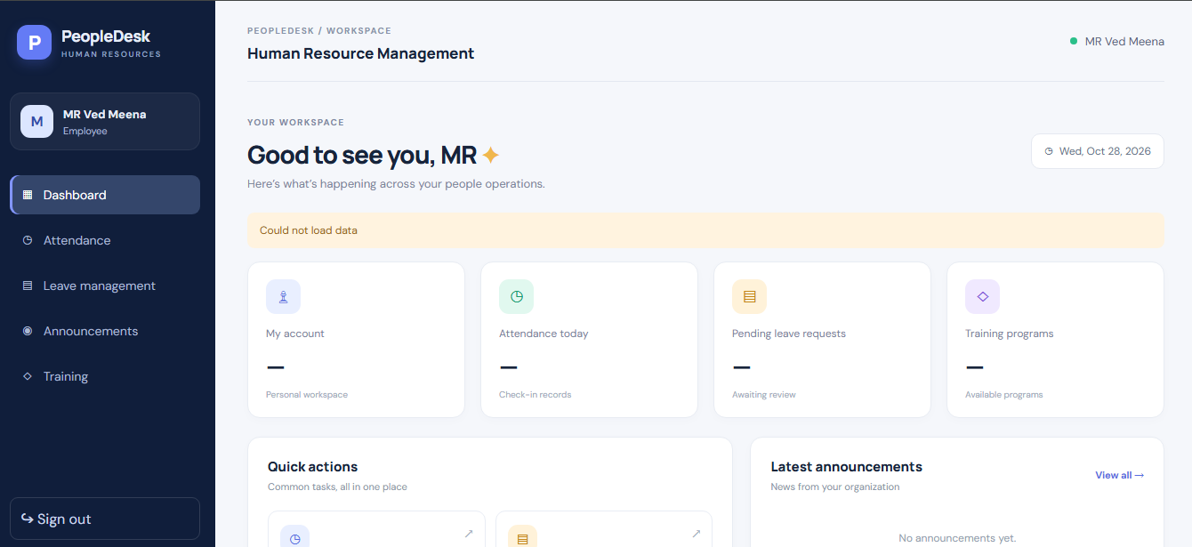

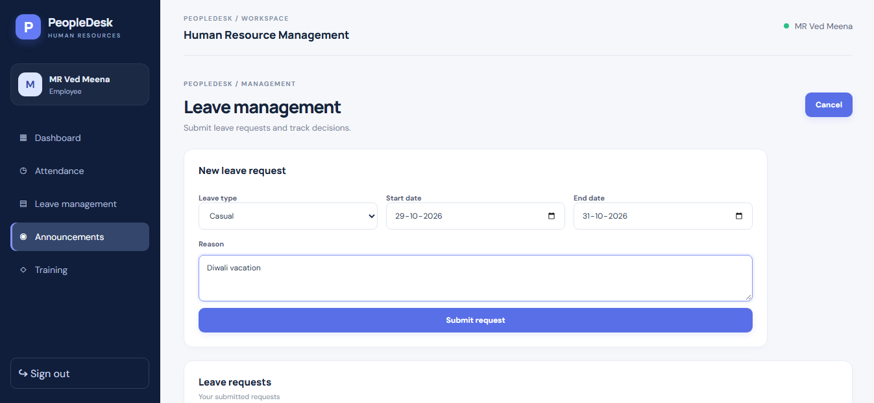

12. Known Risks & Open Decisions
- The supplied materials describe the Staff Sync concept and diagrams, but do not confirm an implemented codebase, database, API, or hosting environment.
- Leave accrual, carry-forward, holidays, half-day rules, approval hierarchy, and cancellation rules must be defined by the organization.
- Attendance device formats, biometric provider APIs, shift schedules, time zones, and exception handling need implementation-specific decisions.
- Payroll calculations, tax rules, statutory deductions, benefits, and payslip publication require jurisdiction-specific review and should not be assumed from this template.
- Employee documents and performance reviews contain sensitive information and require explicit access and retention policies.
- Email/SMS delivery depends on external providers and can fail; the application should record status without exposing message secrets.
- Production use requires backup and restore testing, monitoring, incident response, privacy review, and security testing.

13. Future Enhancements
- Employee self-service mobile application and push notifications.
- Configurable leave accrual, holiday calendars, shift rosters, and overtime workflows.
- Advanced workforce analytics, headcount forecasting, and customizable report exports.
- Single sign-on, multi-factor authentication, and automated joiner/mover/leaver provisioning.
- Integration with accounting, payroll, recruitment, learning management, and identity systems.
- Document e-signatures, onboarding checklists, and configurable employee lifecycle workflows.
- Localization, accessibility improvements, and configurable organization policies.
- Automated unit, API, integration, security, and end-to-end testing in a CI/CD pipeline.

