UAT Process for Innovation Sandbox
Under the aegis of SEBI, all the market intermediaries have come together to ease the process of experimenting newer solutions to improve market coverage and make investment in Indian securities market easier. As part of that initiative, CAMS- the leading mutual Fund RTA, has put together a test kit that will help any new participant integrate their solutions for initiating transactions in Mutual funds. The test kit consists of test data that sandbox participant can use to test out transaction submission and other functionalities.
Below is a step-by-step guide and reference test data that can be used by sandbox participants.
- We have set-up 5 test ARN codes. An ARN code uniquely represents a mutual fund distributor and is mandatory to push transactions to an RTA. Any sandbox participant can test using one of the below ARN codes. The test ARN codes are:
  - ARN-99995
  - ARN-99996
  - ARN-99997
  - ARN-99998
  - ARN-99999

- A mutual fund distributor can submit transactions to MF- RTA using our application – Fundsnet. Below is the link to that application:
https://fundsnetuat.camsonline.com/ecrms/index.aspx

This link is to the testing website where sandbox participant needs to login. We have created the below login credentials for testing. Each User code for login is connected to an ARN code. Below are the details:
ARN Code | User Code
ARN-99999 | SANDBOX9
ARN-99998 | SANDBOX8
ARN-99997 | SANDBOX7
ARN-99996 | SANDBOX6
ARN-99995 | SANDBOX5

- Any participant looking to access the above URL needs to be whitelisted by CAMS. The participant can send a mail to innovation-sandbox@camsonline.com giving the below details for requesting access to the sandbox URL:
  - Name of the participant
  - Address of the participant
  - Use case for which testing URL is needed
  - Email ID
  - Mobile number
  - Public IP using which the sandbox URL will be accessed
  - User code and ARN code that participant is going to use for testing

- Once these details are received by CAMS, CAMS will call the participant as part of its due diligence process. Once done, CAMS will whitelist their accessing IP and share password for login with the chosen user code. The participant can also call +91-99403-02239 if there are any delays or concerns.

- Once CAMS receives the above request, CAMS will share the password, using which the participant can submit transactions using fundsnet URL mentioned above.

Fundsnet Login Screen
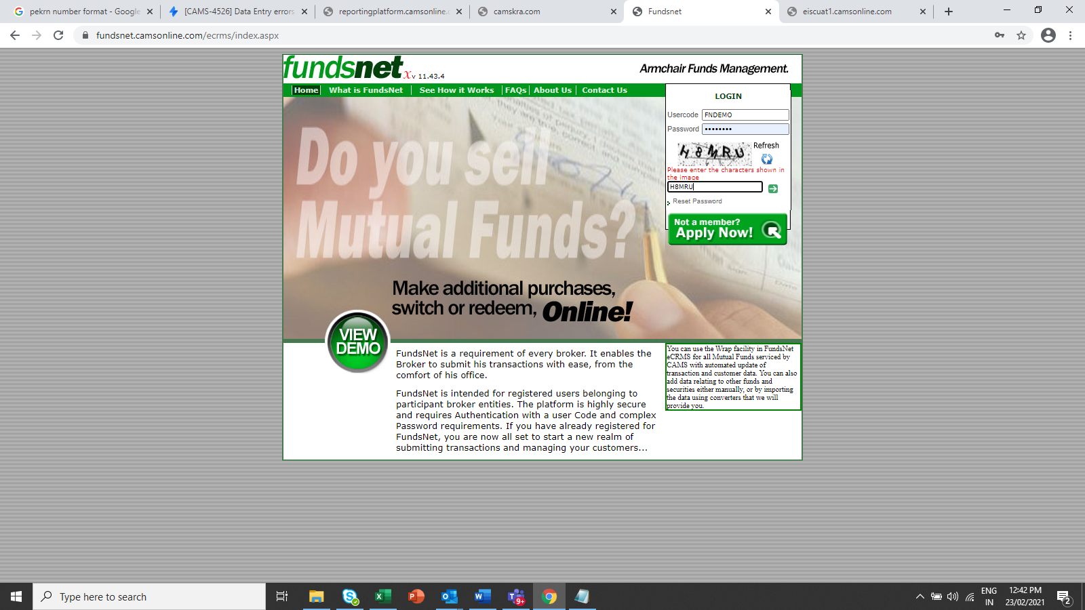

- For initiating a transaction with a mutual fund, and ARN must be empaneled with that fund. We have empaneled each of these test ARNs to 3 test funds- HDFC (H), ICICI (P) and DSP (D).

- Once a participant successfully logs in to fundsnet test environment, participant can upload transaction using the below menu

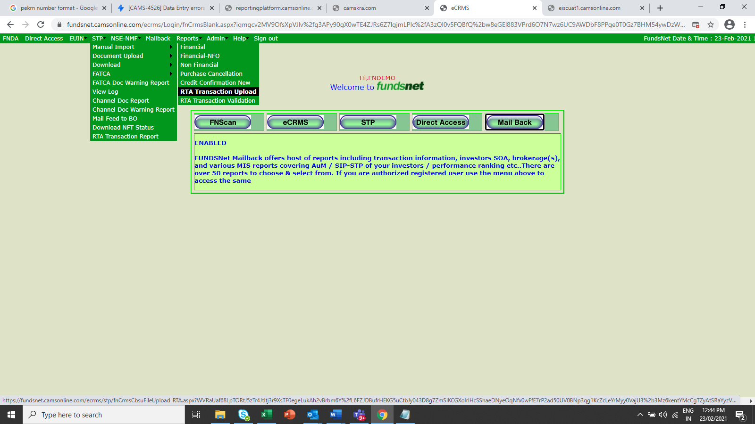

For uploading a transaction, user has to create an upload-able file in the prescribed format. The below format supports all transaction types- purchase (both new purchase and additional purchase), redemption and switch.

The below file contains the column names, description of those columns and other details needed to create the transaction upload file. The transaction data needs to be created in the below format for the participant to upload it successfully for processing.

Sample purchase transaction file (please copy this file in your local machine to open. It will not open from this document)
Sample redemption and switch transaction file (please copy this file in your local machine to open. It will not open from this document)

- In Mutual Funds, for doing additional purchase, redemption and switch, a Folio number is mandatory. For enabling testing of these transaction types, we have setup test data across 3 Funds (ICICI, HDFC and DSP). Every fund has been setup with 10 test folios. Using these folio numbers, participant can setup transaction data in RTA common format and upload the transaction in Fundsnet.

Below are the test data details:
  - ICICI
  - HDFC
  - DSP
- Participants to note that they should not push any redemption or switch transaction with ‘All Units’ option. This will remove all setup unit balance from the folio and participant won’t be able to use the folio for further testing.

- Once participant has created the transaction data in the RTA common format, participant needs to go to below screen and upload the file. The steps to do the same are:
  - Choose fund for which transactions need to be tested (ICICI/HDFC/DSP)
  - Enter count of rows in the transaction file
  - Enter remarks (non-mandatory)
  - The uploadable file can only be in .txt or .dbf format

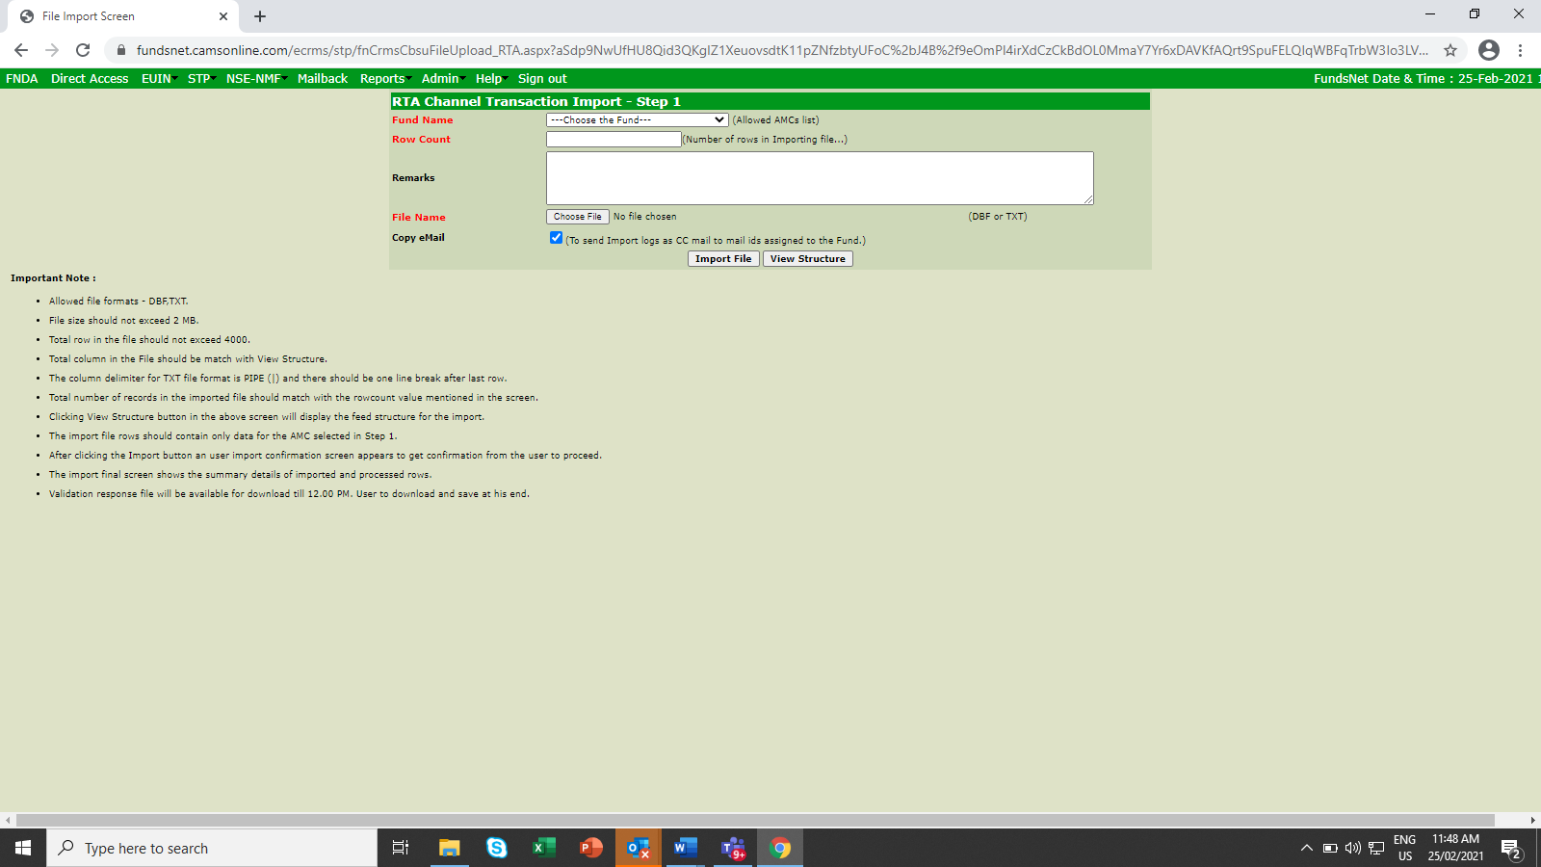

- Once participant uploads the file, they will be taken to the confirmation page

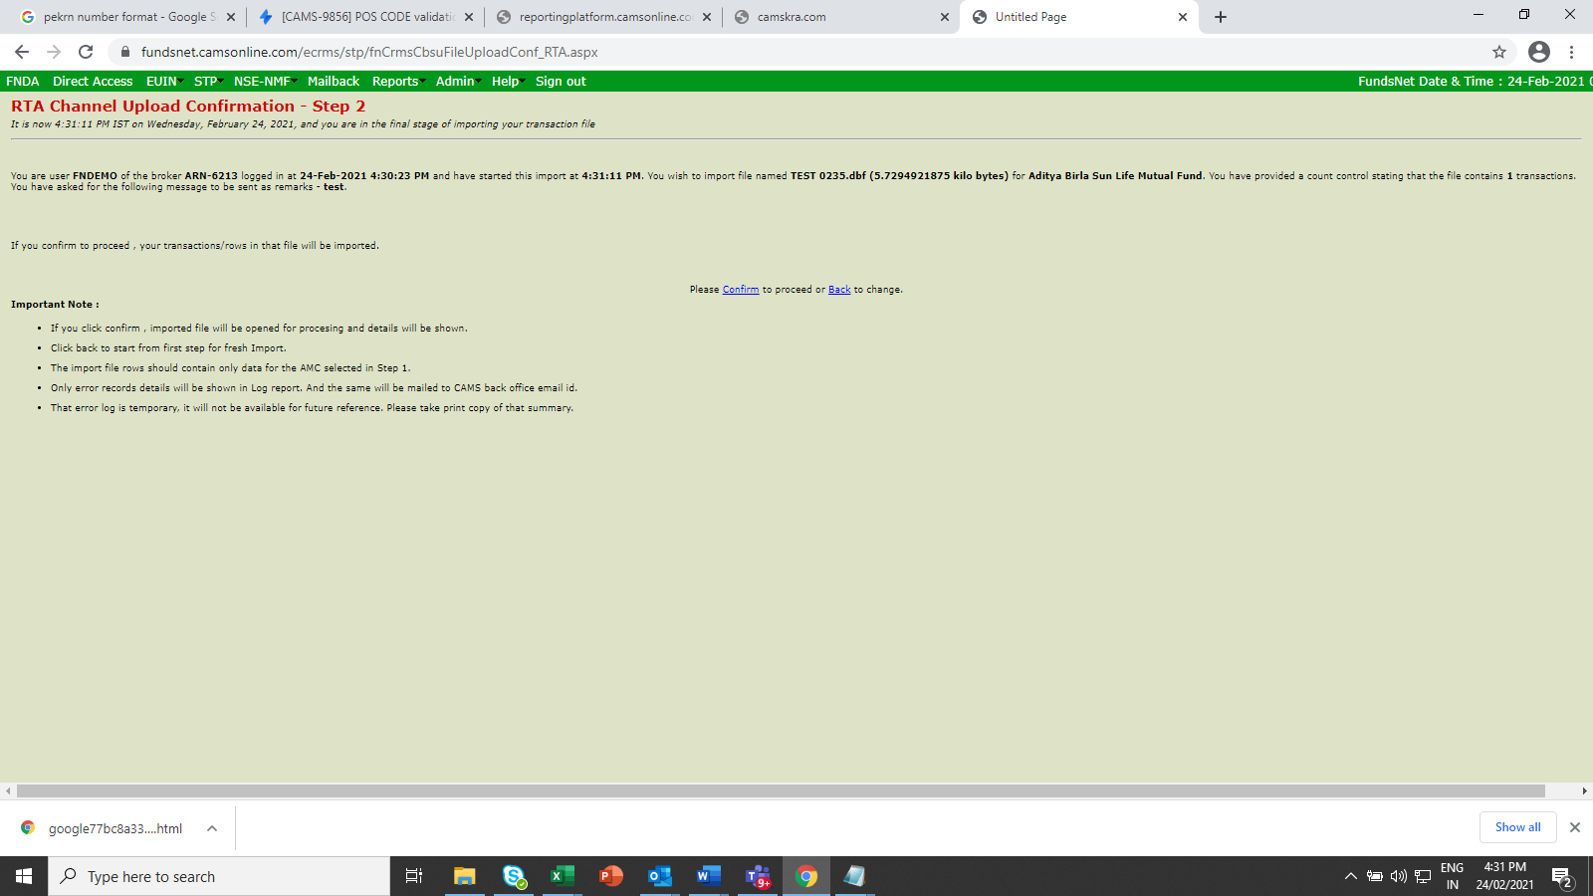

- Once participant confirms, they will see the count of transactions that got successfully imported. They can also see if any transaction failed to get successfully imported. It also shows the timestamp at which transaction is imported which will be used to decide the NAV for the fund.

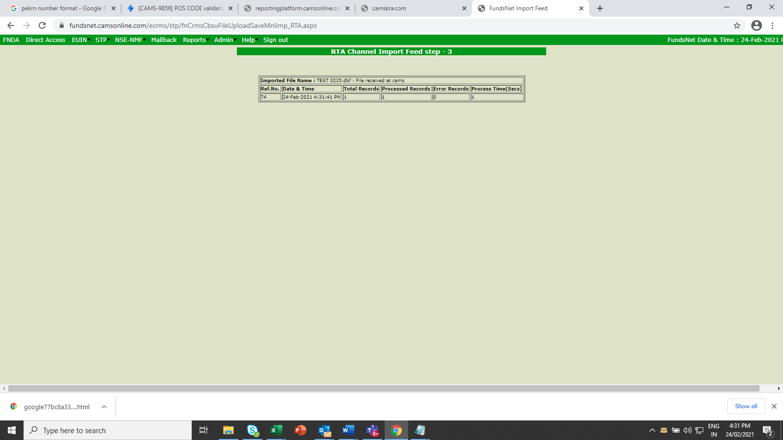

- Once participant has uploaded transaction file, participant needs to provide a credit confirmation for the uploaded transactions (only for purchase transactions). This credit confirmation is used by RTA to reconcile purchase transactions before allotting units. Below is the structure of the credit confirmation file that can be used by participants to upload credit information for purchase transactions.
Please note that credit confirmation is only needed for purchase transactions (both new and additional) and not for redemption or switch.
- Once credit confirmation file is ready, the participant needs to login to fundsent and upload the file in the credit confirmation menu option.

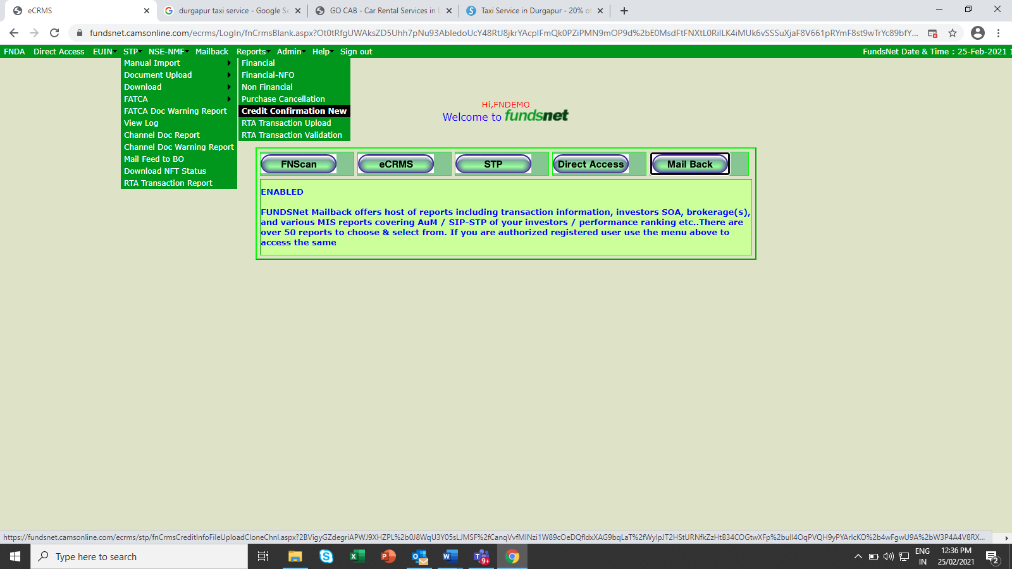
- The credit confirmation screen is same as transaction upload screen. The participant has to choose the mutual fund company for which transactions were submitted, enter count of rows in the file, enter remarks and the upload the file. Here also, the file can be in .txt or .dbf format only.

- Once both transaction and credit confirmation (for purchase only) test data are uploaded successfully, participant to send an email to innovation-sandbox@camsonline.com to ask for confirmation feed. Participant can ask for a confirmation feed immediately after uploading redemption or switch transactions by sending email to the above ID as credit confirmation is need needed for redemption or switch.

- On receiving the email, CAMS will share the confirmation feed on email to the testing ARN.
This completes testing of transaction submission into MF system.

