Facial Expresion Recognition

# INTRODUCTION

In data analytics or decision sciences, we frequently encounter scenarios in which we must categorize our data based on a certain dependent variable. There are several strategies that may be used to assist the answer for this demand, including Logistic Regression, Random Forest Algorithm, and Bayesian Algorithm, to mention a few. SVM is a machine learning approach for data separation that aims to minimize the distance between categories.

A support vector machine is used to categorize the given data. It is a type of supervised learning methods. It is trained given a set of data that has already been sorted into two groups, creating the model as it goes. The support vector machine algorithm is mainly used to determine the category of the new data point. Therefore, SVM is a non-binary linear classifier.

An SVM method should not only classify objects, but also keep the margins between them on a graph as broad as feasible.

SVM is used in the following applications:

1. Text and hypertext categorization
2. Image categorization
3. Identifying handwritten characters
4. Protein categorization is one of the biological sciences

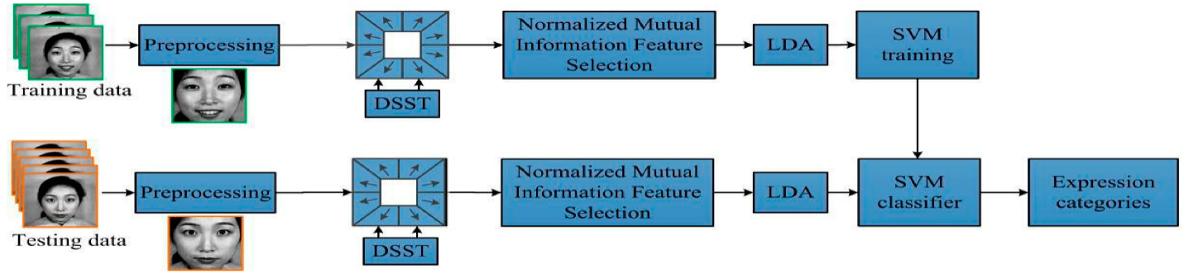

Now-a-days, in this frequently changing world, there has been a lot of changes in the facial expression recognition system starting from the laboratory-controlled techniques to recognizing in the wild conditions, we have seen success in these deep learning techniques and with that there is increasing for learning the discriminative representations to get the accurate values for the automation facial expression recognition. The recent systems for facial recognition concentrate mainly on 2 issues:

1. Overfitting which is caused due to lack of sufficient training.
2. Unrelated variations, such as illumination, head pose and identity bias.

In this problem firstly, we import the dataset and provide data selection by doing data preprocessing and use evaluation principles for those datasets. And then with the related background knowledge describe the standard pipeline of the deep facial expression recognition system and suggestions for the applicable implementations for each stage.

# METHODOLOGY

The code was written in Python. Firstly, we have imported the python modules. The database contains training and testing sets of 6 different types of facial expression (namely: happy, sad, angry, neutral, surprise and fear). The give dataset is containing several samples for training and testing the model.

Now we have imported the dataset for analysis and model building

**Implementation of Support Vector Machine**

# Experiment and Result

Here we have used the existing novel deep neural networks and related strategies which is helpful for facial expression recognition which is based on both static and dynamic images and the competitive performance and experimental comparisons which are widely used benchmarks are summarized. Below we can see an sample of the output having happy faces.

# CONCLUSION

There are 2 ways for facial expressions which are voluntary expressions and emotional expressions. The voluntary expressions are the expressions which are made by the us to show the expression wontedly, but the emotional expression is the expression which comes from us with relation to the situations happening in our surrounding. In simple terms, voluntary expressions are the expressions which we are aware, but the emotional ones are the expressions which we are unaware of. Using the dataset which we have the combination of all this kind of expressions we can recognize all the expressions and categorize them into the facial expression they kept.

# REFERENCES

* [Accurate Facial Parts Localization and Deep Learning for 3D Facial Expression Recognition](https://www.computer.org/csdl/proceedings-article/fg/2018/233501a466/12OmNvm6VG2)
* [Facial Expression Recognition Using Enhanced Deep 3D Convolutional Neural Networks](https://www.computer.org/csdl/proceedings-article/cvprw/2017/0733c278/12OmNxE2mWZ)
* [Single-Image Facial Expression Recognition Using Deep 3D Re-Centralization](https://www.computer.org/csdl/proceedings-article/iccvw/2019/502300b628/1i5mpnwLU0U)
* [Multimodal 2D and 3D for In-The-Wild Facial Expression Recognition](https://www.computer.org/csdl/proceedings-article/cvprw/2019/250600c927/1iTvp8peZOg)
* [Landmarks-assisted Collaborative Deep Framework for Automatic 4D Facial Expression Recognition](https://www.computer.org/csdl/proceedings-article/fg/2020/307900a166/1kecHYD1alq)
* [Facial Expression Recognition Using Residual Masking Network](https://www.computer.org/csdl/proceedings-article/icpr/2021/09411919/1tmhAg4ks5W)

By:

Vedvikas Reddy Magam