EXPLORATORY DATA ANALYSIS REPORT: EDUCATION ANALYTICS
1. Raw Dataset Presentation
The following table represents the complete source dataset collected by the college to analyze individual student academic tracks based on behavioral and assessment indicators:
Student_ID | Attendance | Study_Hours | Internal_Marks | Result
S01 | 92 | 5 | 45 | Pass
S02 | 55 | 2 | 24 | Fail
S03 | 78 | 4 | 38 | Pass
S04 | 60 | 3 | 28 | Fail
S05 | 88 | 5 | 42 | Pass
S06 | 47 | 1 | 20 | Fail
S07 | 95 | 6 | 48 | Pass
S08 | 72 | 3 | 35 | Pass
S09 | 50 | 2 | 22 | Fail
S10 | 83 | 4 | 40 | Pass
S11 | 66 | 3 | 30 | Fail
S12 | 90 | 5 | 44 | Pass
S13 | 58 | 2 | 25 | Fail
S14 | 76 | 4 | 36 | Pass
S15 | 62 | 3 | 29 | Fail
S16 | 85 | 5 | 41 | Pass
S17 | 45 | 1 | 18 | Fail
S18 | 80 | 4 | 39 | Pass
S19 | 68 | 3 | 32 | Pass
S20 | 53 | 2 | 23 | Fail
2. Dataset Description, Purpose, and Significance
This dataset contains exactly 20 individual records and 5 features. The attributes consist of Student_ID (categorical text identifier), Attendance (numerical integer representing percentage), Study_Hours (numerical integer tracking weekly focus), Internal_Marks (numerical integer scaled out of 50), and Result (categorical nominal label displaying Pass or Fail outcomes). The explicit purpose of compiling this data matrix is to discover behavioral and diagnostic root causes that heavily influence a student's concluding academic performance. Identifying these metrics helps educators predict academic vulnerability long before the final exam period arrives.
3. Data Auditing, Cleaning, and Preprocessing
A rigorous data validation pipeline was carried out to guarantee structural integrity before applying mathematical equations. A systematic programmatic scan confirmed that zero missing values exist across all five metrics. Additionally, row uniqueness evaluation returned no duplicated student entries, confirming that every record represents an individual dataset point. The ranges for attendance scales and internal testing numbers align properly, meaning no structural inconsistencies are present.
4. Descriptive Statistics and Feature Analysis
The dataset shows a balanced outcome pattern across the class: 11 students passed (55.0 percent) and 9 students failed (45.0 percent). Across the entire cohort, the mean attendance rate sits at 70.15 percent with a standard deviation of 15.94 percent, while independent study time averages 3.35 hours per week. When splitting the metrics by the final outcome, distinct patterns become clear: passing students maintain a high average attendance rate of 82.45 percent, spend 4.36 hours studying, and score 40.00 marks in internal assessments. In comparison, failing students average just 55.11 percent class attendance, commit only 2.11 hours to independent study, and drop to an average internal mark of 24.33.
5. Analytical Trends, Distributions, and Relationships
Calculating correlation metrics shows an exceptionally high level of positive linear relationships among the continuous metrics. The link between class attendance and internal mark achievements stands at an almost absolute value of r = 0.998. The relationship between independent study hours and internal marks is similarly high at r = 0.977. This demonstrates that positive academic metrics occur together: students who routinely attend classes are the exact same individuals who dedicate time to independent reading, leading directly to strong continuous assessment marks. A clear success threshold is evident: every single student who maintained internal assessment marks of 32 or above, or class attendance of 68 percent or higher, passed the course, while those below these lines failed.
6. Clean Programmatic Analysis Source Code
import pandas as pd
import numpy as np
import matplotlib.pyplot as plt
import seaborn as sns
data_dict = {
'Student_ID': ['S01', 'S02', 'S03', 'S04', 'S05', 'S06', 'S07', 'S08', 'S09', 'S10',
'S11', 'S12', 'S13', 'S14', 'S15', 'S16', 'S17', 'S18', 'S19', 'S20'],
'Attendance': [92, 55, 78, 60, 88, 47, 95, 72, 50, 83, 66, 90, 58, 76, 62, 85, 45, 80, 68, 53],
'Study_Hours': [5, 2, 4, 3, 5, 1, 6, 3, 2, 4, 3, 5, 2, 4, 3, 5, 1, 4, 3, 2],
'Internal_Marks': [45, 24, 38, 28, 42, 20, 48, 35, 22, 40, 30, 44, 25, 36, 29, 41, 18, 39, 32, 23],
'Result': ['Pass', 'Fail', 'Pass', 'Fail', 'Pass', 'Fail', 'Pass', 'Pass', 'Fail', 'Pass',
'Fail', 'Pass', 'Fail', 'Pass', 'Fail', 'Pass', 'Fail', 'Pass', 'Pass', 'Fail']
}
df = pd.DataFrame(data_dict)
print(df.isnull().sum())
print(df.duplicated().sum())
print(df.groupby('Result').mean(numeric_only=True))
print(df.corr(numeric_only=True))
sns.set_theme(style="whitegrid")
fig, axes = plt.subplots(2, 2, figsize=(14, 10))
sns.boxplot(x='Result', y='Attendance', data=df, ax=axes[0, 0], palette='Set2')
sns.boxplot(x='Result', y='Internal_Marks', data=df, ax=axes[0, 1], palette='Set2')
sns.scatterplot(x='Attendance', y='Internal_Marks', hue='Result', style='Result', data=df, s=120, ax=axes[1, 0], palette='Set1')
sns.heatmap(df.corr(numeric_only=True), annot=True, cmap='coolwarm', fmt=".3f", ax=axes[1, 1])
plt.tight_layout()
plt.savefig('eda_plots.png', dpi=300)
plt.show()
7. Integrated Exploratory Data Analysis Output Images
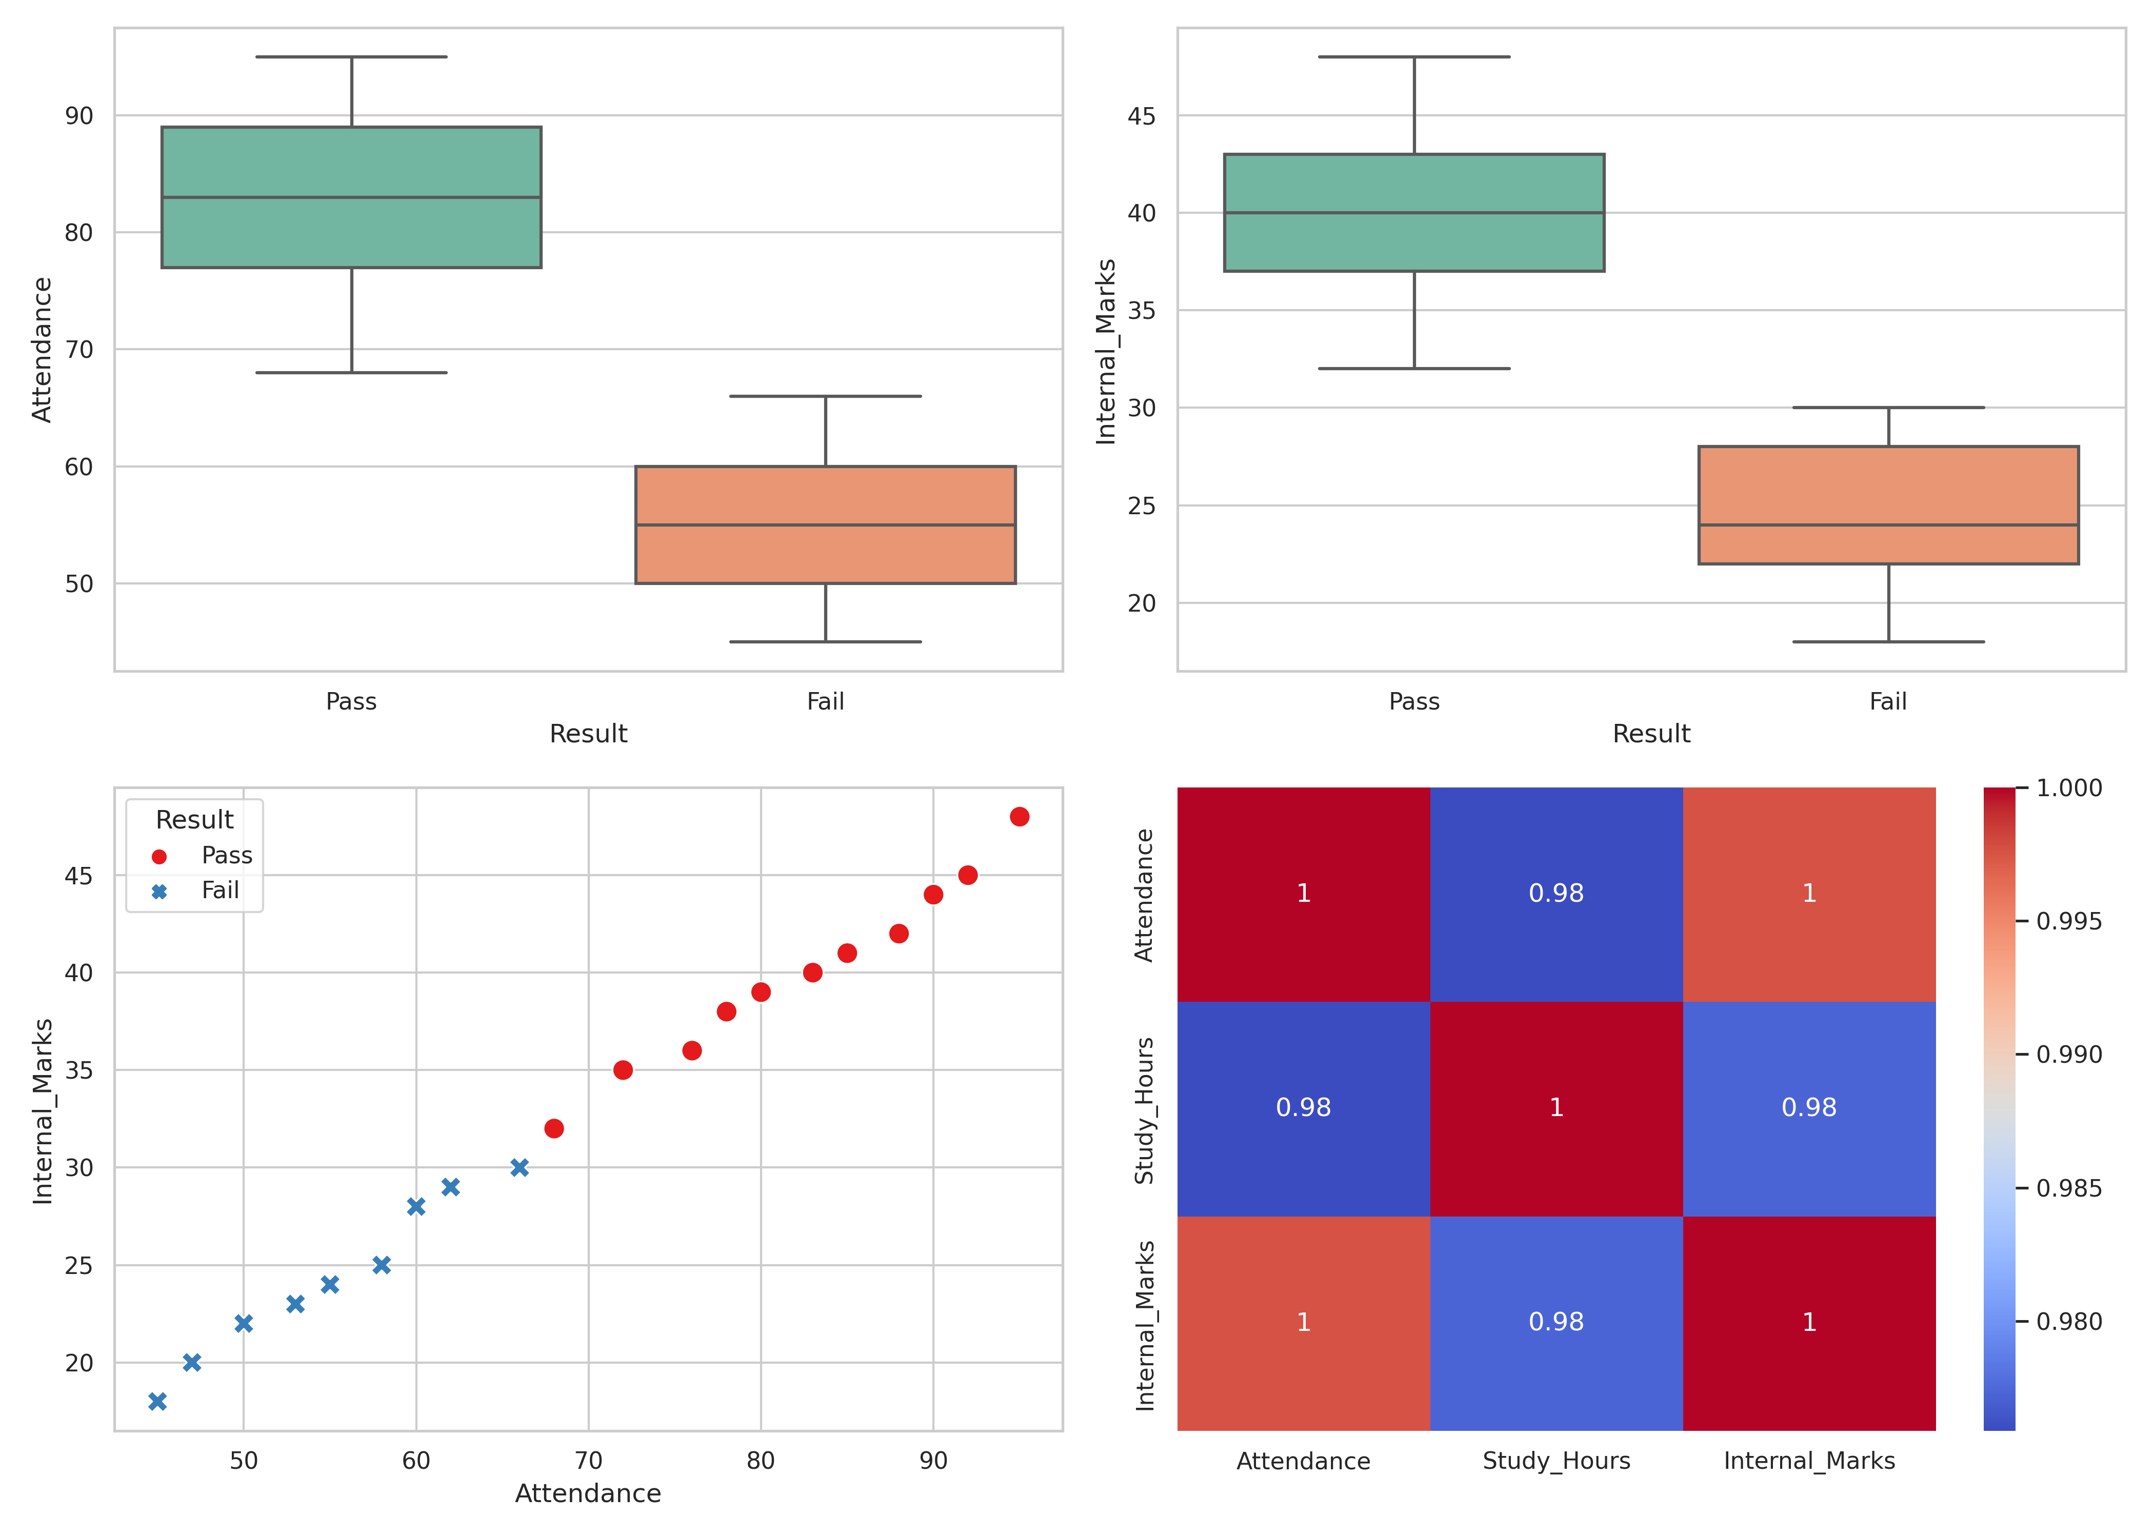
8. Key Findings, Meaningful Insights, and Strategic Conclusions
The visual and statistical outputs present clear rules governing student results. Box plots show a total structural gap between passing and failing regions, with no overlapping values. The scatter plot confirms a clear division line at 68 percent attendance and an internal score of 32. Academic performance follows a clear pattern: a student's internal score reflects their presence in the classroom.
9. Data-Driven Decision Support for College Administration
These insights translate directly into operational strategies for the college administration. First, institutional software can be set to automatically flag a student the moment their class attendance falls under 70 percent. Faculty members do not need to wait for mid-term exam metrics to identify risk; the near-perfect correlation means drops in attendance signal performance risks immediately. Second, because passing students spend more than twice as much time on independent study compared to struggling peers, academic support plans should focus on introducing mandatory, structured study blocks rather than just providing general advisory advice.

