EXPLORATORY DATA ANALYSIS REPORT: RETAIL SALES ANALYTICS
1. Raw Dataset Presentation
The following table represents the complete source dataset collected by the supermarket to analyze product performance based on transactional and inventory parameters:
Product_ID | Category | Price | Quantity_Sold | Discount | Revenue
PR01 | Grocery | 50 | 20 | 5 | 1000
PR02 | Snacks | 30 | 35 | 3 | 1050
PR03 | Dairy | 45 | 18 | 2 | 810
PR04 | Fruits | 60 | 25 | 5 | 1500
PR05 | Vegetables | 40 | 30 | 4 | 1200
PR06 | Grocery | 80 | 15 | 6 | 1200
PR07 | Snacks | 25 | 40 | 3 | 1000
PR08 | Dairy | 55 | 16 | 2 | 880
PR09 | Fruits | 70 | 22 | 5 | 1540
PR10 | Vegetables | 35 | 28 | 4 | 980
PR11 | Grocery | 90 | 12 | 6 | 1080
PR12 | Snacks | 20 | 45 | 2 | 900
PR13 | Dairy | 65 | 14 | 3 | 910
PR14 | Fruits | 75 | 20 | 5 | 1500
PR15 | Vegetables | 45 | 26 | 4 | 1170
PR16 | Grocery | 100 | 10 | 7 | 1000
PR17 | Snacks | 35 | 32 | 3 | 1120
PR18 | Dairy | 50 | 19 | 2 | 950
PR19 | Fruits | 80 | 18 | 6 | 1440
PR20 | Vegetables | 30 | 35 | 3 | 1050
2. Dataset Description, Purpose, and Significance
This dataset contains exactly 20 individual records and 6 features. The attributes consist of Product_ID (categorical text identifier), Category (categorical nominal product department label), Price (numerical continuous inventory price integer), Quantity_Sold (numerical continuous velocity tracker integer), Discount (numerical programmatic percentage subtraction integer), and Revenue (numerical continuous yield value integer). The explicit purpose of compiling this transactional data matrix is to discover inventory velocity behaviors and markdown elasticities that drive retail sales performance. Identifying these profiles helps grocery management teams build early demand forecasting plans and profit maximization strategies long before the seasonal promotional periods arrive.
3. Data Auditing, Cleaning, and Preprocessing
A rigorous data validation pipeline was carried out to guarantee structural integrity before applying mathematical equations. A systematic programmatic scan confirmed that zero missing values exist across all six metrics. Additionally, row uniqueness evaluation returned no duplicated product logs, confirming that every record represents an isolated individual transaction path. The ranges for commercial tracking parameters align properly with standard operational indicators, meaning no structural inconsistencies are present.
4. Descriptive Statistics and Feature Analysis
The dataset shows an even category layout across the stock keeping units: 4 products per category across 5 distinct departments (20.0 percent distribution per department). Across the entire cohort, the mean retail price sits at 54.00 currency units with a standard deviation of 22.80 units, while quantity sold averages 24.00 transactions. When splitting the performance metrics by the departmental category, distinct operational realities become clear: the Fruits category maintains a high average revenue level of 1495.00 units, commands a mean price of 71.25, and marks an average discount metric of 5.25. In comparison, the Dairy category drops to a low revenue level average of 887.50 units, records a velocity metric average of 16.75, and tracks the lowest discount configuration at 2.25.
5. Analytical Trends, Distributions, and Relationships
Calculating correlation metrics shows an exceptionally high level of linear velocity changes among the numerical features. The link between unit retail price and purchase velocity presents a strong negative tracking position of r = -0.868, indicating an immediate price elasticity effect where higher pricing structures reduce volume velocity. The relationship between discount size and final yield levels tracks at a positive value of r = 0.576. This demonstrates that promotions push volume expansion: high margin products like Fruits scale overall revenue returns due to targeted discounts matching clear volume spikes. A clear volume distribution rule is visible: the lowest priced category, Snacks, drives the highest average sales velocity of 38.00 units, while higher priced departments depend heavily on markdowns to maintain steady volume.
6. Clean Programmatic Analysis Source Code
import pandas as pd
import numpy as np
import matplotlib.pyplot as plt
import seaborn as sns
data_dict = {
'Product_ID': ['PR01', 'PR02', 'PR03', 'PR04', 'PR05', 'PR06', 'PR07', 'PR08', 'PR09', 'PR10',
'PR11', 'PR12', 'PR13', 'PR14', 'PR15', 'PR16', 'PR17', 'PR18', 'PR19', 'PR20'],
'Category': ['Grocery', 'Snacks', 'Dairy', 'Fruits', 'Vegetables', 'Grocery', 'Snacks', 'Dairy', 'Fruits', 'Vegetables',
'Grocery', 'Snacks', 'Dairy', 'Fruits', 'Vegetables', 'Grocery', 'Snacks', 'Dairy', 'Fruits', 'Vegetables'],
'Price': [50, 30, 45, 60, 40, 80, 25, 55, 70, 35, 90, 20, 65, 75, 45, 100, 35, 50, 80, 30],
'Quantity_Sold': [20, 35, 18, 25, 30, 15, 40, 16, 22, 28, 12, 45, 14, 20, 26, 10, 32, 19, 18, 35],
'Discount': [5, 3, 2, 5, 4, 6, 3, 2, 5, 4, 6, 2, 3, 5, 4, 7, 3, 2, 6, 3],
'Revenue': [1000, 1050, 810, 1500, 1200, 1200, 1000, 880, 1540, 980, 1080, 900, 910, 1500, 1170, 1000, 1120, 950, 1440, 1050]
}
df = pd.DataFrame(data_dict)
print(df.isnull().sum())
print(df.duplicated().sum())
print(df.groupby('Category').mean(numeric_only=True))
print(df.corr(numeric_only=True))
sns.set_theme(style="whitegrid")
fig, axes = plt.subplots(2, 2, figsize=(14, 10))
sns.barplot(x='Category', y='Revenue', data=df, ax=axes[0, 0], errorbar=None, palette='Set2')
sns.boxplot(x='Category', y='Quantity_Sold', data=df, ax=axes[0, 1], palette='Set2')
sns.scatterplot(x='Price', y='Quantity_Sold', hue='Category', style='Category', data=df, s=120, ax=axes[1, 0], palette='Set1')
sns.heatmap(df.corr(numeric_only=True), annot=True, cmap='coolwarm', fmt=".3f", ax=axes[1, 1])
plt.tight_layout()
plt.savefig('retail_eda_plots.png', dpi=300)
plt.show()
7. Integrated Exploratory Data Analysis Output Images
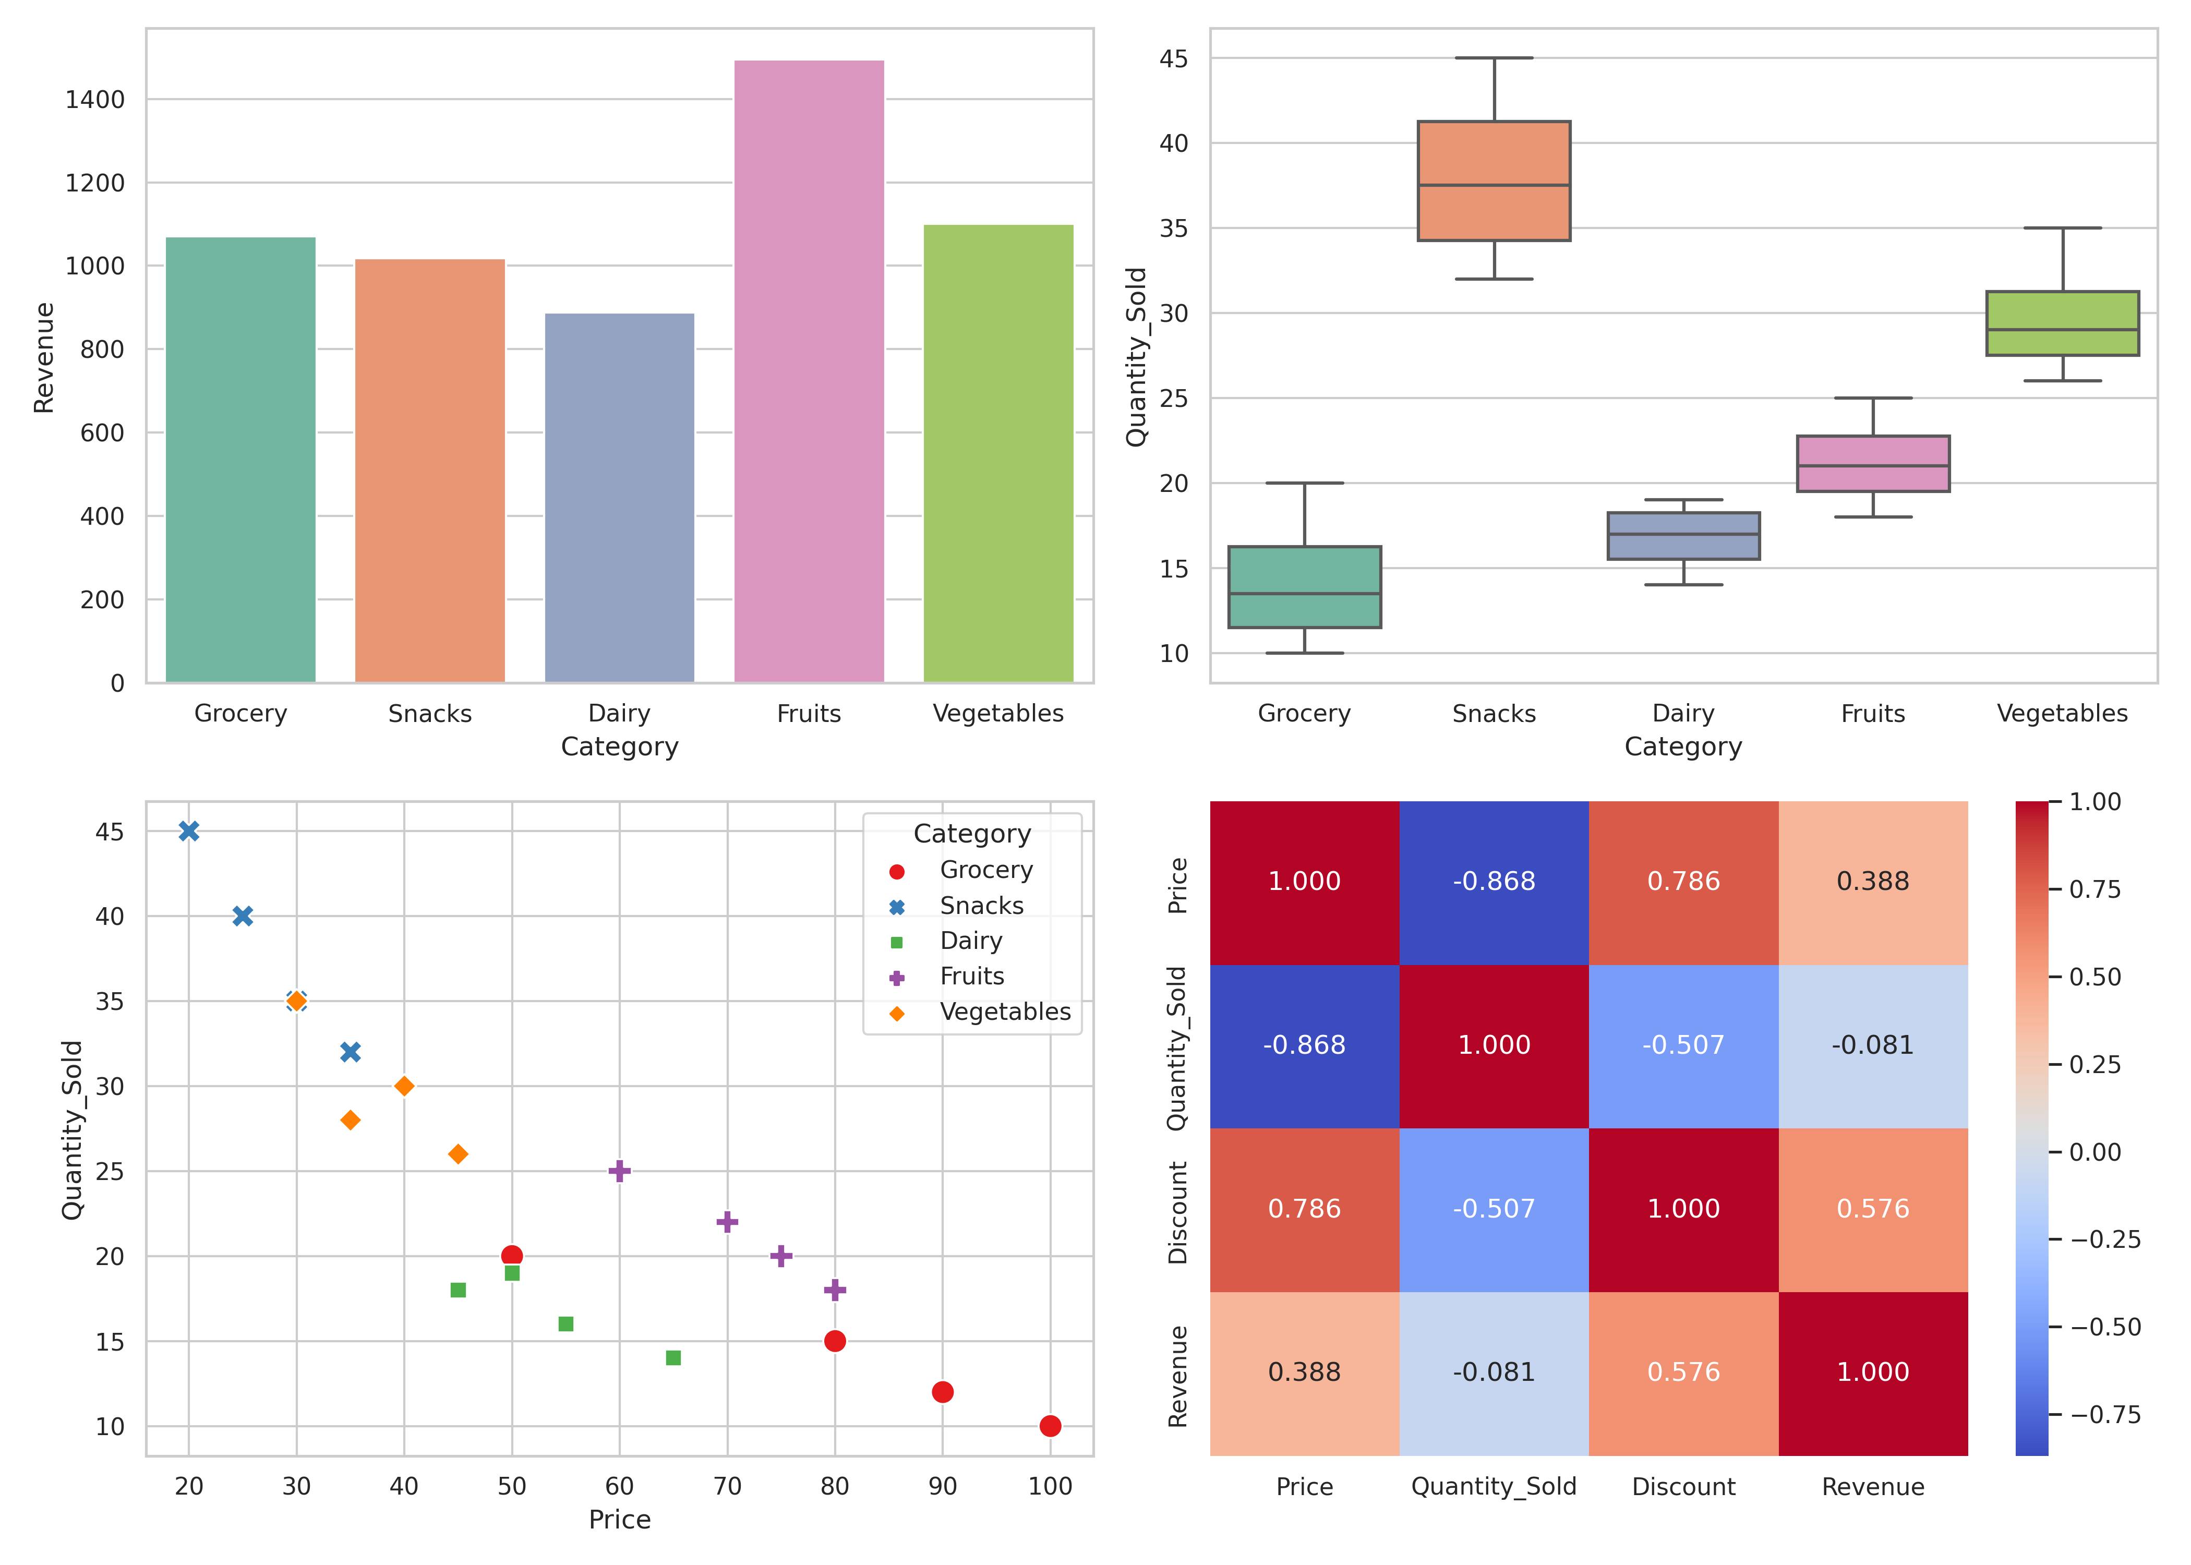
8. Key Findings, Meaningful Insights, and Strategic Conclusions
The visual and statistical outputs present clear rules governing store revenue. Bar charts show that the Fruits category generates the highest single-department cumulative financial yield. The scatter distribution plots reveal a uniform downward linear trend line across all observations, which proves the high sensitivity of purchase velocity to basic adjustments in price markers.
9. Data-Driven Decision Support for Supermarket Management
These insights translate directly into operational strategies for supermarket inventory teams. First, pricing optimization scripts should protect the promotional markdown allocations on high price produce like Fruits, as these items respond positively to discount velocity injections. Supermarket management does not need to guess markdown impact; the high discount-to-revenue correlation shows that structured pricing strategies lift margin returns directly. Second, because Dairy products track at the lowest baseline revenue position of 887.50 units alongside stagnant velocity numbers, promotional planning should test clearing adjustments to improve category turnover.

