

Campus Lost & Found Portal:
A Java-Based Item Recovery and Management System
A CAPSTONE PROJECT REPORT
A Capstone Project Report submitted in partial fulfilment of the requirements
for the Course of
CSA0908 – Programming in JAVA
to the award of the degree of
BACHELOR OF TECHNOLOGY
IN
COMPUTER SCIENCE ENGINEERING
(AI DS)

Submitted by
Vedvyass M (192324267)

Under the Supervision of
Dr. Meganathan E
SIMATS ENGINEERING
Saveetha Institute of Medical and Technical Sciences
Chennai-602105

SEPTEMBER 2026

BONAFIDE CERTIFICATE

This is to certify that the Capstone Project entitled “Campus Lost & Found Portal” has been carried out by Vedvyass M (192324267) under the supervision of Dr. E. MEGANATHAN and is submitted in partial fulfilment of the requirements for the current semester of the B.Tech Computer Science Engineering (AI DS) program at Saveetha Institute of Medical and Technical Sciences, Chennai.
COURSE FACULTY:
Dr. E. MEGANATHAN,
Assistant Professor (SG),
Department of CSE,
Saveetha School of Engineering, SIMATS, Chennai.
COURSE COORDINATOR :
Dr.G.CHARLYN PUSHPA LATHA,
Professor/Dept of CSE,
Saveetha School of Engineering, SIMATS, Chennai.

DECLARATION
I, Vedvyass M (192324267) of the Artificial Intelligence and Data Science, SIMATS Engineering, Saveetha Institute of Medical and Technical Sciences, Chennai, hereby declare that the Capstone Project Work entitled “Campus Lost & Found Portal: A Java-Based Item Recovery and Management System” is the result of our project work based on the submitted project material.
To the best of our knowledge, the work presented herein represents the system, modules, techniques, workflows, and implementation evidence described in the project presentation. The report preserves the terminology and functionality provided in the source material. Any future enhancements mentioned in the project are presented as proposed extensions rather than completed features.

Place : Chennai
Date : 03/09/2026

Signature of the Students with Names

ABSTRACT
The Campus Lost & Found Portal is a Java-based application designed to provide a centralized solution for managing lost and found belongings within a college campus. The system allows students and staff to report lost items, register found items, search and filter reported items, and track the status of reports. Administrators can verify reports, manage users, and monitor item recovery. The proposed portal reduces dependency on physical notice boards, informal messaging groups, and manual searching.
The system is organized into three major modules. Module 1 provides user and authentication management, including registration, login/logout, profile management, role-based access, password management, and access control. Module 2, the focus of the individual contribution in this report, manages lost and found item records, image uploads, search and filtering, report updates and deletion, item status management, and administrator review. Module 3 handles item matching, claim submission, ownership verification, claim decisions, recovery, and history.
The implementation material demonstrates Java packages, inheritance through servlets extending HttpServlet, object creation through constructors, database-oriented processing, and structured application workflows. The architecture connects the presentation layer, Java application layer, database layer, administrator functions, and external notification concepts. The resulting system provides a structured, searchable, and maintainable approach to campus item recovery.
Keywords: Java, Lost & Found, Item Management, Servlets, JDBC, MySQL, Authentication, Item Matching

TABLE OF CONTENTS
Sl. No. | Title | Page No.
i | CERTIFICATE FROM THE SUPERVISOR | 2
ii | DECLARATION BY THE CANDIDATES | 3
iii | ABSTRACT | 4
iv | LIST OF FIGURES | 6
v | LIST OF TABLES | 7
1 | CHAPTER 1: Introduction and Engineering Problem | 8
2 | CHAPTER 2: System Analysis and Existing Approach | 12
3 | CHAPTER 3: Engineering Design, Requirements, Security and Risk | 16
4 | CHAPTER 4: Implementation, Testing & Results, Project Management | 22
5 | CHAPTER 5: Conclusion & Reflection | 23
 | References | 24
 | Appendices | 25

LIST OF FIGURES
Figure No. | Figure Name | Page No.
Figure 2.1 | Campus Lost & Found Portal – System Architecture | 13
Figure 4.1 | Module 2 – Lost & Found Item Management | 23
Figure 4.2 | Verified reports / item-management interface | 24
Figure 4.3 | Item details and reporting interface | 24
Figure 4.4 | Module 2 workflow and database relationship | 26
Figure 4.5 | Team Project Evidence | 27

LIST OF TABLES
Table No. | Table Name | Page No.
1.1 | Project Problem Summary | 9
1.2 | Project Objectives | 10
2.1 | Existing and Proposed Approach | 12
2.2 | Module Overview | 14
2.3 | Data and Item Record Structure | 15
3.1 | Stakeholder Requirements | 16
3.2 | Functional and Non-Functional Requirements | 17
3.3 | Design Specifications | 18
3.4 | Module 2 Feature Specification | 19
3.5 | Design Trade-offs | 20
3.6 | Security and Risk Register | 21
4.1 | Software Tools and Technologies | 22
4.2 | Module 2 Test Plan | 24
4.3 | Individual Contribution – Module 2 | 25

CHAPTER 1
INTRODUCTION AND ENGINEERING PROBLEM

1.1 Background
The Campus Lost & Found Portal is a Java-based application intended to manage lost and found items within a college campus. Students and staff can report lost belongings and register items that they have found. Each item record can contain identifying information such as item name, category, location, date, description, colour, and contact information. The system also supports image uploading to make identification easier.
The project is designed as a centralized alternative to informal reporting through WhatsApp groups, notice boards, and manual searching. The system provides a structured flow from item reporting to search, status management, administrator review, and, through Module 3, matching and recovery.

1.2 Engineering Context
The engineering problem is not limited to storing an item record. The application must provide controlled access, organized item data, searchable reports, editable submissions, status tracking, and administrative verification. The system architecture therefore separates the presentation layer, Java application layer, database layer, administrator functions, and external service concepts.

1.3 Problem Statement
Lost items on campus are often reported through informal channels such as WhatsApp groups or notice boards. There is no centralized system to record and track lost and found belongings. Students may find it difficult to identify whether their lost item has been recovered, while manual management can create duplicate, outdated, or incomplete information.
The proposed engineering solution is a centralized, searchable, and secure platform that records lost and found reports and supports the recovery process. The portal provides a single place for users to submit item information and for administrators to review and manage reports.
Problem | Effect | System Response
Informal reporting channels | Reports are scattered and difficult to track | Centralized item reporting
No searchable record | Users spend time manually searching | Search and filter functionality
Incomplete item information | Identification becomes difficult | Structured item fields
Outdated report status | Users cannot know the current state | Lost / Found / Claimed / Returned status
Unverified listings | Incorrect or inappropriate reports may remain | Administrator review and verification

1.4 Objectives and Scope

Project Objectives
1. Develop a centralized portal for reporting lost and found items.
2. Allow users to register, search, and track items easily.
3. Provide item matching based on category, location, date, and description.
4. Allow administrators to verify and manage submitted reports.
5. Maintain a database of lost and found items.
6. Improve the chances of returning lost belongings to their rightful owners.
7. Reduce manual effort and communication gaps.

Scope
• Lost-item and found-item reporting.
• Structured item details including name, category, colour, description, date, and location.
• Image upload for easier identification.
• Search and filtering by category, location, date, and keywords.
• Update and deletion of user-submitted reports.
• Item status management.
• Administrator review and verification.
• Integration with the authentication and claim/recovery modules.

1.5 Expected Outcomes and Project Benefits
The expected outcome is a centralized campus item-recovery system that makes reporting and searching faster and easier. The portal is intended to improve organization of item information and reduce communication gaps between people who lose items, people who find items, and administrators.
Outcome | Benefit
Centralized records | One structured location for lost and found reports
Image support | Easier visual identification of an item
Search and filter | Faster discovery of potentially relevant reports
Status tracking | Clearer visibility of Lost, Found, Claimed, and Returned states
Admin verification | Improved control over reported listings
Module integration | Connection between reporting, matching, claiming, and recovery

The project presentation also identifies future enhancement possibilities including AI, mobile applications, notifications, and cloud technologies. These are considered future extensions rather than completed capabilities in the submitted material.

CHAPTER 2
SYSTEM ANALYSIS AND EXISTING APPROACH

2.1 Existing Approach
The project identifies informal reporting through WhatsApp groups and notice boards as the existing practical approach. Such channels can communicate a lost-item message quickly, but they do not provide a structured database, controlled status lifecycle, centralized search, or systematic administration of reports.

2.2 Proposed Approach
The proposed portal replaces fragmented reporting with a Java-based application and database-backed workflow. Users interact through the presentation layer, Java application components process requests, and the database layer stores the structured records. Administrator functions provide verification and management.
Aspect | Existing Informal Approach | Proposed Portal
Reporting | Messages / notice boards | Structured item forms
Storage | Scattered messages | Database records
Search | Manual | Category, location, date, keyword filters
Status | Not consistently maintained | Lost, Found, Claimed, Returned
Verification | Informal | Administrator review
Recovery workflow | Communication dependent | Connected to matching and claims module

2.3 System Architecture / Workflow

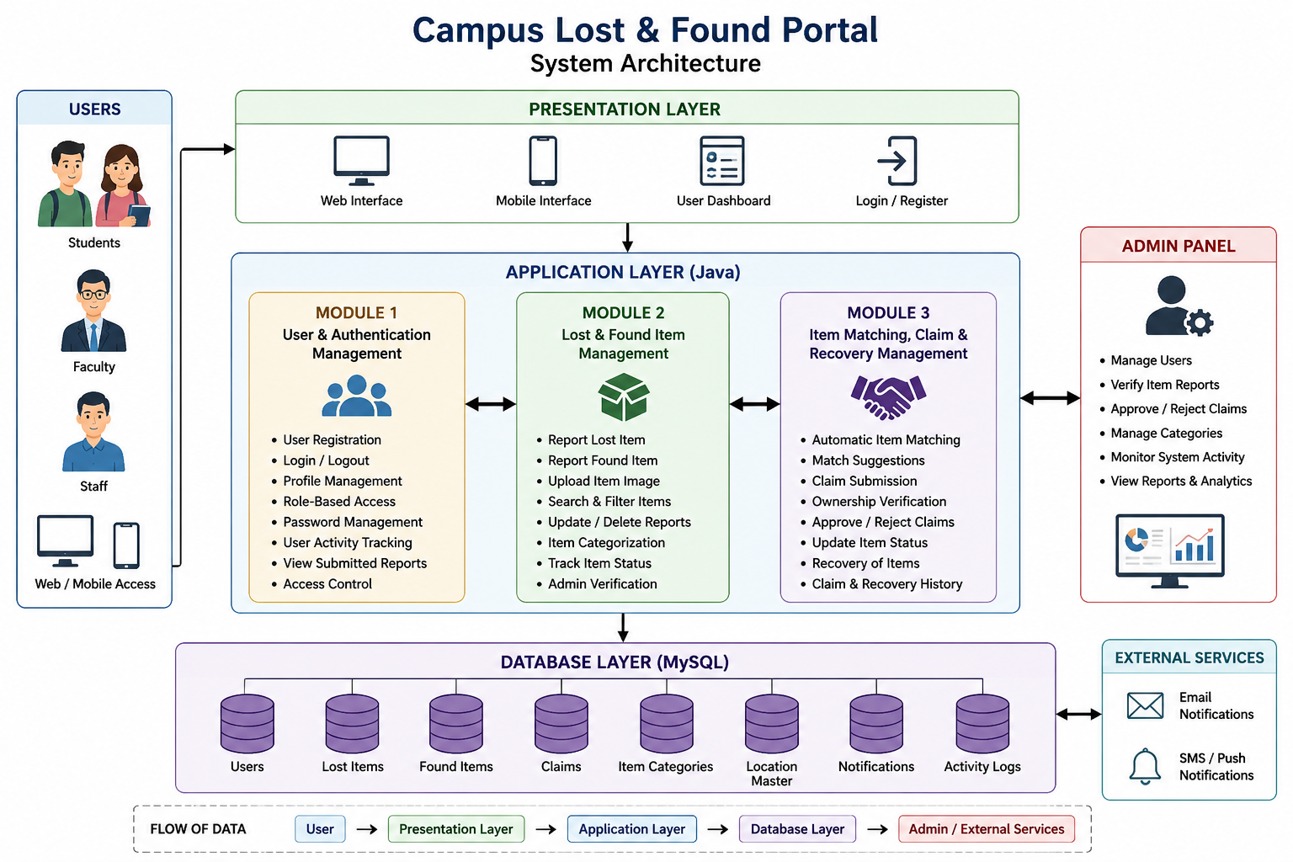

Figure 2.1: Campus Lost & Found Portal – System Architecture

The architecture shown in the project presentation separates the system into a presentation layer, application layer, and database layer. The application layer contains Module 1, Module 2, and Module 3. The architecture also shows an administrator panel and external services for notification concepts. Module 2 sits at the centre of item information management and connects reporting activity with the database and the subsequent matching and recovery workflow.
2.4 Module Overview
Module | Purpose | Key Functions
Module 1 | User & Authentication Management | Registration, login/logout, profiles, role-based access, password management, submitted reports, access control
Module 2 | Lost & Found Item Management | Report lost/found items, image upload, search/filter, update/delete, status management, admin verification
Module 3 | Item Matching, Claim & Recovery Management | Matching, claim submission, ownership verification, approve/reject claims, recovery, history

2.5 Relationship Between Modules
Module 2 provides the item records that are later used by Module 3 for matching and recovery. Module 1 controls the user identity and access context under which reports are submitted and managed. This modular structure allows each major responsibility to be separated while keeping the complete portal workflow connected.

2.6 Data and Item Record Structure
The project presentation identifies the MySQL database layer and an items table for Module 2. The item-management workflow is organized around the stored item record and the actions performed on it.
Item Information | Purpose in Module 2
Item name | Identifies the reported belonging
Category | Supports classification and filtering
Colour | Provides an additional identifying characteristic
Description | Stores detailed identifying information
Date | Supports time-based search and identification
Location | Identifies where the item was lost or found
Image | Provides visual identification support
Status | Tracks Lost, Found, Claimed, and Returned states

The source presentation also identifies contact information as part of the broader reporting context. The exact database column definitions are not provided in the presentation; therefore this report does not invent a detailed schema beyond the stated item-management fields.

CHAPTER 3
ENGINEERING DESIGN, REQUIREMENTS, SECURITY AND RISK

3.1 Stakeholder Requirements
Stakeholder | Requirement
Students | Report lost/found items and search existing reports
Faculty / Staff | Register found items and search for relevant belongings
Administrators | Review, verify, and manage item reports
System / Developer | Maintain structured Java application components and database processing
Project Users | Receive a simple workflow for reporting and finding items

3.2 Functional and Non-Functional Requirements
Requirement Type | Requirement
Functional | Create lost and found item reports
Functional | Upload an item image
Functional | Search and filter item records
Functional | Update or delete submitted reports
Functional | Maintain item status
Functional | Administrator review and verification
Functional | Store item information in the database
Non-Functional | Usability: simple reporting and searching
Non-Functional | Maintainability: organized packages and module separation
Non-Functional | Access control: restricted administrative functions
Non-Functional | Reliability: validate item information and handle database errors

3.3 Design Specifications
Parameter | Target / Requirement | Priority
Input | Lost/found item details | High
Database | items table for item records | High
Image handling | Upload item image | High
Search | Category, location, date, keywords | High
Editing | Update/delete own reports | High
Status | Lost, Found, Claimed, Returned | High
Verification | Administrator review | High
Java structure | Packages and servlet-based inheritance | High

3.4 Module 2 Design Principle
Module 2 is designed as the item-management centre of the portal. Its responsibility begins with capturing item information and continues through storage, image support, retrieval, modification, deletion, status tracking, and administrator verification. The module therefore acts as the operational bridge between users and the item database.

3.5 Module 2 Feature Specification
Feature | Input / Action | Expected Result
Report Lost Item | User enters item details | Lost item record is created
Report Found Item | User enters found-item details | Found item record is created
Image Upload | User selects an item image | Image is associated with item identification
Search & Filter | Category / location / date / keyword | Relevant item records are displayed
Update Report | User edits submitted report | Updated item information is stored
Delete Report | User removes own report | Selected report is removed
Status Management | Status is maintained by workflow | Item reflects current state
Admin Review | Administrator checks report | Report is verified or managed

3.6 Design Trade-offs
Design Decision | Alternative | Benefit | Trade-off
Centralized database | Informal messages | Structured and searchable records | Requires database management
Image upload | Text-only reports | Better item identification | Requires image handling
Search and filters | Manual browsing | Faster discovery | Requires consistent item fields
Status lifecycle | No status tracking | Clearer recovery state | Status must be maintained correctly
Admin verification | Open publishing | Better control over listings | Requires administrator effort
Modular Java design | Single large component | Improves organization | Requires coordination between modules

3.7 Security, Safety and Risk
The project is a software-based campus management application and does not directly control physical equipment. The principal safety concern is therefore the effect of incorrect or misleading information rather than physical system control. Access control, administrator verification, and structured records are important for reducing misuse.
Risk | Impact | Mitigation
Incorrect item information | Difficult identification | Validate and review submitted reports
Duplicate or outdated reports | Confusion during searching | Maintain report status and update/delete capability
Unauthorized administrative action | Incorrect listings or decisions | Role-based access from Module 1
Database operation failure | Report may not be stored correctly | Structured Java database handling and exception handling
Inappropriate image/report | Poor quality or misuse of portal | Administrator review

The source presentation demonstrates exception handling using try-with-resources and SQLException handling. This supports controlled handling of database operations and helps prevent unhandled database errors.

CHAPTER 4
IMPLEMENTATION, TESTING & RESULTS, PROJECT MANAGEMENT

4.1 Development Approach & Resources
The project is implemented as a Java-based application with a database-backed workflow. The presentation identifies Java, servlets, packages, JDBC-related database connectivity, MySQL database storage, and Java programming concepts such as inheritance and constructors. The complete system is divided into three functional modules.

Technology / Concept | Purpose
Java | Application logic and implementation
Servlets / HttpServlet | Receive and process application requests
JDBC | Database connectivity and database operations
MySQL | Storage layer identified in the architecture
Packages | Organized code structure using com.lostfound.*
Inheritance | Servlets extending HttpServlet
Constructors | Object creation and initialization
Exception Handling | Controlled database error handling

4.2 Module 2 Implementation Evidence
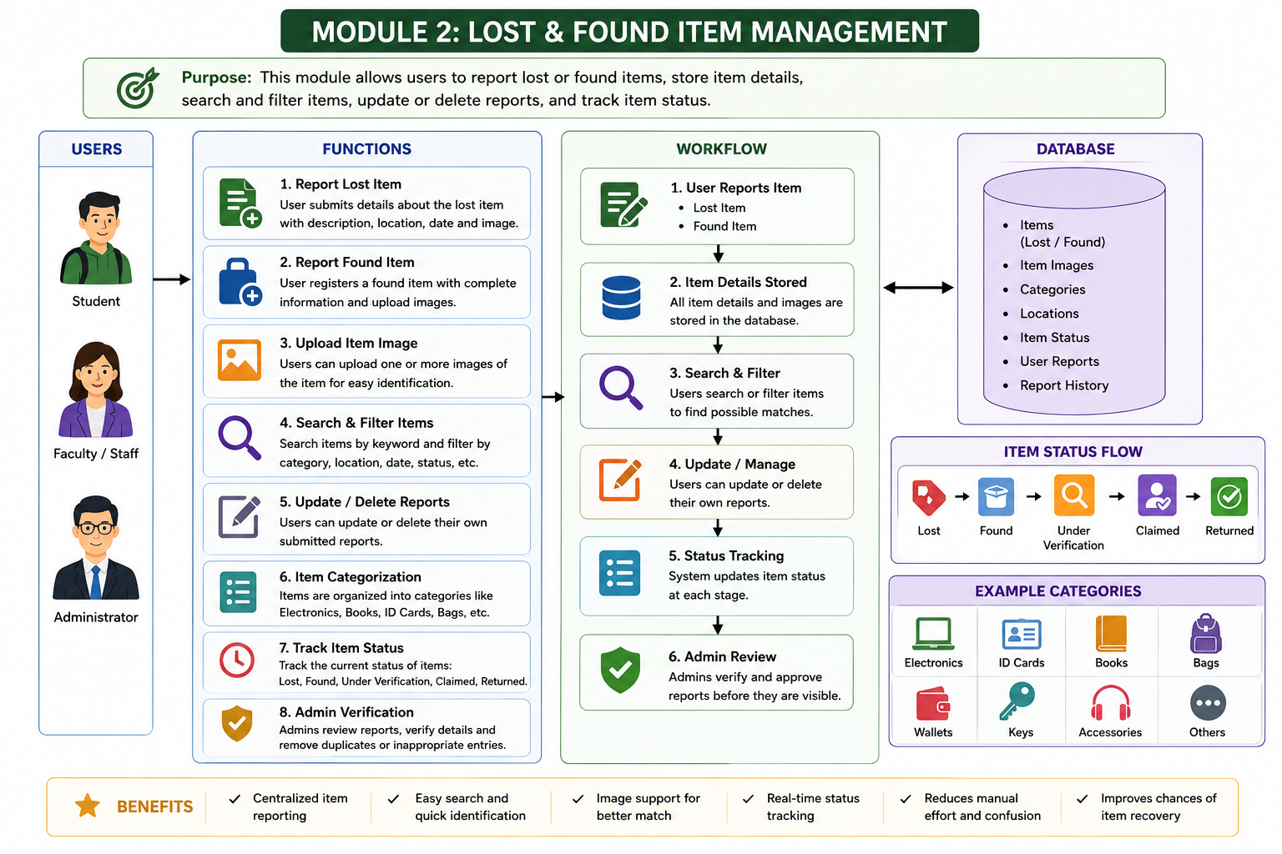

Figure 4.1: Module 2 – Lost & Found Item Management

The Module 2 architecture shown in the project presentation identifies the user-facing functions, workflow, database interaction, and expected benefits. The module includes report-lost and report-found functions, image upload, search and filtering, update/delete operations, status tracking, and administrator verification.

4.3 Module 2 User Interface
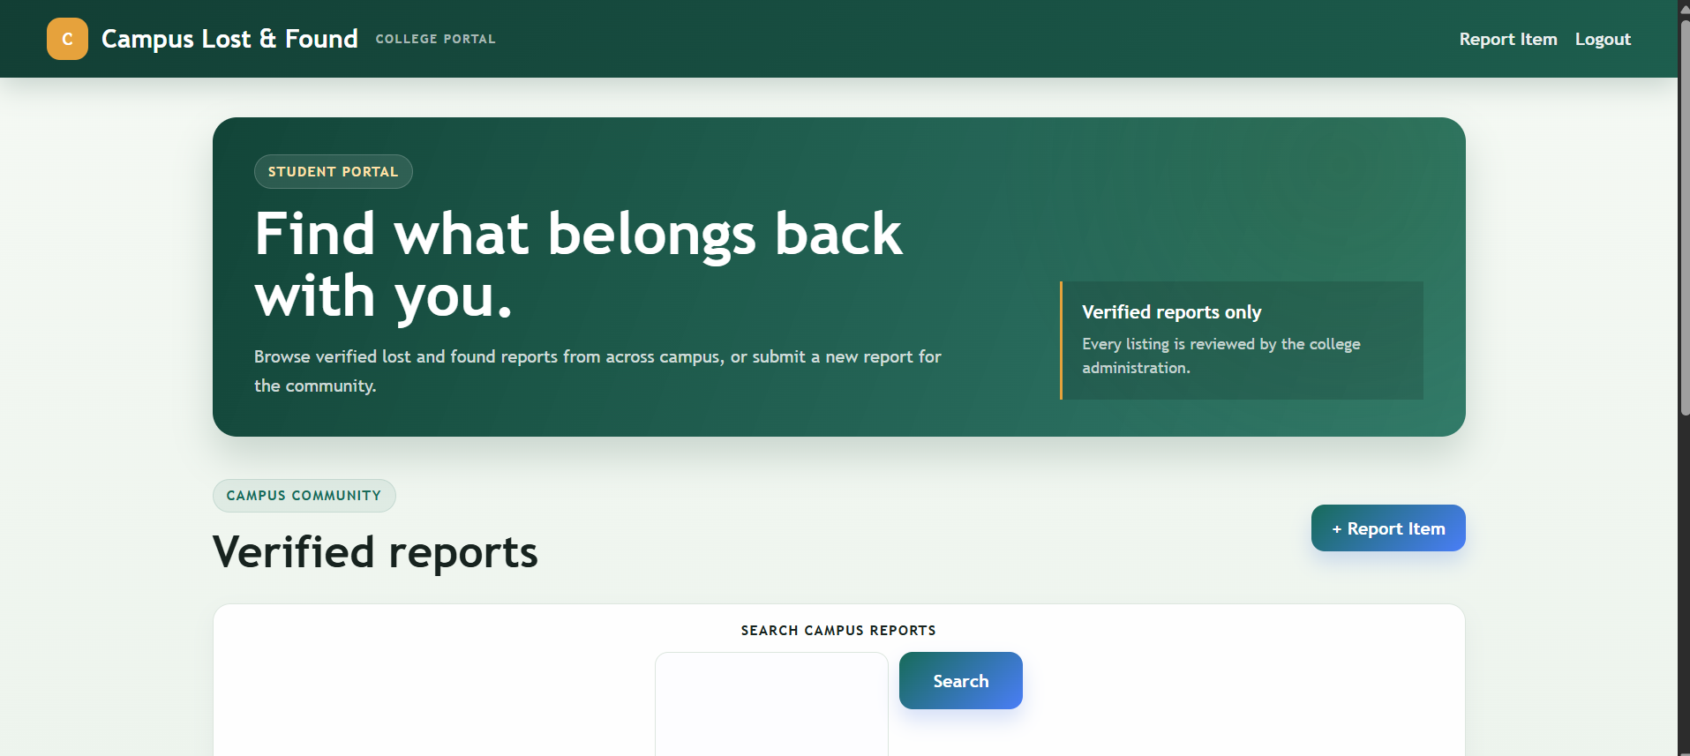

Figure 4.2: Verified reports / item-management interface

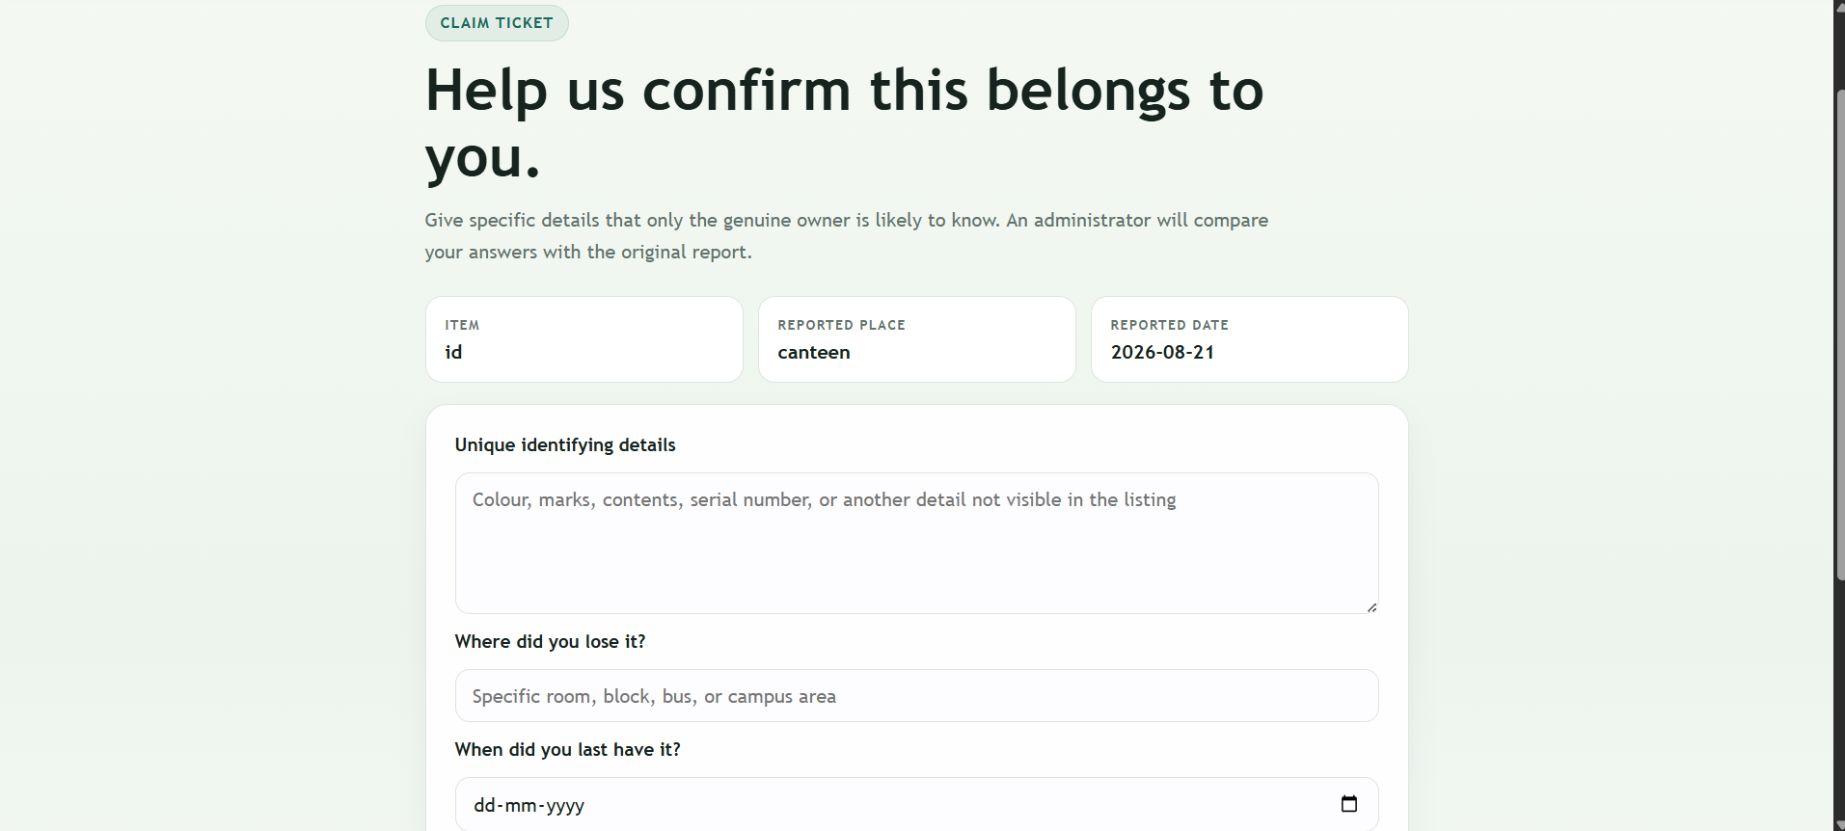

Figure 4.3: Item details and reporting interface

4.4 Module 2 Java Techniques

Packages
The source presentation identifies packages as an organized code structure using `com.lostfound.*`. This keeps related Java components grouped into a maintainable application structure.

Inheritance
Servlets extend the `HttpServlet` class. This demonstrates inheritance by deriving application-specific servlet classes from the servlet framework class.

Object Creation Using Constructor
User user = new User(name, email, password, department, phone, "USER");
public class User {
public User() {} // No-argument constructor
public User(String name, String email, String password, ...) {
this.name = name;
this.email = email;
// Initialize all fields
}
}
The constructor example demonstrates object creation using `new` and initialization of object fields. Although the example is presented under the Module 2 technique slide, it reflects the Java object-oriented structure used across the portal.

4.5 Module 2 Workflow


Figure 4.4: Module 2 workflow and database relationship

1. A user reports a lost or found item with the required details.
2. The item information is associated with the MySQL items table.
3. An image can be uploaded to support identification.
4. Search and filtering allow users to locate relevant reports.
5. Users can update or delete their own submitted reports.
6. The item status is maintained as Lost, Found, Claimed, or Returned.
7. Administrators review and verify reported items before the information is relied upon in the recovery process.

4.6 Test Plan & Verification

Test Case | Test Method | Expected Result
Report lost item | Submit a complete lost-item form | Lost item record is created
Report found item | Submit a complete found-item form | Found item record is created
Image upload | Attach an item image | Image is accepted for identification
Search | Search using a keyword | Relevant reports are displayed
Filter | Apply category/location/date filter | Matching records are narrowed
Update | Edit an existing user report | Changed details are stored
Delete | Delete an own report | Selected report is removed
Status | Change/track item state | Valid status is maintained
Admin review | Administrator checks a report | Report can be verified or managed

The source presentation does not provide numerical test results or formal pass/fail measurements. Therefore, this report records the verification criteria supported by the stated module functions without inventing performance statistics.

4.7 Individual Contribution – Module 2
Individual contributor: Vedvyass M (192324267)
The individual contribution for this capstone is Module 2 – Lost & Found Item Management. The module is responsible for the core item-record workflow: reporting lost items, registering found items, storing identifying information, uploading images, searching and filtering records, updating or deleting submitted reports, maintaining item status, and supporting administrator review.
Contribution Area | Work Represented in the Project
Item reporting | Lost and found item entry workflow
Item data | Name, category, colour, description, date, location and related details
Image support | Item image upload for identification
Search / filter | Category, location, date and keyword-based discovery
Report maintenance | Update and delete operations for submitted reports
Status management | Lost, Found, Claimed, Returned lifecycle
Admin support | Review and verification of item listings
Java concepts | Packages, inheritance, constructors and organized module structure

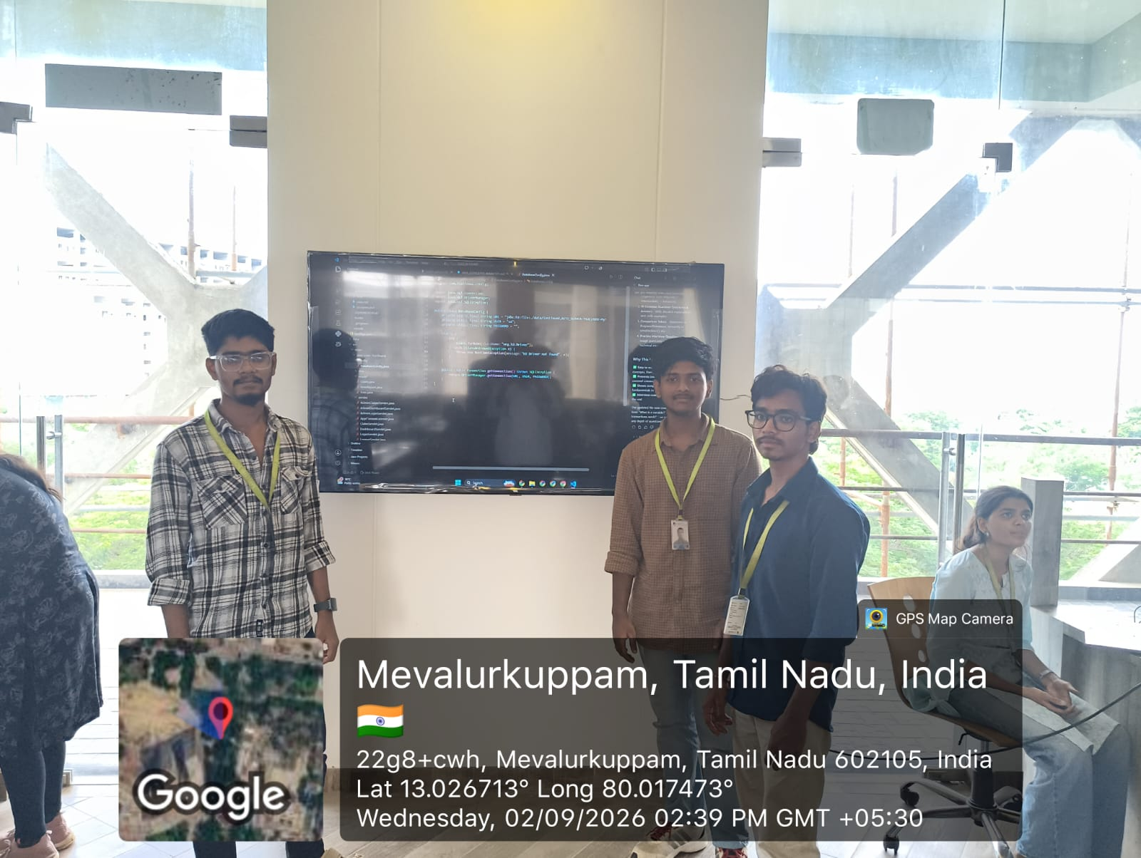
Figure 4.5: Team Project Evidence

CHAPTER 5
CONCLUSION & REFLECTION

The Campus Lost & Found Portal provides a centralized solution for managing lost and found belongings within a college campus. It makes reporting and searching for items faster and easier by replacing fragmented communication with structured item records and a searchable workflow.
Module 2 forms a critical part of the system because it manages the item lifecycle from initial reporting through search, modification, deletion, status tracking, and administrator verification. Its integration with Module 1 provides user and access context, while Module 3 uses the item information for matching, claim, and recovery operations.
The project demonstrates how Java can be used to organize application logic through packages, inheritance, constructors, servlets, and database-oriented processing. The system can be further enhanced with AI, mobile applications, notifications, and cloud technologies as identified in the project presentation.
From an engineering perspective, the project highlights the importance of centralized data management, modular design, controlled access, structured item information, and verification. The individual Module 2 contribution demonstrates how a focused module can support the overall system while remaining connected to the other functional components.

REFERENCES
The supplied project presentation was used as the primary source for the content of this final report. No external reference list was provided in the presentation; therefore, no external sources have been added or represented as if they were part of the submitted project material.

Reference | Use in Report
CSA0908 – Java PPT Final, Campus Lost & Found Portal: A Java-Based Item Recovery and Management System | Primary project source for objectives, modules, architecture, techniques, interfaces and conclusion
Project implementation examples shown in the supplied presentation | Source for the Java package, inheritance and constructor examples reproduced in the implementation discussion

APPENDICES

Appendix A – Module 2 Technique Extract
Packages - Organized code structure (`com.lostfound.*`)
Inheritance - Servlets extending `HttpServlet` class.

Appendix B – Constructor Example
User user = new User(name, email, password, department, phone, "USER");
public class User {
public User() {}
public User(String name, String email, String password, ...) {
this.name = name;
this.email = email;
// Initialize all fields
}
}

Appendix C – Module 2 Feature Flow
MySQL → items table → Image Upload → Search & Filter → Update / Delete Report → Item Status Management → Admin Review & Verification.

Appendix D – Source Presentation Screens
The report incorporates the architecture and interface evidence supplied in the project presentation, including the system architecture, Module 2 design, verified-report interface, item-detail interface, and team project evidence.

