**Date: 02-03-2020**

**Author-MD Fakrul Islam**

[**fakrul.islam@tsi.com.bd**](mailto:fakrul.islam@tsi.com.bd)

**Configuration in Linux OS(ubuntu), Python, OpenVino and Model development using TensorFlow**

**#Step 1: (OS Preparation)**

Please make sure that Ubuntu 18.04(OpenVino, 2019 R3.1, Build date:23 Oct 2019, Supported) is installed properly.

Give the following command in the shell to know your Ubuntu version.

**$ cat /etc/os-release**

And you get the below information.

NAME="Ubuntu"

VERSION="18.04.3 LTS (Bionic Beaver)"

ID=ubuntu

**#Step 2:(Intel distributed OpenVino Toolkit installation)**

1. Go to the link to download OpenVino for Linux

<https://software.intel.com/en-us/openvino-toolkit/choose-download/free-download-linux>

1. Download the 2019 R3.1 version

(Build date:23 Oct 2019)

1. Go to the link to get the installation instruction to configure OpenVino in your workstation

<http://docs.openvinotoolkit.org/2019_R3.1/_docs_install_guides_installing_openvino_linux.html>

***Please stop when you find the

Option 1: Configure all supported frameworks at the same time

Option 2: Configure each framework separately

For both cases(Option 1 or Option 2), you need to configure OpenCV otherwise inferencing will not work.

Please go to the location

**$ cd /opt/intel/openvino/deployment_tools/model_optimizer**

Please see the file, requirements_tf.txt

**$ cat requirements_tf.txt**

tensorflow>=1.2.0,<2.0.0

networkx>=1.11,<2.4

numpy>=1.12.0

defusedxml>=0.5.0

And, add the line ***opencv-python=4.2.0.32*** in requirements_tf.txt and requirements_tf.txt will look like,

**$ cat requirements_tf.txt**

tensorflow>=1.2.0,<2.0.0

networkx>=1.11,<2.4

numpy>=1.12.0

defusedxml>=0.5.0

***opencv-python=4.2.0.32***

1. Please go to,

**$ cd /opt/intel/openvino/deployment_tools/model_optimizer/install_prerequisites**

to configure the Model Optimizer for Caffe, TensorFlow, MXNet, Kaldi*, and ONNX run,

**$ sudo ./install_prerequisites.sh**

Or,

To configure the Model Optimizer for TensorFlow only run

**$ sudo ./install_prerequisites_tf.sh**

Then follow the rest of the steps in, <http://docs.openvinotoolkit.org/2019_R3.1/_docs_install_guides_installing_openvino_linux.html>

to ensure OpenVino installation.

**#Step 3:(Download the Dataset )**

Please go to the link,

https://drive.google.com/open?id=1bom9KhUStVhVqGE3eCh-nkUkc9uzqJ40

Download the dataset, **PlantPathology.zip**

**#Step 4:(Extract the Dataset)**

After extracting the zip file, you will get the following directory structure

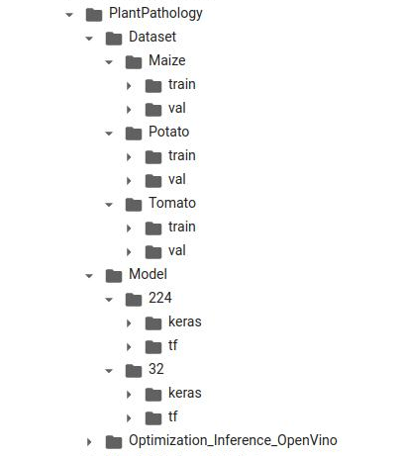

If you open the train and val folder, you will get the following directory structure that holds training and validation images of the diseases.

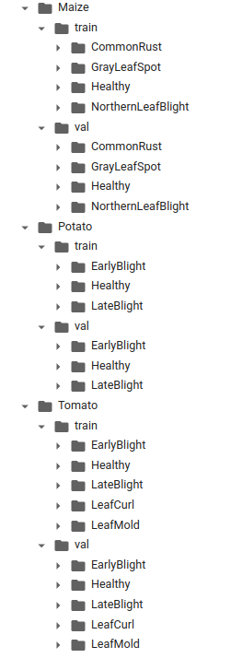

******

224 folder contains KERAS and TENSORFLOW model trained by images of size 224*224

128 folder contains KERAS and TENSORFLOW model trained by images of size 128*128

64 folder contains KERAS and TENSORFLOW model trained by images of size 64*64

32 folder contains KERAS and TENSORFLOW model trained by images of size 32*32

**#Step 5:(Download the ipynb files from the git )**

Go to <https://github.com/tsiAILAB/Plant-Pathology> and download

1. tsiailab_tomato_diseases_solution.ipynb
2. tsiailab_potato_diseases_solution.ipynb
3. tsiailab_maize_diseases_solution.ipynb

**#Step 6:(How to execute ipynb files to develop model in your work-station)-Option 1**

1. Create a virtual environment in your work-station so that your existing setup or libraries are not damaged and all required libraries are loaded inside this virtual environment.
2. Create a directory, “intel_deep_learning_project” inside your /home directory.
3. **$ mkdir intel_deep_learning_project**
4. Create a virtual environment of name, “**PlantPathology**”
5. **$ python3 -m venv PlantPathology**
6. Activate this virtual environment “**PlantPathology**”
7. **$ source PlantPathology/bin/activate**
8. **Now install all required libraries (ignore all warnings)**

**$ pip3 install jupyterlab/pip3 install jupyter**

**$ pip3 install tensorflow==1.14.0**

**$ pip3 install Keras**

**$ pip3 install opencv-python**

**$ pip3 install matplotlib**

**$ pip3 install numpy**

**$ pip3 install voila**

**$ pip3 install joblib**

**$ pip3 install Pillow**

1. Run the jupyter notebook

**$ jupyter notebook**

1. Home screen of your jupyter notebook will be shown.
2. Click upload and load all ipynb files.

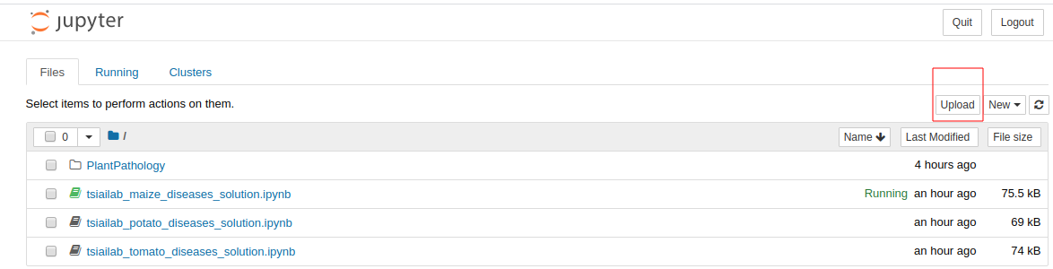

I. Set training and validation dataset location as well as image dimension(32*32 or 64*64 or 128*128 or 224*224) in the cell below.

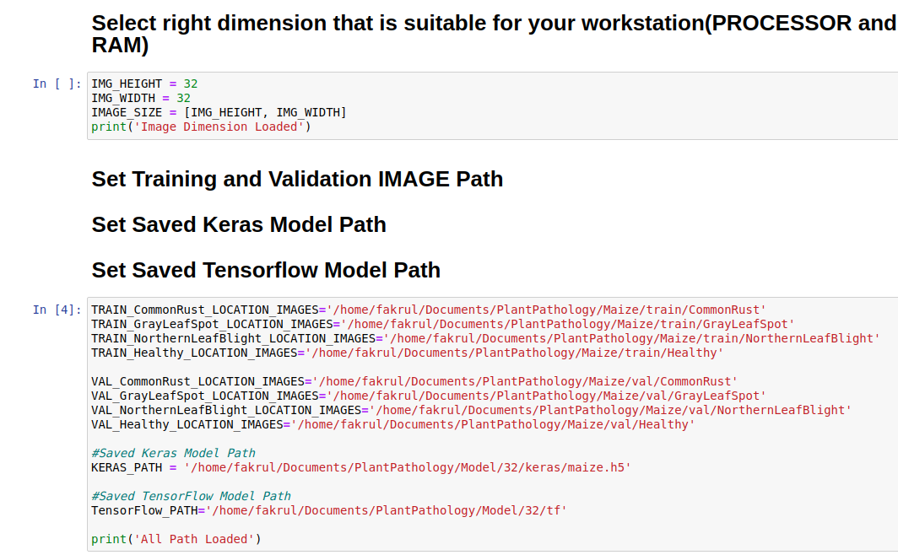

J. Execute each cell of ipynb files one after another to develop the model(both KERAS and TensorFlow) for tomato(tsiailab_tomato_diseases_solution.ipynb), potato(tsiailab_potato_diseases_solution.ipynb) and maize(tsiailab_maize_diseases_solution.ipynb) diseases.

K. You will find that KERAS and TensorFlow model will be created in the following directory,

/home/fakrul/Documents/PlantPathology/Model/32/keras -KERAS model as .h5 format

/home/fakrul/Documents/PlantPathology/Model/32/tf - TensorFlow model as .pb format

**(How to execute ipynb files to develop model in colab platform)-Option 2**

1. Type in your browser, colab.research.google.com
2. Click, File -> Upload notebook

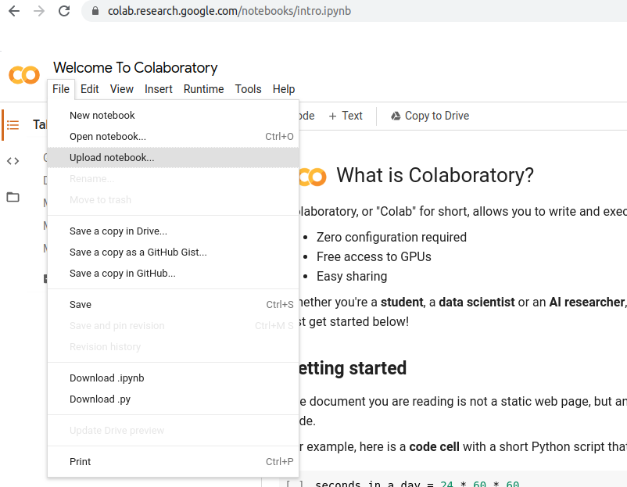

1. Upload below ipnyb files for KERAS and TENSORFLOW Model development

tsiailab_tomato_diseases_solution.ipynb

tsiailab_potato_diseases_solution.ipynb

tsiailab_maize_diseases_solution.ipynb

1. Upload the dataset **PlantPathology.zip** in your google drive.
2. **\*\*\*\*You must mount your google drive to extract the zip** file(**PlantPathology.zip**) as well as to run the

tsiailab_tomato_diseases_solution.ipynb

tsiailab_potato_diseases_solution.ipynb

tsiailab_maize_diseases_solution.ipynb

Please run below in the above each ipynb files to mount your google drive from your colab notebook

from google.colab import drive

drive.mount('/content/drive')

You will get something,

Go to this URL in a browser:https://accounts.google…….

You will click in the above link and will get something,



You will click in your google account and will get below



Click allow ad you will get,

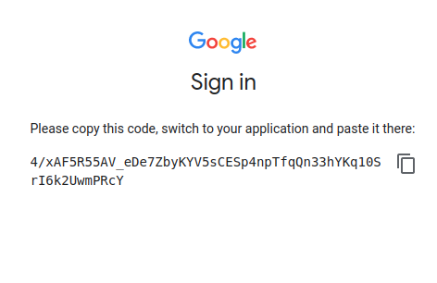

Copy the code and paste in the colab notebook to get access in your drive.

As this is not part of the model development, this is ignored in the below files.

tsiailab_tomato_diseases_solution.ipynb

tsiailab_potato_diseases_solution.ipynb

tsiailab_maize_diseases_solution.ipynb

1. To extract the **PlantPathology.zip** you can run below from you colab notebook,

# importing required modules

from zipfile import ZipFile

# location of the dataset zip file

file_name = "/…../PlantPathology.zip"

# opening the zip file in READ mode

with ZipFile(file_name, 'r') as zip:

# printing all the contents of the zip file

zip.printdir()

# extracting all the files in the destination

print('Extracting all the files now...')

zip.extractall(path='/…../PlantPathology')

print('Done!')

As this is not part of the model development, this is also ignored in the below files.

tsiailab_tomato_diseases_solution.ipynb

tsiailab_potato_diseases_solution.ipynb

tsiailab_maize_diseases_solution.ipynb

1. Set training and validation dataset location in your google drive as well as image dimension(32*32 or 64*64 or 128*128 or 224*224) in the below cell



1. Execute each cell of ipynb files one after another to develop(both KERAS and TensorFlow) the model for tomato(tsiailab_tomato_diseases_solution.ipynb), potato(tsiailab_potato_diseases_solution.ipynb) and maize(tsiailab_maize_diseases_solution.ipynb) diseases.
2. You will find that KERAS and TensorFlow model will be created in the following directory,

/…../PlantPathology/Model/32/keras -KERAS model as .h5 format

/…./PlantPathology/Model/32/tf - TensorFlow model as .pb format