**Date: 02-03-2020**

**Author-MD Fakrul Islam**

[**fakrul.islam@tsi.com.bd**](mailto:fakrul.islam@tsi.com.bd)

**Edge computing for reference implementation**

**(intel dev cloud edge)**

**\*\*\*\*\*Note**

**The below inferencing computation requires an active account in intel dev cloud edge. All the examples were shown from the account of,**

**“u37452-fakrul.islam@tsi.com.bd”**

#Step 1:

Create a directory “EdgeComputation” under, **u37452@s099-n003:~/Model_32$**

#Step 2:

Copy all class levels and image input files into the directory, “EdgeComputation”

1. **u37452@s099-n003:~/Model_32$ cp MHL.JPG EdgeComputation/**
2. **u37452@s099-n003:~/Model_32$ cp PHL.JPG EdgeComputation/**
3. **u37452@s099-n003:~/Model_32$ cp TLB.JPG EdgeComputation/**
4. **u37452@s099-n003:~/Model_32$ cp maize.labels EdgeComputation/**
5. **u37452@s099-n003:~/Model_32$ cp tomato.labels EdgeComputation/**
6. **u37452@s099-n003:~/Model_32$ cp potato.labels EdgeComputation/**

#Step 3:

Down “TSIAILAB_Edge_Node_Compute.ipynb” from the git,

<https://github.com/tsiAILAB/Plant-Pathology>

Upload TSIAILAB_Edge_Node_Compute.ipynb at

**/home/u37452 in the intel dev cloud edge**

#Step 4: Run each cell of the notebook to finish the optimization.

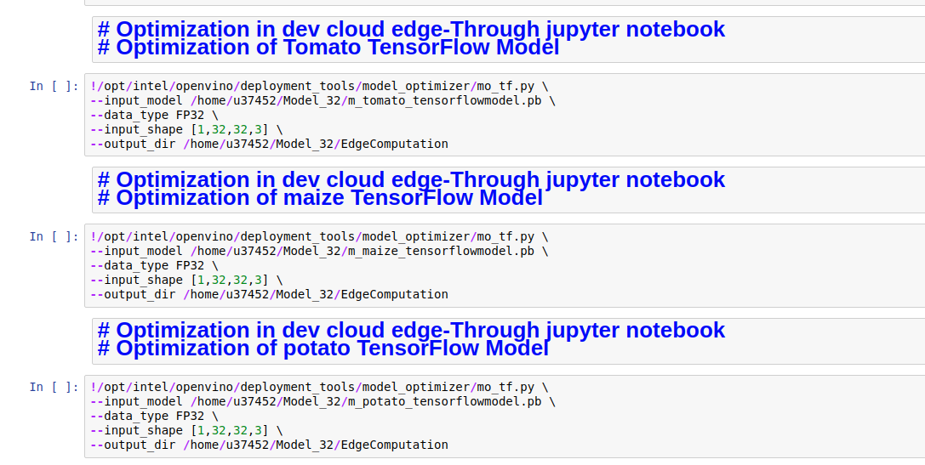

#Step 5: Create 3 JOBs(tomato_job.sh, potato_job.sh and maize_job.sh) to put in the queue to provide in the EDGE NODE. Please execute the cell one by one.

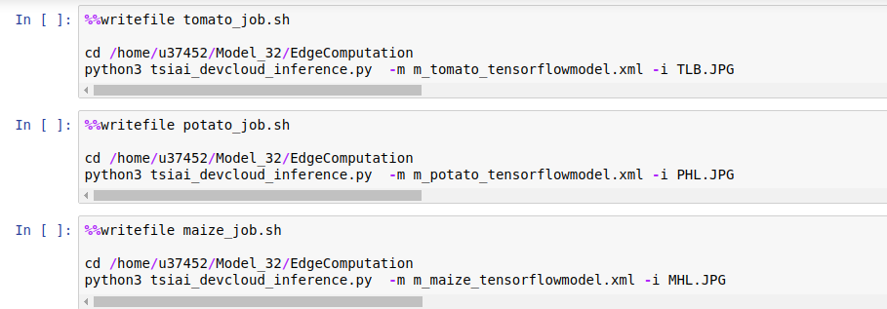

#Step 6: Reference Implementation, Case 1:

# Reference implementation -edge compute

# https://www.ieiworld.com/en/product/model.php?II=525

# TANK-870-Q170

Run below cells to execute 3 jobs in 3 nodes of Intel Corei CPU(Tank 870)

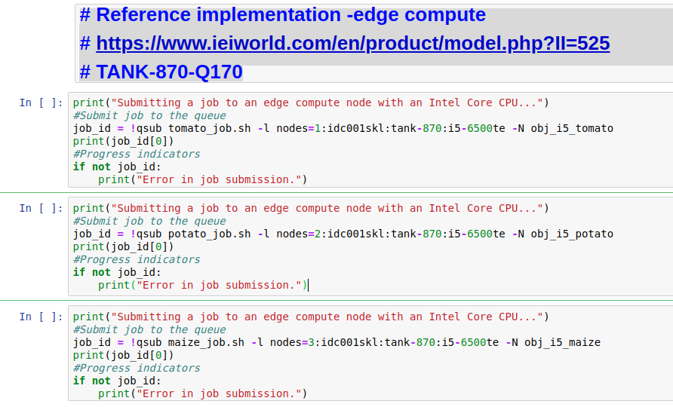

You will find inferencing result as



For Example, if you browse to

<https://jupyter.edge.devcloud.intel.com/user/u37452/edit/obj_i5_maize.o3920>

You will get the result as

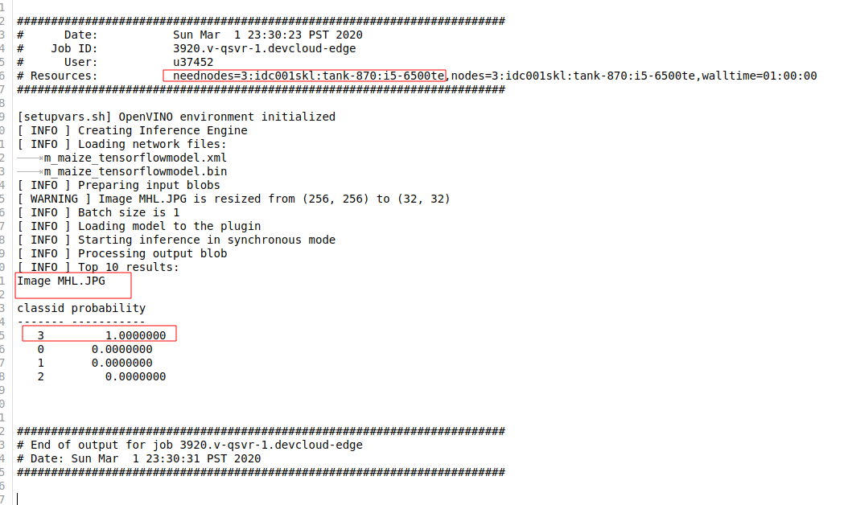

*Maize Healthy Leaf is correctly identified at edge node .

#Step 7 : Reference implementation, Case 2:

# Reference implementation -edge compute

# https://www.aaeon.com/en/p/iot-gateway-maker-boards-up-core-plus

# Atom™ x7-E3950 Processor SoC

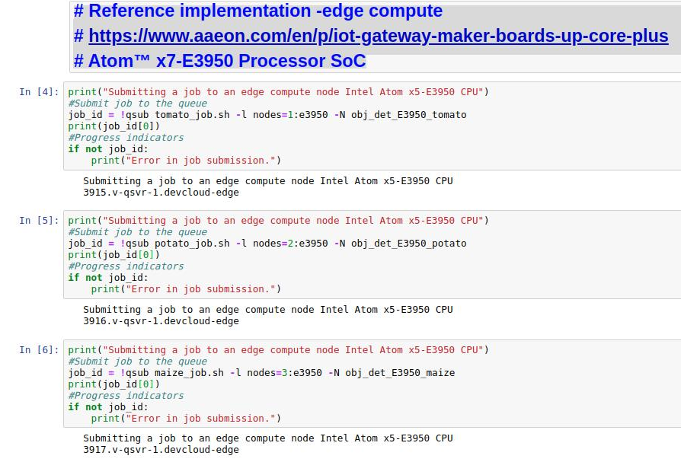

Run below cells to execute 3 jobs in 3 nodes of Atom-E3950.

You will get the inference result as,



For example, if you browse to,

<https://jupyter.edge.devcloud.intel.com/user/u37452/edit/obj_det_E3950_tomato.o3921>

You will get the result as

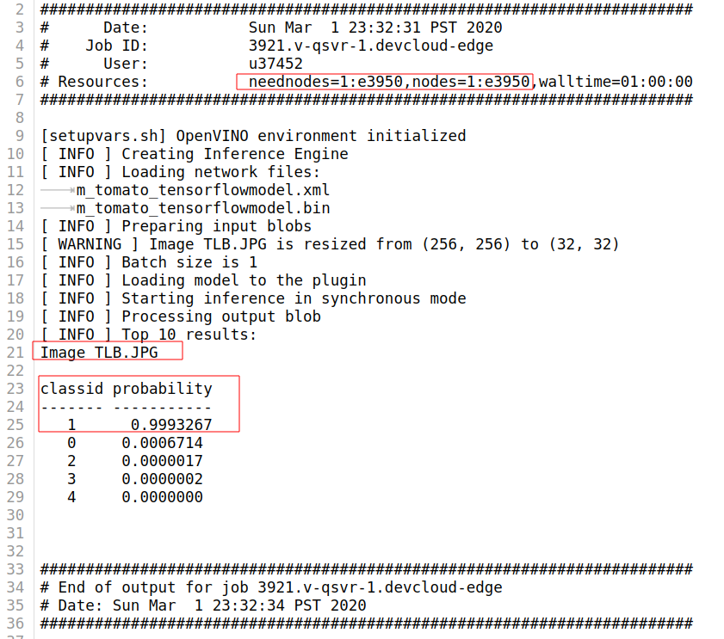

*Tomato Late Blight Leaf is correctly identified at the edge node .