# Contents

1 Contents 1

2 Introduction 2

3 The Game 3

3.1 Main Menu 3

3.1.1 Menu Options 3

3.2 New Game 4

3.3 Edit Mode 5

3.4 The game 6

3.5 Save a Game 6

3.6 Game Over 7

3.7 Highscores 8

3.8 Replaying a game 9

4 License 10

# Introduction

This game is a student project done during the Information Management course at FH JOANNEUM University of Applied Sciences in Graz, Austria.

The game is a recreation of the popular board/paper game Battleship with slightly modified rules.

Development started in December 2017 and finished in January 2018.

# The Game

## Main Menu

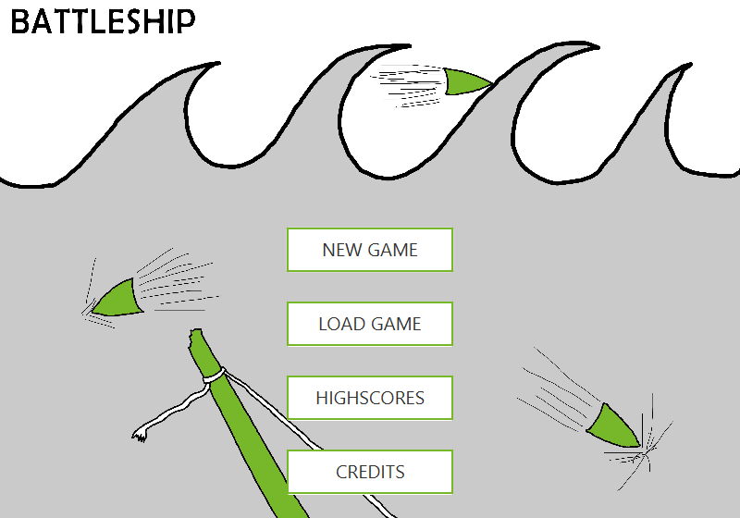

This is the menu. It is the first thing you will see after the splash screen.

### Menu Options

* New Game: Starts a new game.
* Load Game: Opens a file explorer window where you can load the previous saved games.
* Highscores: Provides a view of previously played and saved games on this PC. Also provides access to game replays. You need to load the Playerfield of Player 1 first, followed by loading the Playerfield of Player 2.
* Credits: Opens the credits screen, containing information about the developers and license information

## New Game

After pressing the NEW GAME button, you are asked to enter the names of player 1 and player 2. You can also change the randomly selected battle name if you want to. If you are finished, click continue.

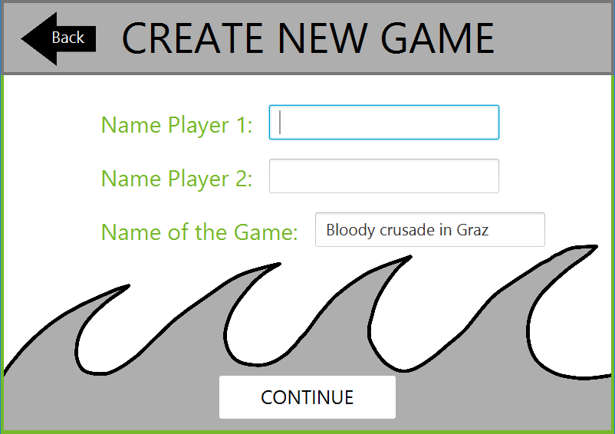

## Edit Mode

In Edit Mode, you are asked to place your fleet on the playing field. You begin by placing your biggest ship, the battleship, and then the game automatically selects the next smallest ship until all your ships have been placed.

To change the orientation, you can use the HORIZONTAL and VERTICAL buttons. Your ships can’t overlap, and it cannot go over the boundary of the playing field.

If you are unhappy with your placement, use the reset fleet button and you can place your ships again.

If you are satisfied with the placement of your fleet, click NEXT PLAYER and let Player 2 place his fleet in the same manner.

Make sure, of course, that neither of you watches the other’s fleet placement!

After you click START GAME, the battle starts!

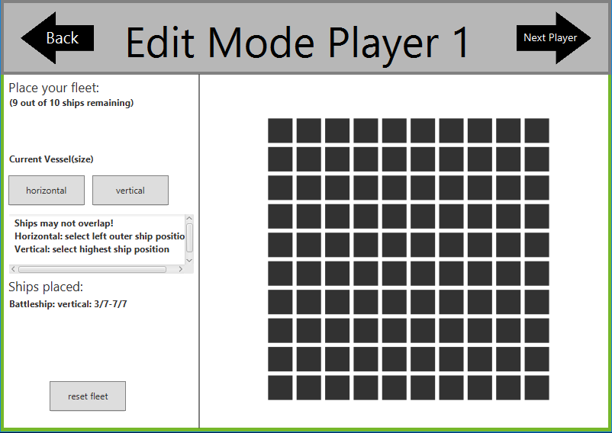

## The game

The battle begins! In turns, you try to hit your opponents’ vessels. Be careful! You only have one shot every turn. Make it count!

You get visual feedback for your hits – light grey means you hit water, green means you managed to hit a vessel.

The logbook on the bottom also keeps track of who hit what in the course of the skirmish.

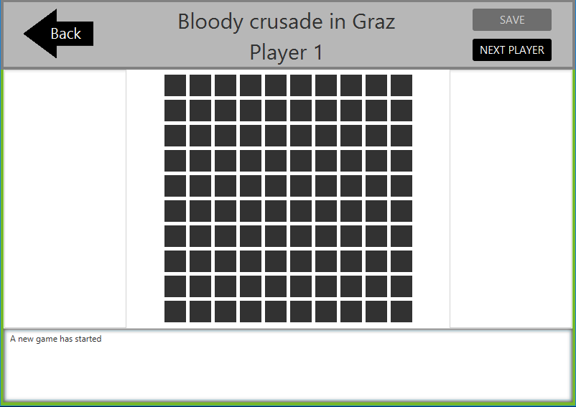

## Save a Game

In the top-right corner you can click on save game, which is only possible after the second Player finished his turn. An Explorer will show up and asks you to save the Playerfield of the second Player. After you saved the file for the second Player, another Explorer will show up to save the Playerfield of the first Player.

## Game Over

As soon as one players’ fleet is completely destroyed, the game ends. You now see how many ships the winner has remaining, and you can review the log one last time if you want to.

After clicking continue the highscores screen appears.

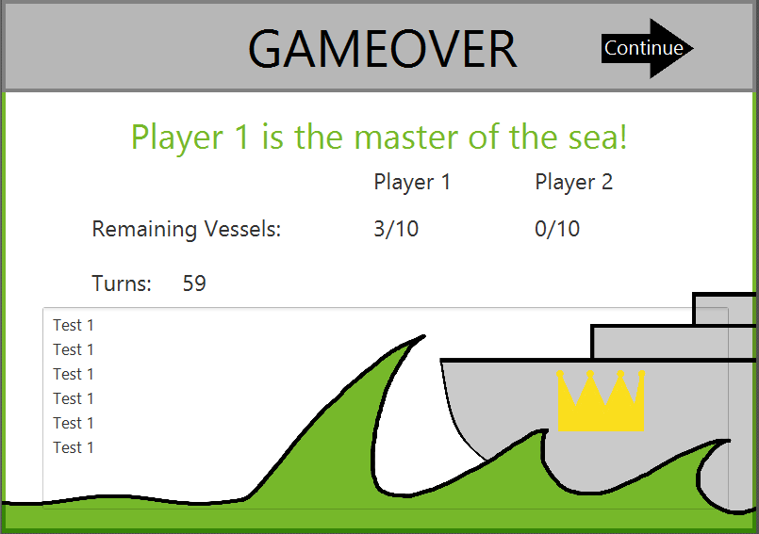

## Highscores

The highscore screen gives an overview of all completed games on your machine. The overview shows the winner, the game name and how many turns it took to win the game. The button on the right side allows you to replay a recording of the game.

To return to the main menu, click BACK in the top left corner.

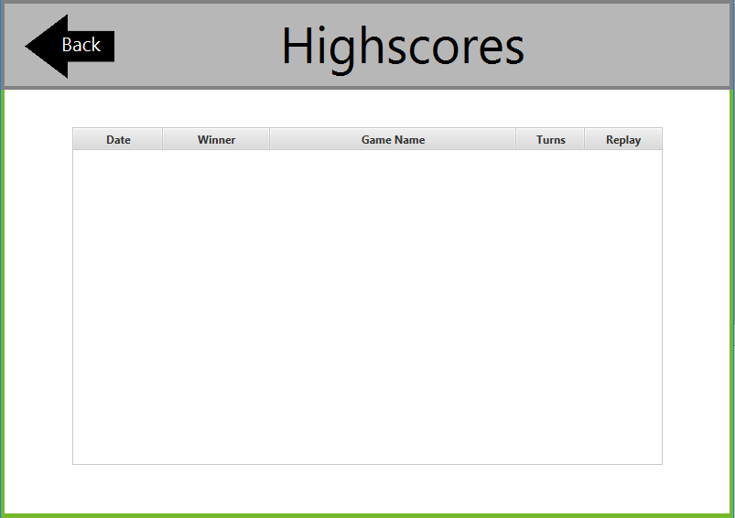

## Replaying a game

The replay screen looks similar to the game screen. On the sides, you can see the status of both the players’ ships, and on the bottom, you can use the slider to scroll through the game. Click BACK to return to the high scores.

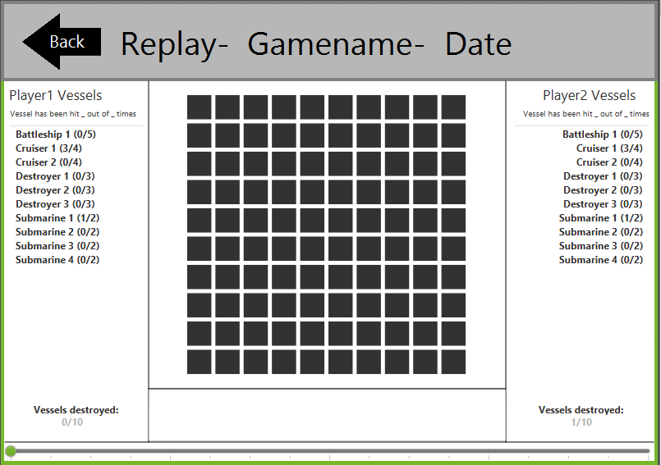

# License

© 2018 8301!=8200

This work is free. You can redistribute it and/or modify it under the terms of the Do What The Fuck You Want To Public License, Version 2, as published by Sam Hocevar.

DO WHAT THE FUCK YOU WANT TO PUBLIC LICENSE

Version 2, December 2004

Copyright (C) 2004 Sam Hocevar <sam@hocevar.net>

Everyone is permitted to copy and distribute verbatim or modified

copies of this license document, and changing it is allowed as long

as the name is changed.

DO WHAT THE FUCK YOU WANT TO PUBLIC LICENSE

TERMS AND CONDITIONS FOR COPYING, DISTRIBUTION AND MODIFICATION

0. You just DO WHAT THE FUCK YOU WANT TO.