Veeam Content Pack for vRealize Log Insight

Version 1.x

User Guide

October, 2019

© 2019 Veeam Software.

All rights reserved. All trademarks are the property of their respective owners.

No part of this publication may be reproduced, transmitted, transcribed, stored in a retrieval system, or translated into any language in any form by any means, without written permission from Veeam Software (Veeam). The information contained in this document represents the current view of Veeam on the issue discussed as of the date of publication and is subject to change without notice. Veeam shall not be liable for technical or editorial errors or omissions contained herein. Veeam makes no warranties, express or implied, in this document. Veeam may have patents, patent applications, trademark, copyright, or other intellectual property rights covering the subject matter of this document. All other trademarks mentioned herein are the property of their respective owners. Except as expressly provided in any written license agreement from Veeam, the furnishing of this document does not give you any license to these patents, trademarks, copyrights, or other intellectual property.

|  |  |
| --- | --- |
| **Important!** | Please read the End User Software License Agreement before using the accompanying software program(s). Using any part of the software indicates that you accept the terms of the End User Software License Agreement. |

# Contents

Contents 3

Contacting Veeam Software 4

About This Guide 5

About Veeam Content Pack 6

Installation and Configuration 7

Before You Begin 8

Step 1. Install Veeam Content Pack 9

Step 2. Install Log Insight Agents 11

Step 3. Configure Log Insight Agents 12

Backup Monitoring 15

Dashboards and Widgets 16

Alerts 20

# Contacting Veeam Software

At Veeam Software we value the feedback from our customers. It is important not only to help you quickly with your technical issues, but it is our mission to listen to your input, and build products that incorporate your suggestions.

#### Customer Support

Should you have a technical concern, suggestion or question, please visit our Customer Center Portal at [www.veeam.com/support.html](https://www.veeam.com/support.html) to open a case, search our knowledge base, reference documentation, manage your license or obtain the latest product release.

#### Company Contacts

For the most up to date information about company contacts and offices location, please visit [www.veeam.com/contacts.html](https://www.veeam.com/contacts.html).

#### Online Support

If you have any questions about Veeam products, you can use the following resources:

* Full documentation set: [www.veeam.com/documentation-guides-datasheets.html](https://www.veeam.com/documentation-guides-datasheets.html)
* Community forum at [forums.veeam.com](https://forums.veeam.com/)

# About This Guide

This document describes features included in the Veeam Content Pack for vRealize Log Insight. It provides usage examples and gives step-by-step instructions that will help you better understand how to install Veeam Content Pack for vRealize Log Insight and monitor your Veeam Backup infrastructure, services and jobs.

Intended Audience

This guide is intended for IT managers, virtual infrastructure administrators, and other personnel who use vRealize Log Insight to monitor their infrastructure. This guide assumes that you have a good understanding of Veeam Backup & Replication and vRealize Log Insight.

Document Revision History

|  |  |  |
| --- | --- | --- |
| Revision # | Date | Description of Changes |
| Revision 1 | 4/25/2017 | Initial version of the document for Veeam Content Pack for vRealize Log Insight v1.0. |

# About Veeam Content Pack

Veeam Content Pack for vRealize Log Insight is a content pack used to monitor the most relevant Veeam Backup & Replication events in the context of vRealize Log Insight. Veeam Content Pack accumulates event log data collected from backup servers and transforms it to vRealize Log Insight dashboards and alerts.

Veeam Content Pack for vRealize Log Insight includes:

* Dashboards and widgets that visualize events data and show the most important aspects of the Veeam Backup & Replication infrastructure and operations
* Pre-defined alerts that help quickly respond to problems and potential data protection issues

# Installation and Configuration

To monitor Veeam Backup & Replication event log data in vRealize Log Insight, you must perform the following steps:

1. Install Veeam Content Pack.
2. Install Log Insight agents on Veeam backup servers.
3. Configure Log Insight agents.

## Before You Begin

Before you install the Veeam Content Pack for vRealize Log Insight, make sure that the environment meets system requirements listed below.

vRealize Log Insight

Log Insight v4 or later.

Veeam Backup & Replication

Veeam Backup & Replication 9.0 or later.

## Step 1. Install Veeam Content Pack

Import from File

To import Veeam Content Pack from a vRealize Log Insight Content Pack (VLCP) file:

1. Log in to the vRealize Log Insight Web user interface.
2. From the menu on the upper right, select **Content Packs**.
3. In the lower left corner, click **Import Content Pack**.
4. Browse for a VLCP file.

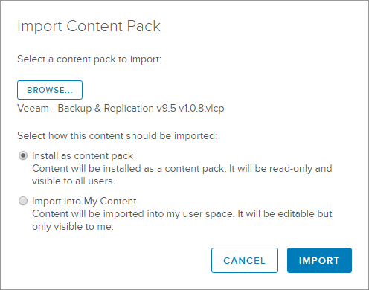

1. Choose an import option: **Install as content pack** (public) or **Import into My Content** (private).

Only users with Administrator privileges can install a content pack. Other users can import content pack data only in their own user space.

1. Click **Import**.

The content pack will appear in the **Installed Content Packs** list.

It is important to note that if you install Content Packs via the Marketplace, you will be notified when there are updates for them. This does not occur when you manually import a content pack.

For more information on importing content packs, see [Import a Content Pack](http://pubs.vmware.com/log-insight-43/index.jsp#com.vmware.log-insight.user.doc/GUID-ABA784C6-65B3-4704-8313-2B431BD59B7F.html).

## Step 2. Install Log Insight Agents

Install Log Insight agents on machines running Veeam Backup & Replication Server. For details, see [Installing or Upgrading vRealize Log Insight Agents](http://pubs.vmware.com/log-insight-43/index.jsp#com.vmware.log-insight.agent.admin.doc/GUID-83976956-C16C-42BD-9950-C6EDDF983086.html).

## Step 3. Configure Log Insight Agents

To write events to Microsoft Windows Event Log, Veeam Backup & Replication uses its own log channel called **Veeam Backup**. To collect Veeam Backup & Replication event data from backup servers, you must add this channel to Log Insight agent configuration.

There are two methods to configure Log Insight agents:

* Client-side configuration. This method is recommended if you have a few Veeam backup servers on which you can manually change agent configuration.
* Server-side configuration (centralized). This method helps automate agent configuration and is recommended if you have multiple Veeam backup servers.

Client-side Agent Configuration

If you have a few Veeam servers from which you want to collect log data, you can configure the agent manually:

1. Log on to the machine running Veeam Backup & Replication.
2. Open the %ProgramData%\VMware\Log Insight Agent folder.
3. Open the liagent.ini file for editing.
4. Add the following entry to the file:

|  |
| --- |
| [winlog | custom]  channel=Veeam Backup |

1. Save the configuration file.
2. Restart VMware vRealize Log Insight Agent service.

Note: The Veeam Backup & Replication server collects entries from Proxy servers so it is not necessary to install the agent on Proxy servers.

Server-side Agent Configuration

If you have multiple Veeam backup servers from which you want to collect log data, you can configure an agent group for them in vRealize Log Insight, and apply the agent configuration to this group.

Note: In v1.1 of the Content Pack we have included an Agent Group. You do not have to use it if the CP is already working for you. But if you are starting new it is easier than creating your own. You would start with Step 5 if you wish to use the v1.1 included agent group.

To configure an agent group:

1. In the vRealize Log Insight web interface, expand the menu in the upper right corner and choose **Administration**.
2. In the left menu, under the **Management** node, choose **Agents**.
3. In the list of agent group templates, choose the **Microsoft - Windows** template and click the **Copy Template** icon.

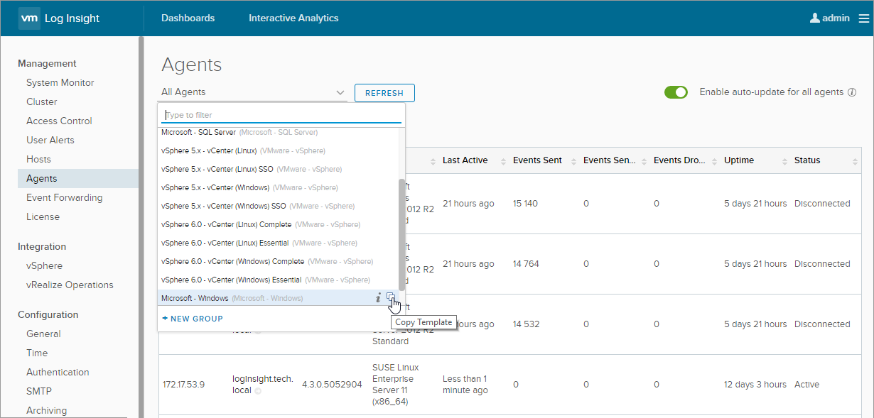

|  |  |
| --- | --- |
| Tip: | If you cannot see the Microsoft - Windows template, install the Microsoft Windows content pack from the Log Insight Marketplace. |

1. In the Copy Agent Group window, customize the name and description of the template and click **Copy**.

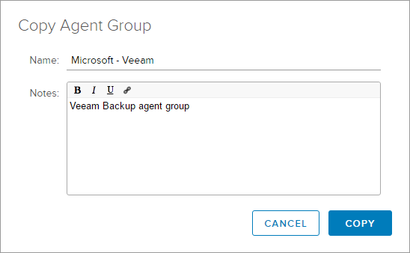

1. Add a filter, to group the agents installed on Veeam backup servers.

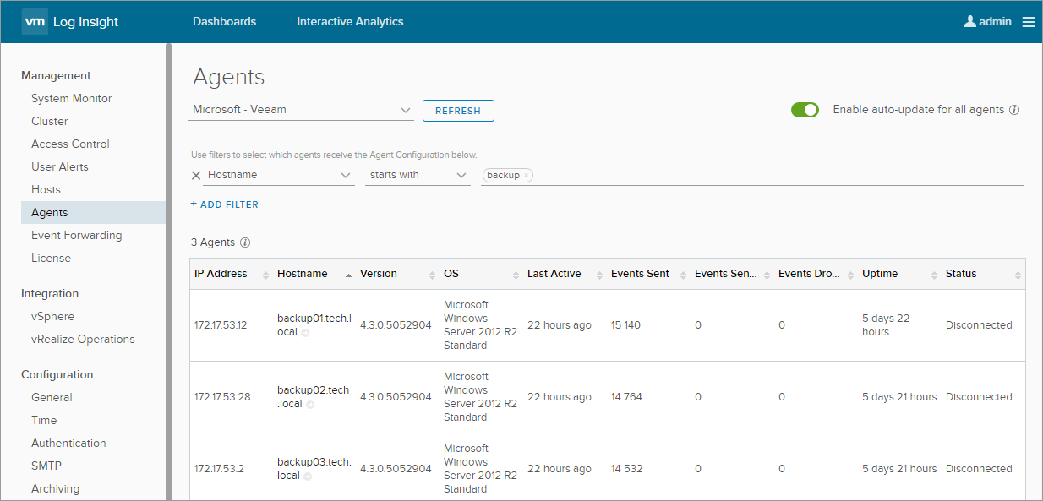

1. Under **Agent Configuration**, open the **Edit** tab.
2. Add the following entry:

|  |
| --- |
| [winlog | custom]  channel=Veeam Backup |

1. Click **Save Agent Group**.

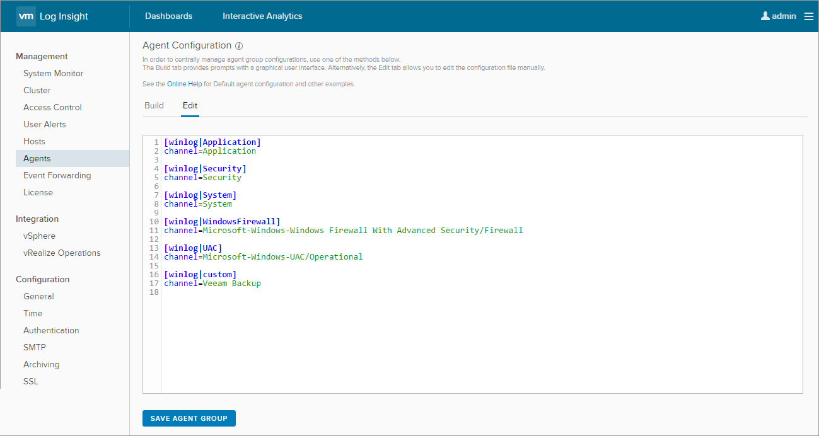

# Backup Monitoring

Veeam Content Pack for vRealize Log Insight includes dashboards and widgets and a set of pre-defined alerts to visualize events data and quickly respond to problems and potential data protection issues.

## Dashboards and Widgets

Veeam Content Pack for vRealize Log Insight includes a number of predefined dashboards. They support all operations available for regular Log Insight dashboards: you can choose time range for data displayed on dashboards, drill down from a dashboard widget to Interactive Analytics, clone a dashboard widget, and so on. To learn more about Log Insight dashboards, see [Working with Dashboards](http://pubs.vmware.com/log-insight-43/index.jsp#com.vmware.log-insight.user.doc/GUID-7866CC30-4A35-459D-BC2E-F879D975B191.html).

The following dashboards are available in Veeam Content Pack for vRealize Log Insight:

* Overview
* Restore
* Backup Jobs
* Backup Copy Jobs
* Replication Jobs
* SureBackup Jobs
* System

Overview Dashboard

This dashboard shows an overview of the most relevant Veeam Backup & Replication events over a chosen period of time.

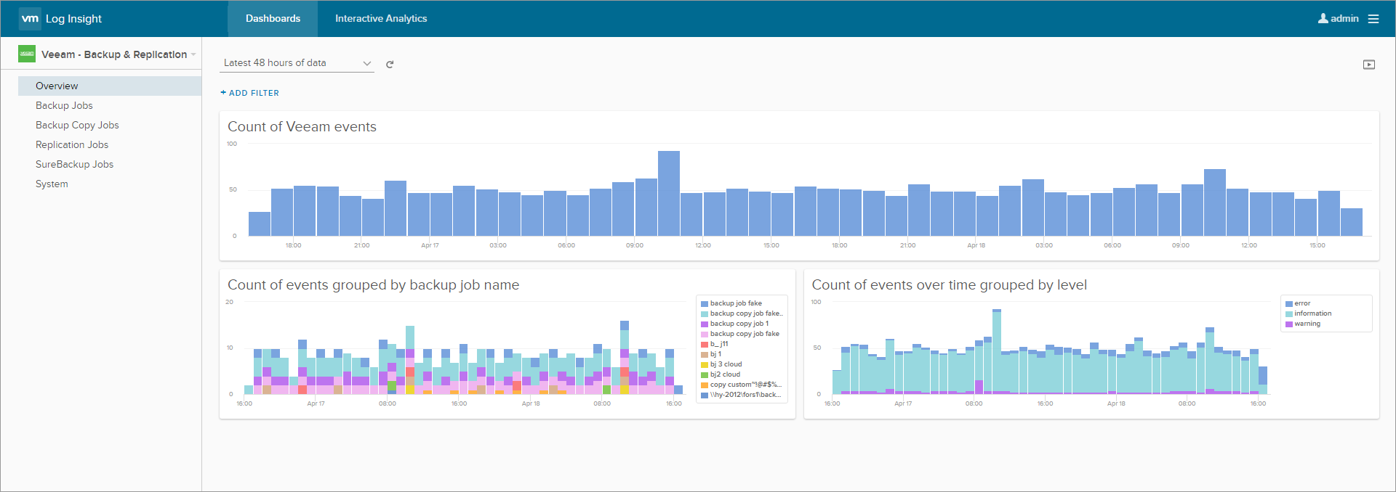

The dashboard includes the following widgets.

|  |  |  |
| --- | --- | --- |
| Widget Name | Description | Based on Events |
| Count of Veeam events over time | Shows all Veeam events that arrive at Log Insight. | Any event from Veeam Backup* channel. |
| Count of events grouped by backup job name | Shows job related events grouped by job. | Events from Veeam Backup channel w |
| Count of events over time grouped by level | Shows events grouped by severity level: information, warning or error. | Events from Veeam Backup channel with level field. |

*For the full list of Veeam events, see [Veeam Backup & Replication Events](https://helpcenter.veeam.com/docs/backup/vsphere/vbr_events.html?ver=95).

Restore Dashboard

This dashboard shows an overview of the most relevant Veeam Backup & Replication events over a chosen period of time.

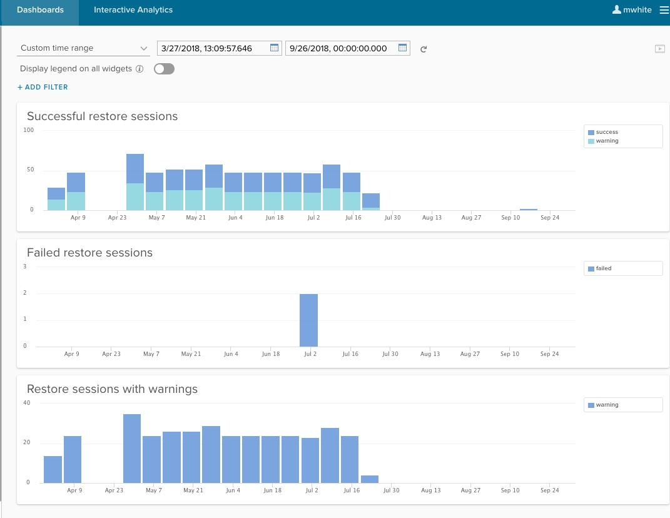

The dashboard includes the following widgets.

|  |  |  |
| --- | --- | --- |
| Widget Name | Description | Based on Events |
| Successful restore sessions | Shows successful runs of restore sessions. | Event IDs 250, 290 |
| Failed restore sessions | Shows restore failures including retries. | Event IDs 250, 290 with error level |

Backup Jobs Dashboard

This dashboard shows events informing about successful and failed backup job sessions over a chosen period of time.

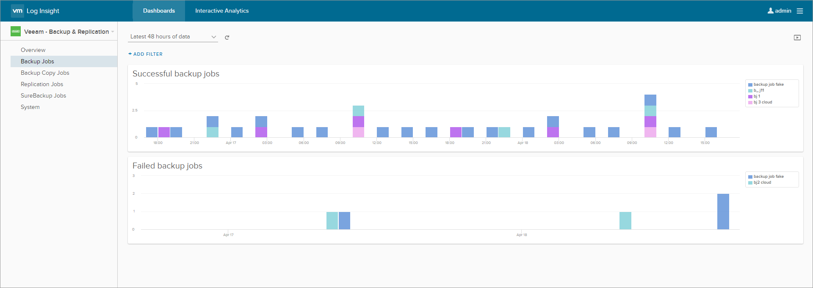

The dashboard includes the following widgets.

|  |  |  |
| --- | --- | --- |
| Widget Name | Description | Based on Events |
| Successful backup jobs over time | Shows successful runs of backup jobs. | Event ID 190 |
| Failed backup jobs over time | Shows backup job failures including retries. | Event ID 190 |

Backup Copy Jobs Dashboard

This dashboard shows events informing about successful and failed backup copy job sessions over a chosen period of time.

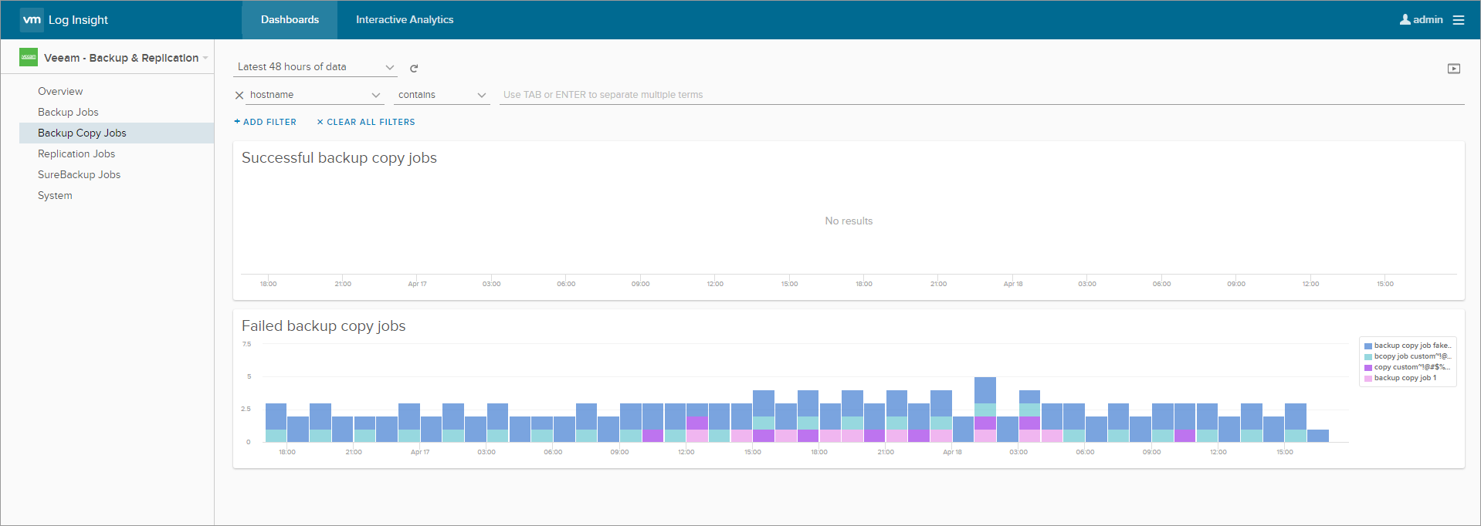

The dashboard includes the following widgets.

|  |  |  |
| --- | --- | --- |
| Widget Name | Description | Based on Events |
| Successful backup copy jobs over time | Shows successful runs of backup copy jobs. | Event ID 490 |
| Failed backup copy jobs over time | Shows backup copy job failures including retries. | Event ID 490 |

Replication Jobs Dashboard

This dashboard shows events informing about successful and failed replication job sessions over a chosen period of time.

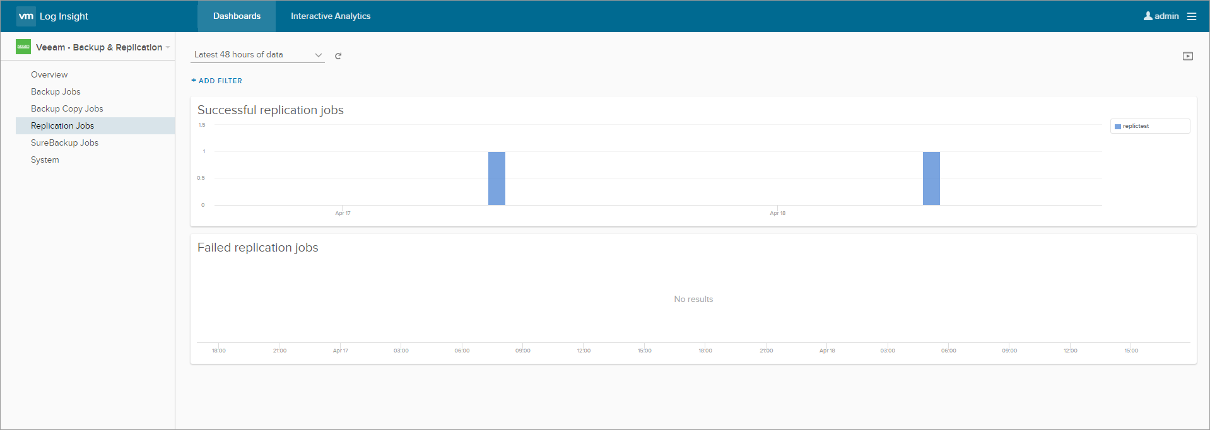

The dashboard includes the following widgets.

|  |  |  |
| --- | --- | --- |
| Widget Name | Description | Based on Events |
| Successful replication jobs over time | Shows successful runs of replication jobs. | Event ID 190 |
| Failed replication jobs over time | Shows replication job failures including retries. | Event ID 190 |

SureBackup Jobs Dashboard

This dashboard shows events informing about successful and failed SureBackup job sessions over a chosen period of time.

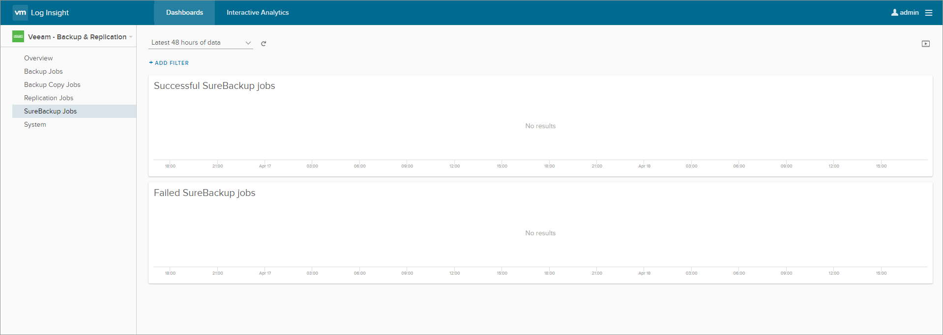

The dashboard includes the following widgets.

|  |  |  |
| --- | --- | --- |
| Widget Name | Description | Based on Events |
| Successful SureBackup jobs over time | Shows successful runs of SureBackup jobs. | Event ID 390 |
| Failed SureBackup jobs over time | Shows SureBackup job failures. | Event ID 390 |

System Dashboard

This dashboard shows system Veeam Backup & Replication events over a chosen period of time.

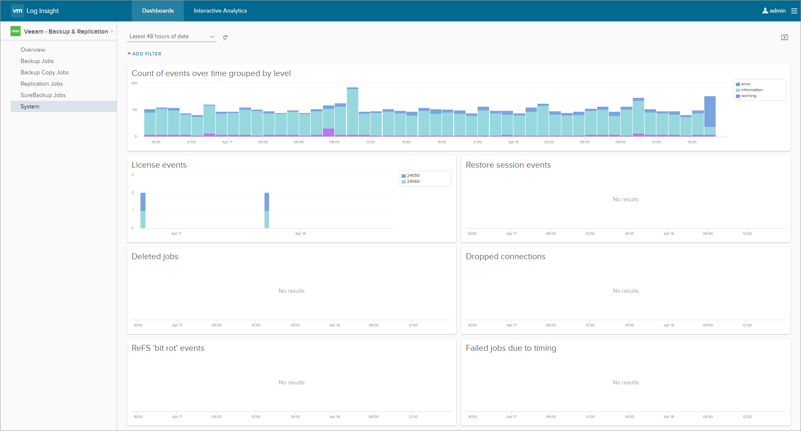

The dashboard includes the following widgets.

|  |  |  |
| --- | --- | --- |
| Widget Name | Description | Based on Events |
| All events over time grouped by level | Shows events grouped by severity level: information, warning or error. | All Veeam Backup & Replication events grouped by severity. |
| Primary events over time grouped by level | Shows Veeam events grouped by level excluding minor events such as: restore point removed, restore point created, restore point updated, backup task finished. | All Veeam Backup & Replication events grouped by severity, excluding events with IDs 10050, 10010, 10090, and 150. |
| Deleted jobs | Shows deleted backup, replication, SureBackup, and backup copy jobs. | Event IDs 23090, 23230 |
| Dropped connections | Shows dropped connections between the Veeam backup server and other backup infrastructure components, such as backup repository, backup proxy or WAN-Accelerator. | Event IDs 21234, 21224, 21214 |
| ReFS issues | Shows any file corruption ('bit rot') detected by ReFS and ReFS partition mounting failures. | ReFS events IDs 133, 135, 136 |

## Alerts

Veeam Content Pack for vRealize Log Insight includes predefined alerts. They support all operations available for regular Log Insight alerts: you can configure, manage, enable/disable alerts, and so on.

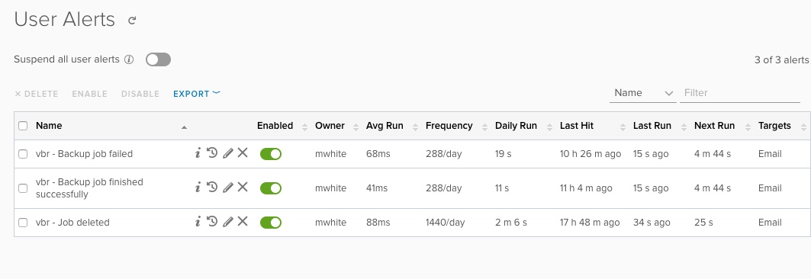

To learn more about Log Insight alerts, see [Alert Queries in vRealize Log Insight](http://pubs.vmware.com/log-insight-43/index.jsp#com.vmware.log-insight.user.doc/GUID-27C2C068-A780-41F5-BCA8-7265AEA9704E.html).

By default, Veeam Content Pack for vRealize Log Insight alerts are disabled. You can enable an alert from the **Content Packs** or **Administration** menu.

To enable a content pack alert from the **Administration** menu:

1. Go to the vRealize Log Insight Web user interface.
2. From the drop-down menu on the upper right, select **Administration** -> **User Alerts**.
3. Select an alert you want to enable and click the **Edit** icon on the right of the alert name.
4. In the **Edit Alert** window, enter an email address to receive alert notifications, choose when to raise an alert, and click **Save**.

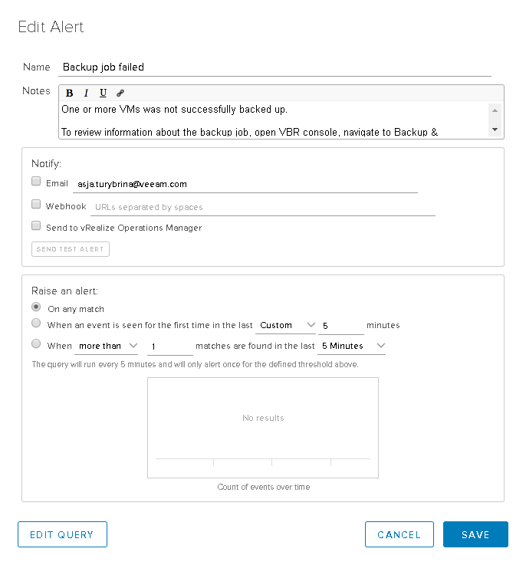

To send email notifications, you must have a configured SMTP.

Alert Reference

The following table lists predefined alerts available in Veeam Content Pack for vRealize Log Insight.

|  |  |
| --- | --- |
| Alert Name | Description |
| Job deleted | Job has been deleted. |
| Backup Сopy job failed | One or more VMs could not be successfully copied from the backup repository. |
| Backup job finished successfully | All VMs were backed up with no issues. |