Vernon Jackson

Aug 8, 2021

IT FDN 110

Assignment 05

# Update Program to Store CD Inventory Data

# Introduction

In this document I will be explaining how I added code to the CD Inventory Starter program for assignment 05, that modifies the script as required to replace the inner data structure by list of dictionaries, add the functionality of loading existing data, and add functionality of deleting an entry. Areas of focus for this document include 1) briefly covering the fundamentals that I learned in this module 2) the steps I took to organize and create the script and 3) a summary of my experience in creating this program.

# Coding Fundamentals

Within this assignment, I learned several new fundamentals of coding. This includes Dictionaries and as well as how to use GitHub. I will briefly summarize my own definitions of each used in the assignment in order to substantiate my learning.

**Dictionary:** A dictionary in Python has key and value pair and when combined, is a data structure used to store the values. They are mainly used to map or associate values that you want to store, and the keys you need in order to reference them.

**GitHub:** GitHub is a website and cloud based service that helps programmers store and manage their code, as well as to track and control any changes that are made to the code.

# Updating the Program

In order to create the script, I first began with the *CDInventory_Starter* script and added coding that replaced the inner data structure by a list of dictionaries, added the functionality of loading existing data, and added functionality of deleting an entry. The main coding fundamentals utilized in this assignment are lists of dictionaries for the data structure, f.string/string.format to display data, append function to load and add dictionaries to lists, remove function to remove dictionaries from lists, open files using the open () function, and write the data to the file using the write arguments.

**Replacing the data structure:** In order to replace the data structure, I first removed the *lstRow*, *strFileName*, and *objFile* from the variables section of the script, as they were either not needed or moved to the appropriate sections of the script. These variables were replaced with *dctLst* to house the list of dictionaries and *key* to house the list of keys for the dictionaries, which were both placed throughout the script in place of the removed variables. I then needed to alter the display functionality of the script that used f.strings to display the needed values within the appropriate keys in the list of dictionaries.

**Adding functionality to load existing data:** In order to load existing data, I started out by hard coding in a file name that will be used to load the data used within the program.This is accomplished using the the open () function to open the text file, then declaring a separate variable which defines how the data in the text file should be structured (strip and split functions), then I append the separate variable in dctLst, as a dictionary using the values from the list, mapped to the corresponding keys in *key.*

**Add functionality to delete existing data:** In order to delete existing data, I started out by asking the user to input which CD ID# they would like to be removed from the existing data. This input is then taken and applied to a separate dltLst variable which defines where in the dctLst should be indexed. I then used a for loop to apply the remove function to the dictionary within the dctLst, that corresponds to the input provided by the user.

To test this script, I ran this as a Python script through Spyder IDE and Anaconda Prompt. Executing the script through both, showed that it had the intended functionality which replacing the data structure with a list of dictionaries, adding the option to load existing data, and allows to user delete to delete existing data. See appendix Listing CDInventory.pyfor highlighted code.

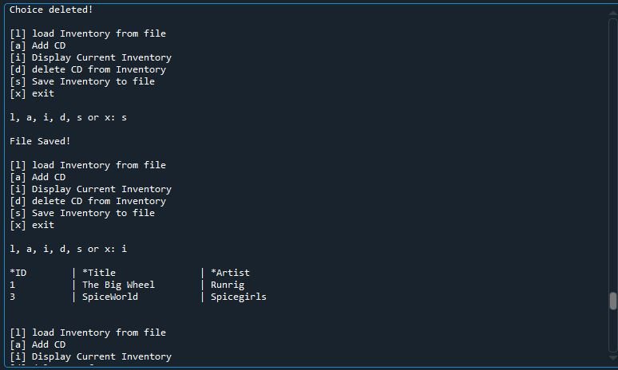

Figure 1 - Showing the program being executed through Spyder.

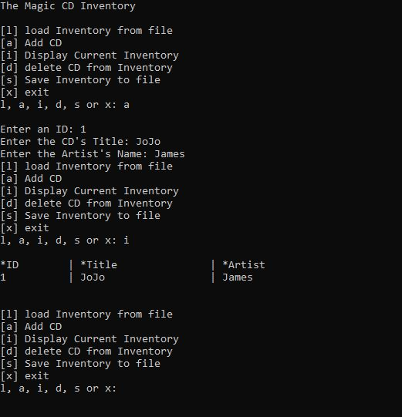

Figure 2 - Shows script being executed through Anaconda prompt.

# Summary

In this assignment we learned about dictionaries and using the remove function to delete a dictionary from a list of dictionaries. The most challenging part was changing the data structure, which required me to double check each separate functionality on its own, as well as altering the formatting to move from a text file list and converting this into a list of dictionaries. The conversion process took a large amount of time, as I was unclear on how the data should be listed in the text file. Since we were using the previous assignments as a starter, I used the same formatting within the previous text files. Additionally, the delete functionality was accomplished through trial and error, as well as viewing online resources to determine the best path forward, as there were numerous options available. Finally, starting with this assignment, I began to make more code more “pythonic” by making it easier to read and trying to limit my lines to fit within the recommended character limits.

# Appendix

## Listing CDInventory.py

1. *#------------------------------------------#*
2. *# Title: CDInventory.py*
3. *# Desc: Starter Script for Assignment 05*
4. *# Change Log: (Who, When, What)*
5. *# DBiesinger, 2030-Jan-01, Created File*
6. *# VJackson, 2021-Aug-06, Updated File to use list of*
7. *#----------------------- dictionaries data structure*
8. *#------------------------------------------#*
10. ***# Declare variabls***
12. key = ['ID', 'Title', 'Artist']
13. dctLst = []
14. strChoice = '' *# User input*
16. *# Get user Input*
17. **print**('The Magic CD Inventory**\n**')
19. *# 1.Display menu allowing the user to choose:*
21. **while** True:
22. **print**(
23. '[l] load Inventory from file**\n**[a] Add CD**\n**[i] Display Current Inventory'
24. )
25. **print(**
26. '[d] delete CD from Inventory**\n**[s] Save Inventory to file**\n**[x] exit'
27. )
28. strChoice = input('l, a, i, d, s or x: ').lower()
29. *# convert choice to lower case at time of input*
30. **print()**

33. *# 5. Exit the program if the user chooses so*
35. **if strChoice == 'x':**
36. *#*
37. **break**

40. ***# 4. load existing data***
42. **if** strChoice == 'l':
43. **with** open('CDInventory.txt', 'r') **as** file:
44. **for** line **in** file:
45. **ftemp = line.strip().split(',')**
46. dctLst.append(
47. {key[0]: ftemp[0],
48. key[1]: ftemp[1],
49. key[2]: ftemp[2]}
50. **)**
51. file.close()
52. **print**("File Loaded! **\n**")
54. *# 2. Add data to the table 2d-list each time the user wants to add data*
56. **elif** strChoice == 'a':
57. strID = input('Enter an ID: ')
58. strTitle = input('Enter the CD**\'**s Title: ')
59. strArtist = input('Enter the Artist**\'**s Name: ')
60. **intID = int(strID)**
61. dctLst.append({
62. "ID": intID,
63. "Title": strTitle,
64. "Artist": strArtist
65. **})**
67. *# 3. Display the current data to the user each time*
68. *# the user wants to display the data*
70. **elif strChoice == 'i':**
71. **print**(
72. f"{'*ID' : <10}",
73. f"{'*Title' : <20}",
74. f"{'*Artist' : <20}", sep=' | ',
75. **end='\n'**
76. )
77. **for** value **in** dctLst:
78. **print**(
79. f"{value['ID'] : <10}",
80. **f"{value['Title'] : <20}",**
81. f"{value['Artist'] : <20}",
82. sep=' | ',
83. end='**\n**'
84. )
85. **print('\n')**
87. **elif** strChoice == 'd':
88. dlt = input("What is the ID of CD you want to delete?")
89. **for** i **in** range(len(dctLst)):
90. **dltLst = [key for key in dctLst if key['ID'] == dlt]**
91. **for** element **in** dltLst:
92. **if** element **in** dctLst:
93. dctLst.remove(element)
94. **print**("Choice deleted! **\n**")
96. **elif** strChoice == 's':
97. **with** open('CDInventory.txt', 'w') **as** wrtfile:
98. **for** i **in** dctLst:
99. filetemp = str(i['ID'] + ',' + i['Title'] +',' + i['Artist'] + '**\n**')
100. **wrtfile.write(filetemp)**
101. wrtfile.close()
102. **print**("File Saved! **\n**")
103. **else**:
104. **print**('Please choose either l, a, i, d, s or x!')