Vernon Jackson

Aug 29, 2021

IT FDN 110

Assignment 08

# Adding Code to CD Inventory Program

# Introduction

In this document I will be explaining how I added code to the CD Inventory Starter program for Assignment 08, that modifies the script to add coding in place of pseudo code, with classes, constructors, properties, and methods. Areas of focus for this document include 1) briefly covering the fundamentals that I learned in this module 2) the steps I took to organize and create the script and 3) a summary of my experience in creating this program.

# Coding Fundamentals

Within this assignment, I learned several new fundamentals of coding, including classes, constructors, properties, methods, and type hints. I will briefly summarize my own definitions of each used in the assignment in order to substantiate my learning.

**Classes:** Classes are a way to group up a set of functions and variables into a single object which can be referenced throughout a program.

**Constructors:** Constructors are methods which are called upon when a new object is created within the class. The constructor is created with the function __*init__*. You write the *self* keyword as a parameter with a constructor, which refers to the object itself. They allow for a prepopulated structure for data types and assign specific values, when an object of the class is created.

**Properties:** The property methods are a way to control and validate values that are assigned to the attributes within a class. These are used with “*getter*s” for getting a value and ”*setters*” for setting a value. These are considered private, which means they can not be accessed directly or modified by a user of the program, and are a means of control to ensure that the values are enclosed within the class.

**Methods:** Methods are similar to functions in that you can define a function inside the body of a class to perform some operation. These include the static method, class method, and the instance method. We mainly covered the static methods within this module, which are added to a class based on relation, but don't need to access any class-specific data or values.

**Type hints:** Type hints allow you to indicate which types of objects you are using within your code, mainly to be referenced by others working with the code.

# Updating the Program

In order to create the script, I reused much of the code from Assignment 07 and added this to the script for Assignment 08. The main coding fundamentals utilized in this assignment are classes, constructors, properties, methods, and type hints.

In first part of the script, within the CD class, I started by adding the constructor for the *CD* class, by setting the cd_id, cd_title, and cd_artist attributes to *self* variables, include the appropriate type hints. I then defined the associated properties for cd_id, cd_title, and cd_artist within the class, along with adding a *__str__()* method to return values back as a formatted string that can be used by the program. This method is used mainly as a print function to return formatted version of a newly added CD. Lastly, the main program loop is mostly reused from Assignment 07, however, I removed the delete function from the list and removed delete options from the menu functions for use in this assignment.

One aspect that was noted in grading for Assignment 07, was to move the exception handling for the initial loading of the file, to the appropriate functions. So, for this assignment, I moved this to the *load_inventory* function within the *FileIO* classto avoid this being placed within the main program.

To test this script, I ran this as a Python script through Spyder IDE and Anaconda Prompt. Executing the script through both, showed that it had the intended functionality. Follow this link to view the script on GitHub: <https://github.com/Veejster/Assignment_08.git>.

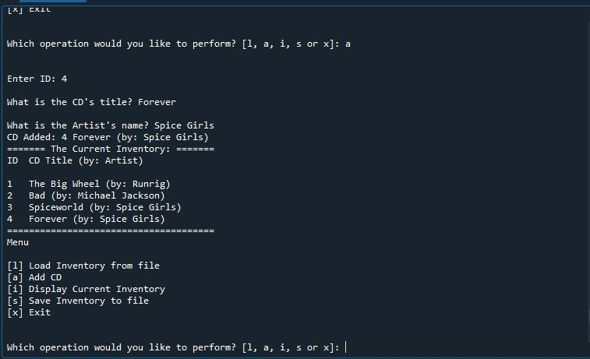

Figure 1 - Showing the program being executed through Spyder.

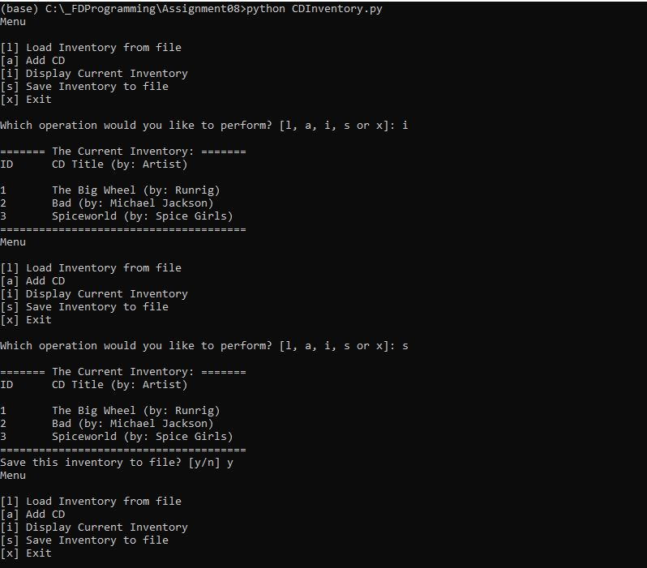

Figure 2 - Shows script being executed through Anaconda prompt.

# Summary

In this assignment we learned about classes, constructors, properties, methods, and type hints. I didn’t have many challenges with this assignment or understanding OOP, as I had held back on using classes in the previous assignments as it was not part of the pseudo code. However, I had learned about classes back in Assignment 04 after adding functions to the initial CDInventory program. After joining the office hours session on Friday (8/27), I hadn’t initially reviewed the Module yet, but had gone through the content and topics. Joining the session had made it relatively easy to understand the information and apply it in the assignment. One thing I did have difficulty with, was ensuring that all of the doc string included the correct information, including the properties and methods for classes, as well as the arguments and returns for the functions. This took me the most time when writing this script. Additionally, I am still confused on when to actually use or not use type hints. I assumed that they should be used throughout the script, but I only used them for functions where I was able to understand if they should be applied, such as the *FileIO* and *CD* classes.