Vikrant Pravin Sankpal

7045401223

Vickysankpal2001@gmail.com

My Library Web App

My Library is a web application that allows users to manage a collection of books. You can add, edit, and delete books in your library.

Features

- Add a new book to your library.

- Edit the rating of an existing book.

- Delete books from your library.

- View the list of books in your library.

Technologies Used

- Python

- Flask (a web framework)

- SQLite (for the database)

- HTML/CSS (for the front-end)

- Pycharm

Screenshots and explanation

If you want to run your Flask project in PyCharm, follow these steps:

1. Open Your Project:

* Launch PyCharm and open your Flask project by selecting the project folder.

1. Create a Run Configuration:

* In PyCharm, you can create a run configuration for your Flask application.
* Go to "Run" > "Edit Configurations..." from the top menu.
* Click the "+" button and select "Python" to create a new Python configuration.
* Set a name for your configuration (e.g., "Flask").
* In the "Script path" field, browse and select your main Flask application file (e.g., app.py or main.py).
* In the "Parameters" field, add run (this tells Flask to run your app).
* In the "Python interpreter" field, choose the virtual environment you've set up for your project.
* Make sure to select the correct working directory. It should point to your project's root directory.

1. Set Environment Variables:

* If your Flask app uses environment variables, you can set them in the run configuration:
* In the "Environment variables" section of the run configuration, click the "..." button to add environment variables

1. Run Your Flask Application:

* Click the green "Run" button in the top right corner of the PyCharm window, or right-click your run configuration and select "Run."

Your Flask app should start, and you'll see output in the console. By default, it will be accessible at http://localhost:5000.

1. Access Your Application:

* Open your web browser and navigate to http://localhost:5000 to access your Flask application.

COMMAND IN TERMINAL

Set FLASK_APP=main (To set up an environment)

Flask –app main run(To run the program)

Overview

Once you successfully run the flask you will get link (local host)

When clicked it will redirect to a project (home page), where first you will get to My Library initially it will be empty

Here when you click on add new book you will get to page /add

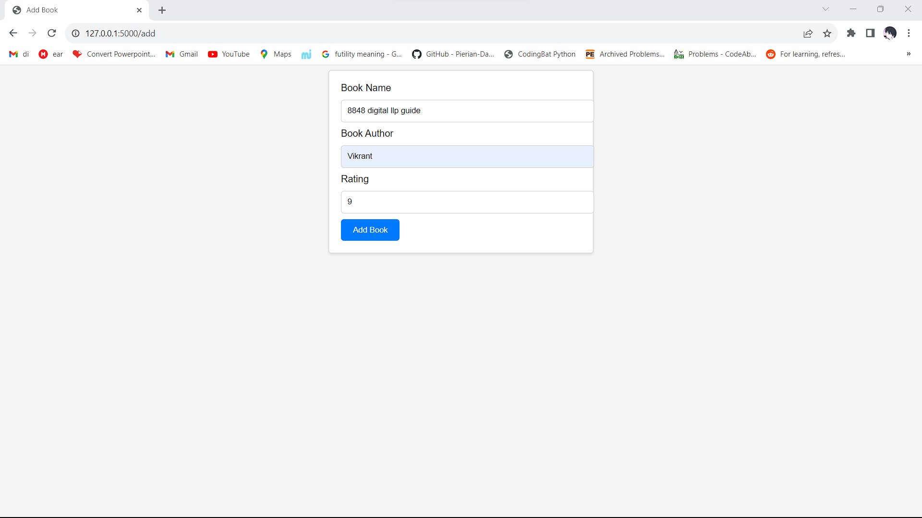

Once add the book you wanted an click on add book you will again redirected to MyLibrary where the book you entered gets added

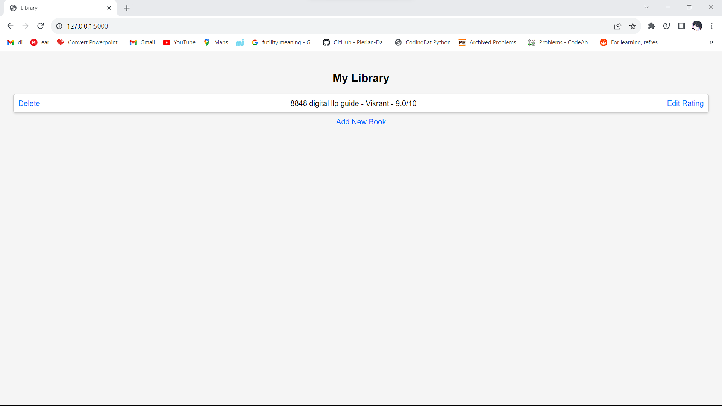

Will try the same process by clicking on add new book

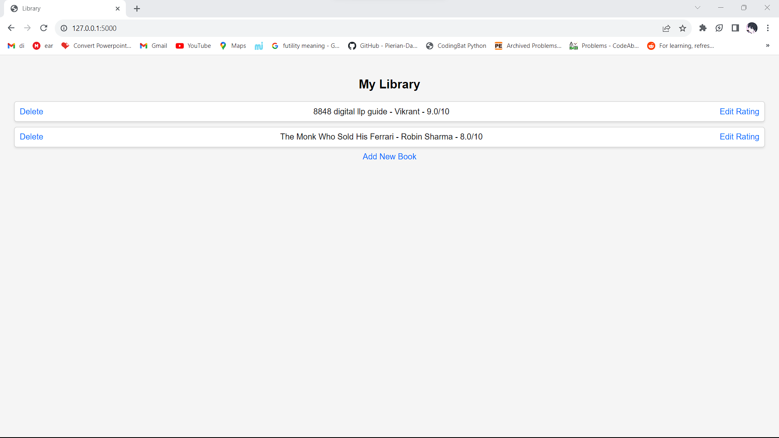

You can even delete the the specific book if needed by clicking on “Delete”

Now for the database I have use SQlite where all the info get’s stored

If you change your mind about the rating , you can even change your rating by clicking on “Edit Rating”

When you click on “Change Rating”

Summary: -

project is a web application built with Flask that serves as a virtual library. It allows users to view, add, edit, and delete book records stored in a SQLite database through a user-friendly web interface.