Important Java Topics for Selenium

**1)Constructor in Java**

In Java, constructor is a block of codes similar to method. It is called when an instance of object is created and memory is allocated for the object.

It is a special type of method which is used to initialize the object.

**Note:** It is called constructor because it constructs the values at the time of object creation. It is not necessary to write a constructor for a class. It is because java compiler creates a default constructor if your class doesn't have any.

Rules for creating java constructor

There are basically two rules defined for the constructor.

1. Constructor name must be same as its class name
2. Constructor must have no explicit return type

Types of java constructors

There are two types of constructors in java:

1. Default constructor (no-arg constructor)
2. Parameterized constructor

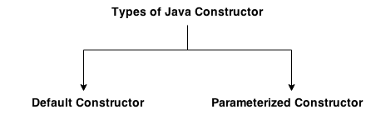

## Default Constructor

A constructor is called "Default Constructor" when it doesn't have any parameter.

### Syntax of default constructor:

<class_name>(){}

**Ex for default constructor**

**class** Bike1{

Bike1(){

System.out.println("Bike is created");

}

**public** **static** **void** main(String args[]){

Bike1 b=**new** Bike1();

}  }

### What is the purpose of default constructor?

Default constructor is used to provide the default values to the object like 0, null etc. depending on the type.

### Example of default constructor that displays the default values

**class** Student3{

**int** id;

String name;

**void** display(){System.out.println(id+" "+name);

}

**public** **static** **void** main(String args[]){

Student3 s1=**new** Student3();

Student3 s2=**new** Student3();

s1.display();

s2.display();

}

}

Parameterized constructor

A constructor which has a specific number of parameters is called parameterized constructor.