Sales forecasting using Machine learning
Project Report
Submitted by
Veena T B

Project Overview
Researching sales forecasting
Sales forecasting is the process of estimating future revenue by predicting how much of a product or service will sell in the next week, month, quarter, or year. Businesses use sales forecasts to plan production, manage budgets, and optimize their supply chains by predicting future demand for products or services. Accurate forecasting helps companies balance inventory levels by avoiding costly shortages or overstocking and allocating resources more efficiently. For example, Amazon uses advanced predictive analytics to anticipate customer demand and streamline its logistics network, while Walmart relies on real-time sales data to adjust inventory across stores. Even small retail stores benefit from forecasting by aligning stock orders with seasonal trends, reducing waste, and improving profitability. Sales forecasting methods are generally classified into two main types: qualitative and quantitative methods.
Qualitative methods rely on expert opinions, market research, and judgement rather than numerical data. They are useful when historical data is limited or when launching new products. Examples,
- Delphi method: Expert panel predictions refined through multiple rounds of feedback
- Market research: Surveys and interviews to estimate customer demand.
- Sales force composite: Sales team estimates future sales based on customer interactions.
Quantitative methods use historical data and statistical models to predict future sales. They are more objective, and data driven. Examples,
- Time series analysis: Uses past sales trends and seasonal patterns
- Regression analysis: Examines relationships between sales and factors like price, advertising, or economic conditions.
- Machine learning models: Uses advanced algorithms and to improve accuracy.
Sales trends are influenced by several key factors such as consumer demand, seasonality, and overall economic conditions. Competition and effective marketing campaigns also play a major role in driving or reducing sales. Product quality, pricing strategy, and availability through efficient supply chains impact customer satisfaction and repeat purchases. Additionally, technological advancements, social trends, and innovation shape consumer behavior, making them crucial for predicting and sustaining long-term sales growth.
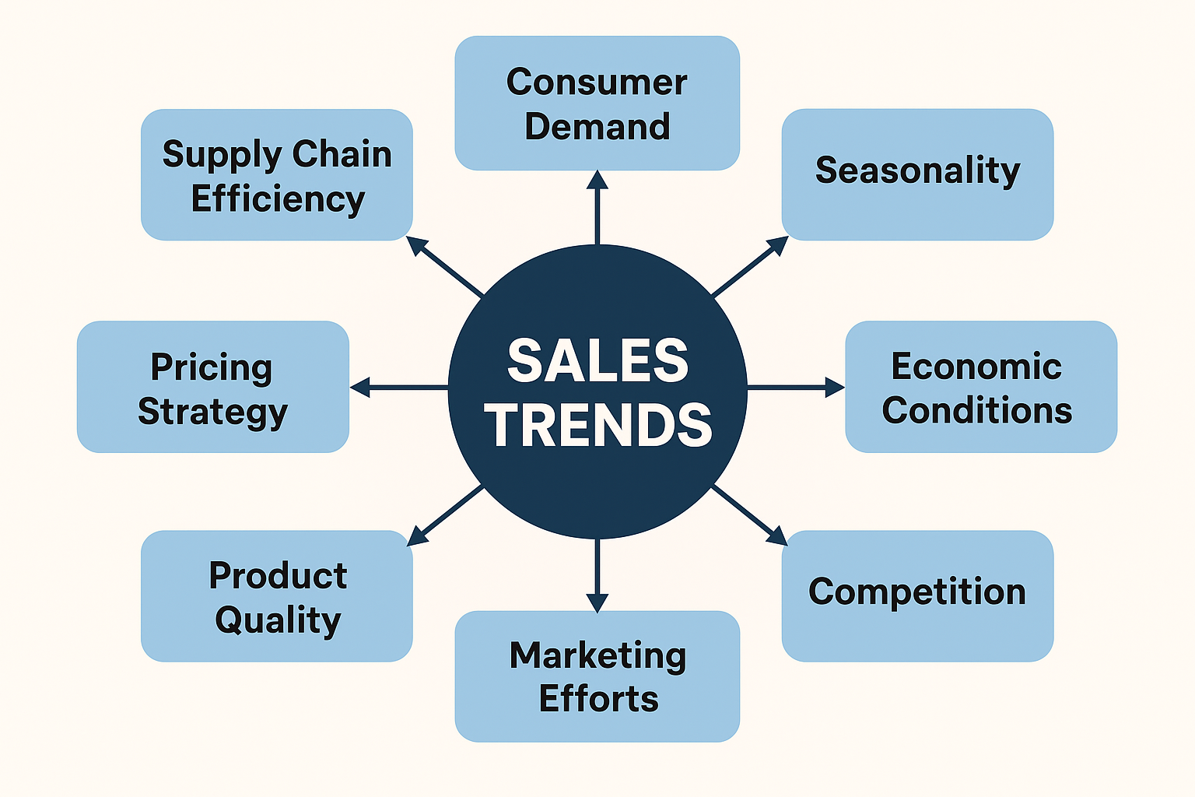
Dataset acquisition and Description
The dataset used for this project is, Store_sales_dataset from Kaggle.
Source link: https://www.kaggle.com/datasets/tanayatipre/store-sales-forecasting-dataset?resource=download
The dataset was uploaded and read using pandas in vscode jupyter notebook. The dataset consists of 2121 rows and 21 columns of the sales data. Out of the 21 columns, the main features are identified as the columns naming, ‘Order Date’, ‘Country’, ‘City’ ‘State’, ‘Category', 'Sub-Category’, ‘Product Name’, ‘Sales’, ‘Quantity’, ‘Discount’, ‘Profit’. Hence, all other columns were dropped.
The dataset found well-structured without no missing values and no duplicates. Date format was not entered properly, so the format changed to datetime64. For the Sales column, the mean value (349.83) was greater than the median value (182.22) which showed it was positively skewed, which means there are high value outliers present.
Project scope and limitations
The primary objective of this project is to predict future monthly sales revenue based on historical sales data. The model will use past transactional records to learn sales patterns and generate accurate monthly forecasts that support business decision-making, inventory planning, and revenue management.
The forecasting model will predict sales for the next 3 months. This short-term forecasting period is suitable for the dataset and aligns with operational needs such as inventory planning, procurement scheduling, and monthly sales goal setting.
Data Constraints
- The dataset is complete, with no missing values and no duplicates, ensuring clean inputs for the model.
- Although the data captures daily transactions, it does not explicitly include special events, such as holiday sales or promotional campaigns. Therefore, the model must infer seasonality and sales spikes indirectly from the date column.
- The dataset does not include external factors (economic conditions, competitor promotions, and market trends). As a result, the forecasting model assumes that future sales patterns will follow historical trends.
- Sales forecasts will be generated at the monthly level due to the granularity and consistency of monthly patterns in the dataset.
Evaluation Metrics
To measure forecasting accuracy and compare different models, the following evaluation metrics will be used.
- Root Mean Squared Error (RMSE): To measure the magnitude of prediction errors and penalize large deviations.
- Mean Absolute Percentage Error (MAPE): To express errors as a percentage of actual sales for easier business interpretation.
- R² Score: To assess how well the model explains the variability in historical sales.

Exploratory Data Analysis (EDA) and Data Preprocessing
Data Cleaning
A detailed data cleaning process was performed to prepare the dataset for sales forecasting. The dataset was checked for missing values across all columns using exploratory functions, and no missing values were found, so no imputation or removal was required. The dataset was inspected for duplicate records, and no duplicates were found. To ensure consistency across the dataset, the ‘Order Date’ column was converted from an object type to datetime64, enabling accurate time-series processing. All object-type text columns were standardized by converting values to lowercase, ensuring uniform category labels during grouping, filtering, and analysis.
Outlier detection
Outliers in the Sales column were visualized to understand their distribution. Boxplot Revealed several high-value points far above the upper quartile. Histogram showed strong right-skewness with many small transactions and a long tail of large sales amounts.
For statistical detection, Interquartile Range (IQR) method was used to compute outlier thresholds:
Q1=47.04
Q3=435.17
IQR=388.13
Upper Bound=1017.36
Using these thresholds, 164 records outliers were detected, and the maximum sales amount was 4416.17. This confirms the presence of extreme high-value sales points. Since these outliers represent genuine large purchases and affect monthly totals, they should not be removed. Instead, they were capped (winsorization) at the IQR upper bound to prevent extreme values from distorting the forecasting model. This method preserves the overall distribution while reducing the impact of extreme spikes.
EDA Findings
A comprehensive Exploratory Data Analysis (EDA) was conducted to understand sales patterns, identify key drivers of revenue, and detect potential data challenges that may influence forecasting accuracy.
Sales trends and seasonality
- Daily Trend: Daily sales fluctuate heavily, with several noticeable spikes caused by large transactions. This is expected in retail data involving furniture products.
- Monthly Trend: Monthly sales show clear seasonal patterns, with recurring peaks and dips across the years. Certain months, particularly mid-year and year-ed periods, show higher sales volumes.
- Yearly Trend: Sales have shown consistent growth from 2014 to 2017, indicating an upward demand trend.
- Seasonality: The “Average Sales by Month” plot highlights repeating seasonal behavior, with stronger sales in months like January, March, June, August, September, and November, and dips in months like February and October.
Key Variables Influencing Sales
Correlation and scatter-plot analysis revealed the following important relationships:
- Quantity has a moderate positive correlation with Sales (0.44). Higher quantities sold generally lead to higher revenue, although high-value items can create large sales even with low quantity.
- Discount shows almost no direct correlation with Sales (-0.028). Discounts do not significantly increase total sales revenue.
- Discount has a strong negative correlation with Profit (-0.48). Increased discounting significantly reduces profit margins. This is a crucial business insight.
- Profit shows a week positive correlation with sales (0.17). Not all high sales result in high profit, mainly due to varying discount levels.
Overall, no pairs of variables were highly correlated (>0.8), indicating no multicollinearity issues.
Data challenges Identified
While the dataset is clean and contains no missing values or duplicates, several challenges were identified:
- Presence of Extreme Outliers:
The sales column is right-skewed, with several transactions exceeding the IQR upper bound (1017). A total of 164 outliers were detected, but these represent genuine high-value purchases.
- High Variability in Daily Sales:
Daily-level data is noisy and unsuitable for forecasting, which is why monthly aggregation was chosen.
- Seasonal Peaks and Spikes:
Strong Seasonality means forecasting models must account for recurring patterns.
Despite these challenges, no unrealistic values or data entry errors were found.
Business Insights from EDA
- High-value transactions significantly influence revenue, especially in furniture-related categories.
- Discounting reduces profit but does not meaningfully increase sales revenue, indicating potential overuse of discount strategies.
- Certain months repeatedly outperform others, suggesting clear seasonal opportunities for targeted marketing or inventory planning.
- Top-selling states and cities (California, New York, Los Angeles, New York City) highlight regional strengths that businesses can leverage.
Feature Engineering
Feature engineering was performed to enhance the predictive power of the dataset and prepare it for monthly sales forecasting. The major steps included creating new time-based variables, generating lag features, encoding categorical data, and selecting relevant features for modeling.
Date-Based feature creation
From the Order Date column, several time features were extracted to capture seasonal behavior and recurring sales patterns:
- Day – Numeric day of the month (dt.day)
- Month – Numeric month value
- Year – Year extracted from order date
- Quarter – Quarter of the year (1 to 4)
- DayOfWeek – Day index (0 = Monday, 6 = Sunday)
- IsWeekend – Binary indicator (1 for Saturday/Sunday)
These features help detect weekly trends, month-end effects, quarterly cycles, and seasonality in sales.
Holiday Indicators
Specific U.S. holiday dates (Black Friday, Christmas, Independence Day, New Year) were manually defined, and a new feature was added:
- IsHoliday – Indicates whether an order occurred on a major holiday date.
Holiday indicators capture sales spikes during retail shopping events.
Lag features and rolling statistics (Monthly level)
A monthly_sales series was created. To help the model learn from past sales performance, several time-series features were generated:
Lag Features:
- Lag_1 – Previous month’s sales
- Lag_2 – Sales from two months ago
- Lag_3 – Sales from three months ago
These help capture short-term trends and momentum.
Rolling Averages:
- Rolling_3 – 3-month moving average
- Rolling_6 – 6-month moving average
- Rolling_12 – 12-month moving average
Rolling averages smooth out noise and highlight medium/long-term patterns.
Rolling Standard Deviation:
- Rolling_STD_3 – Sales volatility over the last 3 months
- Rolling_STD_6 – Volatility over 6 months
These measure fluctuations and irregularity in sales patterns. After creating lag and rolling features, rows containing NaN (initial months) were removed
Encoding categorical variables
One-Hot Encoding (Low-cardinality features) applied to:
- Category
- Sub-Category
- Country
This created binary indicator variables such as “Sub-Category_chairs”, “Sub-Category_furnishings”, and “Sub-Category_tables”. These appeared as True/False, which are equivalent to 1/0.
Label Encoding (High-cardinality features) applied to:
- City
- State
- Product Name
Each unique category was assigned to a numeric label. This avoids dimensionality explosions and keeps the model efficient.
Feature Selection Decisions
Removed irrelevant columns:
- Product Name (too many categories)
- Order Date (date features already extracted)
- YearMonth (not needed in transaction-level model)
- Country (single unique value)
Retained Key Transaction-level features:
- Sales (target)
- Quantity
- Discount
- Profit
- Sales_capped (outlier-treated sales)
- City (encoded)
- State (encoded)
- Sub_Category_Chairs (one-hot encoded)
- Sub_Category_Furnishings (one-hot encoded)
- Sub_Category_Tables (one-hot encoded)
- Day, DayOfWeek, Month, Quarter
- IsWeekend
- IsHoliday
Retained Key Monthly Features for Forecasting
- Sales
- Lag_1, Lag_2, Lag_3
- Rolling_3, Rolling_6, Rolling_12
- Rolling_STD_3, Rolling_STD_6
These features will form the basis for building the forecasting model.

Model Selection and Training
Selecting Machine Learning Models
Multiple forecasting models were evaluated based on their suitability for monthly sales prediction. Time-series models such as ARIMA and SARIMA were considered due to their ability to capture trends and seasonality. Machine learning models, including Linear Regression, Random Forest, and Gradient Boosting, were also evaluated since lag-based and holiday features were engineered into the dataset. For this project, SARIMA was selected as the primary forecasting model due to its ability to handle seasonal monthly patterns, while Random Forest was chosen as an alternative model for leveraging engineered numerical and categorical features. Linear Regression was chosen as the baseline model for comparison.
Splitting data for Training and Testing
Since the dataset represents a time-series of monthly sales from 2014 to 2017, the train-test split was performed chronologically rather than randomly to prevent data leakage and preserve temporal ordering. An 80-20 split was used, where historical data from early years was used for training, and the most recent months were reserved for testing to simulate real future predictions. This ensures the model evaluates performance on unseen future periods while retaining seasonality and trend patterns.
Training the Baseline Model
The purpose of the baseline model is to establish a simple performance benchmark before implementing advanced forecasting models. Based on prior model selection, Linear Regression was chosen as the baseline model. Forecasting was performed on the monthly aggregated dataset, which includes:
- Monthly total sales
- Lag features (Lag_1, Lag_2, Lag_3)
- Rolling averages and statistical features
The dataset was sorted chronologically to preserve time dependency. Since the data is time-series, records were split chronologically, not randomly, to prevent data leakage.
- 80% earliest months for training
- 20% most recent months for testing
This ensures the model learns from historical data and is evaluated on unseen future values. Lag-based features were used as predictors since they represent past sales trends. The model was trained using scikit-learn, and predictions were generated for the test period.
The Linear Regression baseline model achieved an RMSE of approximately 10,551 and a MAPE of 30%, indicating notable prediction error. The model captures basic linear trends from past sales but fails to model seasonal variations and non-linear fluctuations in monthly sales. These baseline scores will be used to compare advanced forecasting models.

SARIMA Model
After evaluating the baseline Linear Regression model and observing high prediction error, an advanced time-series model was implemented to better capture seasonal and temporal patterns. SARIMA (Seasonal AutoRegressive Integrated Moving Average) was selected due to the monthly structure of the data and clear yearly seasonality trends.
The model was trained on the monthly aggregated dataset (monthly_model), which includes total sales per month from 2014-2017. A chronological 80-20 split was applied, where earlier months were used for training and the most recent months for testing to prevent data leakage.
An initial SARIMA configuration was chosen using commonly recommended starting parameters for seasonal monthly forecasting:
- Non-seasonal: (p,d,q) = (1,1,1)
- Seasonal: (P,D,Q,m) = (1,1,1,12)
Future monthly values were predicted for the same length as the test period, and performance was evaluated using RMSE and MAPE.
The SARIMA model significantly outperformed the baseline Linear Regression model, reducing RMSE from 10,550 to 5,199 and lowering MAPE from ~30% to ~20%. This improvement indicates that SARIMA is effective in capturing monthly seasonal patterns and temporal dependencies that the baseline model failed to model.

Hyperparameter Tuning and Model Improvement
Hyperparameter optimization
After training the baseline and initial SARIMA model, forecasting accuracy still had room for improvement. Hyperparameter optimization was conducted to refine the SARIMA model by systematically adjusting ARIMA and seasonal parameters to minimize prediction errors. SARIMA tuning involves both seasonal and non-seasonal parameters.
Hyperparameters considered
Component | Parameters | Purpose
Non-seasonal Terms (ARIMA) | p,d,q | Capture trend and short-term dependencies
Seasonal Terms | P,D,Q,m | Capture yearly seasonal sales patterns
Seasonal Period (m) | 12 | Monthly data, 12 months per cycle

Since the dataset was small (only 29 training points), a reduced parameter range was used. The seasonal order was fixed based on observed yearly seasonality. This ensures efficient computation while still capturing seasonal trends.
Tuning Method – Grid Search
A Grid Search strategy was used, testing all combinations of (p,d,q) while keeping seasonal parameters constant.
Tuned Model Performance
Model Version | RMSE | MAPE | Improvement
Baseline Linear Regression | 10550.77 | 29.97%
SARIMA (Default Parameters) | 5199.06 | 20.38% | ~50% better than baseline
SARIMA (After Tuning) | 4162.42 | 16.22% | Best performance so far

Hyperparameter tuning significantly improved forecasting accuracy, reducing RMSE by approximately 20% compared to the default SARIMA model and nearly 60% compared to the baseline regression model. The tuned model better captures seasonal patterns and reduces prediction error, making it a strong candidate for final deployment.

Testing Advanced Models
After evaluating the baseline Linear Regression model and achieving improved performance with SARIMA, additional advanced machine learning models were tested to further enhance predictive accuracy. The goal was to compare different algorithmic approaches and identify the best-performing model for monthly sales forecasting. Advanced models evaluated are SARIMA, Random Forest Regressor, XGBoost Regressor. These models were selected because they balance interpretability, time-dependency, and complex pattern recognition.
All models were trained using monthly aggregated sales data, derived from the cleaned transactional dataset. The dataset includes:
- Lag features (Lag_1, Lag_2, Lag_3)
- Rolling means (3,6,12-month windows)
- Rolling standard deviations
- Time-based features (Month, Year, Quarter)
A chronological train-test split was used to prevent data leakage, training earlier years and testing on the most recent months.
Evaluating model performance
Model | RMSE | MAPE | Interpretation
Baseline (Linear Regression) | 10550.77 | 29.97% | Weak benchmark, poor trend capture
SARIMA (Default) | 5199.06 | 20.38% | Captures seasonality well
Random Forest Regressor | 5646.27 | 20.45% | Handles features, limited seasonal learning
SARIMA (Tuned) | 4162.42 | 16.22% | Strong performance, best seasonal fit
XGBoost Regressor | 4052.31 | 16.52% | Best RMSE, highly predictive

- SARIMA (tuned) and XGBoost outperform all other models, indicating that both seasonality and feature-driven trends are important.
- Random Forest improved accuracy vs. Baseline but could not model seasonal patterns effectively.
- XGBoost achieved the lowest RMSE, showing stronger numerical prediction accuracy, while SARIMA slightly outperformed in percentage error (MAPE).

Insights and model weaknesses
Model | Strengths | Weaknesses
Linear Regression | Simple, fast | Cannot model trends or seasonality
SARIMA (Tuned) | Best seasonal forecasting; interpretable | Limited external feature handling
Random forest | Handles categorical/structured data | Ignores sequential dependencies
XGBoost | Most accurate RMSE; handles non-linearity | Less explainable; needs tuning

Based on evaluation, both SARIMA (Tuned) and XGBoost are strong candidates, with SARIMA providing the lowest percentage error (better interpretability) and XGBoost providing the lowest absolute error (better numeric precision). For business forecasting scenarios emphasizing seasonal patterns and explainability, SARIMA is selected as primary model, while XGBoost serves as a secondary high-accuracy alternative.

Visualization and Business Insights
Visualizing predictions
Plotting Actual vs Predicted Sales
Line charts were created comparing actual sales against the predicted values from the two selected advanced models: Tuned SARIMA and XGBoost. These plots allowed us to assess how closely each model followed real sales behavior over time.
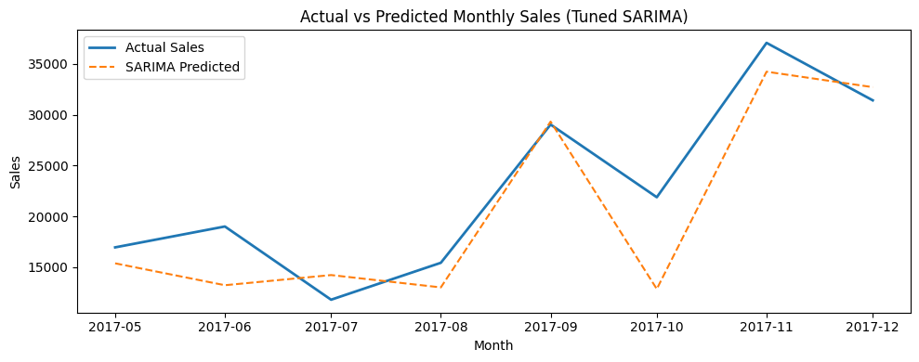
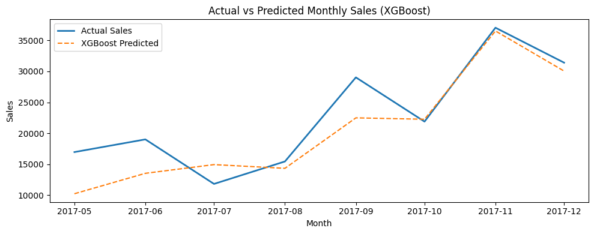
- Both models were able to follow the upward trend seen during late 2017
- SARIMA captured seasonal spikes more accurately, especially in high demand months like November.
- XGBoost predictions were smoother, staying closer to average values and avoiding large fluctuations.
- SARIMA handles seasonal patterns better than XGBoost.
- Errors are higher during specific periods, particularly mid-year dips and december spikes.
- SARIMA overpredicts peaks; XGBoost underpredicts them slightly.
Visualizing forecasted sales
Future monthly sales were forecasted using Tuned SARIMA and plotted along with confidence intervals to represent prediction of uncertainty.
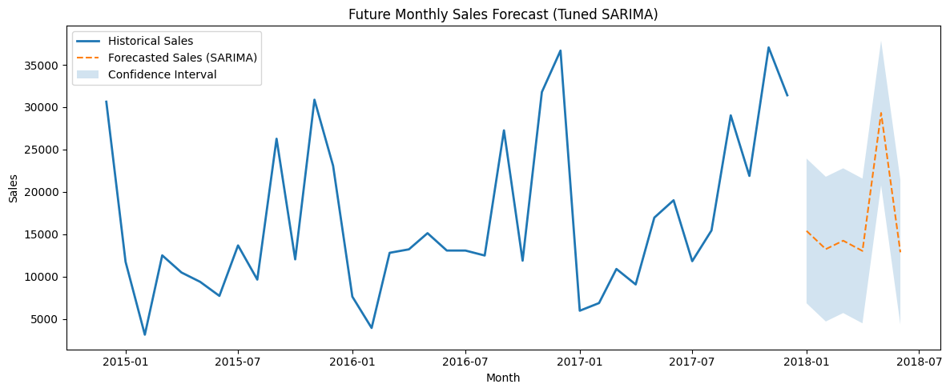
- The forecast suggests moderate sales volatility with recurring seasonal peaks.
- Confidence bands widen over time, indicating less certainty in longer-term predictions
- Predicted values align with historical seasonal patterns but do not reflect external factors.
Scatter plots
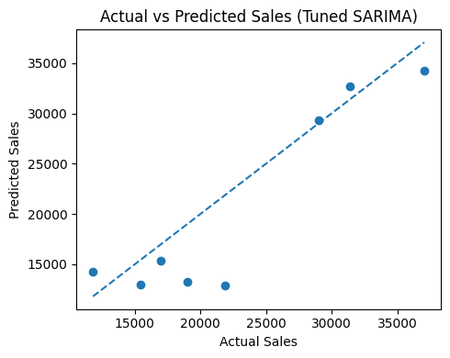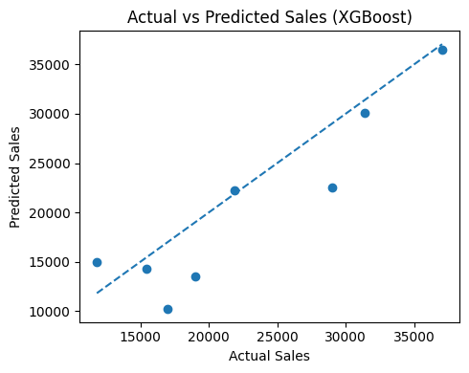
- SARIMA scatter plots points diverge significantly from the identity line at extreme values (especially high-sales months like October-December)
- The model clusters well around moderate sales values but fails to capture sudden spikes, showing its reliance on seasonal averages rather than external factors.
- There is evident directional bias: underprediction at high values and overprediction at low values.
- XGBoost scatter plot points are more tightly clustered around the identity line than SARIMA, indicating better fit across general sales values.
- The model predicts mid-range sales accurately but shows systematic underestimation beyond a threshold
- Outliers lie below the diagonal line, meaning the model is too conservative during peak demand months.

Residual plots
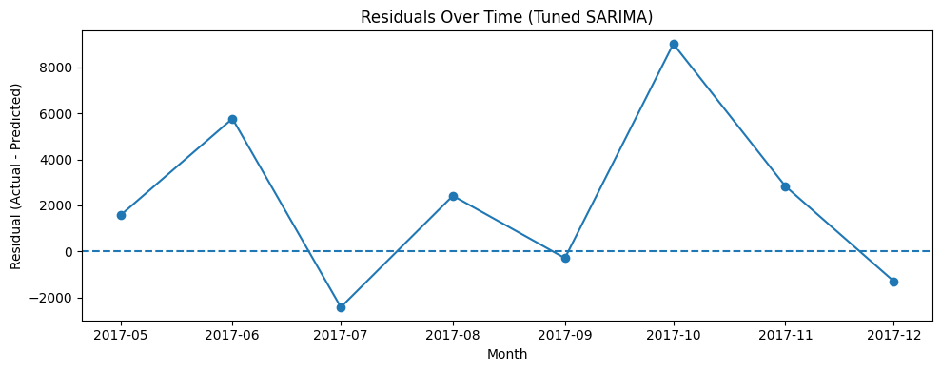
- SARIMA Residual plots have large positive residuals occur during peak months (sep-dec), meaning SARIMA underpredicted major seasonal surges.
- Residuals in low-demand months remain small, indicating strong performance when sales follow regular seasonal cycles.
- The residual curve shows periodic patterns, suggests model captures seasonality but misses event-driven demand spikes.
- No strong random noise pattern, implying model may not fully explain variance in demand peaks

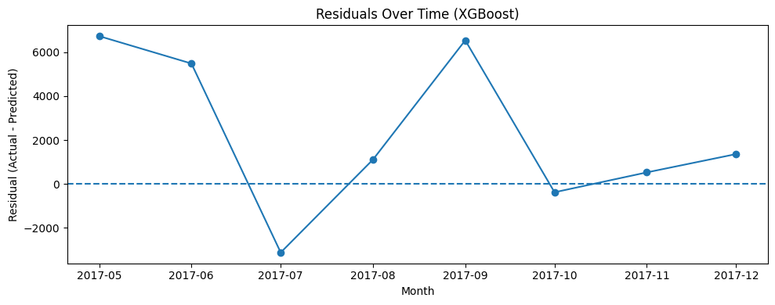
- XGBoost Residuals are more evenly distributed across months, indicating better consistency.
- Like SARIMA, large errors occur around holiday months, but the error magnitude is smaller than SARIMA.
- A noticeable underprediction bias appears; residuals mostly positive during peak months.
- Slight randomness in residual distribution suggests better variance capture but limited seasonal context.
- XGBoost adapts well to typical demand but lacks seasonality awareness without additional engineer features.
Bar plots findings
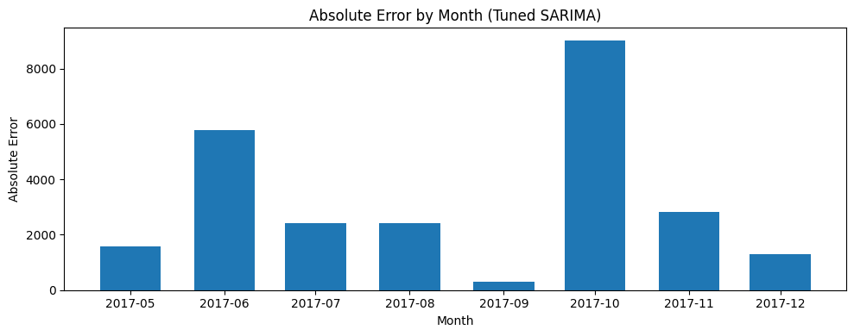
- Highest errors in October-December, aligning with major historical sales peaks.
- Low absolute error in early and mid-year months where demand is stable
- Error spikes align with real demand shocks, suggesting seasonality alone cannot explain peak spikes.
- Seasonal models are insufficient for months influenced by marketing campaigns, product launches, or festivals.
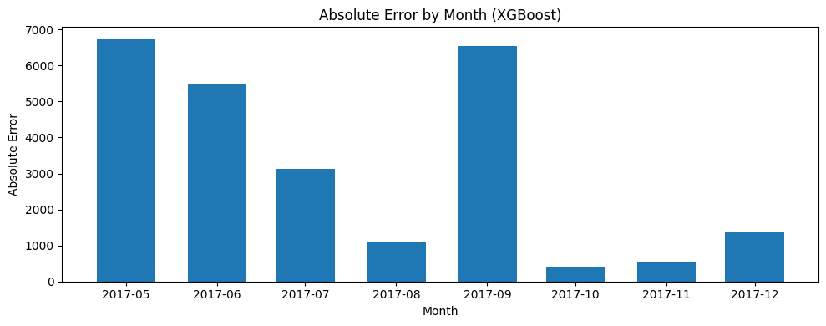
- Lower peak-month errors compared to SARIMA, but still notable.
- Slightly higher errors in normal months (may-july), where SARIMA performed better.
- Indicates XGBoost tracks trends well but has difficulty predicting break-point seasonal patterns.
- XGBoost is better at generalizing average demand but weaker when demand patterns shift rapidly.

Business Insights
Analysis of Sales Trends
Based on historical data (2014-2017) and predicted values:
- Sales exhibit strong seasonality, with major spikes toward Q4, especially November-December. These align with holiday seasons, suggesting seasonal demand cycles.
- Mid-year months (May-July) showed relatively lower sales and consistent behavior, indicating stable demand periods.
- The forecasting models show continued cyclical behavior in future months, indicating that seasonal trends are expected to repeat.
- Certain product categories such as furniture and office supplies experienced frequent sales fluctuations due to variable order size and pricing
- Sales volume was highly concentrated in specific urban regions, suggesting that geographic factors play a role in demand.
Demand is not random. It follows predictable yearly cycles, meaning procurement, staffing, and marketing can be planned around seasonal peaks. Models struggled most during high-demand months, which implies external business drivers (like marketing campaigns) are not yet included but strongly influence sales.

Business Recommendations
1. Inventory & Supply Chain Strategy
- Increase stock ahead of peak demand (especially Q4).
- Maintain lower stock for mid-year months to reduce holding costs.
- Plan logistics and supplier contracts based on seasonal cycles.
2. Marketing & Promotion Strategy
- Schedule promotions during slow demand periods to maintain revenue stability.
- Avoid excessive discounting during peak months—demand is high even without price reductions.
3. Pricing Optimization
- Use dynamic pricing for high-demand periods (holiday seasons).
- Offer bundle pricing or value packs during low-demand periods.
4. Product & Market Expansion
- Expand into high-performing regions where sales consistently spike.
- Prioritize product lines with historically high peak demand.
- Identify low-performing cities for targeted marketing interventions.
5. Forecasting Model Improvement
- Integrate promotional, pricing, and stock data to improve extreme value prediction.
- Build hybrid models combining SARIMA + XGBoost to leverage both seasonal and feature-driven signals.

