[Q]
(a)
(b)
(c) 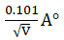
(d) 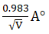
[qtype] MCQ4
[ans] c
[Marks]1
[sortid] 1
[soln] 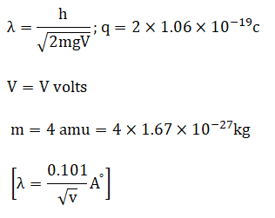
[Q]
(a)
(b)
(c)
(d)
[qtype] MCQ4
[ans] d
[Marks]1
[sortid] 2
[soln] 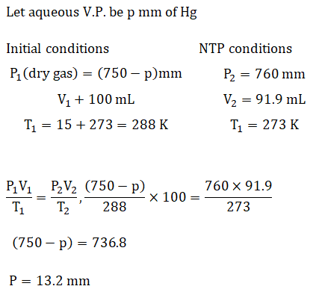
[Q] 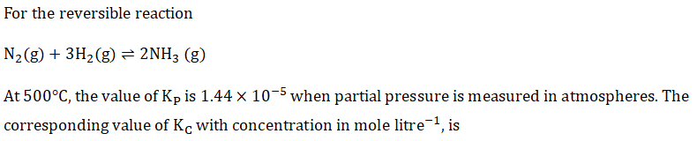
(a) 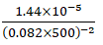
(b) 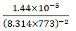
(c) 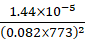
(d) 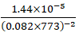
[qtype] MCQ4
[ans] d
[Marks]1
[sortid] 3
[soln] 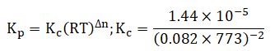
[Q] 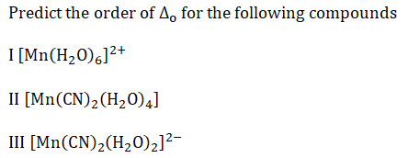
(a)
(b)
(c) 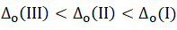
(d)
[qtype] MCQ4
[ans] a
[Marks]1
[sortid] 4
[soln]
[Q] 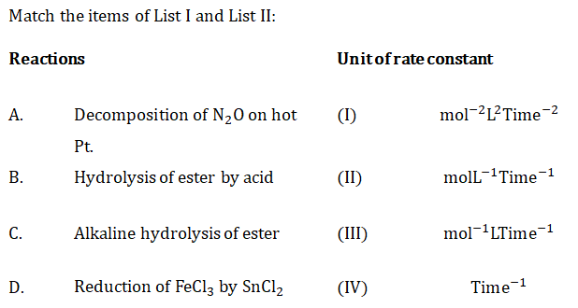
(a)
(b)
(c)
(d)
[qtype] MCQ4
[ans] d
[Marks]1
[sortid] 5
[soln] 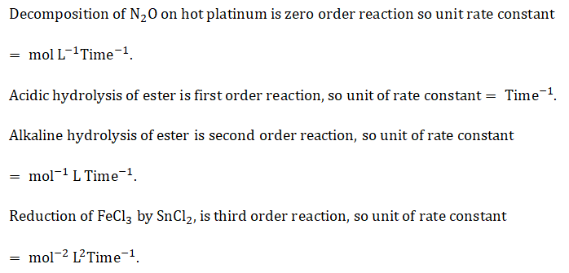
[Q]
(a)
(b)
(c) 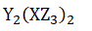
(d)
[qtype] MCQ4
[ans] d
[Marks]1
[sortid] 6
[soln]
[Q]
(a)
(b)
(c)
(d)
[qtype] MCQ4
[ans] c
[Marks]1
[sortid] 7
[soln]
[Q]
(a)
(b)
(c)
(d)
[qtype] MCQ4
[ans] a
[Marks]1
[sortid] 8
[soln] 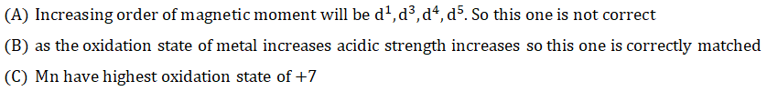
[Q] 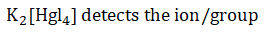
(a)
(b)
(c)
(d)
[qtype] MCQ4
[ans] c
[Marks]1
[sortid] 9
[soln]
[Q] 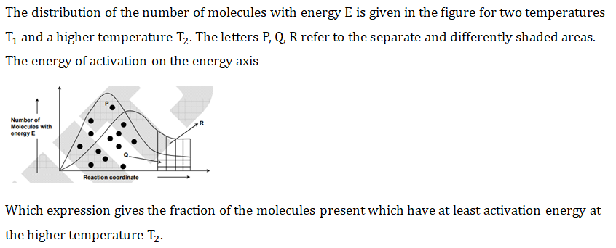
(a)
(b) 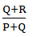
(c) 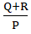
(d) 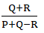
[qtype] MCQ4
[ans] b
[Marks]1
[sortid] 10
[soln] 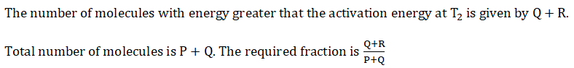
[Q] 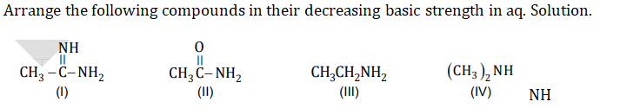
(a)
(b)
(c)
(d)
[qtype] MCQ4
[ans] c
[Marks]1
[sortid] 11
[soln] 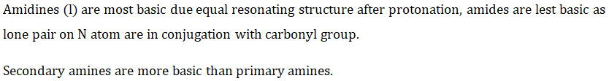
[Q] 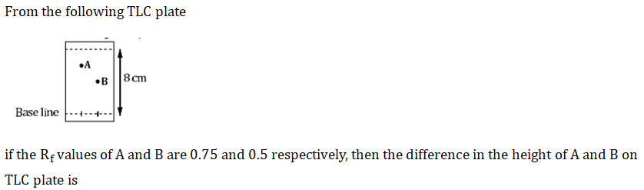
(a)
(b)
(c)
(d)
[qtype] MCQ4
[ans] c
[Marks]1
[sortid] 12
[soln] 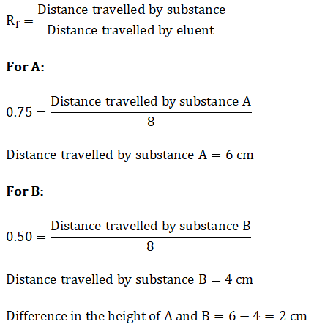
[Q]
(a)
(b)
(c)
(d)
[qtype] MCQ4
[ans] a
[Marks]1
[sortid] 13
[soln] 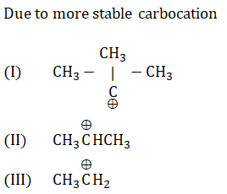
[Q] 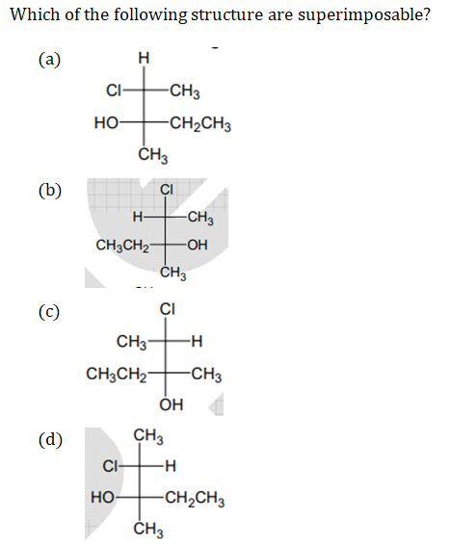
(a)
(b)
(c)
(d)
[qtype] MCQ4
[ans] d
[Marks]1
[sortid] 14
[soln] 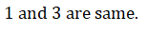
[Q]
(a)
(b)
(c)
(d)
[qtype] MCQ4
[ans] b
[Marks]1
[sortid] 15
[soln] 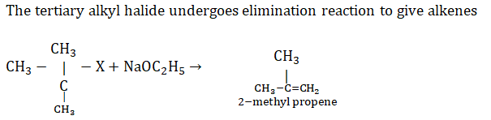
[Q]
(a)
(b)
(c)
(d)
[qtype] MCQ4
[ans] b
[Marks]1
[sortid] 16
[soln] 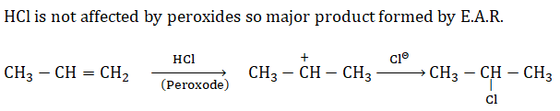
[Q]
(a) 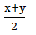
(b) 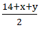
(c) 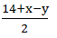
(d) 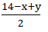
[qtype] MCQ4
[ans] d
[Marks]1
[sortid] 17
[soln] 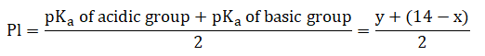
[Q] 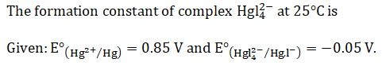
(a)
(b)
(c)
(d)
[qtype] MCQ4
[ans] d
[Marks]1
[sortid] 18
[soln] 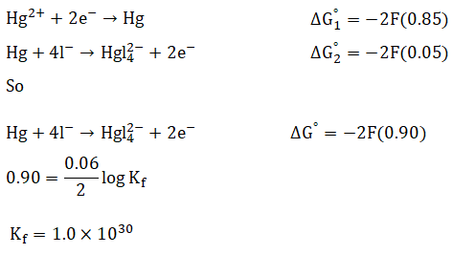
[Q] 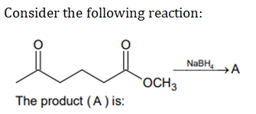
(a) 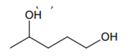
(b) 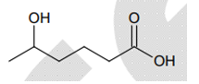
(c) 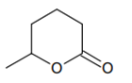
(d) 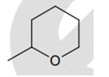
[qtype] MCQ4
[ans] c
[Marks]1
[sortid] 19
[soln] 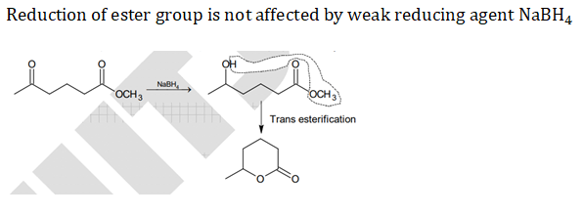
[Q] 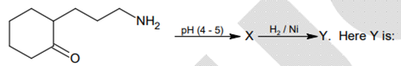
(a) 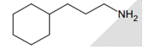
(b) 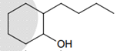
(c) 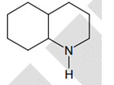
(d) 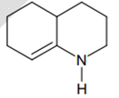
[qtype] MCQ4
[ans] c
[Marks]1
[sortid] 20
[soln] 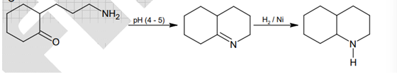
[Q]
(a)
(b)
(c)
(d)
[qtype] MCQ4
[ans] c
[Marks]1
[sortid] 21
[soln]
[Q]
(a)
(b)
(c)
(d)
[qtype] MCQ4
[ans] d
[Marks]1
[sortid] 22
[soln]
[Q]
(a)
(b)
(c)
(d)
[qtype] MCQ4
[ans] d
[Marks]1
[sortid] 23
[soln]
[Q]
(a)
(b)
(c)
(d)
[qtype] MCQ4
[ans] a
[Marks]1
[sortid] 24
[soln]
[Q]
(a)
(b)
(c)
(d)
[qtype] MCQ4
[ans] d
[Marks]1
[sortid] 25
[soln]
[Q]
(a)
(b)
(c)
(d)
[qtype] MCQ4
[ans] d
[Marks]1
[sortid] 26
[soln]
[Q]
(a)
(b)
(c)
(d)
[qtype] MCQ4
[ans] c
[Marks]1
[sortid] 27
[soln]
[Q]
(a)
(b)
(c)
(d)
[qtype] MCQ4
[ans] a
[Marks]1
[sortid] 28
[soln]
[Q]
(a)
(b)
(c)
(d)
[qtype] MCQ4
[ans] c
[Marks]1
[sortid] 29
[soln]
[Q]
(a)
(b)
(c)
(d)
[qtype] MCQ4
[ans] b
[Marks]1
[sortid] 30
[soln]
[Q]
(a)
(b)
(c)
(d)
[qtype] MCQ4
[ans] c
[Marks]1
[sortid] 31
[soln]
[Q]
(a)
(b)
(c)
(d)
[qtype] MCQ4
[ans] c
[Marks]1
[sortid] 32
[soln]
[Q]
(a)
(b)
(c)
(d)
[qtype] MCQ4
[ans] a
[Marks]1
[sortid] 3
[soln]
[Q]
(a)
(b)
(c)
(d)
[qtype] MCQ4
[ans] d
[Marks]1
[sortid] 34
[soln]
[Q]
(a)
(b)
(c)
(d)
[qtype] MCQ4
[ans] b
[Marks]1
[sortid] 35
[soln]

