[PRG]
[Q] 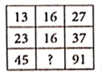
(a)
(b)
(c)
(d)
[qtype] CTQ
[ans] a
[Marks]4,1
[sortid] 21
[PQNo] 1
[soln] 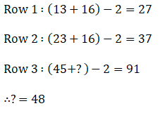
[Q] 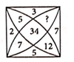
(a)
(b)
(c)
(d)
[qtype] CTQ
[ans] c
[Marks]4,1
[sortid] 22
[PQNo] 2
[soln] 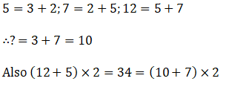
[PRG]
[Q] 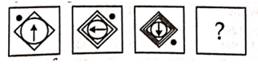
(a) 
(b) 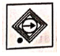
(c) 
(d) 
[qtype] CTQ
[ans] c
[Marks]4,1
[sortid] 23
[PQNo] 3
[soln]
[Q] 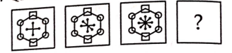
(a) 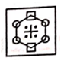
(b) 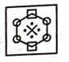
(c) 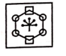
(d) 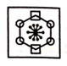
[qtype] CTQ
[ans] d
[Marks]4,1
[sortid] 24
[PQNo] 4
[soln]
[Q] 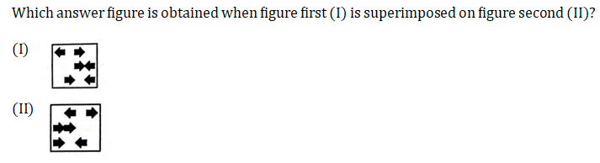
(a) 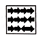
(b) 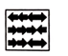
(c) 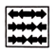
(d) 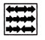
[qtype] MCQ4
[ans] c
[Marks]4,1
[sortid] 25
[soln]
[Q] 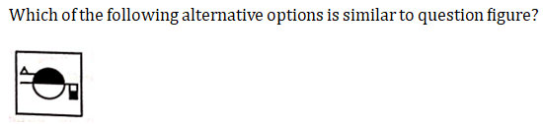
(a) 
(b) 
(c) 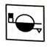
(d) 
[qtype] MCQ4
[ans] c
[Marks]4,1
[sortid] 26
[soln]
[PRG]
[Q] 
(a) 
(b) 
(c)
(d) 
[qtype] CTQ
[ans] d
[Marks]4,1
[sortid] 27
[PQNo] 5
[soln]
[Q] 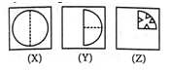
(a) 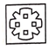
(b) 
(c) 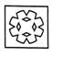
(d) 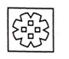
[qtype] CTQ
[ans] b
[Marks]4,1
[sortid] 28
[PQNo] 6
[soln]
[Q] 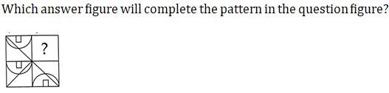
(a) 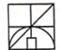
(b) 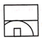
(c) 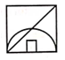
(d) 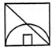
[qtype] MCQ4
[ans] c
[Marks]4,1
[sortid] 29
[soln]
[Q] 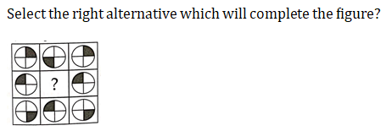
(a) 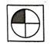
(b) 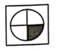
(c) 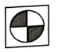
(d) 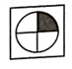
[qtype] MCQ4
[ans] b
[Marks]4,1
[sortid] 30
[soln]

