[Q]
(a)
(b)
(c) 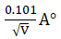
(d) 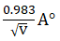
[qtype] MCQ4
[ans] c
[Marks]1
[sortid] 1
[soln] 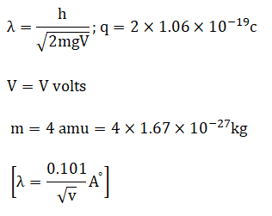
[Q]
(a)
(b)
(c)
(d)
[qtype] MCQ4
[ans] d
[Marks]1
[sortid] 2
[soln] 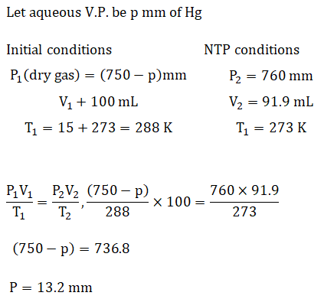
[Q] 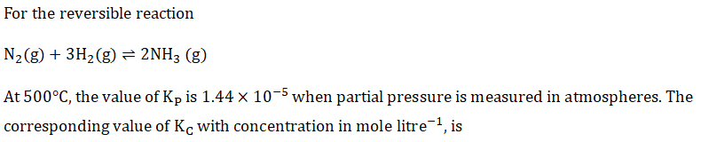
(a) 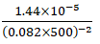
(b) 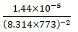
(c) 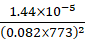
(d) 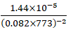
[qtype] MCQ4
[ans] d
[Marks]1
[sortid] 3
[soln] 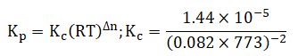
[Q] 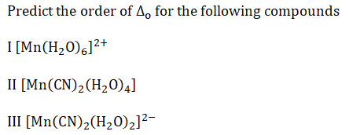
(a)
(b)
(c) 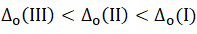
(d)
[qtype] MCQ4
[ans] a
[Marks]1
[sortid] 4
[soln]
[Q] 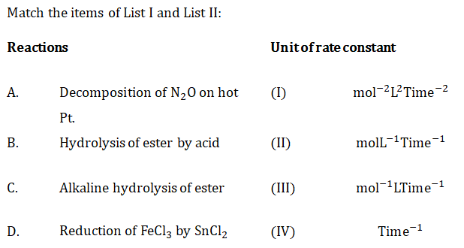
(a)
(b)
(c)
(d)
[qtype] MCQ4
[ans] d
[Marks]1
[sortid] 5
[soln] 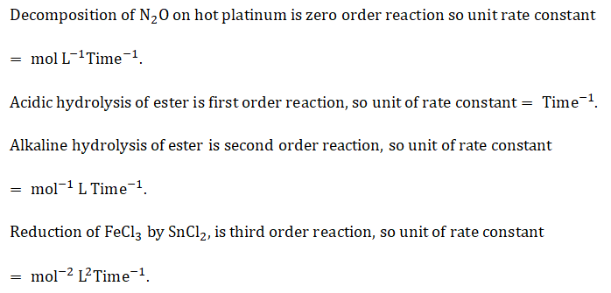
[Q]
(a)
(b)
(c) 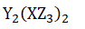
(d)
[qtype] MCQ4
[ans] d
[Marks]1
[sortid] 6
[soln]
[Q]
(a)
(b)
(c)
(d)
[qtype] MCQ4
[ans] c
[Marks]1
[sortid] 7
[soln]
[Q]
(a)
(b)
(c)
(d)
[qtype] MCQ4
[ans] a
[Marks]1
[sortid] 8
[soln] 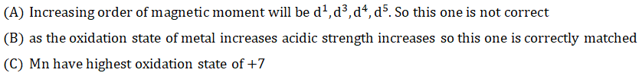
[Q] 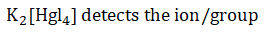
(a)
(b)
(c)
(d)
[qtype] MCQ4
[ans] c
[Marks]1
[sortid] 9
[soln]
[Q] 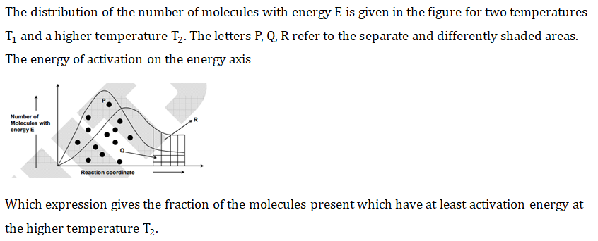
(a)
(b) 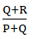
(c) 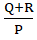
(d) 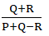
[qtype] MCQ4
[ans] b
[Marks]1
[sortid] 10
[soln] 