**[Q]** 

(a) 

(b) 

(c) 

(d) 

[qtype] MCQ4

[ans] c

[Marks]4,1

[sortid] 1

[soln] 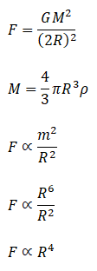

**[Q]** 

(a) 

(b) 

(c) 

(d) 

[qtype] MCQ4

[ans] c

[Marks]4,1

[sortid] 2

[soln] 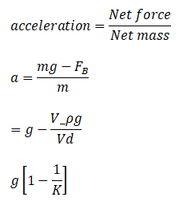

**[Q]** 

(a) 

(b) 

(c) 

(d) 

[qtype] MCQ4

[ans] d

[Marks]4,1

[sortid] 3

[soln] 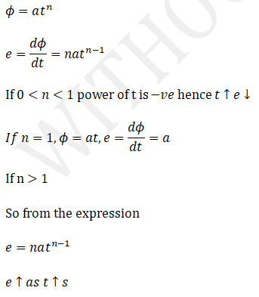

**[Q]** 

(a) 

(b) 

(c) 

(d) 

[qtype] MCQ4

[ans] d

[Marks]4,1

[sortid] 4

[soln] 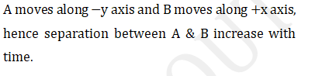

**[Q]** 

(a) 

(b) 

(c) 

(d) 

[qtype] MCQ4

[ans] d

[Marks]4,1

[sortid] 5

[soln] 

**[Q]** 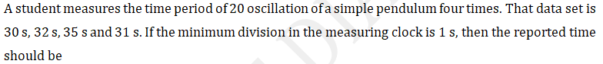

(a)

(b)

(c)

(d)

(e)

[qtype] MCQ5

[ans] c

[Marks]4,1

[sortid] 6

[soln] 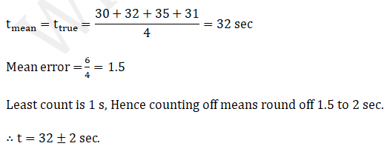

**[Q]** 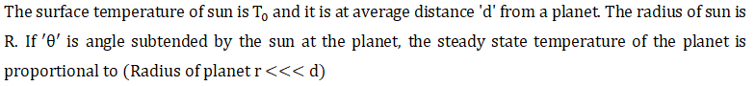

(a)

(b)

(c)

(d)

(e)

[qtype] MCQ5

[ans] b

[Marks]4,1

[sortid] 7

[soln] 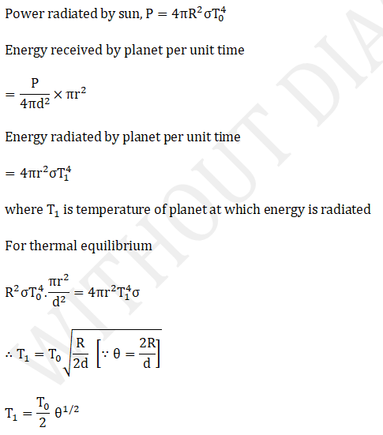

**[Q]** 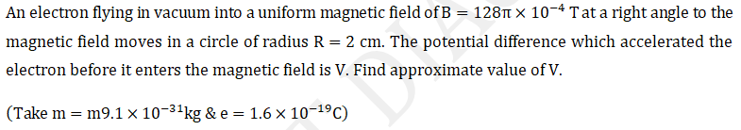

(a)

(b)

(c)

(d)

(e)

[qtype] MCQ5

[ans] d

[Marks]4,1

[sortid] 8

[soln] 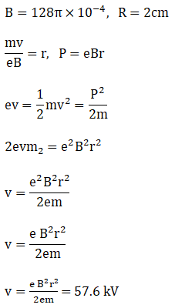

**[Q]** 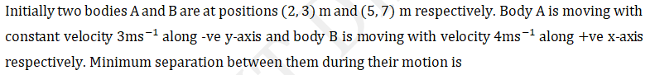

(a)

(b)

(c)

(d)

(e)

[qtype] MCQ5

[ans] d

[Marks]4,1

[sortid] 9

[soln] 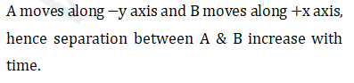

**[Q]** 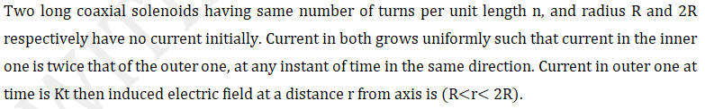

(a)

(b)

(c)

(d)

(e)

[qtype] MCQ5

[ans] b

[Marks]4,1

[sortid] 10

[soln] 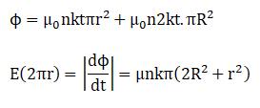

**[Q]** 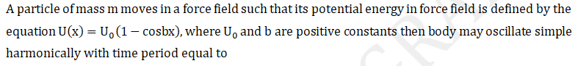

(a) 

(b) 

(c) 

(d) 

[qtype] MSQN

[ans] c,d

[Marks]4,1

[sortid] 11

[soln] 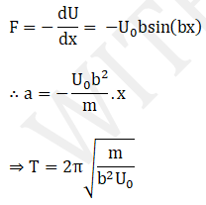

**[Q]** 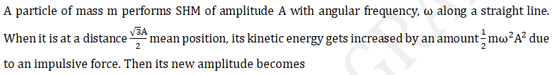

(a) 

(b) 

(c) 

(d) 

[qtype] MSQN

[ans] c,d

[Marks]4,1

[sortid] 12

[soln] 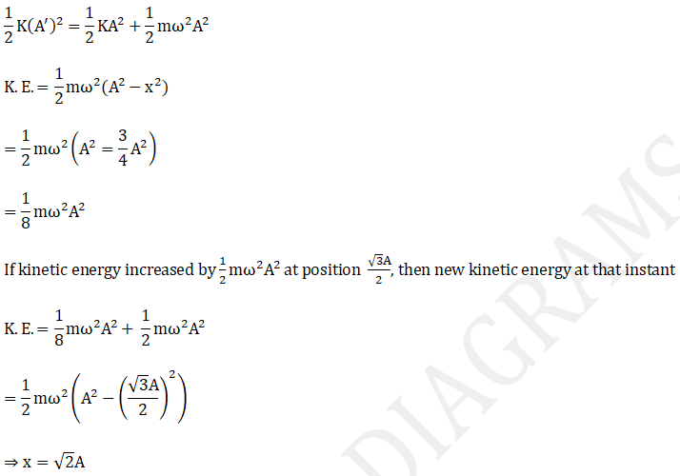

**[Q]** 

(a) 

(b) 

(c) 

(d) 

[qtype] MSQN

[ans] b,d

[Marks]4,1

[sortid] 13

[soln] 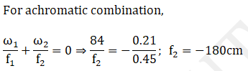

**[Q]** 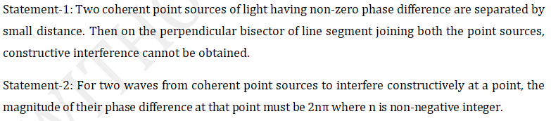

(a) 

(b) 

(c) 

(d) 

[qtype] MSQN

[ans] a,d

[Marks]4,1

[sortid] 14

[soln] 

**[Q]** 

(a) 

(b) 

(c) 

(d) 

[qtype] MSQN

[ans] d

[Marks]4,1

[sortid] 15

[soln] 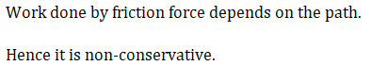

**[Q]** 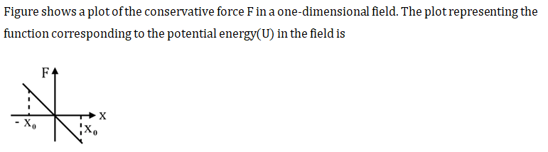

(a) 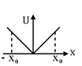

(b) 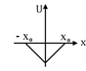

(c) 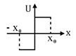

(d) 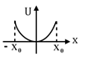

[qtype] MSQ

[ans] d

[Marks]4,1

[sortid] 16

[soln] 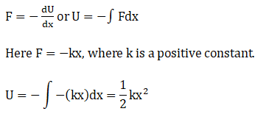

**[Q]** 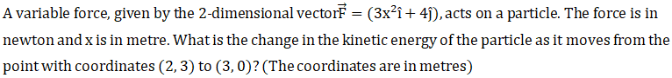

(a) 

(b) 

(c) 

(d) 

[qtype] MSQ

[ans] c,d

[Marks]4,1

[sortid] 17

[soln] 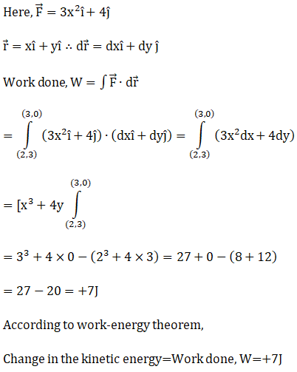

**[Q]** 

(a) 

(b) 

(c) 

(d) 

[qtype] MSQ

[ans] a,d

[Marks]4,1

[sortid] 18

[soln] 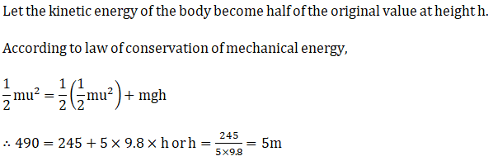

**[Q]** 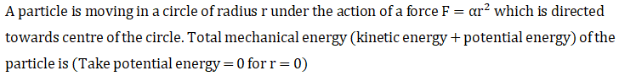

(a) 

(b) 

(c) 

(d) 

[qtype] MSQ

[ans] a,d

[Marks]4,1

[sortid] 19

[soln] 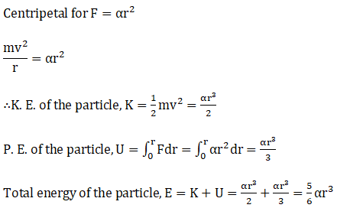

**[Q]** 

(a) 

(b) 

(c) 

(d) 

[qtype] MSQ

[ans] b,d

[Marks]4,1

[sortid] 20

[soln] 