Low Level Design (add HOTEL module)

Project Code | Team4
Project Name | Hotel Booking Management System(Hbms)

Prepared/Modified by | Role | Date of Preparation
Deepthi Thirumani | Software Engineer | 06/10/2017
Reviewed by | Role | Date of Review
Vaishali Srivastava | Software Engineer | 12/10/2017
Approved by | Role | Date of Approval
Uma M Ponniamman | Training Manager
Circulation List | banala.saikumar@capgemini.com  patibandla.saivamsi@capgemini.com  choudharytusharsingh@capgemini.com  pratyusha.appala@capgemini.com  deepthi.thirumani@capgemini.com | Version Number of the template:1.0
Version Number | 1.3

Table of Contents

1. Description Of The Unit 3
2. References 4
3. Dependencies / Assumptions 5
4. Class Diagrams 6
5. Sequence Diagrams 7
6. Design Components 8
6.1 List Of UI Components 8
6.2 List Of Design Classes 8
7. Re-Usable Routines/Components 9
8. Messages 10
9. Configuration Files 11
10. Crud Matrix Table 12
11. Data Mapping Matrix 13
12. Action Flow Matrix 14
13. Stored Procedures 15
14. Program Specification / Pseudo Code 16
REVISION HISTORY OF THE WORK PRODUCT 17

Description Of The Unit

The add Hotel module allows the admin of the application to add new Hotel into the database. This module can be used only by the admin of the application.

On clicking on the add button in the admin home page, the admin is redirected to a add page. The admin enters all the details of the customer like hotel name, city, hotel description, hotel address, phone number, avg_rate_per night, ratings, fax, and email..

After entering all the details, they are inserted into the database on clicking the add button.

References

Reference | Description
Repository reference | https://IGTEBLRSVNTNG.igatecorp.com/svn/oct3_Team4
Class Diagram | /Project Documents/Design Documents/HLD/Class Diagrams
URS | /Project Documents/Requirements/Case Study/HotelBookingManagement.doc
UTP | /Project Documents/Test Plan/UTP/Test Cases/AddHotel/UTP_AddHotelModule.xlsm
DB Design | /Project Documents/Design Documents/HLD/DB Design/HOTEL_GROUP_DBDESIGN.xls

Dependencies / Assumptions

Dependencies:
The admin should be logged in.

Assumptions:
The admin details are stored in the database.

Class Diagrams

Class Diagram

Sequence Diagrams

Sequence Diagram
NA

Design Components

List Of UI Components
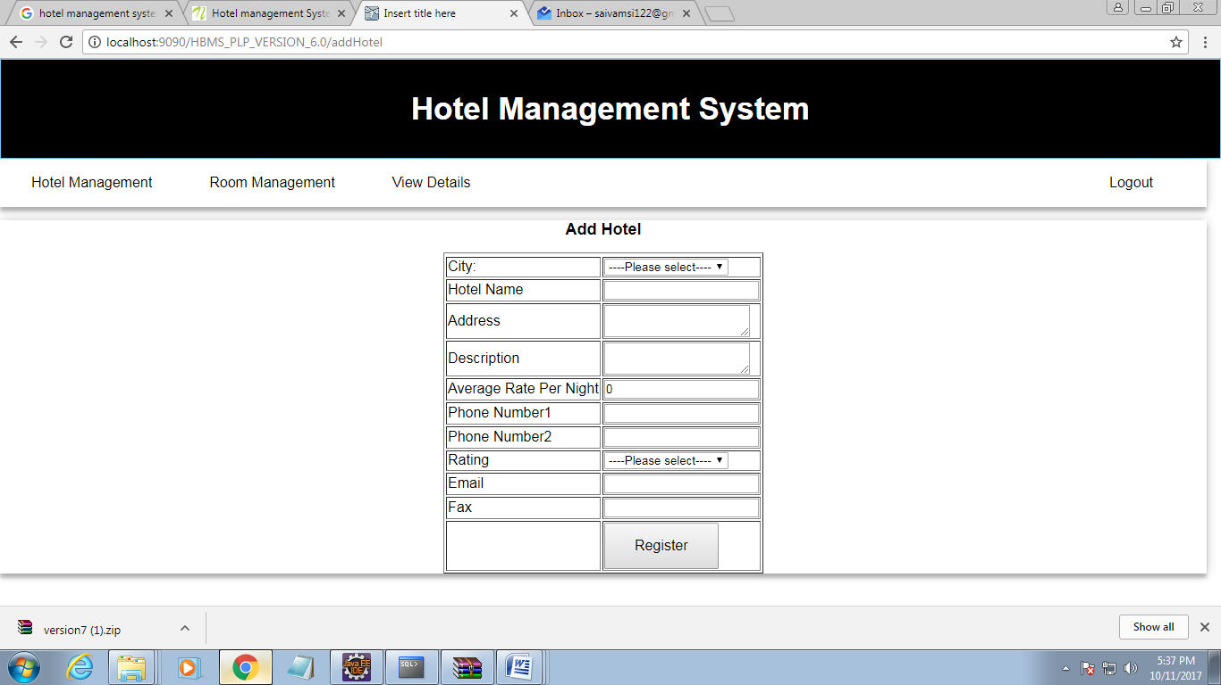

List Of Design Classes
Sr. No. | LLD Name | Class Name | Method Name | Method Description
1 | Add HotelModule | HotelDto | Appropriate getters and setters methods | Getters retrieve the property values and setters set the property values
2 | Add HotelModule | HBMSController | @RequestMapping(value="/addHotel",method=RequestMethod.POST) | It will call the jsp page containing add hotel form to fill the details of the new hotel
3 | AddHotelModule | HBMSServiceImpl | Int addNewHotel(HotelDto hotelDto) | Call the dao function and return the hotel id
4 | Add Hotel Module | HBMSDaoImpl | Int addNewHotel(HotelDto hotelDto) | It will add a new hotel details in database and returns the hotel id to service layer

Re-Usable Routines/Components

Re-Usable Routines/Components

- CSS files
- Javascript files
- DataAccessException class
- Database properties files
- Logger properties files

Messages

#. | Type | Message Text
M1 | Error | Enter a valid value
M2 | Error | Enter a valid description
M3 | Error | Select a sub-category
M4 | Error | Enter a
M5 | Error | Enter a valid product quantity
M6 | Error | This field cannot be empty

Configuration Files

File Name | Path | Description
oracle.properties | /Development/Source | To configure database connection.
Web.xml | /Development/Source | To configure the bean properties.
Dispatcher-servlet.xml | /Development/Source | To configure the request mapping and view resolver.
HBMS_logger.properties | /Development/Source | To configure the logger.
HBMS_error.properties | /Development/Source | To configure error messages.

Crud Matrix Table

# | Table Name | Create | Read | Update | Delete
1. | Hotel | Y | N | N | N

Data Mapping Matrix

Sr. No. | Screen Label | Field Source | Field Type | Data Type | Max Length | Data Flow | Mandatory
1 | City | hotelDto.City | Dropdown | varchar2 | 10 | UI->D | Yes
2 | Hotel Name | hotelDto.Hotel_Name | TextBox | Varchar2 | 20 | UI->D | Yes
3 | Address | hotelDto.Address | TextBox | Varchar2 | 40 | UI->D | Yes
4 | Description | hotelDto.Description | TextBox | Varchar2 | 150 | UI→D | Yes
5 | Average Rate Per Night | hotelDto.Avg_Rate_Per_night | TextBox | Number | (6,2) | UI->D | Yes
6 | Phone Number1 | hotelDto.Phone_No1 | TextBox | Number | 10 | UI→D | Yes
7 | PhoneNumber2 | hotelDto.Phone_No2 | TextBox | Number | 10 | UI->D | Yes
8 | Rating | hotelDto.Rating | Dropdown | Varchar2 | 10 | UI→D | Yes
9 | Email | hotelDto.Email | TextBox | Varchar2 | 25 | UI->D | Yes
10 | Fax | hotelDto.Fax | TextBox | Varchar2 | 15 | UI→D | Yes

Legend
D → UI (Database to User Interface)
UI → D (User Interface to Database)
UI (User Interface Only)

Action Flow Matrix

Sr. No. | Action | Description | Process
1 | On click of Add Button in Admin Homepage | Redirected to the Add page | The admin clicks on the add button in the admin homepage and gets redirected to the add page.

Stored Procedures

# | Stored Procedure Name  (with Description) | Input/Out Parameters | Type | Size
1. | NA | NA | NA | NA

Program Specification / Pseudo Code

-------NA------
REVISION HISTORY OF THE WORK PRODUCT

# | Date | Version # | Section Changed | Details of changes made | Approved By
1 | 10/06/2017 | 1.0 | LLD prepared | N/A | Uma M Ponniamman
2 | 10/07/2017 | 1.1 | Reusable components,  Pseudo code | Reusable components added.  The pseudo code is modified as per the specified flow. | Uma M Ponniamman
3 | 10/09/2017 | 1.2 | Reusable components,  References,  Data Mapping Matrix. | Reusable Components added.  File name with relative path is added in the references section.  The name of text boxes(screen label is changed). | Uma M Ponniamman
4 | 10/11/2017 | 1.3 | Configuration files,UI Components | Paths of the configuration files is updated and UI components(Screen Shots) added. | Uma M Ponniamman

