Low Level Design (view item module)

Project Code | Team 4
Project Name | Hotel Booking Management System

Prepared/Modified by | Role | Date of Preparation
Sai kumar | Software Engineer | 10/11/2017
Reviewed by | Role | Date of Review
Vaishali Srivastava | Training Manager | 10/12/2017
Approved by | Role | Date of Approval
Uma M Ponniamman | Training Manager
Circulation List | banala.saikumar@capgemini.com  patibandla.saivamsi@capgemini.com  choudharytusharsingh@capgemini.com  pratyusha.appala@capgemini.com  deepthi.thirumani@capgemini.com | Version Number of the template:1.0
Version Number | 1.4

Table of Contents

1. Description Of The Unit 3
2. References 4
3. Dependencies / Assumptions 5
4. Class Diagrams 6
5. Sequence Diagrams 7
6. Design Components 8
6.1 List Of UI Components 8
6.2 List Of Design Classes 8
7. Re-Usable Routines/Components 9
8. Messages 10
9. Configuration Files 11
10. Crud Matrix Table 12
11. Data Mapping Matrix 13
12. Action Flow Matrix 14
13. Stored Procedures 15
14. Program Specification / Pseudo Code 16
REVISION HISTORY OF THE WORK PRODUCT 17

Description Of The Unit

The Delete module is basically used by the administrator of the system, to delete the existing Hotel. It requires a pre-requisite that the administrator should be logged into the system.

On clicking Hotel Management , data from database is retrieved and there we will be viewed with delete hyperlink . Once the hyperlink is clicked that row data will be deleted .The admin can check the database whether the data is deleted or not .

References :

Reference | Description
Repository reference | https://IGTEBLRSVNTNG.igatecorp.com/svn/oct3_Team4
Class Diagram | /Project Documents/Design Documents/HLD/Class Diagrams
URS | /Project Documents/Requirements/Case Study/HotelBookingManagementSystem.doc
UTP | /Project Documents/Test Plan/UTP/Test Cases/DeleteModule/UTP_DeleteModule.xls
DB Design | /Project Documents/Design Documents/HLD/DB Design/HBMS_GROUP_DBDESIGN.xls

Dependencies / Assumptions

Assumptions:
Valid details of the product stored in the database.

Class Diagrams

Class Diagram

Sequence Diagrams

Sequence Diagram
NA

Design Components

List Of UI Components

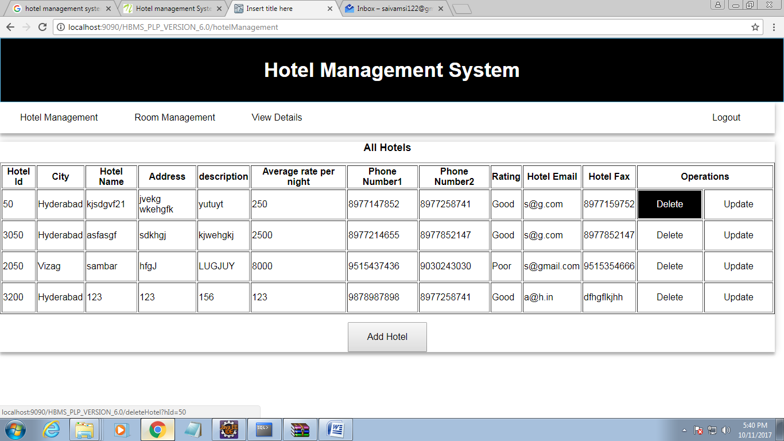

List Of Design Classes
Sr. No. | LLD Name | Class Name | Method Name | Method Description
1 | DeleteModule | Product,  ProductImage | Appropriate getters and setters methods | Getters retrieve the property values and setters set the property values
2 | Delete Item Module | EshopController | @RequestMapping("/deleteHotel")  public ModelAndView deleteHotel(@RequestParam("hId")int hotelId) | .With the help of hotel id ,it will call the delete method of service layer and show the details of all hotels after deletion of that particular hotel.
3 | Delete Item Module | EshopBOImpl | public void deleteHotel(int hotelId) throws HotelException | It will call the delete method of dao layer and provide the id to that method.
4 | Delete Item Module | EshopDAOImpl | public void deleteHotel(int hotelId) throws HotelException | Using id ,it will delete the hotel from the database

Re-Usable Routines/Components

Re-Usable Routines/Components

- CSS files
- Javascript files
- DataAccessException class
- Database properties files
- Logger properties files

Messages

#. | Type | Message Text
M1 | Error | Enter a valid quantity.
M2 | Error | Quantity cannot be empty.

Configuration Files

File Name | Path | Description
oracle.properties | /Development/Source | To configure database connection.
Web.xml | /Development/Source | To configure the bean properties.
Dispatcher-servlet.xml | /Development/Source | To configure the request mapping and view resolver.
HBMS_logger.properties | /Development/Source | To configure the logger.
HBMS_error.properties | /Development/Source | To configure error messages.

Crud Matrix Table

# | Table Name | Create | Read | Update | Delete
1 | Hotel | N | Y | N | Y

Data Mapping Matrix

Sr. No. | Screen Label | Field Source | Field Type | Data Type | Max Length | Data Flow | Mandatory
1 | City | hotelDto.City | Dropdown | varchar2 | 10 | UI->D | Yes
2 | Hotel Name | hotelDto.Hotel_Name | TextBox | Varchar2 | 20 | UI->D | Yes
3 | Address | hotelDto.Address | TextBox | Varchar2 | 40 | UI->D | Yes
4 | Description | hotelDto.Description | TextBox | Varchar2 | 150 | UI→D | Yes
5 | Average Rate Per Night | hotelDto.Avg_Rate_Per_night | TextBox | Number | (6,2) | UI->D | Yes
6 | Phone Number1 | hotelDto.Phone_No1 | TextBox | Number | 10 | UI→D | Yes
7 | PhoneNumber2 | hotelDto.Phone_No2 | TextBox | Number | 10 | UI->D | Yes
8 | Rating | hotelDto.Rating | Dropdown | Varchar2 | 10 | UI→D | Yes
9 | Email | hotelDto.Email | TextBox | Varchar2 | 25 | UI->D | Yes
10 | Fax | hotelDto.Fax | TextBox | Varchar2 | 15 | UI→D | Yes

Legend
D → UI (Database to User Interface)
UI → D (User Interface to Database)
UI (User Interface Only)

Action Flow Matrix

Sr. No. | Action | Description | Process
1 | On click delete Button | On clicking this button automatically it deletes the data. | Admin clicks the button and data is deleted from db.
 |  |  | .

Stored Procedures

# | Stored Procedure Name  (with Description) | Input/Out Parameters | Type | Size
1. | N/A | N/A | N/A | N/A

Program Specification / Pseudo Code

--------NA--------
REVISION HISTORY OF THE WORK PRODUCT

# | Date | Version # | Section Changed | Details of changes made | Approved By
1 | 10/06/2017 | 1.0 | LLD prepared | N/A | Uma M Ponniamman
2 | 10/08/2017 | 1.1 | List of design classes  Action Matrix | Name of controller is modified to “EshopControleer”.  Action Matrix was added | Uma M Ponniamman
3 | 10/09/2017 | 1.2 | Reusable components,  References,  Data Mapping Matrix. | Reusable Components added.  File name with relative path is added in the references section.  The name of text boxes(screen label is changed). | Uma M Ponniamman
4 | 10/10/2017 | 1.3 | List of design classes,  Pseudo code | The names of the methods in list of design classes and pseudo code were changed as per the class diagrams. | Uma M Ponniamman
5 | 10/11/2017 | 1.4 | Configuration files,UI Components | Paths of the configuration files is updated and UI components(Screen Shots) added. | Uma M Ponniamman

S

