Low Level Design (Login Module)

Project Code | Team4
Project Name | Hotel Booking Management System (hbms)

Prepared/Modified by | Role | Date of Preparation
TusharChoudhary | Software Engineer | 03/10/2017
Reviewed by | Role | Date of Review
Vaishali Srivastava | Training Manager | 12/10/2017
Approved by | Role | Date of Approval
 | Training Manager
Circulation List | banala.saikumar@capgemini.com  patibandla.saivamsi@capgemini.com  choudharytusharsingh@capgemini.com  pratyusha.appala@capgemini.com  deepthi.thirumani@capgemini.com | Version Number of the template:1.0
Version Number | 1.4

Table of Contents

1. Description Of The Unit 3
2 References 4
3. Dependencies / Assumptions 5
4. Class Diagrams 6
5. Sequence Diagrams 7
6. Design Components 8
a. List Of UI Components 8
b. List Of Design Classes 9
7. Re-Usable Routines/Components 10
8. Messages 11
9. Configuration Files 12
10. Crud Matrix Table 13
11. Data Mapping Matrix 14
12. Action Flow Matrix 15
13. Stored Procedures 16
14. Program Specification / Pseudo Code 17
REVISION HISTORY OF THE WORK PRODUCT 19

Description Of The Unit

The login module allows the users and admin of the application to login into the system using their valid credentials.

The userId and password entered by the user and admin is validated from the database. If the entered credentials are valid then he/she is redirected to their respective pages based on their roles. Admin is redirected to Admin Page where options are provided to add, delete, modify Hotel .Customer/users are redirected to Home Page where he/she can search and book rooms in respective hotel..

If the entered credentials are invalid then he/she is redirected to the login page and an appropriate error message is displayed.

2 References

Reference | Description
Repository reference | https://IGTEBLRSVNTNG.igatecorp.com/svn/oct3_Team1
Class Diagram | /Project Documents/Design Documents/HLD/Class Diagrams
URS | /Project Documents/Requirements/Case Study/HotelBookingManagementSystem.doc
UTP | /Project Documents/Test Plan/UTP/Test Cases/Login Module/UTP_LoginModule.xls
DB Design | /Project Documents/Design Documents/HLD/DB Design/HOTEL_GROUP_DBDESIGN.xls

Dependencies / Assumptions

Dependencies:
This module is dependent on the registration module wherein the user details are taken and stored in the database.

Assumptions:
UserId and password of the user are in the database. The customer details are stored in the database through registration module whereas admin/sales manager valid credentials are already exists in the database.

Class Diagrams

Class Diagram

Sequence Diagrams

Sequence Diagram
N/A

Design Components

List Of UI Components

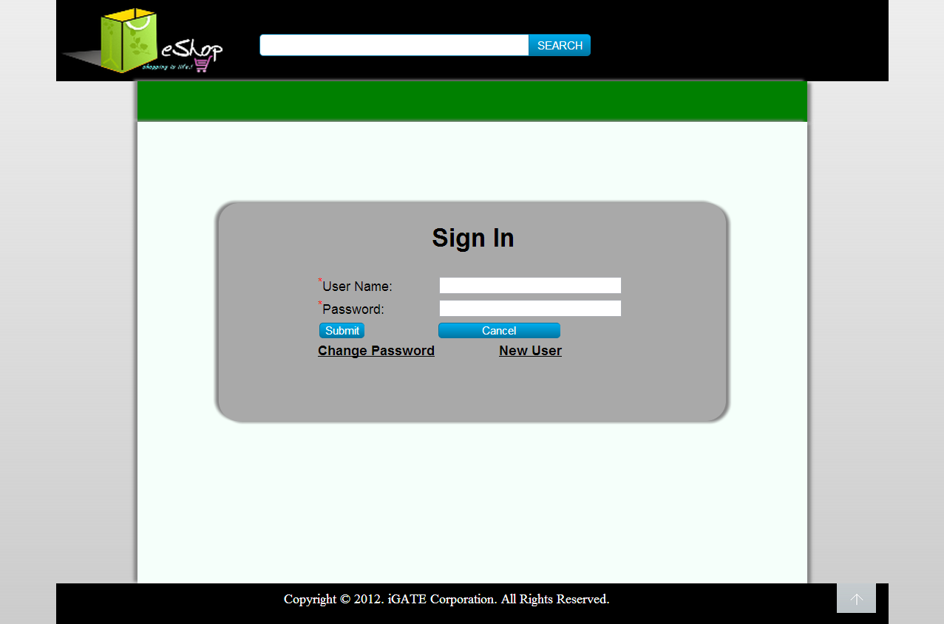

List Of Design Classes

Sr. No. | LLD Name | Class Name | Method Name | Method Description
1 | Login Module | User and  Customer | Appropriate getters and setters methods | Getters retrieve the property values and setters set the property values
2 | Login Module | HotelController | @RequestMapping("/login") | It will direct the flow to jsp login page
3 | Login Module | HotelServiceImpl | public boolean validateUserDetails(int userid, String pwd) | Call the dao function
4 | Login Module | HotelDAOImpl | public boolean loginUserDetails(String userid, String pwd) | Matches the values from database and return boolean.

Re-Usable Routines/Components

Re-Usable Routines/Components

- CSS files
- Javascript files
- DataAccessException class
- Database properties files
- Logger properties files

Messages

#. | Type | Message Text
M1. | Error | Invalid User Name/ Password

Configuration Files

File Name | Path | Description
oracle.properties | /Development/Source | To configure database connection.
Web.xml | /Development/Source | To configure the bean properties.
Dispatcher-servlet.xml | /Development/Source | To configure the request mapping and view resolver.
Hotel_logger.properties | /Development/Source | To configure the logger.
Hotel_error.properties | /Development/Source | To configure error messages.

Crud Matrix Table
# | Table Name | Create | Read | Update | Delete
1 | User | N | Y | N | N

Data Mapping Matrix

Sr. No. | Screen Label | Field Source | Field Type | Data Type | Max Length | Data Flow | Mandatory
1 | UserId | N/A | Label | N/A | N/A | UI | N/A
2 | txtUserId | User.User_id | TextBox | Varchar2 | 10 | UI→D | Yes
3 | Password | NA | Label | N/A | N/A | UI | N/A
4 | txtPassword | User.Password | TextBox | Varchar2 | 20 | UI→D | Yes
5 | Login | N/A | Button | N/A | N/A | UI | N/A
6 | Change Password | N/A | Link | N/A | N/A | UI | N/A
7 | New User | N/A | Link | N/A | N/A | UI | N/A

Legend

UI (User Interface Only)
UI → D (User Interface to Database)
D → UI (Database to User Interface)

Action Flow Matrix
Sr. No. | Action | Description | Process
1 | On click of Login Button | Valid User gets logged | UserId and Password is validated from the database. If user is valid he/she is directed to respective Pages based on roles.Admin is redirected to Admin Page, Sales Manager is redirected to View Report Page and Customer is redirected to Home Page.

Stored Procedures

# | Stored Procedure Name  (with Description) | Input/Out Parameters | Type | Size
1. | NA | NA | NA | NA

Program Specification / Pseudo Code

----NA----
REVISION HISTORY OF THE WORK PRODUCT
# | Date | Version # | Section Changed | Details of changes made | Approved By
1 | 16/12/2013 | 1.0 | Document prepared | N/A | Uma M Ponniamman
2 | 17/12/2013 | 1.1 | List of design classes  Data Mapping Matrix | The controller’s name is changed to “EshopController”  Change Password field added | Uma M Ponniamman
3 | 18/12/2013 | 1.2 | Reusable components,  References,  Data Mapping Matrix. | Reusable Components added.  File name with relative path is added in the references section.  The name of text boxes(screen label is changed). | Uma M Ponniamman
4 | 20/12/2013 | 1.3 | Messages | Changes made in Error Messages | Uma M Ponniamman
5 | 24/12/2013 | 1.4 | Configuration files,UI Components | Paths of the configuration files is updated and UI components(Screen Shots) added. | Uma M Ponniamman

