Low Level Design(UPDATE PRODUCT MODULE)

Project Code | Team4
Project Name | Hotel Booking Management System

Prepared/Modified by | Role | Date of Preparation
Vamsi | Software Engineer | 10/10/2017
Reviewed by | Role | Date of Review
Vaishali Srivastava |  | 10/12/2017
Approved by | Role | Date of Approval
Uma M Ponniamman | Training Manager
Circulation List | banala.saikumar@capgemini.com  patibandla.saivamsi@capgemini.com  choudharytusharsingh@capgemini.com  pratyusha.appala@capgemini.com  deepthi.thirumani@capgemini.com | Version Number of the template:1.0
Version Number | 1.3

Table of Contents

1. Description Of The Unit 3
2. References 4
3. Dependencies / Assumptions 5
4. Class Diagrams 6
5. Sequence Diagrams 7
6. Design Components 8
6.1 List Of UI Components 8
6.2 List Of Design Classes 8
7. Re-Usable Routines/Components 9
8. Messages 10
9. Configuration Files 11
10. Crud Matrix Table 12
11. Data Mapping Matrix 13
12. Action Flow Matrix 14
13. Stored Procedures 15
14. Program Specification / Pseudo Code 16
REVISION HISTORY OF THE WORK PRODUCT 17

Description Of The Unit

The Update module is basically used by the administrator of the system, to update the existing Hotel. It requires a pre-requisite that the administrator should be logged into the system.

On clicking Hotel Management , data from database is retrieved and there we will be viewed with update hyperlink . Once the hyperlink is clicked for updating, previously existing details about that product which are brought from the database are displayed in the text fields. The admin can then modify desired fields and then update the changes in the database. Modified fields are first validated, if valid the details are updated into the database .

References

Reference | Description
Repository reference | https://IGTEBLRSVNTNG.igatecorp.com/svn/oct3_Team1
Class Diagram | /Project Documents/Design Documents/HLD/Class Diagrams
URS | /Project Documents/Requirements/Case Study/HotelBookingMangementSystem.doc
UTP | Project Documents/Test Plan/UTP/Test Cases/ UpdateHotel/ UTP_UpdateHotelModule.xls
DB Design | /Project Documents/Design Documents/HLD/DB Design/HBMS_GROUP_DBDESIGN.xls

Dependencies / Assumptions

Dependencies:
Update module depends on the Login module in such a way that, the admin is able to update a product only when he is logged in.

Class Diagrams

Class Diagram

Sequence Diagrams

Sequence Diagram
NA

Design Components

List Of UI Components
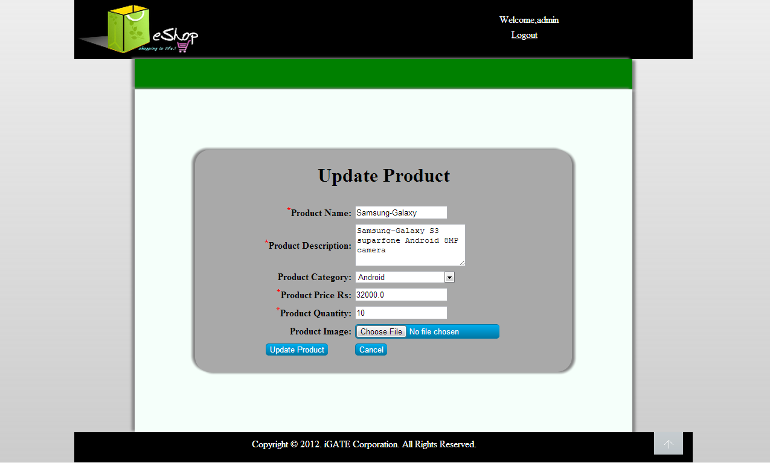

List Of Design Classes
Sr. No. | LLD Name | Class Name | Method Name | Method Description
1 | Update Module | Product,  ProductImage | Appropriate getters and setters methods | Getters retrieve the property values and setters set the property values
2 | Update Module | HBMSController | public ModelAndView updateHotel(@ModelAttribute("update") @Valid HotelDto hotel,BindingResult result) | The control will go to the jsp page with update form
3 | Update Module | HBMSServiceImpl | Void updateHotel(HotelDto hotel) | Calls update function in dao layer

4 | Update Module | HBMSDaoImpl | Void updateHotel(HotelDto hotel) | Update data in the database

List Of UI Components

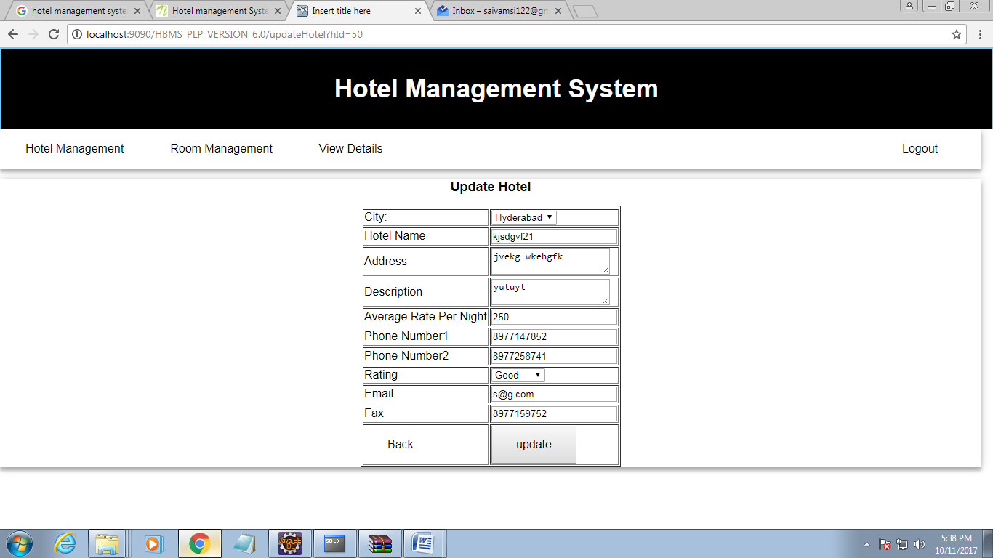

Re-Usable Routines/Components

Re-Usable Routines/Components

- CSS files
- Javascript files
- DataAccessException class
- Database properties files
- Logger properties files

Messages

#. | Type | Message Text
M1 | Error | Enter a valid product name
M2 | Error | Enter a valid product description
M3 | Error | Enter a valid product price
M4 | Error | Enter a valid product quantity
M5 | Error | Choose an appropriate file
M6 | Error | Product name should not exceed 50 characters
M7 | Error | Description should not exceed 100 characters

Configuration Files

File Name | Path | Description
oracle.properties | /Development/Source | To configure database connection.
Web.xml | /Development/Source | To configure the bean properties.
Dispatcher-servlet.xml | /Development/Source | To configure the request mapping and view resolver.
HBMS_logger.properties | /Development/Source | To configure the logger.
HBMS_error.properties | /Development/Source | To configure error messages.

Crud Matrix Table

# | Table Name | Create | Read | Update | Delete
1 | Hotel | N | Y | Y | N

Data Mapping Matrix

Sr. No. | Screen Label | Field Source | Field Type | Data Type | Max Length | Data Flow | Mandatory
1 | City | hotelDto.City | Dropdown | varchar2 | 10 | UI->D | Yes
2 | Hotel Name | hotelDto.Hotel_Name | TextBox | Varchar2 | 20 | UI->D | Yes
3 | Address | hotelDto.Address | TextBox | Varchar2 | 40 | UI->D | Yes
4 | Description | hotelDto.Description | TextBox | Varchar2 | 150 | UI→D | Yes
5 | Average Rate Per Night | hotelDto.Avg_Rate_Per_night | TextBox | Number | (6,2) | UI->D | Yes
6 | Phone Number1 | hotelDto.Phone_No1 | TextBox | Number | 10 | UI→D | Yes
7 | PhoneNumber2 | hotelDto.Phone_No2 | TextBox | Number | 10 | UI->D | Yes
8 | Rating | hotelDto.Rating | Dropdown | Varchar2 | 10 | UI→D | Yes
9 | Email | hotelDto.Email | TextBox | Varchar2 | 25 | UI->D | Yes
10 | Fax | hotelDto.Fax | TextBox | Varchar2 | 15 | UI→D | Yes

Legend
D → UI (Database to User Interface)
UI → D (User Interface to Database)
UI (User Interface Only)

Action Flow Matrix

Sr. No. | Action | Description | Process
1 | On click of Update Button on admin home page | Admin is navigated to home screen | When admin clicks on this button he/she is navigated to the home screen where he/she can select the product to be updated.
2 | On click of Update button for a particular product on home screen | Admin is navigated to product description page | When admin clicks on update button if one particular product he is navigated to description page where he can modify desired fields related to that product.
3 | On click of Update Product button in Product Description page. | Admin is notified about the updation of product | On clicking update product button, the modified values of the product attributes are updated into the database.
4 | On click of Go to Home Page Button | Control goes back to admin home page | When Go to Home Page button is pressed, the admin is navigated to the admin home page

Stored Procedures

# | Stored Procedure Name  (with Description) | Input/Out Parameters | Type | Size
1. | N/A | N/A | N/A | N/A

Program Specification / Pseudo Code

--------NA----------
REVISION HISTORY OF THE WORK PRODUCT

# | Date | Version # | Section Changed | Details of changes made | Approved By
1 | 10/06/2017 | 1.0 | LLD prepared | NA | Uma M Ponniamman
2 | 10/07/2017 | 1.1 | List of Design classes(6.2) | Name of the controller is modified to EshopController | Uma M Ponniamman
3 | 10/07/2017 | 1.2 | 6.2,10 | Added a method getSubCategoryList() | Uma M Ponniamman
4 | 10/07/2017 | 1.3 | Configuration files,UI Components | Paths of the configuration files is updated and UI components(Screen Shots) added. | Uma M Ponniamman

